# Analysis

Both the calculated values for the resistance RL which is 25.81 +- 3.03 Ohm and the capacitance C which is 4.82e-7 +- 6.3e-9 F are the same as the measured values which are 24.61 Ohm and 0.478 µF within their error. The graphs from which these values were taken are Figure 1 and Figure 2.

The predicted values which are 201.06 and 109.15 Ohm shown in Figure 3 and Figure 4 for the impedances are also very close the experimentally determined values which are 202.46 +- 0.14 and 107.78 +- 0.58 Ohm. If I had calculated the error for the two predicted impedances, then the errors would probably overlap to show the range in which the true value lies.

Looking at the parallel currents for the capacitor which was calculated to be 0.021 A and the inductor, which was 0.073 A, they are once again very close to the measured values of 20.6 mA for the capacitor and 72.5 mA for the inductor. The same can be said about the voltages. Predicted series values are 9.57 V for the capacitor and 2.78 V for the inductor. Measured in series was 9.599V and 2.76 V for the capacitor and inductor. Once again if errors had been calculated I would expect these to overlap because of how close the values are which would confirm their correctness.

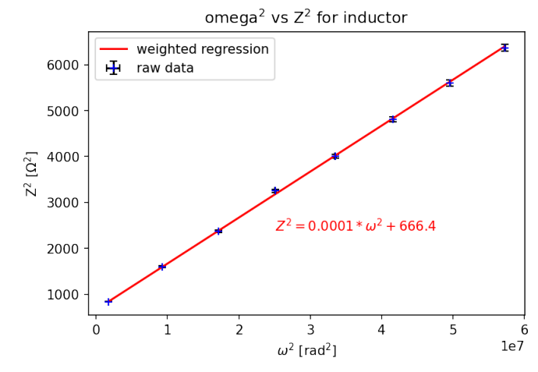

Figure 1: Plot of calculated data points with weighted regression line to calculate the resistance of L

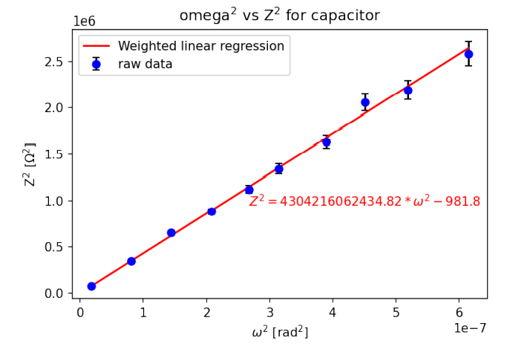

Figure 2: Plot with calculated data points and weighted regression to get capacitance of the capacitor

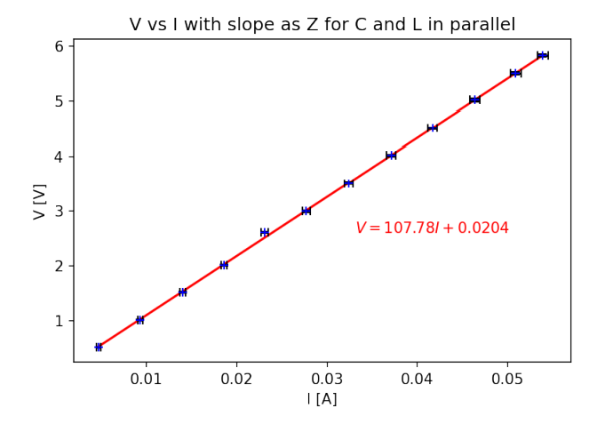

Figure 3: Plot of measured voltage and current for RCL parallel circuit to calculate impedance

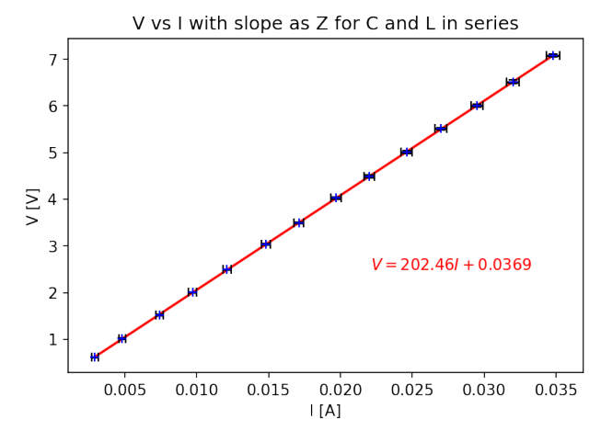

Figure 4: Measured voltage and current plotted to calculate impedance of series RLC circuit

## Calculations

To calculate RL Eq. 1 and Eq. 2 was used which give RL as the y-intercept when plotted and the error was determined through the square root of the diagonal elements of the co-variance matrix for its standard deviation which can be seen in the analysis appendix. For the capacitance C the same Eq. 1 and Eq. 2 was used. In this case the capacitance was the slope of the graph of the impedance and the frequency in the form of 1/C2. Impedances were determined with Eq. 5 for impedance of an inductor and Eq. 6 for the impedance of a capacitor. These were combined using Eq. 3 for series and Eq. 4 for parallel circuit configurations.

|  |  |
| --- | --- |
|  |  |
|  |  |
|  |  |
|  |  |
|  |  |
|  |  |