## Analysis

For the calculations and the analysis of the resulting values the measured anode voltages were reduced by 1% to account for a protection resistor in the leads. For both beam orbit diameters (8 +- 0.05 cm and 10 +- 0.05 cm) Kr was evaluated using Eq. 1 to calculate BT and BE using Eq. 2 and Eq. 3. B/B0 is a ratio given by the manufacturer. The values weren’t exact for the chosen ratio of r/R which is why the data sheet which can be seen in Figure 1 was interpolated using Scipy’s interp1d. Kr for the 8cm orbit was 7.7103 e-4 +- 3.99e-06 T/A and 7.6837 e-4 +- 3.98e-06 T/A for Kr of the 10cm orbit. BT varies over each measurement pair while BE for each pair is around the actual value for the earth’s magnetic field. Therefore, BT values were all used as an array to calculate a series of e/m values with Eq. 4 which were then averaged for an estimate. The resulting BE values were also averaged to give the best estimate.

BE as calculated from the taken measurements resulted in 5.09e-05 +- 3.38e-06 T which is within error of the accepted reference value of 5.33375e-05 T [1]. The result of e/m from the BT values was 2.086 e11 +- 0.075 e11 C/kg which is not within error of the reference value of 175882001076.0 C/kg [2]. The calculated e/m values before they were averaged did not fluctuate around the actual value. Instead, they were all consistently too high. In the end the e/m from the experiment was roughly 118.6% of the reference value. The reason for this discrepancy will be discussed in the discussion section.

To evaluate K to compare to the value given by the manufacturer Eq. 5 was used in the form of Eq. 6. The result of calculating K was 7.709 e-4 +- 2.57e-05 T/A which is within error of the provided 7.73e-4 +- 0.04e-4 T/A.

Details to calculations and sample calculations can be seen in the analysis appendix. The derivation of Eq. 5 can be seen below the equations.

Ein Bild, das Tisch enthält.

Figure 1: Magnetic field strength as a function of distance from the centre of Helmholtz coils

## Equations

|  |  |
| --- | --- |
|  | 1 |
|  | 2 |
|  | 3 |
|  | 4 |
|  | 5 |
|  | 6 |

## Derivation of Eq. 5

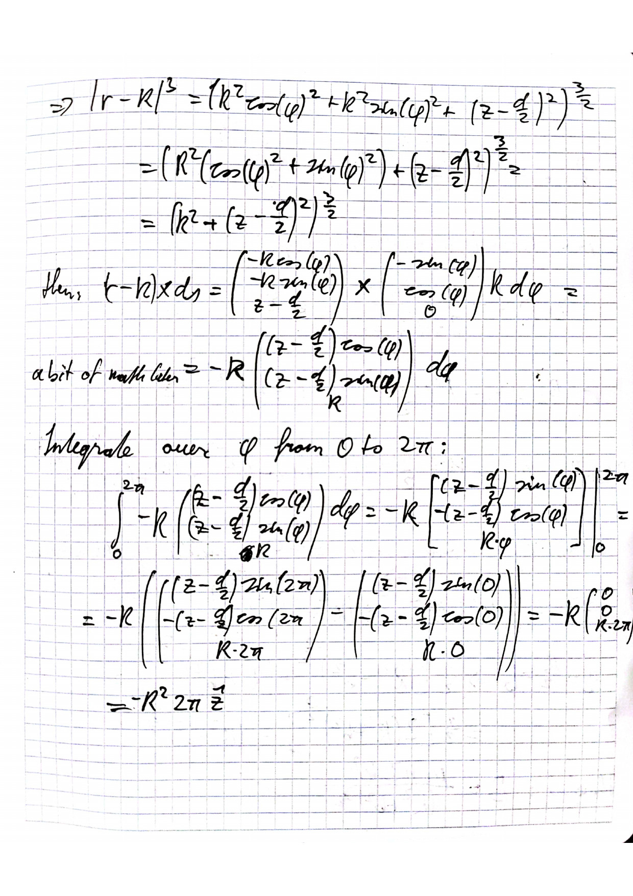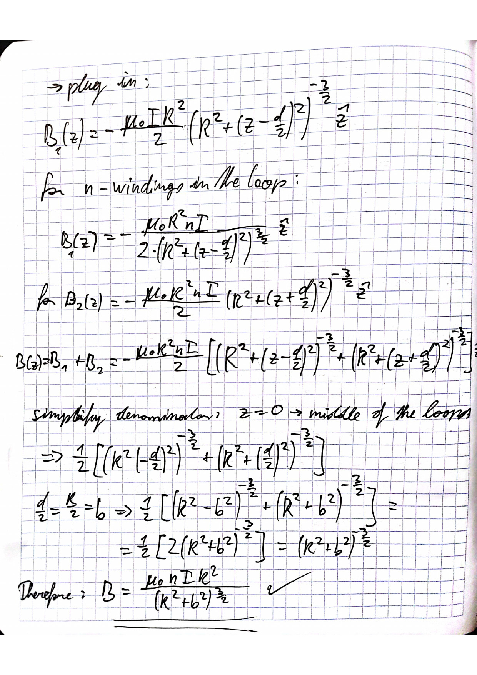

## Sources

[1] “Magnetic Declination in Kingston, Canada,” *What is the Magnetic Declination at your location?* https://www.magnetic-declination.com/Canada/Kingston/335754.html (accessed Mar. 24, 2022).

[2] “CODATA Value: electron charge to mass quotient.” https://physics.nist.gov/cgi-bin/cuu/Value?esme (accessed Mar. 24, 2022).