Implementation of ITIL Framework for Health and Wealth Mobile Application

Aditya Chebiyyam

Kapilan Kumanan

Prashanth Boovaragavan

Shrija Chavan

School of Applied Technology, Department of Information Technology and Management Illinois Institute of Technology

RACI Matrix
 | R | A | C | I
Overviewof ITIL and Demand Management | Aditya | Aditya | Kapilan | All
Financial Management | Shrija | Shrija | Prashant | All
Service Portfolio Management | Kapilan | Kapilan | Aditya | All
Availability Management and Info Sec Management | Prashant | Prashant | Shrija | All

Abstract
Whealth Application is a Mobile Application which offers the consumers who shop at all the leading supermarket chains two most important services Wealth Friendly and Health Friendly user experience. More often than not we end up overshooting our Budget when we shop for our monthly groceries and this is a result of not having a real time tracker of the expenses. Our App, will enable the consumers to keep a track of each Dollar they are spending at the store and if/when the consumer exceed the preset Budget he/she will be notified. This way one can curtail the unnecessary cost. For the Health Conscious people this App will also enable the consumer to monitor the kind of food products they are buying and based on some pre defined metrics, the App will make suggestions to the consumers. For example, for a person who is buying more of Fatty/High Cholesterol Food, the App will pop up alternatives such as more Green Vegetables or Fiber Food or for a consumer whose cart has very little protein food the App may suggest an alternative such as Fruits. This mobile application will make use of the in built camera of the phone, which will act as the Barcode reader to take note of the product details and with the available price list it keeps a track of the shopping cart value. As an additional service the App also lists the prices of the scanned product from other stores as well.

Overview of ITIL
The services offered using Whealth Mobile Application will be managed based on the principles of Information Technology Infrastructure Library (ITIL). ITIL is one of the most widely recognized and adopted Information Technology (IT) Service Management framework in the world. As highlighted by Arraj, V. (2010) many organizations today are now implementing ITIL in their work environments because it is a practical approach for planning, delivery and IT services support to the businesses. ITIL is becoming one of the most popular and widely accepted approach to IT Service Management and the it provides a set of best practices which are responsible to drive the organization towards their IT growth objective. McLaughlin, K., & Damiano, F. (2007) further affirm that these best practices are documented in books so that the organizations can use them to manage their IT domains. The books are as mentioned below:
- Service Strategy
- Service Design
- Service Transition
- Service Operation
- Continual Service Improvement
Service Strategy
Service Strategy is the source of guidance on how to design and develop service management as a strategic asset apart from being an organizational capability. As stated by Office of Government Commerce Großbritannien. (2007) that the guidance mentioned above is provided to develop service management guidelines and processes across the service lifecycle.

Service Design
Service Design process is responsible for providing the base to design and develop the services and service management processes. It is also responsible for covering principles of design to fructify the strategic objectives into services portfolios and service assets. Not only for new services but service design plays a key role to increase and maintain the customer value for existing services. As suggested by Office of Government Commerce Großbritannien. (2007), Service Designs main objective is to provide guidance on developing design capabilities for IT service management.
Service Transition
Service Transition helps the organization to develop and improve the capabilities to transition new and altered services into operations. While keeping track of the various risks of failure and potential business disruptions, the service transition process helps realize the many service strategy requirements. As highlighted by Lacy, S., Macfarlane, I., Taylor, S., & Office of Government Commerce Großbritannien. (2007), the Service Transition process also fosters innovation while providing guidance to manage the complex changes to services and service management processes.
Service Operation
Service Operation is the key ITIL process for any organization to achieve efficiency and effectiveness in delivering and supporting IT services. This in turn ensures a good value for the service providers and the customers. This process offers guidance on maintaining stability in service operations through changes in design and service levels. Taylor, S., Cannon, D., & Wheeldon, D. (2007) suggest that it is through Service Operation process an organization handles the reactive and proactive control perspectives.
Continual Service Improvement
Last but not the least is the Continual Service Improvement process that is instrumental in helping the organization achieve high customer satisfaction standards. This is done by combining the various methods, principles and practices from Change Management and Quality Management. ITIL Continual Service Improvement helps in realizing the organizational goals of large improvements in business continuity and operational efficiency.
The ITIL framework was first introduced by the Office of Government Commerce in UK and due to its iterative and multidimensional nature it is one of the most widely accepted framework for IT organizations. Sahibudin, S., Sharifi, M., & Ayat, M. (2008) point out that although there are many frameworks and standards today in the IT management systems, on their own they are not enough to function as efficient IT management system and thus many authors have found the area of integrating ITIL with the other frameworks which are Control Objectives for Information and related Technology (COBIT) and ISO/IEC 27002 to build efficient systems to be of particular interest for further research. Implementation of ITIL best practices are not limited to only IT organizations as many government firms are also looking to ITIL for increasing service levels, reducing overhead costs and above all improve the security for their business. Meziani, R., & Saleh, I. (2010) suggest that in order to achieve pre-defined service levels for many services a systematic approach is required and ITIL is the one stop solution for this. People, Process and Technology issues are the constant occurrences in every IT organization and having a string Information Technology Service Management (ITSM) is very important. Transformation is the key to success and every organization has a plan to implement their transformation plans in phases, refer Figure 1.

The first question “Where do you want to be?” is a part of the Vision and Business Objective team but the subsequent stages of transformation phases are driven by ITIL Process Assessment, ITIL Implementation and ITIL Process Review processes. Business is mainly driven by IT today and having highest availability of services along with profitability and high customer satisfaction is achieved through ITIL. There are many benefits if ITIL but the authors of this paper feel the following are some of the most important ones:
- High Availability and reliability of mission critical services.
- Clear communication and documentation of all the roles/responsibilities.
- Having an optimal infrastructure of IT systems to cater to future business requirements
- Reduce the Total Cost of Ownership (TCO) permanently.
Implementing Demand Management for Whealth Application
To ensure there is proper management of Planning, Production and Delivery in any efficiently run business, balancing the orders for its products and services (Demand) is the most important task.This is co related to producing these services or products (Supply) as per the requirements otherwise there could be too little of what is required or too much of what is required. All the above can be carried out only through one of ITIL’s most important sub-process, Demand Management. The writers of this paper strongly believe that having a successful Service Strategy is only possible by managing and predicting the demand of services. Demand Management is a very important aspect of Service Management because if the planned capacity is more than the demand, it affects the whole products strategy for the market. According to the Information Technology Service Management (ITSM), Demand Management is the key process to predict the demand from the customer’s perspective. Using the Pattern of Business Activity (PBA), we can foresee if a particular service’s demand will rise or fall in the future. According to ITIL® Demand Management (2016), identification of appropriate PBA’s and linking them to the customer profiles can help us to include or remove services in the service catalogue. In other words, it acts as an input to other Service Strategy sub processes such as Financial and Capacity Management. In addition to the aforementioned, Demand Management also helps in ensuring accurate allocation of infrastructure, financial and manpower resources.
For the Whealth mobile application, the major challenge was to predict the consumer spending and according to Amadeo, K. (2016), in a survey conducted in 2016 it was found that more than two thirds of consumer spending is on services such as health and housing. The writers found this point to be of particular interest because since this applications utility was also to suggest health foods to the consumers based on their shopping cart, it would be ideal to focus on the age group of 30-50 years. This segment of age group are usually the ones who have shown strong interest in spending for health along with being conservative in their spending’s. The writers strongly felt that in order to formulate a Service Strategy for the Whealth Mobile Application, the first step is to adopt Demand Management at three levels such as the Basic Level, at Infrastructure Level and at Mobile Application Level. As suggested by Van Bon, J.et al (2008) with the proper prognosis of demand we can completely remove the potential threat of demand related uncertainty. Thus, Demand Management takes key role in Service Strategy management.
- To ensure there is proper Planning, Production and Delivery management in any efficiently operated business, orders have to be balanced for all the products and services (Demand) and this is the most important task. This activity is related to arranging these services or products (Supply) as per the requirement otherwise there could be an overall excess of the supply or reduced supply depending on the case. The above can be carried out through efficient Demand Management (one of ITIL’s most important sub-process). The authors of this paper strongly believe that having a successful Service Strategy is only possible by managing and predicting the demand of services. Demand Management is a very important aspect of Service Management because if the planned capacity is more than the demand, it affects the whole product/ service strategy for the market.
- For whealth mobile application, the major aspects which have to be considered to predict the demand include:
- Demand for the mobile application at point of sale.
- Demand for access of Mobile information.
- Demand from all categories of user community (students, house wife, health freaks, senior citizens etc., with different demands).
Demand for the mobile application at point of sale
In general, a demand management process is discussed as component of supply chain management. However, the goal of demand management is to meet service demand in the most effective and efficient way. The demand management process can have a significant impact on the cost-effectiveness of a firm and its customers. A good demand management process can enable a company to be more proactive to anticipate demand, and more reactive to unanticipated demand. Croxton, K. L., Lambert, D. M., García-Dastugue, S. J., & Rogers, D. S. (2002).
In case of Whealth Mobile application the demand for a point of sale may vary significantly as in the case of retailer outlets based on seasonality and peak hour sales delivery. Therefore, there could be wide variance in workload on the application and hardware infrastructure. The writers felt that the best scenario which can be looked at to conduct a baseline research for the above-mentioned point is during the Thanksgiving period every year. The season of gifts and purchasing goods is the highest during this time and the team at Whealth feel the necessity of managing the traffic on the application is high. Hence in order to have a successful delivery of the application service, effective management of this workload variation will improve product availability and hereby increase customer loyalty leading to repeat business. The writers of this paper suggest to use trace based capacity and demand management to formulate their Service Strategy and this is further affirmed by Gmach, D., Rolia, J., Cherkasova, L., & Kemper, A. (2007, July).
The workload demand prediction service enables: To recognize whether a workload’s demands change significantly over time; The generation of synthetic traces that represent future demands to support capacity planning exercises; and, model that can support forecasting exercises.
Demand for access of Mobile information
In addition, for service management of Whealth Mobile Application the Mobile Information Access is also an important aspect of demand management. The ability to access information on demand at every point of sale is crucial for managing the demand of uses
Satyanarayanan, M. (1996). As users become more dependent on this ability, the span of access of data repositories will have to grow. The increasing social recognition of the shops or any other location as a place of sale is a further impetus to the development of mechanisms for mobile information access. These considerations imply that data from shared file systems, relational databases, object-oriented databases and other repositories must be accessible to programs running on mobile computers Satyanarayanan, M. (1996). The writers believe that the above-mentioned points form the second layer of foundation for the Whealth Mobile Application because in order for the application to make suggestions to the customers on alternatives in the food /grocery/miscellaneous item it has to have constant access to the other stores pricing and list of products and this means a seamless access to the databases and information repository.
Depending on the need the writers shall explore appropriate strategy to use both application-transparent and application-aware adaptation but for now during the pilot phase implementation the team is focused on working closely with the technology group at Whealth to identify the key systems which are required for the continuity of the application availability which in turns manages the demand.
Demand from all categories of user community
Recognizing the demographic of people who would be the prospective customers of Whealth Mobile Application was the most important thing. For the pilot phase, we wanted to understand what the consumers choose amongst the money and health. According to the survey conducted, we could find that there is a need for this kind of application. The two most important categories of everyone’s priority were health and preservation of health. The best way to use ITIL’s Demand Management for this application was to see which category of users would use this application the most. The writers could focus on three main categories:
- People in the age group of 30-40
- International Students
- People who were fitness and sports enthusiasts.
People in the age group of 30-40.
The first category of people were our primary customers as they had the money to spend but also were inclined towards services which provide value for money. Our application provides them the functionality of reducing the over spending in supermarkets by keeping track of the cart value in their smartphones and this is exactly what they were looking for in an application. If someone wanted only $200 as their cap limit, our application would warn them if they exceeded it and hence they would drop the excess items in such a case.
International Students.
The second category of target audience were International Students. Since many students come to study abroad and they have limited source of money to spend on groceries, it is very important for them to keep tap on how much money goes into the groceries every week or month. Our application is designed perfectly to their needs as it would only let them spend their pocket money according to the limit.
People who were fitness and sports enthusiasts.
Last but not the least, this set of target audience are the primary takers of our applications second functionality which is suggestion of healthy food alternatives. Gym and fitness enthusiasts may or may not spend more but, they would love any suggestions on their food intake which would help them buy more nutrional food. Initially we have designed the application which would only suggest alternatives from the current supermarket and others as well but depending on the demand, in the second phase of growth we would explore use of analytics and technology to come up with suggestions based on calorie intake for these set of users. Further market research will help to identify dynamic changing needs of existing customers and new expectations of prospective customers.
Implementing Service Portfolio Management for Whealth Application
Service portfolio is one of the important phases of the service strategy lifecycle as this phase is what defines services are provided by the service provider. The service portfolio is used to describe all the functionalities of a service or in our case an application. Service portfolio can be subdivided into three parts: Service Pipeline, Service catalog, Retired Services. Service portfolio consists of several activities in it, refer figure 2.
Define Phase
The first activity is called as the Define phase. This phase is used to explain what services exists in present. This phase also provides an outline of the all the functions that will be provided by the service provider. This phase would clearly give an idea on what services the provider would provide if he/she had unlimited resources with them.
Analyze Phase
The second activity is called as the Analyze phase. In this phase, the service that is to be provided is thoroughly analyzed. Understanding what is going to be done will greatly help the upper management for taking clear decisions.
Approve phase
The third activity is called as the Approve phase. In this phase, a final blueprint for the service portfolio is drawn for understanding what is being offered to the customers. The service that already exists is categorized in six different outcomes. The first type is called as Renew. This type is called so because the services provided maybe functionally proficient but the technical aspects of it are not up to date. Therefore, the service or product needs to be renewed or updated in other words. The second type is called as Replace. Services need to be replaced when the existing services are ambiguous in nature. The third type is called the Retain. This type is called so because the service already exists and is modified in such a way to adapt to the service strategy of the company. The next type is called as Refractor. This is called so because services may have both the functionality and the latest technologies implemented in them but may be ambiguous in nature due to a lot of functionalities. Hence by implementing only the functionalities that are necessary or otherwise called as refactoring the service may become efficient. The next type is called as Retire. This is where the original service is deemed unusable because it does not meet the functional and technical standards requirements. The last type is called as the Rationalize. Sometimes existing services may be provided from the different versions of the same software. Such services need to be rationalized.
Charter Phase
The fourth and last type of activity are called as Charter. In this stage, all the decision taken are documented, and the resources required for the process is segregated.
Our application has various functionalities which will be beneficial to the customer with respect to money and health. The flow of the application is explained below. Firstly, the application requires the user of the application to sign up using their Facebook, Google or email account. After signing up, the user can now log in using their credentials. Upon logging, the user will have the option to set a budget for their shopping. How this will work is the user must scan each product the user picks up at the store, and this will be stored by the application with its price. Therefore, each time the user picks up an item it needs to scanned using the phone’s camera for its barcode. The cost of each item keeps adding up in the application and alerts the user when the total is equal to budget the user has specified at the beginning. The cost of each item is retrieved from the store’s website. Now for the application to retrieve prices form the store’s website it needs to know inside which store the customer is. The application uses GPS to pin point the location of the user and then finds the store inside which the customer is. Apart from this the application also keeps track of the type of food items the user picks up. Our application uses some predefined metrics to calculate the level of nutrients the human body requires. The application suggests customers on the type of food they should take to lead a healthy life. For example, consider a user of the application takes more of fatty food like cheese then the application would suggest the user to take of green vegetables and fruits. This suggestion can be turned off by the customer inside the application.
Apart from the above mentioned services our application has value added services as well. When the user scans the barcode using their smartphone’s camera the price of the product being scanned is pulled from all major retail stores and presented to the user. This data is being pulled from the websites of the other dealers. Since the application already has the location of the user it checks the surrounding places and displays the rates for that store first. This data can be hugely beneficial for the customer as the customer can check if the price of the product is lower at someplace else and buy it from that place itself rather than spending more money here. This service is a value-added service provided to the customer. The application also uses targeted advertising meaning that the application keeps track of the products the customer usually buys and uses this information to provide advertisements to the customer. This is used to generate revenue for the application. The customer can also get rid of these advertisements by buying a premium version of this application which does not have any advertisements in it. The application most importantly requires internet to function as the price of each product may differ from day to day, and the application needs to provide the latest information possible to the customer.
Implementing Financial Management for Whealth Application
Financial management for IT services is a service delivery element of the ITIL framework. The aim of this process is to give accurate and cost effective management of IT assets and resources used in providing IT services. Financial management helps to plan and recover the cost expended on the IT services which will be agreed on the SLA’s.
As per the ITIL (Information Technology Infrastructure Library) principals, the financial management in service strategy should aim to include the following things for any new product development:
- It should be accountable for all the funds for the IT services required for the new product development.
- Assign the cost to the services which are delivered to the customer using the IT services.
- All the changes in the IT services should be monitored by the decision-making team and explain in detail the IT investments and cost analysis to the organization.
As rightly said by Powell, M., & Ansic, D. (1997) the key concepts of financial management should be:
- Budgeting: It involves the prediction of cost and revenue to the company. The primary function of the budgeting is to understand the demand for the services and the related cost which the company incurs to fulfill the demand.
- Accounting: To monitor the flow of money a particular IT organization spends is called accounting. It’s very important to determine the cost for each customer, service and activities of the organization.
- Charging: The activities involved in the process to bill the customer is called charging.
- Cost Models: There are two different cost models:
1.cost to customer.
2.cost to service.
Referring to figure 3, which was disclosed by Planview (Organization), we can confidently plan investments for new product success if we refer to the process and best practices mentioned above. They explain how to perform the Top-Down and Bottom-Up product financial planning. According to Planview, we can perform the strategic financial planning by distributing the budget by priorities of the project. They explain that by centralizing all the budget information, the management is well informed about the available budget to spend on the product or any service launch in the market.
They also explain in detail a very important factor which every organization should do on a regular basis i.e. Tracking the total cost of development: It is very essential to stay on top of all the factors that are affecting the financial costs to the organization to mitigate the issues before they are uncontrollable. We have to measure and compare project finances at each stage to make sure if it needs more financing or investment to be successful when the product or services are launched. By referring mainly to Planview’s financial procedures and O'Reilly, C. A. we try to rule down our financial management strategies for our new product launch.
Considering the above standard principles of ITIL, Planview and referring to many peer review articles, we try to layout the financial management system for our Whealth app. As this is new product in the market we try to allocate the cost by finding the cost objects such as marketing department, IT services, customer relationship, advertising, R&D and so on. We tend to achieve the market share by focusing on the short term and long term goals.
According to O'Reilly, C. A. (1982) a company who launches new product in the market should mainly focus on investing 20% of the budget on the marketing and advertising to introduce the product and make the customers aware of the new service. In this scenario, by knowing our target customers we can have a clear picture as in where to invest the money and how to achieve the market place for our product.
To survive the tough competition in the initial days we tend to spend 10% of our budget to give many offers and deals to the customer to initialize the service. After we lay out the strategies to capture the market, our major focus of cost allocation will be on the IT services, over 50% of the money will be invested in the IT services. As this a software product, and we need to concentrate more on the Hardware and software part of this product. IT services will cover the hardware, software, database, servers, systems and manpower to handle the process.
We initially focus only on one city so the cost incurred to set up the IT services and the cost of manpower are low. If the response of the product is good and if we generate a good revenue, our next goal will be to expand our services to other cities and then we have to invest more on the IT services as we will require more manpower, software and hardware to fulfill the demand. Out of the remaining 20% of the budget, 10% will be spend towards the miscellaneous costs of the company and the rest 10% will be kept as liquidity to handle any incident and problem management issues.
We will continuously monitor the flow of our money and make the required changes once the process is in flow. We will cut down the cost in the areas in which the investments are not necessary at this point of time and focus on the revenue generating areas. Once the pilot process is completed we will start charging the customers according to the standard market price to generate profit.
As finance is included in all the areas of a product development we will follow the standard ITIL principles to manage the flow of money by fulfilling the goals of the organization taking care of all the areas such as budgeting, accounting, charging and cost models.
Service Design for Whealth Application
Many organizations have long recognized the importance of service management for customer satisfaction and service improvement. The growing competition for service offering in Information Technology has raised the need for service advancement on a regular basis. Service design plays a primary role in the introduction of new components to a service. The changes done in an existing service is also decided and logged in the service design module of the service management life cycle. According to Goldstein, S. M., Johnston, R., Duffy, J., & Rao, J. (2002), designing a service means defining an appropriate mix of physical and non-physical components. Non-physical components include elements such as labour force, and people skills. ITIL v3® Service Design categorizes service design into several processes namely – Service Catalogue Management, Service Level Management, Capacity Management, Availability Management, IT Service Continuity Management, Information Security Management and Supplier Management. Refer Figure 4 for a detailed view of the service design module. It is highly necessary to understand that not every change in an IT Service needs to be launched as a Service Design activity. It is important to strategize the changes as “significant” and “immeasurable”. Only changes that are significant enough for the service requires being a part of the service design activity.
Implementing Information Security Management for Health and Wealth Application
Security issues have become a major part of the organization’s primary concern. It is necessary to ensure that security is properly maintained. According to Susanto12, H., Almunawar, M. N., & Tuan, Y. C. (2011), Information is the lifeblood of organizations, a vital business asset in today’s Information Technology (IT) -enabled world Various frameworks such as ISO/IEC 17799 and British standard for information security, BS 7799 are available to help organizations examine their security risks. The term “information” within itself has too many inferences. It can often be referred to raw data, customer information or Meta data. For most of the organizations, the major security objectives include:
- Making sure that the information is available when required. This includes condition when the system which provides information is being attacked and is still able to resist attacks and recover from such failures.
- Establishing the fact that information abstraction is well executed. Information needs to be made available or disclosed only to those who have a right to access. This would ensure that confidentiality is well maintained within the service.
- Enabling proper authentication services so that the information exchange between various service providers, customers and enterprises are trust worthy.
The authors of the paper believe that Information Security Management is one of the vital processes in the service management life cycle. Given the need for availability, confidentiality and integrity of information, it is necessary to integrate all the processes in business from end to end and include all the physical and technical aspects. Service design is the module that helps business professionals strategize methods to manage information and its level of security in all possible ways. The Health and Wealth application mainly deals with a large volume of data in terms of health factors and the amount of money that could possibly be invested on it. There are certain processes that had to been taken in consideration while implementing information security policies to the application. They include:
- Defining an Information Security Management System (ISMS) with a comprehensive set of procedures and guidelines to back the information security policies.
- Developing a powerful security organizational structure to maintain the integrity of information that the customer provides and work on it with complete authenticity.
- Building a stable system with necessary strategies and policies to manage risks and system failures.
- Establishing standards on various policies such as access control policy, internet policy, antivirus policy and password control policy.
Figure 5 provides a comprehensive explanation on IT Security Management framework. The major aspects of security considered for the health and wealth application is the information classification hierarchy wherein factors such as the age of the customer, severity of the health issues and the amount of money available need to be taken in account. Other aspects such as accountability for customer provided information, authenticity of the results and the efficiency of implementation should also be considered. A successful implementation of the information security management for the application incorporates a constant need for improvement in the security agreement controls and measures. Saint-Germain, R. (2005) affirms that the goals of information security are to ensure business continuity, to maintain legal compliance, and to achieve competitive edge. The writers of the article believe that their set of standardized security policies and solutions concerning the organization as well as technology rightly work towards achieving the goal.
Implementing Availability Management for Health and Wealth Application
It is a well-known fact that the growing competition for providing a better service to the customer has built a surge for availability of resources and information in of the most convenient ways. Availability Management, being an important aspect of Service Design makes sure that the measure of service available for the business needs matches the current and future requirements of the business. Brenner, M. (2006, April) believes that IT organizations have focused on improving availability through adapting their technical infrastructure, e.g. by using more reliable components or building more fault-tolerant systems. The authors of the paper have adopted a similar methodology to meet the growing demand of the application in terms of service and dependability of information. The main objectives of Availability Management for the health and wealth application are:
- To ensure that the health tips being provided align with the appropriate and up to date compilation of all the health factors taking cost into consideration
- To make sure that the application is user friendly and constantly available to meet the current and future needs of the business.
- To constantly consider a room for improvement by a careful diagnosis and resolution of incidents related to availability.
- To study the impact of change in the availability plan on the basis of performance and reachability of all other co-services and resources.
Availability Management is a continual process wherein the improvements are necessary in terms of IT infrastructure services and technology related services. It is rightly quoted that “The simplest way to increase availability is to focus on Incident Management and Change Management”. The wealth and health application strives to work on any incidents related to availability of information in a timely manner with the utmost priority. As it is known that change is the only constant, the authors of the article believe that a regular analysis of the business trends in the health sector on the growing needs and the technology edge will help them in providing one of the best customer based service experiences. Refer Figure 6, for a detailed explanation on availability management objectives.
Various services such as IT Service Desk are a major part of the application. The major objectives of such desks include the minimization of service outages and provide a user-friendly experience to the customers using the application. The availability management module should mainly take the current business processes, availability of components and the future business plans and requirements into consideration. The authors of the article assert that the success of the application depends on achieving the trust of the customers by an increased usability of the service. To achieve this success, it is vital to monitor all aspects of the availability, reliability and accountability of the health and wealth application. The writers of the article have made sure that the application interests most of the age groups such as the aged people (60 years and above), young people (between 20-40 years) and people with varied requirements such as managing fitness and weight loss.
Service Design plays a crucial role in determining the success of a service. This application has efficiently managed to categorize people in terms of age and requirements and provide them with the most budget friendly options to maintain a healthy lifestyle. A service gets better with a room of improvement. The application, currently being in the initial phase provides a comprehensive alternative to the super markets available in the vicinity. With the increase in demands of the application, the authors wish to incorporate more exciting service features and value adds to the existing system to ultimately develop a healthy and nutrition rich society.

Conclusion and Future Scope
So far, the writers have focused on two of ITIL service management processes for implementation of the Whealth Mobile application. The ideal approach to the launch of any new service or product would be to come up with a Strategy and followed by the Design phase and Implementation phase. For, Whealth application after the pilot phase has been completed the writers intend to move towards applying other ITIL principles such as Service Operation, Service Transition and the last step would be to improve on the deficiencies and the issues through Continual Service Improvement(CSI). We feel that the real test for any technology product or service is having a robust operations support, hence in our phase two of implementation we would focus on having a strong IT operations management team with the help of ITIL Service Operations, we would focus on two main components which are Incident Management and Problem Management. Being a mobile application we anticipate some downtimes, connectivity issues and user experience issues. To start with we would work closely with the Mobile Service Providers to mitigate any kind of coverage issue for the customers. As there are many service providers in the market, we would manage to collect enough data for the peak usage and the least usage times for our application so that we can plan the Infrastructure scaling up as per the requirement. By doing this we not only use ITIL’s capacity management but also each time there is an incident reported by a user not able to connect to the application we can build our error database for quick turnarounds in the future. As a follow up to this, we will have a strong technology management team in place to better design the systems flow and our problem management team to work on the root cause for each incident reported. With the help of Service Transition we intend to drive our efforts to have a strong Change Management in place because our technology infrastructure will only expand from here on which means more systems to be added and more software updates and firmware upgrades. We strongly feel that making these changes will lead to better customers experience . Finally through CSI we intend to improve the areas mainly focused on Customer User Experience. Depending on the feedback form the customers in the pilot phase the application User Interface, value add services such as suggestion about alternative stores, products and categories will be improved to deliver the ultimate user experience. We strongly believe that with the help of above mentioned ITIL framework processes, we would be able to successfully drive Whealth application to consumers to provide a better health and wealth management experience.

References
Amadeo, K. (2016, September 30). Consumer Spending Improved 4.2% in Late Spring 2016. Retrieved November 21, 2016, from https://www.thebalance.com/consumer-spending-trends-and-current-statistics-3305916
Arraj, V. (2010). ITIL®: the basics. Buckinghampshire, UK.
Arsanjani, A., Ghosh, S., Allam, A., Abdollah, T., Ganapathy, S., & Holley, K. (2008). SOMA: A method for developing service-oriented solutions. IBM systems Journal, 47(3), 377-396.
Brenner, Michael. "Classifying ITIL processes; a taxonomy under tool support aspects." 2006 IEEE/IFIP Business Driven IT Management. IEEE, 2006.
Croxton, K. L., Lambert, D. M., García-Dastugue, S. J., & Rogers, D. S. (2002). The demand management process. The International Journal of Logistics Management, 13(2), 51-66.
Flamholtz, E. G. (1983). Accounting, budgeting and control systems in their organizational context: theoretical and empirical perspectives. Accounting, organizations and society, 8(2), 153-169.
Gmach, D., Rolia, J., Cherkasova, L., & Kemper, A. (2007, July). Capacity management and demand prediction for next generation data centers. In IEEE International Conference on Web Services (ICWS 2007) (pp. 43-50). IEEE.
Goldstein, Susan Meyer, et al. "The service concept: the missing link in service design research?" Journal of Operations management 20.2 (2002): 121-134.
http://www.managementstudyguide.com/financial-management.htm#
http://www.planview.com/solutions/product-development/financial-management-pd/
https://www.linkedin.com/pulse/20140825024259-11499331-the-5-recommended-steps-for-completing-a-financial-justification-for-product-launch

ITIL v3® Service Design, Office of Government and Commerce, London: TSO, 2011.
ITIL® Demand Management. (n.d.). Retrieved September 14, 2016, from http://www.bmc.com/guides/itil-demand-management.html
Lacy, S., Macfarlane, I., Taylor, S., & Office of Government Commerce Großbritannien. (2007). ITIL.[3]. Service transition. TSO (The Stationery Office).
McLaughlin, K., & Damiano, F. (2007, October). American itil. In Proceedings of the 35th annual ACM SIGUCCS fall conference (pp. 251-254). ACM.
Merchant, K. A. (1981). The design of the corporate budgeting system: influences on managerial behavior and performance. Accounting Review, 813-829.
Meziani, R., & Saleh, I. (2010, November). e-government: Itil-based service management case study. In Proceedings of the 12th International Conference on Information Integration and Web-based Applications & Services (pp. 509-516). ACM.
O'Reilly, C. A. (1982). Variations in decision makers' use of information sources: The impact of quality and accessibility of information. Academy of Management journal, 25(4), 756-771.
Office of Government Commerce Großbritannien. (2007). Service strategy. TSO,(The Stationery Office).
Office of Government Commerce Großbritannien. (2007). Service strategy. TSO,(The Stationery Office).
Oliveira, J. A., Sauvé, J., Moura, A., Queiroz, M., Bartolini, C., & Hickey, M. (2010, April). Value-driven IT service portfolio selection under uncertainty. In 2010 IEEE Network Operations and Management Symposium-NOMS 2010 (pp. 416-423). IEEE.
Powell, M., & Ansic, D. (1997). Gender differences in risk behavior in financial decision-making: An experimental analysis. Journal of economic psychology, 18(6), 605-628.
Rehman, S., & Guenov, M. D. (1998). A methodology for modelling manufacturing costs at conceptual design. Computers & Industrial Engineering, 35(3), 623-626.
Sahibudin, S., Sharifi, M., & Ayat, M. (2008, May). Combining ITIL, COBIT and ISO/IEC 27002 in order to design a comprehensive IT framework in organizations. In 2008 Second Asia International Conference on Modelling &# x00026; Simulation (AMS) (pp. 749-753). IEEE.
Saint-Germain, René. "Information security management best practice based on ISO/IEC 17799." Information Management 39.4 (2005): 60.
Satyanarayanan, M. (1996). Accessing information on demand at any location. mobile information access. IEEE Personal Communications, 3(1), 26-33.
Shehab, E. M., & Abdalla, H. S. (2001). Manufacturing cost modelling for concurrent product development. Robotics and Computer-Integrated Manufacturing, 17(4), 341-353.
Susanto12, Heru, Mohammad Nabil Almunawar, and Yong Chee Tuan. "Information security management system standards: A comparative study of the big five." International Journal of Electrical Computer Sciences IJECSIJENS 11.5 (2011): 23-29.
Taylor, S., Cannon, D., & Wheeldon, D. (2007). ITIL V3–Service operation. Office of Government Commerce. Norwich: The Stationery Office.
Walker, M., & Choudhury, N. (1987). Agency Theory and Management Accountin. Arnold, JA, R. Scapens and D. Cooper, Management Accounting: Expanding the horizons, London: Chartered Institute of Management Accountants, 61-112.
Wei, X., & Zhiqiang, Z. (2011, March). A method of IT service portfolio selection based on BDIM. In Computer Research and Development (ICCRD), 2011 3rd International Conference on (Vol. 2, pp. 178-182). IEEE.
Wei, X., & Zhiqiang, Z. (2011, November). Service portfolio selection driven by multiple business objectives. In 2011 International Conference on Information Management, Innovation Management and Industrial Engineering (Vol. 2, pp. 146-149). IEEE.

Figures Title:
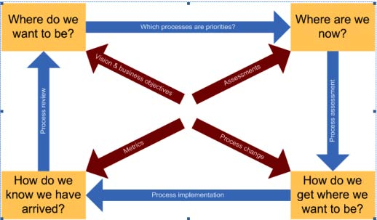
Figure 1. Meziani, R., & Saleh, I. (2010) Organization Transformation Phases.

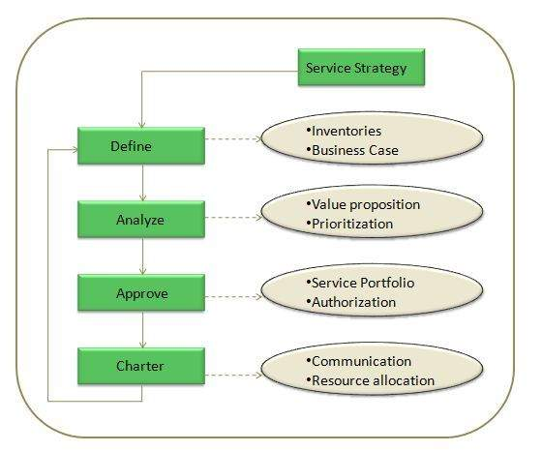
Figure 2. https://www.tutorialspoint.com/itil/service_portfolio_management.
Service Portfolio Management.
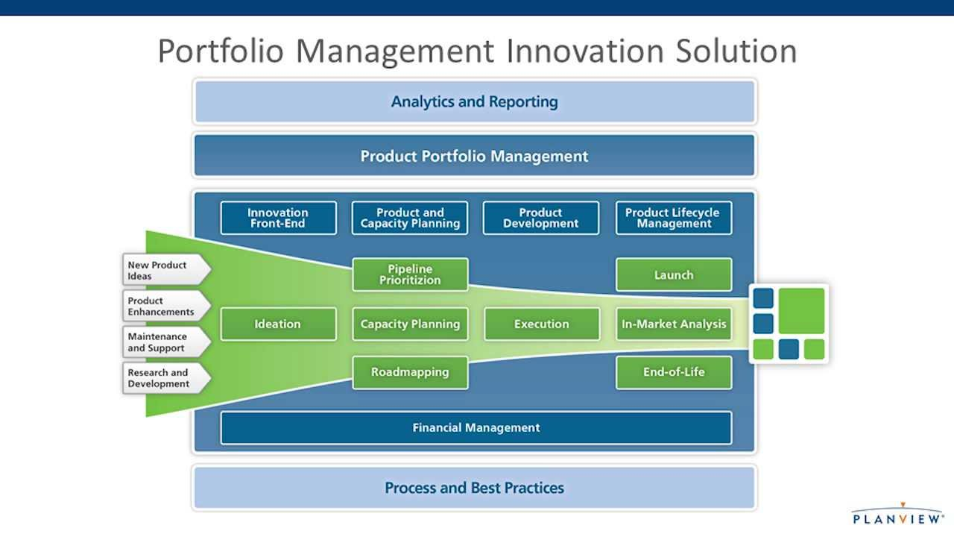
Figure 3. Product Development Solutions | Planview.
Financial management.

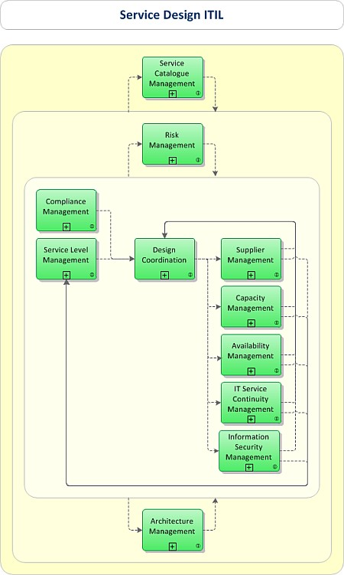
Figure 4. Kempter, S. (n.d.). ITIL Service Design.
ITIL Service Design.

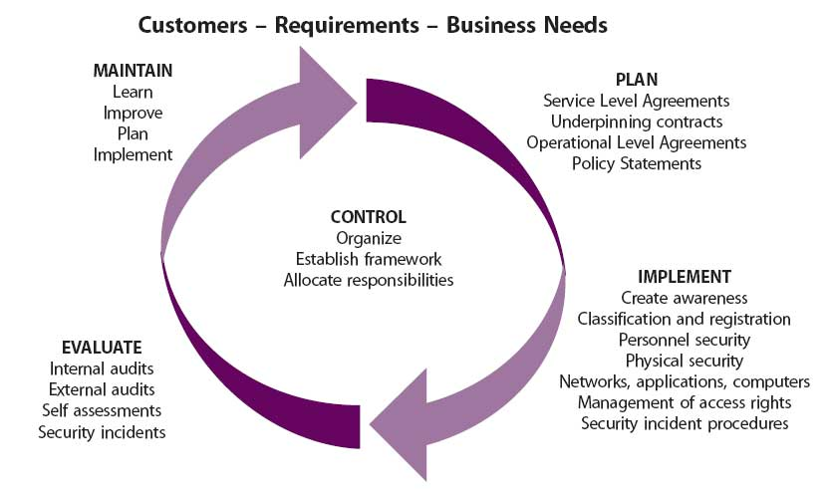
Figure 5. R,B Palmer (2016), Framework for Managing IT Security.

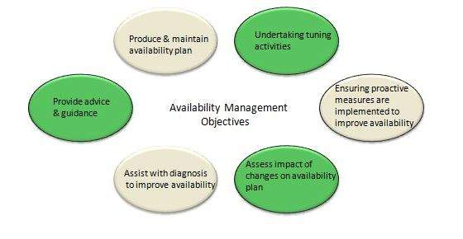
Figure 6. https://www.tutorialspoint.com/itil/availability_management.
Availability Management Objectives.

