**COMPUTER PROJECT**

**'Quickdocs'**

ADITI JUNEJA

XII A

|  |
| --- |
| ***CONTENTS*** |

➢*INTRODUCTION*

➢*ACKNOWLEDGEMENT*

➢*CERTIFICATE*

➢*USER MANUAL*

➢*SOURCE CODE*

➢*OUTPUTS*

➢*BIBLIOGRAPHY*

|  |
| --- |
| ***INTRODUCTION*** |

***Quickdocs*** *helps users to make microsoft*

*word documents faster, by providing samples, and*

*also enables the user to create their own samples*

*and manage them.*

|  |
| --- |
| ***ACKNOWLEDGEMENT*** |

*It would be my pleasure to express my sincere  thanks*

*to my Computer Science teacher Ms Prajjya  Dutta*

*in providing a helping hand in this project.*

*Her valuable guidance, support and supervision*

*all  through this project titled “Quickdocs”,*

*are  responsible for attaining its present form.*

*Aditi juneja (XII A)*

|  |
| --- |
| ***CERTIFICATE*** |

*This is to certify that Aditi Juneja of class XII-A*

*has successfully completed the Computer*

*Science project on Quickdocs under the  guidance of*

*Ms. Prajjya Dutta (Computer Science  Teacher)*

*during the academic year 2020-21 as per*

*the guidelines issued by the Central Board*

*of  Secondary Education (CBSE).*

*Ms Prajjya Dutta*

*(P.G.T. Computer Science)*

|  |
| --- |
| ***USER MANUAL*** |

**Required packages** : docx , os , pickle , csv

**Before using** : Run the samples.py program in python IDLE to install

in built samples and user manual. Don’t delete or open the

files created, in the folder, after executing the program.

**How to use the program** :

1. Put files quickdocs.py and samples.py and folder sample in a folder on desktop and run samples.py .

2. Make a sample docfile by writing  **{n{**  in place of variable characters .

Here n is a number , assigned to the variable characters. For first variable character(s), n would be 1,

For second variable character(s), n would be 2,

For third variable character(s), n would be 3 ,...and so on.

These numbers would be used for further occurrences, in the document also , in the above syntax only. You can refer to the in built samples for more clarity. Skip , if want to use in built samples only.

3. Run the program quickdocs in python IDLE . A menu would be displayed. By entering :

1. 0 : the program will end.
2. 1 : a series of menus would appear to help you create your document from the sample. It would iterate until the necessary character(s) to stop the process is/are not entered.
3. 2 : a series of menus would appear to help you create your own ,new sample.
4. 3 : the names of all the existing samples with there location would be shown .
5. 4 : a series of menus would appear to help you delete an already existing sample’
6. Otherwise , this ‘help’ section would appear.

4. The docfile, once created would be in the folder in point no. 1 and can be removed from the folder.

5. If you change the position of a user created sample, then to change the address , the sample would have to be deleted and created again with the different address. It would  appear in the list of names of samples but would give an error when you would try to create a file.

|  |
| --- |
| ***SOURCE CODE*** |

**FILE 1 : quickdocs.py**

from docx import Document

import os

import csv

import pickle

#function to make new samples

def add_sample():

n=input('Enter docfile name (without extention) : ')

loc1=input('Enter location of the docfile : ')

loc=loc1+'\\'+n+'.docx'

a=loccheck(loc)

if a==True:

k=int(input('How many replacing variable character phase(s) are there ? ')) # getting numer of variables from user

d={}

for i in range(k):

m=input('Enter variable '+str(i+1)+' name: ') # getting variable names from user

d[i+1]=m

f=open('samples.csv','a',newline='') #opening samples.csv

wo=csv.writer(f) #writer object

wo.writerow((n,loc,d)) # adding sample's name,location and dictionary of the format : {1:<variable 1>,2:<variable 2>,3:<variable 3>.....}

f.close()

print('Added',n,'as a Sample !! ')

else:

print(n,'not found at',loc)

#function to delete a samples

def del_sample():

sname=input('Enter docfile name (without extention) : ')

i1=[]

f=open('samples.csv','r',newline='') #opening samples.csv

ro=csv.reader(f) #reader object

for i in ro: #extracting records of all docfiles from samples.csv except the with name as <sname>

if i[0]!=sname:

i1+=[i]

f1=open('samples1.csv','w',newline='') #creating a copy of samples.csv but without record of <sname> file

w=csv.writer(f1)

w.writerows(i1) #entering records

f1.close()

f.close()

print('Sample',sname,' deleted')

os.remove('samples.csv') # deleting samples.csv

os.rename('samples1.csv','samples.csv') #renaming new file

#function to create a new document

def use_sample():

s,s1=filename_loc() #names of all samples

sname=input('Enter sample docfile name (without extention) : ') #sample name

if sname not in s:

print('Sorry :( File not found. ')

else:

while sname !='b': # loop for using samples one by one

f=open('samples.csv','r',newline='') #opening samples.csv

ro=csv.reader(f) #reader object

for i in ro: # extracting dictionary of sample <sname> as i1

if i[0]==sname:

i1=i[2]

loc=i[1] #extracting location of the sample file

f.close()

i1=eval(i1) #making i1's type from string to dictionary

print('\nEnter 0 to stop making documents of this sample')

name=input('Enter the new docfile\'s name (without extention) you want to create : ')

while name!='0': # loop for making docfiles one by one from a sample

name+='.docx'

d={}

for num in i1: #creating dictionary of the format : {1:<variable 1's value>,2:<variable 2's value>,3:<variable 3's value>.....}

val=input(i1[num])

d[num]=val

new_doc(loc,name,d) #making docfile

print('\nEnter 0 to stop making documents of this sample')

name=input('Enter the new docfile\'s name (without extention) you want to create : ')

print('\n\nEnter sample name to use another sample\nEnter \'b\' to end.')

sname=input('Enter sample docfile name (without extention) : ')

#function to create a new document from the existing sample

def new_doc(sample,new_doc,dic) :

doc = Document(sample) #opening sample docfile

a=doc.paragraphs #extracting paragraphs from the sample docfile

p1=[]

for i in a: # extracting text and putting variable values in place of {<number>{

a1=i.text.split('{') #spliting the text of every paragraph such that <number> is a sepsrate element of list

for j in a1:

if j.isdigit()==True: # checking for <number>

index=a1.index(j)

a1[index]=dic[int(j)] #subsituting variable value

a1=' '.join(a1) #joining the paragraph

p1+=[a1] #making list of paragraphs

doc= Document() #opening new docfile

for i in p1: #adding paragraphs one by one in new docfile

doc.add_paragraph(i)

doc.save(new_doc) #saving file by the name that user entered

print(new_doc,'Created.')

#function to shows documentation stored in binary file help.dat

def info():

with open('help.dat','rb') as s:

a=pickle.load(s)

print(a)

#function to show names of all existing samples

def show_samples():

i1,i2=filename_loc()

print('\nSamples (location) : ')

for i in range(len(i1)): #showing samples one by one

print(i1[i],'\t (',i2[i],')')

#function that returns the list of all samples' names

def filename_loc():

f=open('samples.csv','r',newline='') #opening samples.csv

ro=csv.reader(f) #reader object

i1,i2=[],[]

for i in ro: #extracting all samples' names from samples.csv

i1+=[i[0]]

i2+=[i[1]]

del i1[0]

del i2[0]

f.close()

return i1,i2

#function to check that the new sample exists at the location entered by user

def loccheck(loc):

try:

d=Document(loc)

return True

except:

return False

#__main__

print('Enter 0 to end the program\nEnter 1 to create document(s)\nEnter 2 to add sample\nEnter 3 to see all samples\nEnter 4 to delete a sample\nEnter 5 for help')

c=int(input('0/1/2/3/4/5 : '))

while c!=0: #loop for menu driven program

if c==1: #to make docfiles from samples

use_sample()

elif c==2: # to add new samples

add_sample()

elif c==3: #to show existing samples

show_samples()

elif c==4: # to delete a sample

del_sample()

else: #to see user manual for help

info()

print('\n\nEnter 0 to end the program\nEnter 1 to create document(s)\nEnter 2 to add sample\nEnter 3 to see all samples\nEnter 4 to delete a sample\nEnter 5 for help')

c=int(input('0/1/2/3/4/5 : '))

else:

print('Program Ended.\nThank you :)')

**FILE 2 : samples.py**

#samples

import csv

f=open('samples.csv','w',newline='') #file will contain all samples' names,locations and variables in them

wo=csv.writer(f) #Writer object

ro=csv.reader(f) #Reader object

h=('filename','filelocation','variables')

x=('health check up authorisation letter',r'C:\Users\Admin\Desktop\quickdocx\sample\health check up authorisation letter.docx',{1:'Name '})

y=('FORM 24',r'C:\Users\Admin\Desktop\quickdocx\sample\FORM 24.docx',{1:'File number ',2:'Year ',3:'Name',4:'Date of birth',5:'Number of years',6:'Number of months',7:'Number of days',8:'Last date of service',9:'First day of service '})

z=('exam intimation',r'C:\Users\Admin\Desktop\quickdocx\sample\exam intimation.docx',{1:'Diary number',2:'Date',3:'Name',4:'Branch where working',5:'UPSC/SSC',6:'Name of board',7:'Advertisement number',8:'advertisement date'})

wo.writerow(h) #adding rows in csv file

wo.writerow(x)

wo.writerow(y)

wo.writerow(z)

f.close()

#user manual

import pickle

f=open('help.dat','wb') #file of user manual

st='''Help

Required packages : docx , os , pickle , csv

Before using : Run the samples.py program in python IDLE to install in built samples and user manual. Don’t delete or open the files created, in the folder, after executing the program.

How to use the program :

1. Put files quickdocs.py and samples.py and folder sample in a folder on desktop and run samples.py .

2. Make a sample docfile by writing {n{ in place of variable characters .

Here n is a number , assigned to the variable characters. For first variable character(s), n would be 1,

For second variable character(s), n would be 2,

For third variable character(s), n would be 3 ,...and so on.

These numbers would be used for further occurrences, in the document also , in the above syntax only. You can refer to the in built samples for more clarity. Skip , if want to use in built samples only.

3. Run the program quickdocs in python IDLE . A menu would be displayed. By entering :

a. 0 : the program will end.

b. 1 : a series of menus would appear to help you create your document from the sample. It would iterate until the necessary character(s) to stop the process is/are not entered.

c. 2 : a series of menus would appear to help you create your own ,new sample.

d. 3 : the names of all the existing samples with there location would be shown .

e. 4 : a series of menus would appear to help you delete an already existing sample’

f. Otherwise , this ‘help’ section would appear.

4. The docfile, once created would be in the folder in point no. 1 and can be removed from the folder.

5. If you change the position of a user created sample, then to change the address , the sample would have to be deleted and created again with the different address. It would appear in the list of names of samples but would give an error when you would try to create a file.

'''

pickle.dump(st,f) #adding st in file

f.close()

|  |
| --- |
| ***OUTPUTS*** |

'''Enter 0 to end the program

Enter 1 to create document(s)

Enter 2 to add sample

Enter 3 to see all samples

Enter 4 to delete a sample

Enter 5 for help

0/1/2/3/4/5 : 1

Enter sample docfile name (without extention) : salary

Sorry :( File not found.

Enter 0 to end the program

Enter 1 to create document(s)

Enter 2 to add sample

Enter 3 to see all samples

Enter 4 to delete a sample

Enter 5 for help

0/1/2/3/4/5 : 1

Enter sample docfile name (without extention) : FORM 24

Enter 0 to stop making documents of this sample

Enter the new docfile's name (without extention) you want to create : FORM

File number 112/880

Year 2020

NameRahul

Date of birth12/09/1975

Number of years25

Number of months6

Number of days7

Last date of service22/11/2020

First day of service 30/09/2005

FORM .docx Created.

Enter 0 to stop making documents of this sample

Enter the new docfile's name (without extention) you want to create : 0

Enter sample name to use another sample

Enter 'b' to end.

Enter sample docfile name (without extention) : b

Enter 0 to end the program

Enter 1 to create document(s)

Enter 2 to add sample

Enter 3 to see all samples

Enter 4 to delete a sample

Enter 5 for help

0/1/2/3/4/5 : 2

Enter docfile name (without extention) : result

Enter location of the docfile : C:\Users\Admin\Desktop\quickdocx

How many replacing variable character phase(s) are there ? 5

Enter variable 1 name: name

Enter variable 2 name: class

Enter variable 3 name: Roll No

Enter variable 4 name: Total marks

Enter variable 5 name: Result(pass/fail)

Added result as a Sample !!

Enter 0 to end the program

Enter 1 to create document(s)

Enter 2 to add sample

Enter 3 to see all samples

Enter 4 to delete a sample

Enter 5 for help

0/1/2/3/4/5 : 3

Samples (location) :

health check up authorisation letter ( C:\Users\Admin\Desktop\quickdocx\sample\health check up authorisation letter.docx )

FORM 24 ( C:\Users\Admin\Desktop\quickdocx\sample\FORM 24.docx )

exam intimation ( C:\Users\Admin\Desktop\quickdocx\sample\exam intimation.docx )

result ( C:\Users\Admin\Desktop\quickdocx\result.docx )

Enter 0 to end the program

Enter 1 to create document(s)

Enter 2 to add sample

Enter 3 to see all samples

Enter 4 to delete a sample

Enter 5 for help

0/1/2/3/4/5 : 1

Enter sample docfile name (without extention) : result

Enter 0 to stop making documents of this sample

Enter the new docfile's name (without extention) you want to create : stud1

nameRashi

class12

Roll No1

Total marks450

Result(pass/fail)pass

stud1.docx Created.

Enter 0 to stop making documents of this sample

Enter the new docfile's name (without extention) you want to create : 0

Enter sample name to use another sample

Enter 'b' to end.

Enter sample docfile name (without extention) : b

Enter 0 to end the program

Enter 1 to create document(s)

Enter 2 to add sample

Enter 3 to see all samples

Enter 4 to delete a sample

Enter 5 for help

0/1/2/3/4/5 : 4

Enter docfile name (without extention) : result

Sample result deleted

Enter 0 to end the program

Enter 1 to create document(s)

Enter 2 to add sample

Enter 3 to see all samples

Enter 4 to delete a sample

Enter 5 for help

0/1/2/3/4/5 : 3

Samples (location) :

health check up authorisation letter ( C:\Users\Admin\Desktop\quickdocx\sample\health check up authorisation letter.docx )

FORM 24 ( C:\Users\Admin\Desktop\quickdocx\sample\FORM 24.docx )

exam intimation ( C:\Users\Admin\Desktop\quickdocx\sample\exam intimation.docx )

Enter 0 to end the program

Enter 1 to create document(s)

Enter 2 to add sample

Enter 3 to see all samples

Enter 4 to delete a sample

Enter 5 for help

0/1/2/3/4/5 : 5

Help

Required packages : docx , os , pickle , csv

Before using : Run the samples.py program in python IDLE to install in built samples and user manual. Don’t delete or open the files created, in the folder, after executing the program.

How to use the program :

1. Put files quickdocs.py and samples.py and folder sample in a folder on desktop and run samples.py .

2. Make a sample docfile by writing {n{ in place of variable characters .

Here n is a number , assigned to the variable characters. For first variable character(s), n would be 1,

For second variable character(s), n would be 2,

For third variable character(s), n would be 3 ,...and so on.

These numbers would be used for further occurrences, in the document also , in the above syntax only. You can refer to the in built samples for more clarity. Skip , if want to use in built samples only.

3. Run the program quickdocs in python IDLE . A menu would be displayed. By entering :

a. 0 : the program will end.

b. 1 : a series of menus would appear to help you create your document from the sample. It would iterate until the necessary character(s) to stop the process is/are not entered.

c. 2 : a series of menus would appear to help you create your own ,new sample.

d. 3 : the names of all the existing samples with there location would be shown .

e. 4 : a series of menus would appear to help you delete an already existing sample’

f. Otherwise , this ‘help’ section would appear.

4. The docfile, once created would be in the folder in point no. 1 and can be removed from the folder.

5. If you change the position of a user created sample, then to change the address , the sample would have to be deleted and created again with the different address. It would appear in the list of names of samples but would give an error when you would try to create a file.

Enter 0 to end the program

Enter 1 to create document(s)

Enter 2 to add sample

Enter 3 to see all samples

Enter 4 to delete a sample

Enter 5 for help

0/1/2/3/4/5 : 0

Program Ended.

Thank you :)'''

**ADDING SAMPLE 'RESULT'**

**'RESULT' CONTENT**

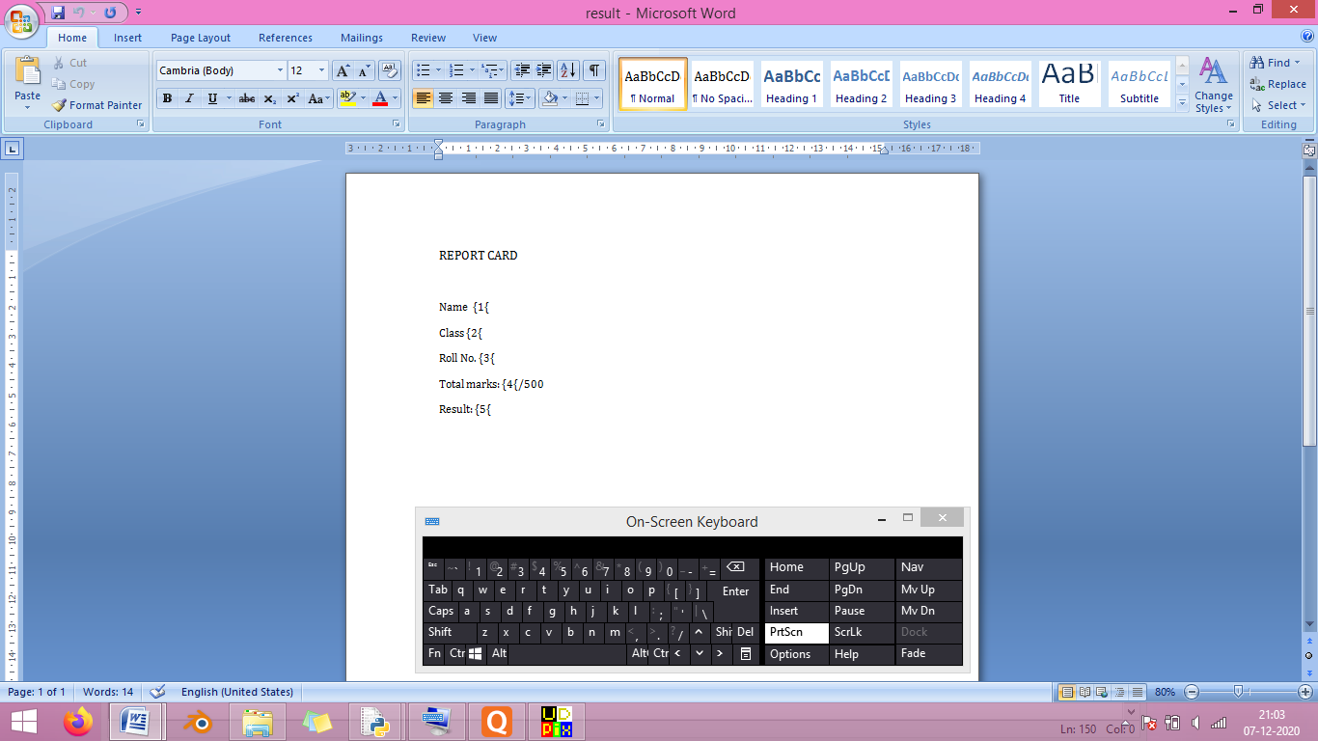

**SAMPLES.CSV**

**INITIALLY AFTER**

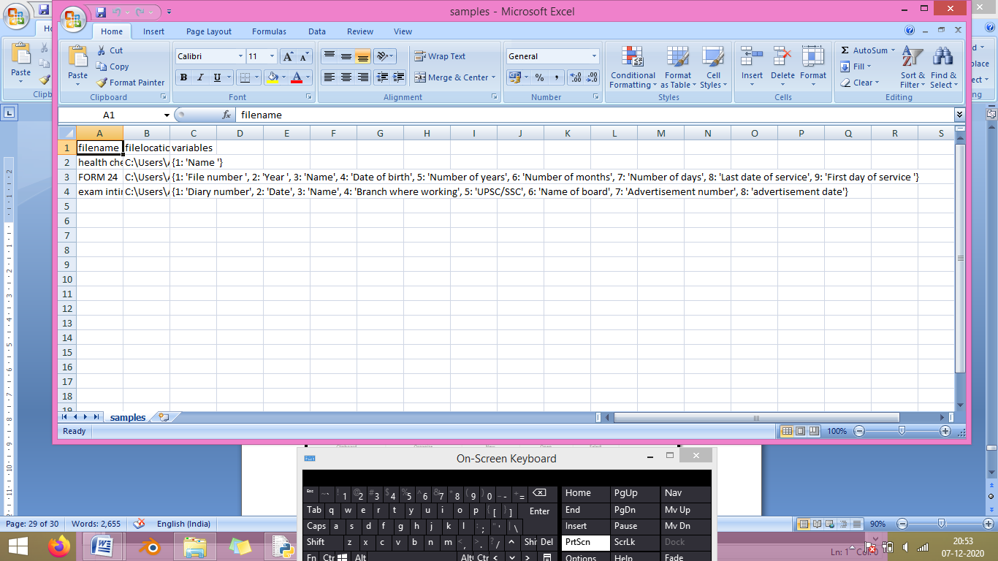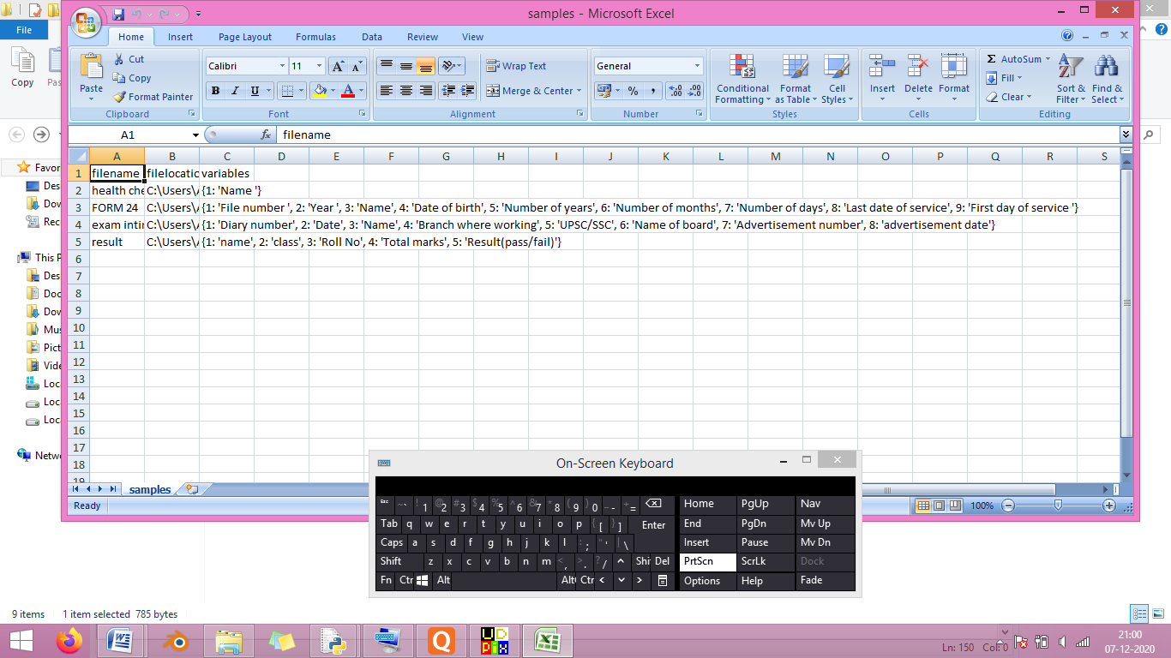

**'STUD1' CONTENT QUICKDOCX FOLDER**

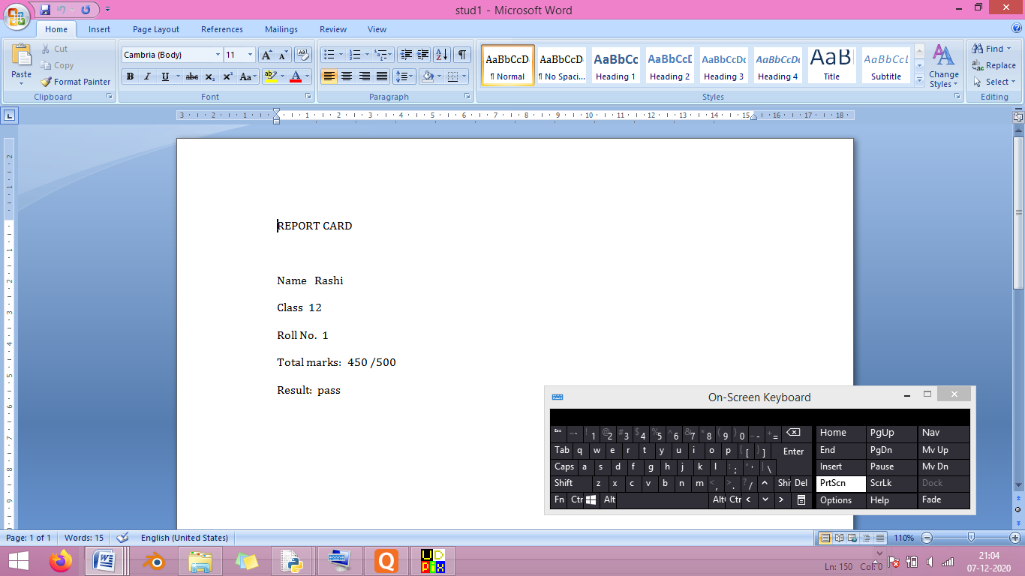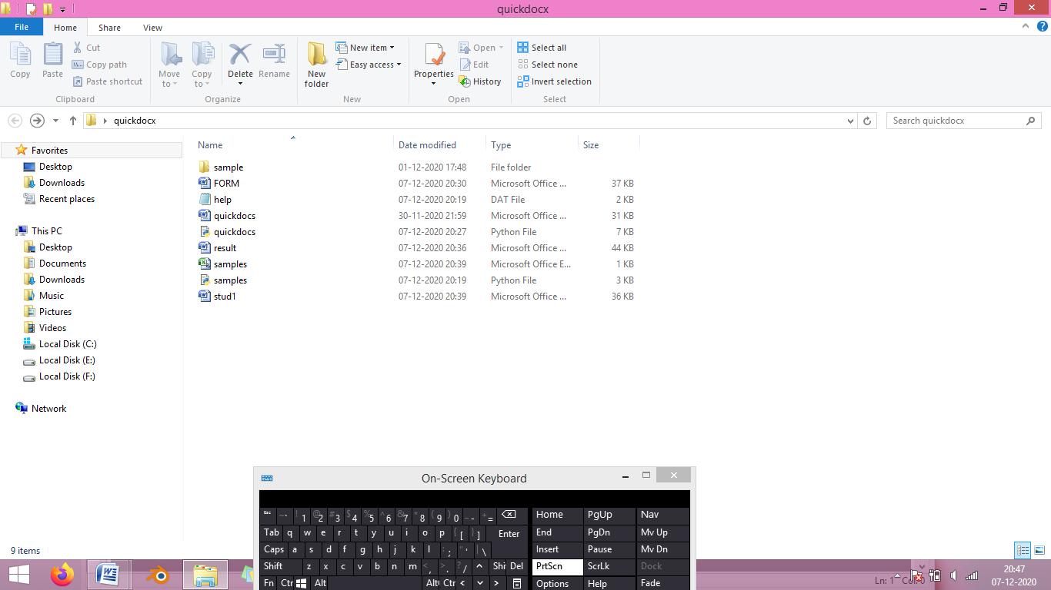

***BIBLIOGRAPHY***

*~ Computer science with Python -Sumita Arora*

*~ Python documentation - https://python-docx.readthedocs.io/en/latest/*

*~ geeksforgeeks.org - https://www.geeksforgeeks.org/python-working-with-docx-module/*

*~ Youtube tutorials*