A template for the *arxiv* style

Enter the text of your abstract here.

# Introduction

# Headings: first level

See Section .

## Headings: second level

$$ξ_{ij}(t)=P(x_{t}=i,x_{t+1}=j|y,v,w;θ)=\frac{α_{i}(t)a_{ij}^{w_{t}}β_{j}(t+1)b_{j}^{v_{t+1}}(y_{t+1})}{\sum_{i=1}^{N}{\sum_{j=1}^{N}{α_{i}}}(t)a_{ij}^{w_{t}}β_{j}(t+1)b_{j}^{v_{t+1}}(y_{t+1})}$$

### Headings: third level

# Examples of citations, figures, tables, references

some text (Kour and Saabne 2014b, 2014a) and see Hadash et al. (2018).

The documentation for may be found at

Of note is the command , which produces citations appropriate for use in inline text. For example,

produces

## Figures

See Figure . Here is how you add footnotes. [^Sample of the first footnote.]

plot(mtcars$mpg)

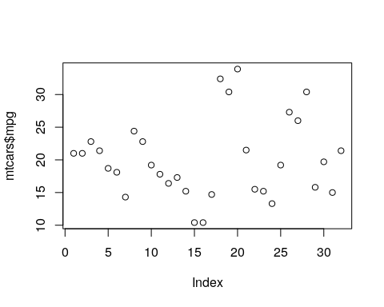

## Tables

See awesome Table~.

## Lists

* Lorem ipsum dolor sit amet
* consectetur adipiscing elit.
* Aliquam dignissim blandit est, in dictum tortor gravida eget. In ac rutrum magna.

Hadash, Guy, Einat Kermany, Boaz Carmeli, Ofer Lavi, George Kour, and Alon Jacovi. 2018. “Estimate and Replace: A Novel Approach to Integrating Deep Neural Networks with Existing Applications.” *arXiv Preprint arXiv:1804.09028*.

Kour, George, and Raid Saabne. 2014a. “Fast Classification of Handwritten on-Line Arabic Characters.” In *Soft Computing and Pattern Recognition (Socpar), 2014 6th International Conference of*, 312–18. IEEE.

———. 2014b. “Real-Time Segmentation of on-Line Handwritten Arabic Script.” In *Frontiers in Handwriting Recognition (Icfhr), 2014 14th International Conference on*, 417–22. IEEE.