Hi Mike,

The itinerary for your package now looks like this:

Mike Kaplan + 1

13/8-20/8                        7 nights in Tórshavn; Hotel Hafnia “cottage”  incl. breakfast

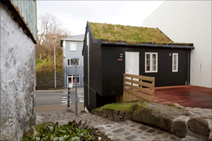

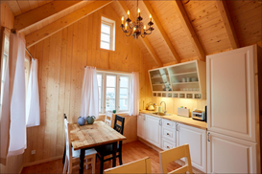

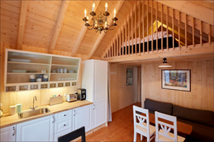

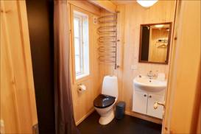

13/8      20:55                    Pick-up in the airport and private transfer to your own cozy cottage down town Tórshavn

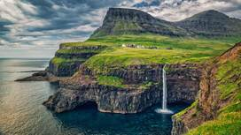

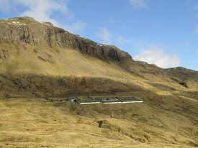

14/8     08:00-12:00     Half day private sightseeing in Tórshavn and the old cultural centre Kirkjubøur (4 hours)

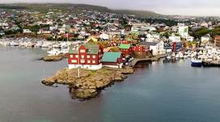

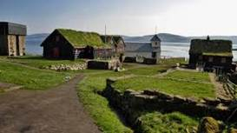

               13:00-17:00      Cruise under the famous bird cliffs north of the village of Vestmanna

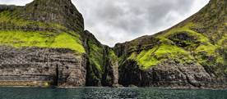

15/8      09:00-19:00     Full days tour to the bird paradise on the island of Mykines (10 hours) incl. ferry, local guide, lunch and island-fee.

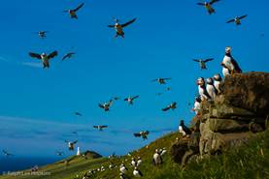

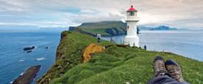

16/8      09:00-17:00     Full days private sightseeing to the island of Streymoy and Eysturoy incl. lunch in Gjógv (8 hours)

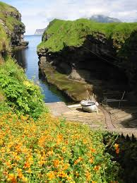

17/8      09:00-14:00     Half day private sightseeing tour to the island of Vágar incl. lunch in Sørvágur (5 hours)

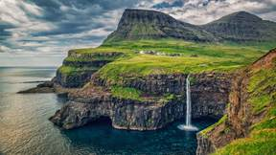

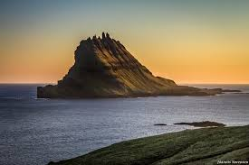

20/8     13:45                     Private transfer from your accommodation i Tórshavn to the airport

Best regards – and have a fantastic day

MakeTravel-Logo-RGB-Small

Kent L. Christensen

Tlf.: +298 232101

[www.make.fo](http://www.make.fo/)