Hi Mike,

A package could look like this:

2 persons

13/8-17/8         4 nights in Tórshavn incl. breakfast

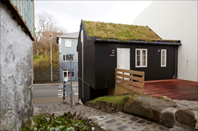

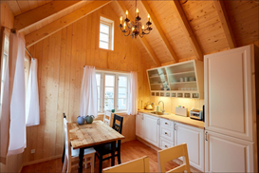

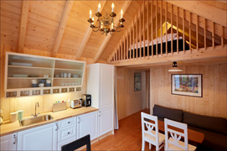

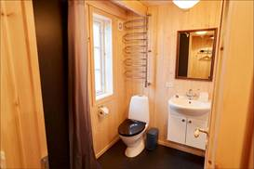

13/8                      Pick-up in the airport and private transfer to your own cozy cottage down town Tórshavn

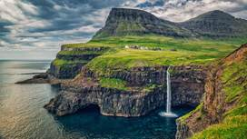

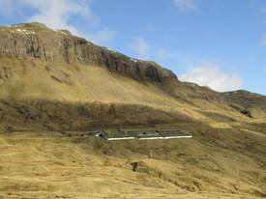

14/8                     Half day private sightseeing in Tórshavn and the old cultural centre Kirkjubøur (4 hours)

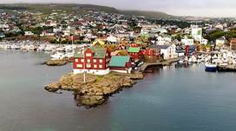

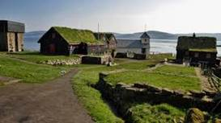

                                Cruise under the famous bird cliffs north of the village of Vestmanna

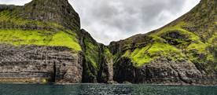

15/8                      Full days tour to the bird paradise on the island of Mykines (10 hours) incl. ferry, local guide, lunch and island-fee.

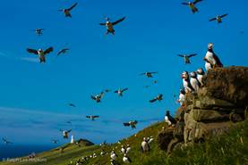

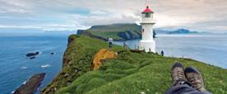

16/8                      Full days private sightseeing to the island of Streymoy and Eysturoy incl. lunch in Gjógv (8 hours)

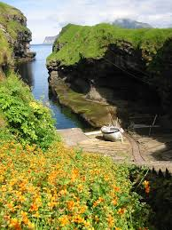

17/8                      Private transfer from your accommodation i Tórshavn to the airport

**Price for above package DKK 29.300,-**

Hope this will be of interest and look forward to hear from you again.

Best regards – and have a fantastic weekend

MakeTravel-Logo-RGB-Small

Kent L. Christensen

Tlf.: +298 232101

[www.make.fo](http://www.make.fo/)