NeuroNeuer TASKS

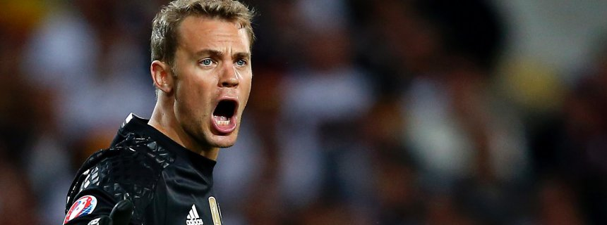

# Read out DVs

* Filter data
* Get ball position

# Controll Servo

* Build Neuer
* Controll Servo

# Model

* Design Neural network (4 inputs 1 output)

# Training

* Train Neural Network

# Data

* Generate model on physical basis
* Generate Trainigs set
* Get GUMMIBALL

# Create Final Presentation