Project Proposal: AI-Powered Patient Simulation for Therapist Training

- Context
Introduction
Mental health disorders pose a significant global challenge, affecting approximately 5% of adults worldwide, with depression and anxiety prevalence ranging from 0.9% to 28.3% (Shahbazi et al., 2022). Despite the increasing demand for mental health services, the field faces a critical shortage of trained professionals (Lange, 2021). One approach to mitigating this gap is task-sharing models, where non-specialists are trained to deliver psychotherapy. However, these models require extensive training and supervision, making large-scale implementation difficult (Lange, 2021).
Cognitive Behavioral Therapy (CBT) is one of the most effective treatments for depression and anxiety, yet CBT training remains resource-intensive and difficult to scale (Henrich et al., 2023). Many mental health professionals report a disconnect between their formal training and real-world patient interactions, emphasizing the need for more practical, scalable training methods (Wang et al., 2024).
To address these challenges, AI-driven patient simulations have emerged as a promising solution. Patient-Ψ, an LLM-powered system, enables mental health trainees to engage with realistic virtual patients in a controlled learning environment, providing unlimited, on-demand training opportunities. By allowing trainees to practice clinical interactions anytime, anywhere, and at scale, Patient-Ψ helps bridge the gap between theoretical training and real-world patient engagement (Wang et al., 2024).
However, existing models are limited in adaptability, meaning they fail to evolve dynamically based on therapist interventions. This project proposes a dual AI-driven system that improves upon these limitations by:
- Developing a dynamic AI patient model that adjusts psychological states in real-time.
- Creating an AI-powered therapist training system that evaluates diagnostic accuracy and cognitive model construction.
- Introducing a reinforcement-based training loop where the patient model and therapist assessment system improve each other, similar to Generative Adversarial Networks (GANs).

Key Background Sources

Citation | Summary | Relevance
Shahbazi et al. (2022) | Examines global mental health statistics and socioeconomic disparities in depression/anxiety prevalence. | Justifies the project’s significance and need for scalable training solutions.
Lange (2021) | Reviews task-sharing psychotherapy models and the feasibility of training non-specialists. | Highlights the need for scalable training solutions like AI-driven patient simulations.
Henrich et al. (2023) | Systematic review on CBT training effectiveness and scalability challenges. | Supports the transition from resource-intensive training to AI-based alternatives.
Wang et al. (2024) | Introduces Patient-Ψ, an LLM-based mental health patient simulation tool. | Establishes existing AI-based approaches and identifies limitations in adaptability.
Wu et al. (2024) | Proposes COKE (Cognitive Knowledge Graphs) for encoding human thought processes. | Enables AI-patient models to update psychological states dynamically.
Limpanopparat et al. (2024) | Systematic review of mental health chatbots and their effectiveness. | Supports AI-powered therapist training and digital mental health interventions.

2. Aim and Objectives
Aim
To develop an adaptive AI-powered patient simulation system that enables realistic therapist training by modeling, assessing, and iteratively refining patient psychological traits.
Objectives
Task 1: AI-Driven Patient Modeling (primary task)
- Develop a cognitive patient model that captures and stores key psychological attributes, including identity information and CBT-related features (core/intermediate beliefs, depression level, coping strategies, emotions, behaviors, and automatic thoughts).
- Implement an interactive AI dialogue system that continuously updates patient psychological traits through real-time conversations, refining its cognitive model dynamically.
- Integrate adaptive learning mechanisms to track patient mental state changes over time and provide insights into psychological progression.
Task 2: Therapist Training & Evaluation (if time allowed)
- Fine-tune an LLM such as Ollama 3, to simulate diverse psychological patient profiles, ensuring it accurately reflects various mental health conditions in therapist training scenarios compared to GPT-4 (Baseline comparison, general-purpose reasoning).
- Develop an evaluation framework that assesses therapists’ ability to diagnose and model patient psychology based on AI-driven simulations.
- Implement a real-time feedback system where the AI compares therapist assessments with ground truth patient data, providing accuracy ratings and improvement suggestions.
Task 3: Dual-Training System (GAN-like Framework if time allowed)
- Establish a reinforcement learning mechanism where AI-generated patients evolve based on therapist interactions, improving realism in simulations.
- Refine therapist evaluation accuracy by iteratively adjusting the AI patient model based on discrepancies between therapist cognitive models and the AI’s baseline psychological state.

3. Planning
Work Plan (Feb 21 - May 5)
Task | Start Date | End Date | Duration
Literature Review | Feb 21 | Mar 3 | 10 days
System Architecture Design | Feb 28 | Mar 10 | 11 days
AI Patient Model Development | Mar 11 | Apr 5 | 25 days
Therapist Training LLM Fine-Tuning | Mar 20 | Apr 15 | 26 days
Evaluation System Implementation | Apr 1 | Apr 21 | 20 days
Testing & Validation | Apr 22 | Apr 30 | 8 days
Final Refinements & Documentation | May 1 | May 5 | 5 days
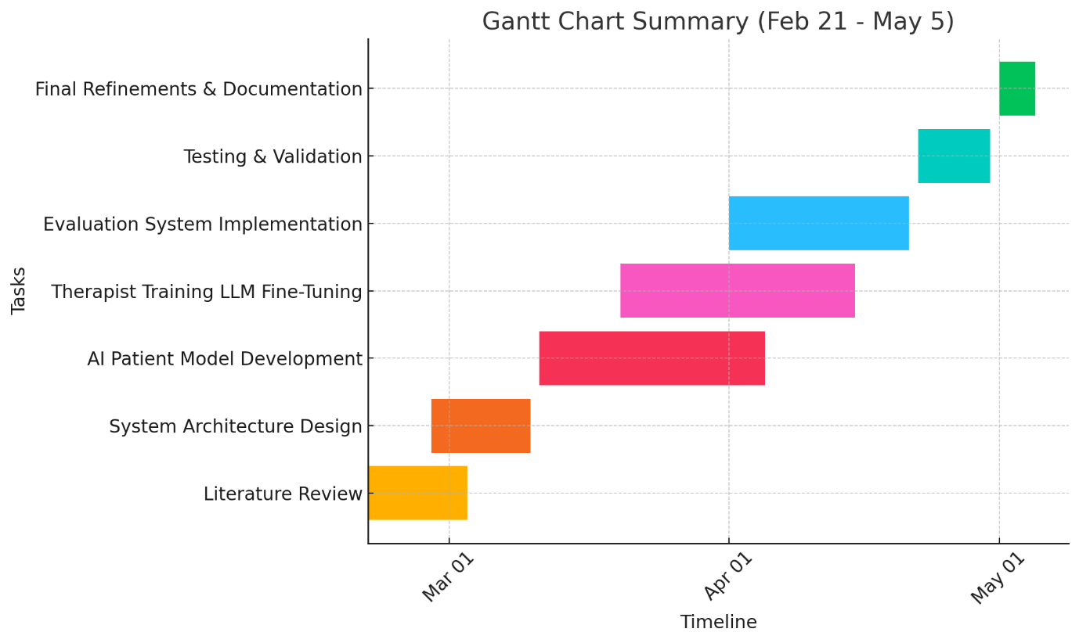

This structure ensures that foundational work (literature review and architecture design) is completed before AI model development. Fine-tuning of the therapist training LLM occurs after the patient model is functional. Testing and validation follow implementation to ensure quality.

Risk Assessment & Mitigation
Risk | Impact | Likelihood | Mitigation Strategy
Delays in AI Model Development | High | Medium | Set weekly milestones, prioritize core functionalities.
LLM Fine-Tuning Complexity | High | Medium | Start with pre-trained models and refine in iterations.
Evaluation System Accuracy Issues | Medium | High | Develop benchmark datasets for comparison.
Limited Testing Time | High | Medium | Begin incremental testing alongside development.
Task Overlaps in Tight Schedule | High | High | Maintain flexibility in scheduling and adjust task dependencies.

4. References
Henrich, D., Glombiewski, J.A., and Scholten, S. (2023) 'Systematic review of training in cognitive-behavioral therapy: Summarizing effects, costs, and techniques', Clinical Psychology Review, 101, p. 102266. doi:10.1016/j.cpr.2023.102266.
Lange, K.W. (2021) 'Task sharing in psychotherapy as a viable global mental health approach', Global Health Journal, 5(3), pp. 120-127. doi:10.1016/j.glohj.2021.07.001.
Limpanopparat, S., Gibson, E., and Harris, A. (2024) 'User engagement, attitudes, and chatbot effectiveness in mental health interventions: A systematic review', Computers in Human Behavior: Artificial Humans, 2, p. 100081. doi:10.1016/j.chbah.2024.100081.
Wang, R., Milani, S., et al. (2024) ‘PATIENT-Ψ: Using LLMs to Simulate Patients for Therapist Training’, arXiv preprint arXiv:2405.19660v3.
Wu, J., Chen, Z., et al. (2024) ‘COKE: A Cognitive Knowledge Graph for Machine Theory of Mind’, arXiv preprint arXiv:2305.05390v2.
Shahbazi, F., Shahbazi, M. and Poorolajal, J. (2022) 'Association between socioeconomic inequality and the global prevalence of anxiety and depressive disorders: an ecological study', General Psychiatry, 35(e100735). doi:10.1136/gpsych-2021-100735​

