1.小梅哥ACG720
重量：200g
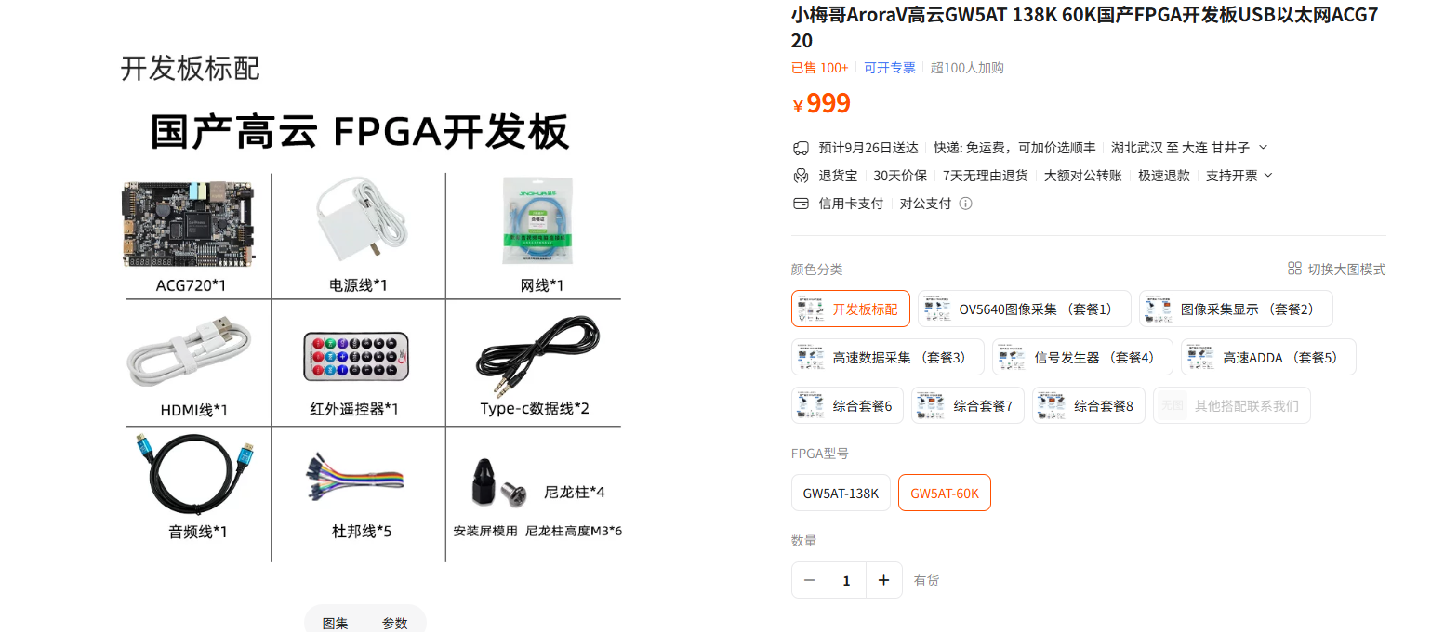
https://item.taobao.com/item.htm?from=cart&id=849198089202&mi_id=0000yaDK4ax7M56Ulwjyc2CZmuKCMF5xz1QnkBO94zBh9q4&skuId=5869647881591&spm=a1z0d.6639537%2F202410.item.d849198089202.adb07484EXQLcU&upStreamPrice=119900&xxc=taobaoSearch
2. ICM-42688-P 模块
重量：5g
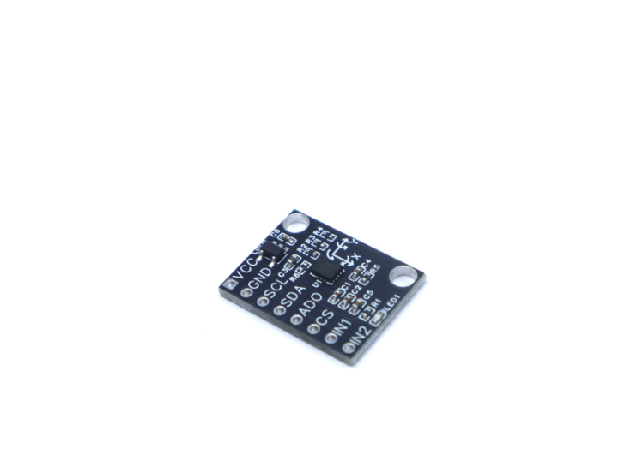
https://item.taobao.com/item.htm?id=910960145105&mi_id=0000z11sQWqvILHL6PYBiqNtErELGU3mvZ9TcXdijXSpyWs&spm=tbpc.mytb_itemcollect.item.goods&upStreamPrice=11900
3. PMW3901 光流传感器模块
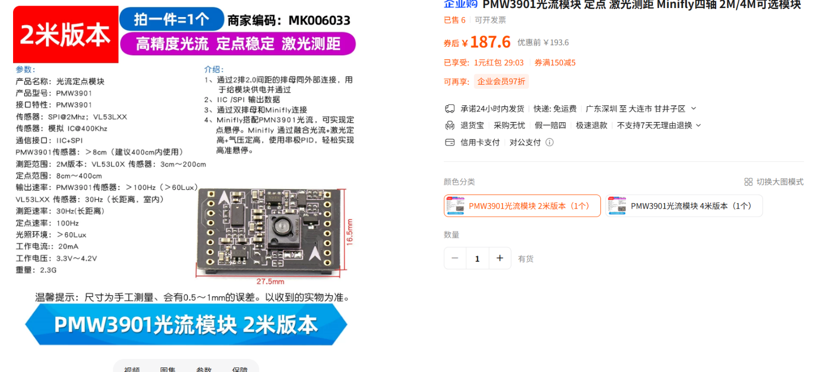
重量：2.3g

https://detail.tmall.com/item.htm?ali_refid=a3_430582_1006%3A1109983619%3AH%3Ahpsry6WQHhmGPZkfMl30DTQ1aOLao4FT%3A444c4b7fab910548502ff5f842def2c3&ali_trackid=294_444c4b7fab910548502ff5f842def2c3&id=585754830280&mi_id=0000I6gr9wfiANlhLpEwBZlWe3YNNLhO5Vap9WhKXBKX3O4&mm_sceneid=2_0_98938874_0_0&priceTId=213e026617901734943067161e11ff&skuId=4140061383850&spm=a21n57.1.hoverItem.1&utparam=%7B%22aplus_abtest%22%3A%22b6a134459cb48f52463a48911d3918f9%22%7D&xxc=ad_ztc
4. 北醒TFmini-S激光测距传感器
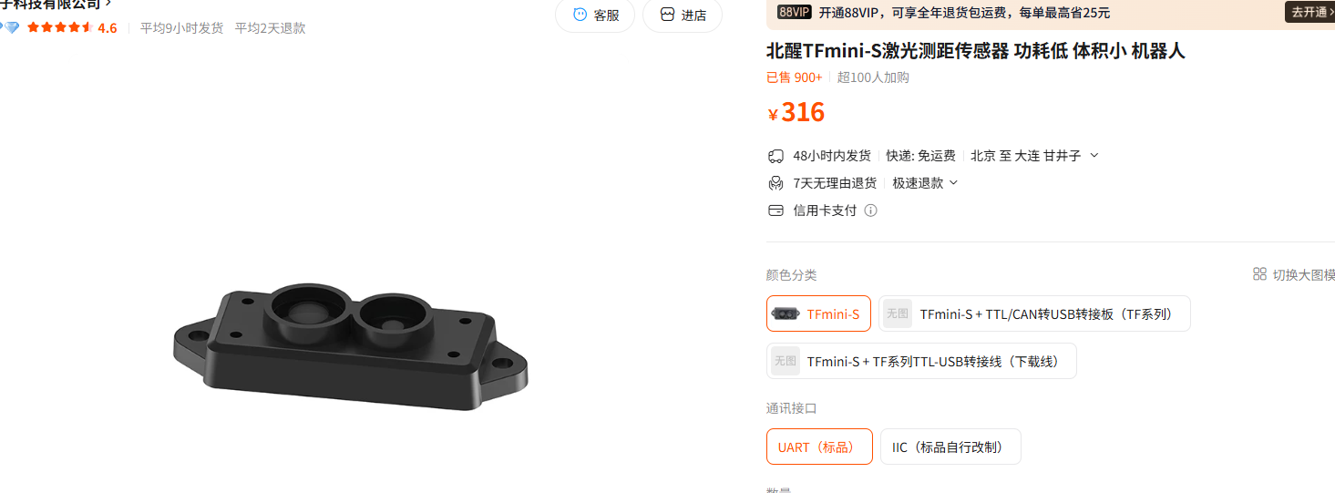
重量：5g

https://item.taobao.com/item.htm?from=cart&id=613248440201&mi_id=0000N4DBhdCFJG3axHHVSW2mTdSbqSSbjmEQSbQXvlYNyLk&skuId=5496416323568&spm=a1z0d.6639537%2F202410.item.d613248440201.adb07484EXQLcU&upStreamPrice=31600&xxc=taobaoSearch
5. Holybro SiK Telemetry Radio V3 数传电台
重量：21.1g
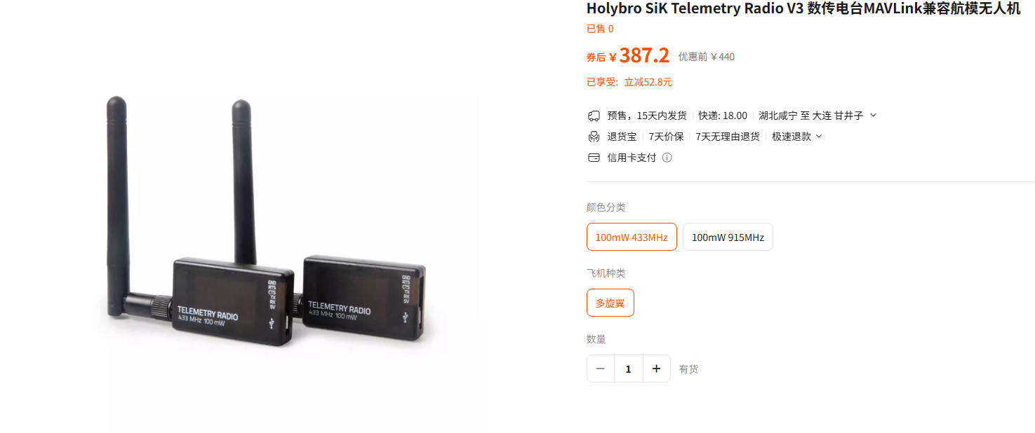
https://item.taobao.com/item.htm?from=cart&id=971545989536&mi_id=0000iLgNBM1x-z-2jOla-oZdcs_fTXhpDnnFDFgN-q9empQ&skuId=5938188944149&spm=a1z0d.6639537%2F202410.item.d971545989536.6b4d7484l9QdpV&upStreamPrice=38720&xxc=taobaoSearch
6.d435i相机
重量：75g
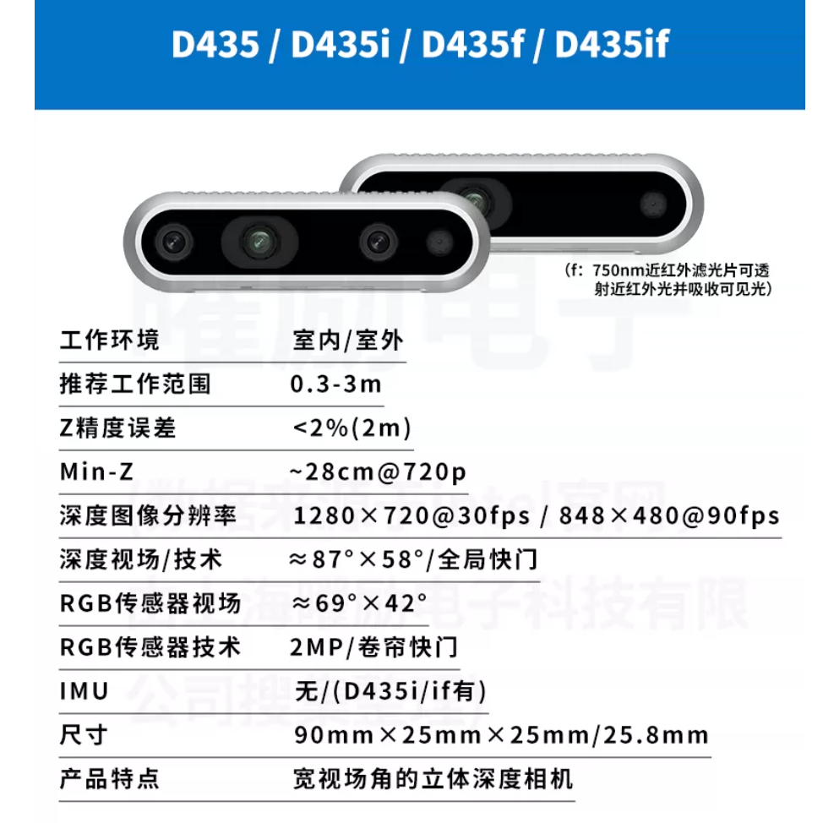
https://item.taobao.com/item.htm?from=cart&id=632116160748&mi_id=0000vDIH3lNU1R-LZiYHQ-AfYb4b8KxGUYUuQTHmXx1xBvU&skuId=5074953867734&spm=a1z0d.6639537%2F202410.item.d632116160748.adb07484EXQLcU&upStreamPrice=248000&xxc=taobaoSearch
7. TMOTOR AIR GEAR 450II 四轴多旋翼动力套装
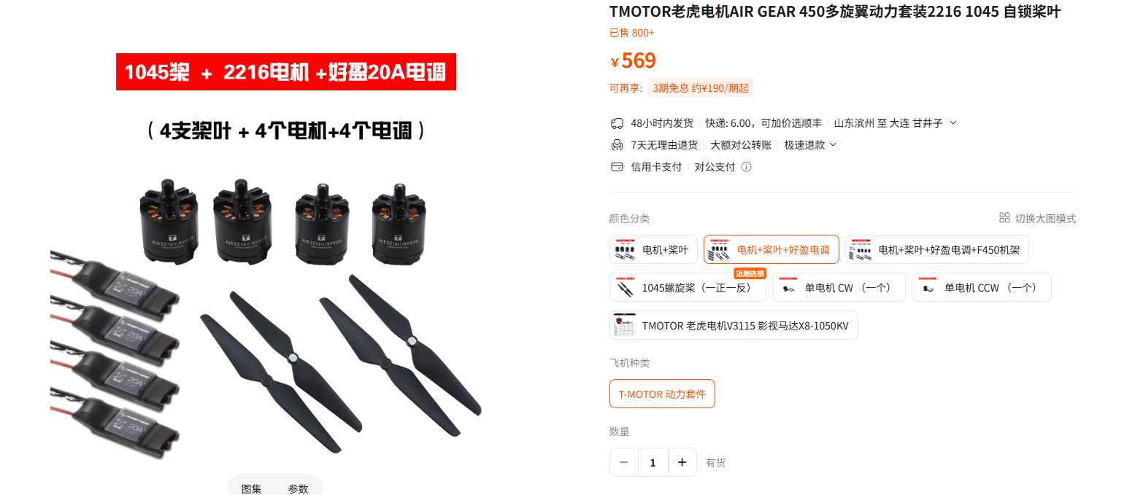
重量：408g

https://item.taobao.com/item.htm?abbucket=11&id=716237885188&mi_id=0000F8vlHODnBHNs1Q_3ZY0-vP55THCa77_tFwue5SMFxMM&ns=1&priceTId=214782fa17901688652815851e1272&skuId=5005920429394&spm=a21n57.1.hoverItem.2&utparam=%7B%22aplus_abtest%22%3A%22015a0040e0a7dd383296fdd6c6fc632a%22%7D&xxc=taobaoSearch
8.电池
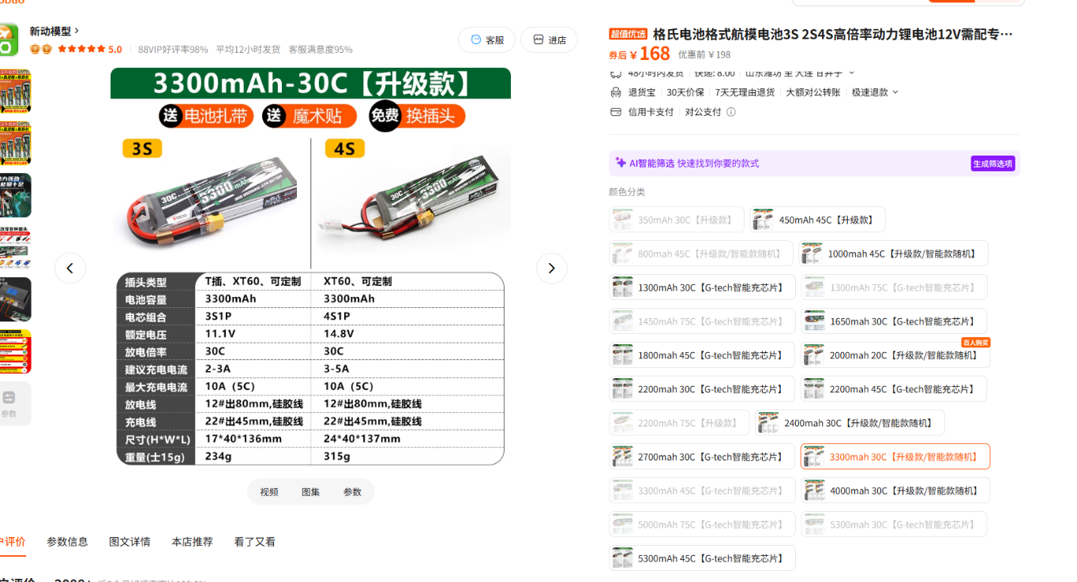
重量：234g

https://item.taobao.com/item.htm?id=41728701920&mi_id=0000UFNnaodDJr2T9cGlNAp9MIoLT2Cp5ppTTeJxE6g8ZGk&skuId=4978516243635&spm=tbpc.boughtlist.suborder_itemtitle.1.7c832e8d9c25fk
9.降压模块
重量：5g
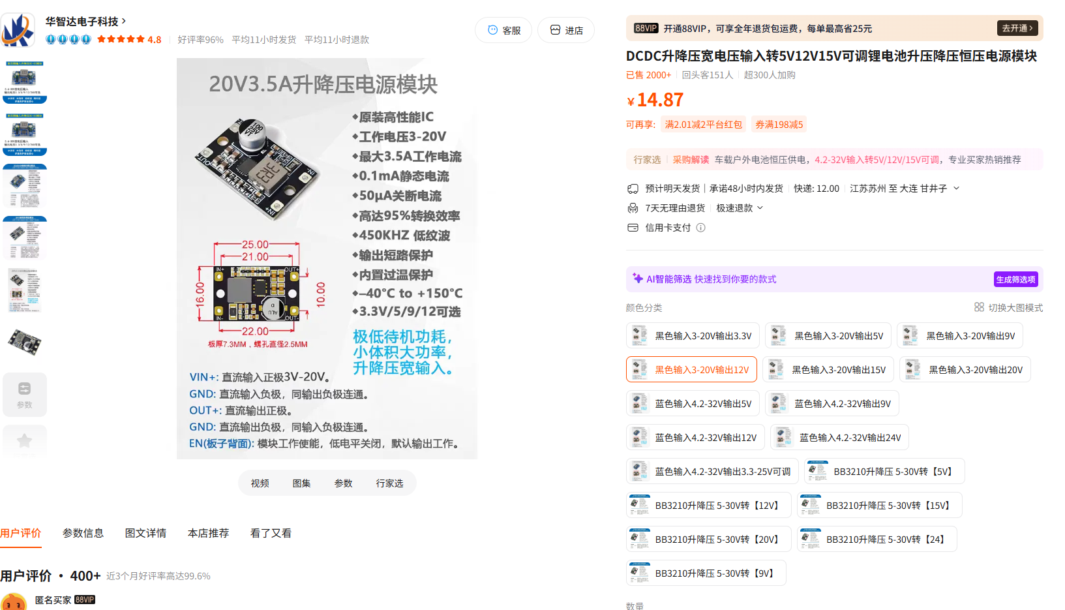
https://item.taobao.com/item.htm?abbucket=11&id=893314501844&mi_id=0000Acyx7YVRdADtr9A8VoOK45wsOsw0S-RzJroKcjIEfIA&ns=1&priceTId=213e067f17901694424441477e11ff&skuId=5741041348568&spm=a21n57.1.hoverItem.11&utparam=%7B%22aplus_abtest%22%3A%22b290a1689360d199a82f57e9710a8a95%22%7D&xxc=taobaoSearch

