Calor5.0: Guide of Commands

Topics
1 Introduction 2
1.1 Detectors 2
1.2 Primary particle souces 2
2 Changing some detector parameters 3
2.1 Commands for reading the file with description of detectors positions 3
2.2 Commands for changing the detectors characteristics 4
3 Commands for the primary particle 4
3.1 Primary particle type 4
3.1.1 PhaseSpaceFile 4
3.1.2 Particle 5
3.1.2.1 To change the energy: 5
3.1.2.2 To change the particle type: 5
3.1.2.3 To change the direction: 5
3.1.3 Isotope: 6
3.1.4 IntrinsicRadiation 6
3.1.5 Angular Distribution 6
3.1.5.1 To set the angular distribution ON or OFF (1 or 0): 6
3.1.5.2 To set the directory of the file with the Angular Distribution W(k,q) coefficients 6
3.1.5.3 To set the name of the file with the Angular Distribution W(k,q) coefficients 7
3.1.5.4 To set the maximum k-value used in the calculation of the Angular distribution function (default is 4) 7
4 Commands for changing the chamber and target holder parameters: 7
4.1 Chamber material 7
4.2 Chamber thickness 7
4.3 Chamber external radius 7
4.4 Target Holder material 8
5 Command to change the output file name: 8
6 Examples 9
7 Notes 12
7.1 Note 1 12
7.2 Note 2 13

Introduction

The Calor5.0 code provides the simulation of gamma rays detection by a set of scintillators placed around the center of emission of particles. By default one detector is positioned along the Z axis at the position (X,Y,Z) = (0,0,300 mm). A set of detectors can be placed with commands to choose a file that contains the description of all detectors positions.
The code has the option to include a scattering chamber. In this version the chamber is made of a section of sphere of 200 mm external radius, thickness of 10 mm, and a target holder in the center. Changes for the chamber and target holder can be applied by macro commands too.
The present version allows four different types of primary sources, which can be used in different ways to evaluate the response and efficiency of the system, background, intrinsic radiation contribution, etc.
This code has been built using the Geant4 version 11.2.2.

Detectors
→ The detector’s geometry is fixed (see figure 1). Changes in dimensions must be done in the code (DetectorElement.cc) and recompilation is needed.
The detector’s material and shape (cylinder or parallelepiped) can be changed by commands;
→ The detector element has the following parts (for cylinder, the diameter corresponds to the square size) :
- the scintillator (12.4 mm x 12.4 mm x 40 mm) whose material can be changed by command (LaBr₃, LYSO, GAGG);
- a reflector cover at the four larger sides of the scintillator, made of BaSO₄ with thickness of 0.4 mm;
- external to the reflector, a Teflon tape at the four larger sides of the scintillator with thickness of 0.2 mm;
- a Teflon piece at the front side of the scintillator (12.4 mm x 12.4 mm x 0.5 mm)
- an aluminum cover (16.0 mm x 16.0 mm x 56 mm) – it has a thickness of 1.0 mm at the sides and 4.0 mm at the front.

Primary particle souces

There are four options for the source of primary particles:

- Particles: any type of particle with energies in the range of Geant4 application;
- Isotopes: any isotope defined in the Geant4 library;
- Phase space file in the form of Tree (ROOT file) with entry information of:
number of particles, particle PDG code, energy, momentum direction (dirX, dirY, dirZ) and time;
- Intrinsic radiation of LYSO (¹⁷⁶Lu 2.6% in natural form of Lu, activity of 307 Bq/cm³ in LSO family scintillators) or LaBr3 (¹³⁸La, 0.09% in natural form of La, 1.5 Bq/cm³ in LaBr₃).

Figure 1 – Diagram of the Detector Element of Calor4.1.

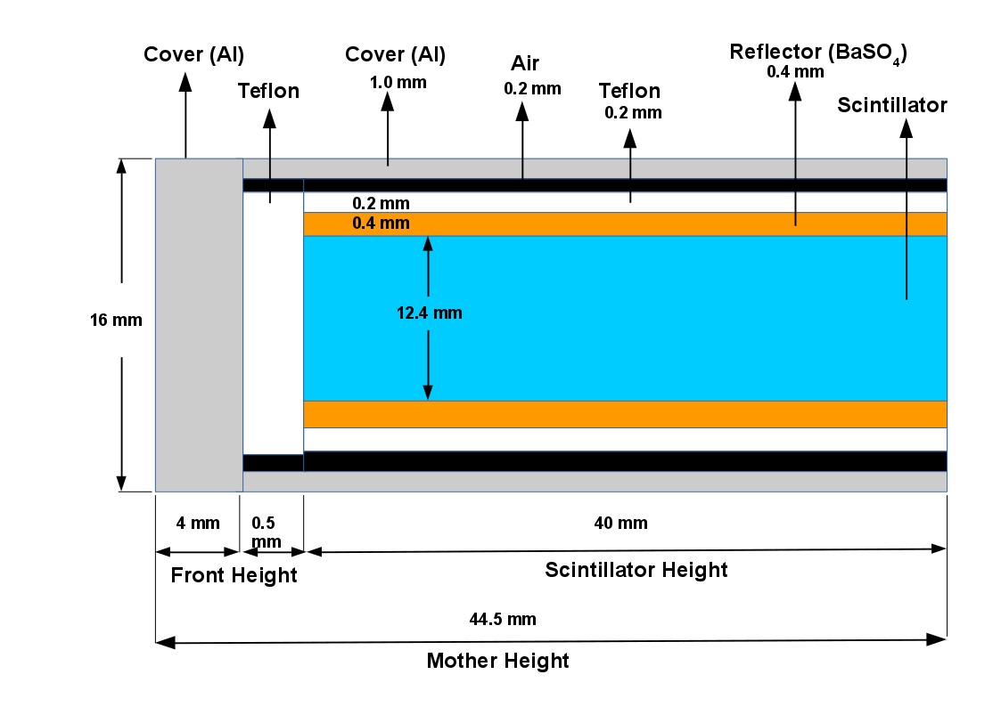

Changing some detector parameters

The detectors placement is read from a ASCII file that must provide:
→ First line: number of detectors N
→ N lines with: X, Y, Z, Phi, Theta, Psi

where (X, Y, Z) are the coordinates of the geometric center of each detector
(Phi, Theta, Psi) are the Euler angles for rotation of the detector.
There are also commands to change the detector’s material and shape.

Commands for reading the file with description of detectors positions

/detectors/FileDirectory path
default value for path: ./

/detectors/FileName name
default value for name: lplace-onedetector.dat

Commands for changing the detectors characteristics

/detectors/Material name
where name can be LYSO, LaBr3 or GAGG.

/detectors/Shape type
where type can be Box or Cylinder

/detectors/Dislocation value unit
where value is the new value for the dislocation of the detectors in the radial direction. This is useful to avoid that the detectors touch the chamber when defining new dimensions for the chamber. Unit can be mm, cm, etc.

Commands for the primary particle

Primary particle type

/primary/Type type
Possible values for type: Particle, Isotope, PhaseSpaceFile, IntrinsicRad

PhaseSpaceFile

/primary/Type PhaseSpaceFile

/primary/PhaseSpaceDirectory path
default value for path: ./

/primary/PhaseSpaceName name
default value for name: PhSpace_01.root
This is the default name of the file produced by the code PhaseSpace5.0 (and probably future versions), which simulates nuclear reactions.

/primary/RadiusOfSphere value unit
This command is used to change the radius of the surface from where the particles will be emitted. Since the interactions of the particles with the target material was already simulated in the PhaseSpace code, this command is used to choose a distance greater than the size of the target.
Each particle will be emitted from the surface of the sphere, following the radial direction given by the vector (dirX, dirY, dirZ). The time given by the ROOT file is the interval from the beam creation (of the reaction) to the time that the particle reached the radius of the sphere. In the present version of PhaseSpace5.1, for example, the beam starts at (X,Y,Z) = (0,0,25 mm) from the target center (0,0,0), and the phase space information of the particles emerging from the reactions are collected at the surface of a sphere of 100 mm radius.

Particle

/primary/Type Particle

The default particle is “gamma”, the default energy is 1 MeV and the default direction is spherical isotropic (4π).
But you can change the particle and energy with conventional Geant4 commands for /gun.
Examples:

To change the energy:
/gun/energy 10 MeV
/gun/energy 100 keV

To change the particle type:
For electron
/gun/particle e-

For proton
/gun/particle proton

To list all possible particle names that are included in the used PhysicsList:
/gun/particle list

To change the direction:

There are commands of the Calor5.0 to limit the Phi and Theta angles for emission:
/primary/PhiMin value unit
/primary/PhiMax value unit
/primary/ThetaMin value unit
/primary/ThetaMax value unit

Example:
/primary/PhiMin 0 deg
/primary/PhiMax 360 deg
/primary/ThetaMin 0 deg
/primary/ThetaMax 10 deg
will limit the emission to a cone with axis on Z and aperture angle of 10 degrees.

Isotope:
/primary/Type Isotope

/primary/Ion Z A E

where Z and A are the atomic number and mass. E is the excitation energy in MeV - can be 0 in the case of a Radioactive Isotope.
Example 1: ⁶⁰Co source at rest
/primary/Type Isotope
/primary/Ion 27 60 0
/gun/energy 0.0 MeV

Example 2: ¹⁸O in an excited state with some kinetic energy to see the Doppler broadening. The particle is emitted at the origin (center of the target).
/primary/Type Isotope
/primary/Ion 8 20 1.67368 # excited state in MeV
/gun/energy 270.0 MeV
/gun/position 0 0 0

IntrinsicRadiation

/primary/Type IntrinsicRadiation

This command simulates the emission of the detector’s intrinsic radiation, depending on the detectors material. There is no othe command.

Angular Distribution

Angular distribution is applied only to the particle type. Its main application is the analysis of the detection efficiency for gamma rays emitted from nuclear reactions when the angular distributions for specific gamma rays are known.

To set the angular distribution ON or OFF (1 or 0):

/primary/AngularDistribution 1
/primary/AngularDistribution 0

To set the directory of the file with the Angular Distribution W(k,q) coefficients
/primary/AngularDistDirectory DirectoryName

To set the name of the file with the Angular Distribution W(k,q) coefficients

/primary/AngularDistName FileName

To set the maximum k-value used in the calculation of the Angular distribution function (default is 4)
/primary/kmax Value

After these commands, set the energy of the gamma ray.

/gun/energy Value unit

Example:

/primary/AngularDistDirectory /home/moralles/geant4.10.06.p02/Calor4.1-build/Wkq_files/

/primary/AngularDistName Wkq_Zero_1712MeV_Li7_Sn120.dat

/primary/kmax 4 # kmax for the spherical harmonics

/primary/AngularDistribution 1 # ON: 1 or OFF: 0 (default)

/gun/energy 500 keV

Commands for changing the chamber and target holder parameters:

Chamber material
/chamber/Material name
where name can be G4_Al for aluminum or G4_Galactic for vacuum (absence of the spherical chamber), for example. When changed for G4_Galactic, the chamber volume will appear as transparent in the visualization. When changing back to G4_Al or other material, it will return to the grey color.

Chamber thickness
/chamber/Thickness value unit
where value is the new thickness of the chamber and unit can be mm, cm, etc

Chamber external radius
/chamber/Radius value unit
where value is the new external radius of the chamber and unit can be mm, cm, etc

Target Holder material
/chamber/TargetHolderMaterial name
where name can be G4_Cu for copper, G4_Al for aluminum or G4_Galactic for vacuum (absence of the target holder), for example. When changed for G4_Galactic, the volume will appear as transparent in the visualization. When changing back to G4_Al or other material, it will have the grey color. For G4_Cu it will have red color.

Command to change the output file name:
Example:
/OutputFile/FileName gamma_10MeV.root
The Calor5.0 code produces a file with a Tree (ROOT file) where each line has the following data:

- Event number (Event);
- Number of Hits of this event (Nhits);
- PDG code of the particle in this Hit (PDG);
- Detector ID where the particle deposited its energy in this Hit (DetID);
- Energy (in MeV) deposited in this Hit (En);
- Time (in ns) relative to the primary particle generation (Time);
- Phi (azimuthal angle) of this Hit (Phi). This angle does not correspond exactly to the geometric center of the detector. It represents the angle where the energy was deposited inside the detector;
- Theta (polar angle) of this Hit Theta). This angle does not correspond exactly to the geometric center of the detector. It represents the angle where the energy was deposited inside the detector;

Example of Output of the tree→Scan() command
***********************************************************************************************************************
* Row * Instance * Event * Nhits * PDG * DetID * En * Time * Phi * Theta *
***********************************************************************************************************************
* 0 * 0 * 2 * 3 * 22 * 218 * 0.3574765 * 4.9148300 * 52.209545 * 78.426224 *
* 0 * 1 * 2 * 3 * 2112 * 300 * 0.0016156 * 69.258092 * 103.41019 * 93.658417 *
* 0 * 2 * 2 * 3 * 2112 * 207 * 0.0020420 * 96.502548 * 117.17437 * 63.175710 *
* 1 * 0 * 3 * 1 * 22 * 243 * 0.1800666 * 1.3587962 * 86.549565 * 58.830755 *
* 2 * 0 * 4 * 1 * 22 * 10 * 0.0493911 * 1.3610265 * 58.860638 * 146.24755 *
* 3 * 0 * 6 * 1 * 1.000e+09 * 297 * 0.1239280 * 9.6084047 * 88.891491 * 103.91777 *
* 4 * 0 * 10 * 3 * 1.000e+09 * 234 * 1.3276229 * 7.3363942 * 122.77455 * 96.073473 *
* 4 * 1 * 10 * 3 * 1.000e+09 * 235 * 0.1761699 * 6.6964024 * 121.03903 * 90.491591 *
* 4 * 2 * 10 * 3 * 22 * 35 * 1.9471388 * 4.9055796 * 128.40100 * 34.993482 *
* 5 * 0 * 11 * 1 * 22 * 314 * 0.1774901 * 3.4223773 * 89.899805 * 88.477470 *
* 6 * 0 * 12 * 2 * 22 * 60 * 0.1711454 * 1.7109165 * 59.546824 * 139.99718 *
* 6 * 1 * 12 * 2 * 22 * 270 * 0.8037880 * 1.4210120 * 82.409329 * 66.545286 *
* 7 * 0 * 17 * 3 * 2112 * 222 * 0.0128268 * 7.9613563 * 60.860286 * 101.49739 *
* 7 * 1 * 17 * 3 * 1.000e+09 * 222 * 0.0505400 * 7.8733129 * 60.860286 * 101.49739 *
* 7 * 2 * 17 * 3 * 1.000e+09 * 184 * 0.5126465 * 6.1564155 * 51.924355 * 89.139196 *
* 8 * 0 * 22 * 1 * 22 * 98 * 0.8747606 * 1.2685106 * 33.358153 * 84.079324 *
* 9 * 0 * 23 * 9 * 1.000e+09 * 138 * 8.289e-06 * 7.0355945 * 50.788925 * 53.55639 *

Examples

Several examples covering all types of primary particles are included in the folder “Examples_Version5”.

Picture with a list of the example folders with names that are self-explanatory:
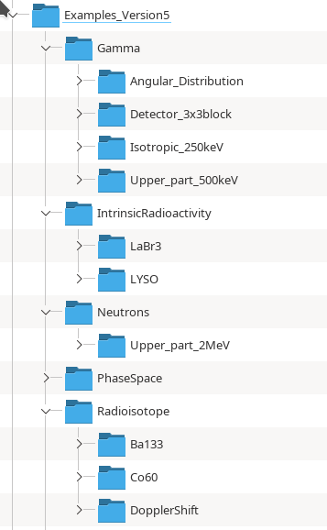

These example folders contain:
- One file initInter.mac and one file Calor_vis.mac to run the example in the Idle Mode with visualization. In the Idle Mode, commands must be given by hand. A list of commands s printed by typing “help” (see Note 2 at the end of this document).
If you copy a link of the executable Calor5.0 inside the example’s folder, you can run the code inside this folder by typing ./Calor5.0.

- One file run_batch.mac to run in batch mode.
If you copy a link of the executable Calor5.0 inside the example’s folder, you can run in batch mode using ./Calor5.0 run_batch.mac > run_batch.log. The file run_batch.log contains the output of some information about the initialized geometry, detectors, physics process, run time, etc.

- Some examples contain files “.txt” with outputs of some typical Tracking (run the code with option /tracking/verbose 1), and typical outputs of ROOT Scan command (tree→Scan()).

- The CalorRunInfo.txt shows the report of the run produced by the Calor5.0 code.

- Some examples have also PDF files with relevant plots produced with the ROOT.

- In the example folder there are three files that help in some operations with the ROOT:
→ Angles.C: to calculate the angles Theta and Phi (in degree or Radians) from the dX, dY and dZ directions of the particles of the Phase Space files.
→ PDG_ZA.C: to transform the large PDG integers of heavy nuclei in a shorter form. Example: O-16 has a PDG of 10000080160 in its ground state. The output of PDG_ZA(PDG) is 80160.
These routines can be loaded in root by using .L PDG_ZA.C and .L Angles.C. Open these files with an editor to see the names of the defined functions.

- Some examples contain pictures of the geometry produced by the Geant4 Viewer.

Examples:

Figure of the setup with 315 detectors around the semi-spherical aluminum chamber. Gamma irradiation with isotropic distribution only in the upper part of the setup. File of detectors’ positions: TesteGN.dat.
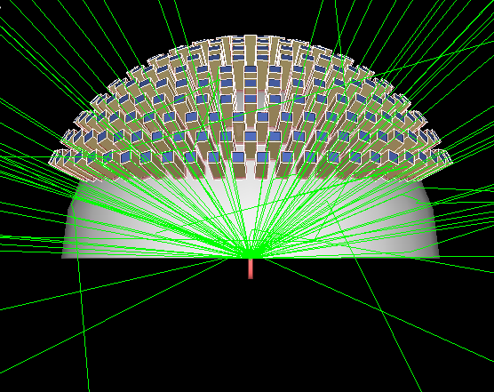
Figure of the setup with a block of 9 detectors Gamma irradiation with conical distribution covering the detectors. File of detectors’ positions: one_block_3x3.dat

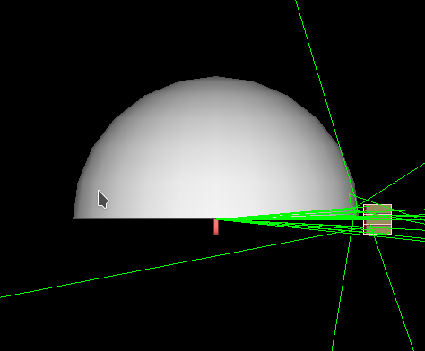

Figure of the run for Intrinsic Radiation with the setup with a block of 9 LYSO detectors. File of detectors’ positions: one_block_3x3.dat.

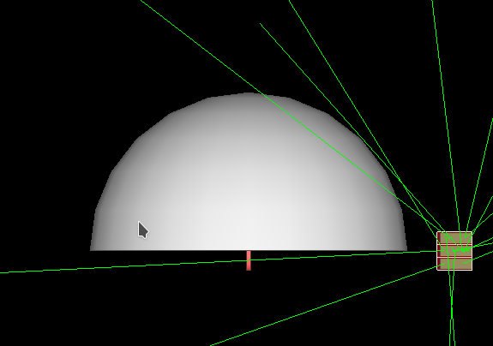

Notes

Note 1
The Calor5.0 code saves a report-file called CalorRunInfo.txt, with some information about the run.
Example of a CalorRunInfo.txt file for a run of 200000 particles with type IntrinsicRad and detectors made of LYSO.

CalorRunInfo.txt

End of Run 0
Number of Events: 200000
Data file: Run_Intrinsic_LYSO.root

--- Chamber configuration
Material: G4_Al
Outer Radius: 200 mm
Thickness: 10 mm

--- Target holder
Material: G4_Cu

--- Calorimeter configuration

--- Detector properties ---
--- Detector Type: Box
--- Scintillator ---
Scintillator material: LYSO
Section side: 12.4 mm
Height: 40 mm
--- Reflector ---
Reflector material: G4_BARIUM_SULFATE
Thickness: 0.4 mm
--- Teflon ---
Teflon material: G4_TEFLON
Side Thickness: 0.2 mm
Front Thickness: 0.5 mm
--- Cover ---
Cover material: G4_Al
Side thickness: 1 mm
Front thickness: 4 mm
--- Complete detector ---
Section side: 15.9999 mm
Height: 44.5 mm

Directory of file for detectors positioning:
/home/moralles/geant4-v11.2.2/Calor5.0-build/DetectorsPositionFiles/
File with the detectors positioning: one_block_3x3.dat
Calorimeter number of detectors: 9
Radial extra dislocation: 0

--- PrimaryGenerator info for this Run
Type of primaries: Intrinsic Radioactivity
Intrinsic Radiation
Detector material: LYSO
Detector shape: Box
Detector Side: 12.4
Detector Height: 40

The calorimeter has 9 of LYSO
Each scintillator has 6.1504 cm3
The calorimeter has 55.3536 cm3 of scintillator
LYSO has activity of 307 Bq/cm3
Calorimeter activity: 16993.6 Bq
Number of primaries: 200000 corresponds to 11.7692 seconds of measurement

The following commands where applied in the case above:
/primary/Type IntrinsicRad
/detectors/Material LYSO
/OutputFile/FileName Run_Intrinsic_LYSO.root
/vis/disable
/tracking/storeTrajectory 0
/run/beamOn 200000

Note 2
The command “help”, applied when the program is in the Idle state, shows the menus for commands of /detectors/, /primary/, /chamber/ and /OutputFile/.

help

Command directory path : /
Sub-directories :
1) /control/ UI control commands.
2) /units/ Available units.
3) /profiler/ Profiler controls.
4) /particle/ Particle control commands.
5) /tracking/ TrackingManager and SteppingManager control commands.
6) /geometry/ Geometry control commands.
7) /process/ Process Table control commands.
8) /event/ EventManager control commands.
9) /cuts/ Commands for G4VUserPhysicsList.
10) /run/ Run control commands.
11) /random/ Random number status control commands.
12) /material/ Commands for materials
13) /Physics/ Commands to activate physics models and set cuts
14) /detectors/ Commands to change the detectors parameters
15) /chamber/ Commands to change the chamber parameters
16) /gun/ Particle Gun control commands.
17) /primary/ Commands to change some primary generator parameters
18) /OutputFile/ Commands to change the file name for output data
19) /vis/ Visualization commands.

Output of the Help commands:

14) /detectors/ Commands to change the detectors parameters

Command directory path : /detectors/
Guidance :
Commands to change the detectors parameters
Sub-directories :
Commands :
1) FileDirectory * Change the DIRECTORY of the File
2) FileName * Change the NAME of the File
3) Material * Change the Material (LYSO, LaBr3 or GAGG)
4) Shape * Change the shape (Box or Cylinder)
5) Dislocation * Change the Radial Dislocation (value and unit)
15) /chamber/ Commands to change the chamber parameters

Command directory path : /chamber/
Guidance :
Commands to change the chamber parameters
Sub-directories :
Commands :
1) Material * Change the Material (G4_Al or G4_Galactic (vacuum))
2) Thickness * Change the Chamber Thickness
3) Radius * Change the Chamber External Radius
4) TargetHolderMaterial * Change the Material (G4_Al, G4_Cu or G4_Galactic)

16) /primary/ Commands to change some primary generator parameters

Command directory path : /primary/
Guidance :
Commands to change some primary generator parameters
Sub-directories :
Commands :
1) PhiMin * Enter new MINIMUM value for PHI and unit
2) PhiMax * Enter new MAXIMUM value for PHI and unit
3) ThetaMin * Enter new MINIMUM value for THETA and unit
4) ThetaMax * Enter new MAXIMUM value for THETA and unit
5) AngularDistribution * Set angular distribution ON: 1 or OFF: 0
6) kmax * Change the kmax for coefficients of angular distribution 7) AngularDistDirectory * Change the DIRECTORY of the file of the Wkq coefficients for Angular Distribution
8) AngularDistName * Change the NAME of the file of the Wkq coefficients for Angular Distribution
9) RadiusOfSphere * Change the radius of the sphere for Phase Space generation
10) PhaseSpaceDirectory * Change the DIRECTORY of the Phase Space File
11) PhaseSpaceName * Change the NAME of the Phase Space File
12) Type * Change the TYPE of primary: Particle, Isotope, PhaseSpaceFile or IntrinsicRad
13) Ion * Change the Ion Z A E

17) /OutputFile/ Commands to change the file name for output data

Command directory path : /OutputFile/
Guidance :
Commands to change the file name for output data
Sub-directories :
Commands :
1) FileName * Change the NAME of the File, with .root extension

