Dave Phillips

2021-07-15

IT FDN 110 A Su 21: Foundations Of Programming: Python

Module 2 – Assignment 1

Basic Math Time!

# **Introduction:**

In this assignment we’ll be coding a simple math script. The user will input two numbers (integer or float) and the script will return the sum, different, product, and quotient of the two provided numbers.

# **Code Overview:**

The full block of code for this assignment can be viewed at the end of this document (Appendix 1). However relevant sections of code are provided throughout. We will break it down into chunks to examine the functionality of each section.

# **Discussion:**

To begin, lines 1-6 are initial comments. They give basic information regarding the module for easy reference in the future – including file name, file path, assignment summary, and change log. (Figure 1)

1. #==================================================#
2. # Basic Math Script -- basicmath.py --
3. # C:\Users\Alleg\Python\UW Course\Week 2\basicmath.py
4. # Assignment #2 – Perform basic math fuctions
5. # DJP -- 2021-07-14 -- Initial script composition
6. #==================================================#

Figure 1 – Module metadata

Following the initial comments, the script displays a “title” to the user. This is simply comprised of some decorator lines surrounding the words “Basic Math Solver” Next is a set of **input** statements prompting the user to enter two numbers, which are then stored in the `first` and `second` variables. (Figure 2)

1. first = float(input("Please enter a number || "))
2. second = float(input("**\n**Please enter a second number || "))

Figure 2 – Initial input statement.

It’s important to note that the **input** statements are wrapped inside a `float` initializer. This is necessary otherwise the values specified by the user will be considered strings which are unable to be used in mathematical operations. Alternatively, for significantly less accurate results, the values could also be wrapped in an `int` statement.

To facilitate cleaner print statements later on, the four calculations are performed following the **input** statements. There are also two additional calculations (utilizing the floor division (//) and modulo (%) signs) that allow an extra line to be added to the output noting the quotient and remainder values instead of using decimal notation. (Figure 3)

1. sum = round(first + second, 2)
2. diff = round(first - second, 2)
3. product = round(first * second, 2)
4. quot = round(first / second, 2)
5. floorDv = int(first // second)
6. remain = round(first % second, 2)

Figure 3 – Process user input

The equation is run through the `round` method which, in this case, reduces decimal places to two. This should help readability. Additionally, the `floorDv` equation is wrapped in an `int` statement since the value returned from floor division will never have a decimal value.

Finally is the collection of **print** statements that presents the processed data back to the user. Again, to improve code readability, the print statements utilize `f-strings` to insert variables directly into the statement as opposed to breaking out of the sentence with closing quotes and using the ‘+’ operator (along with `str()` conversions) to concatenate the values into the output.

# **Summary:**

Upon executing the script, the command line window will display the following.

(Figure 4):

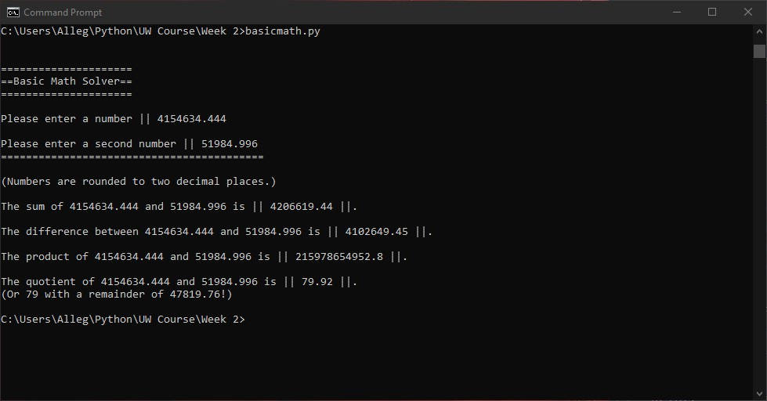

Figure 4. – Successful execution of the script via command line.

# **Full Code:**

1. #==================================================#
2. # Basic Math Script -- basicmath.py --
3. # C:\Users\Alleg\Python\UW Course\Week 2\basicmath.py
4. # Assignment #2 - Perform basic math functions
5. # DJP -- 2021-07-14 -- Initial script composition
6. #==================================================#
7. **print**("**\n\n**=====================")
8. **print**("==Basic Math Solver==")
9. **print**("=====================**\n**")
10. ####################
11. first = float(input("Please enter a number || "))
12. second = float(input("**\n**Please enter a second number || "))
14. sum = round(first + second, 2)
15. diff = round(first - second, 2)
16. product = round(first * second, 2)
17. quot = round(first / second, 2)
19. floorDv = int(first // second)
20. remain = round(first % second, 2)
21. ####################
22. **print**("==========================================**\n**")
23. **print**("(Numbers are rounded to two decimal places.)**\n**")
24. **print**(f"The sum of {first} and {second} is || {sum} ||.**\n**")
25. **print**(f"The difference between {first} and {second} is || {diff} ||.**\n**")
26. **print**(f"The product of {first} and {second} is || {product} ||.**\n**")
27. **print**(f"The quotient of {first} and {second} is || {quot} ||.")
28. **print**(f"(Or {floorDv} with a remainder of {remain}!)")
30. # basicmath.py