TestAnalyzer
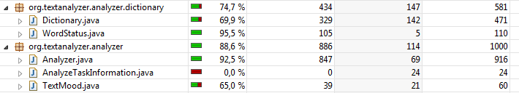

TestDatabaseConnector
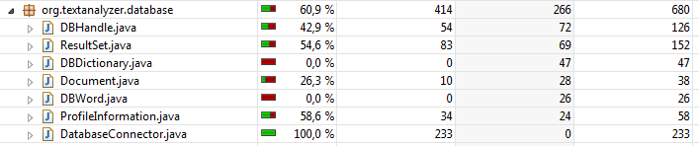

TestDocumentImporter
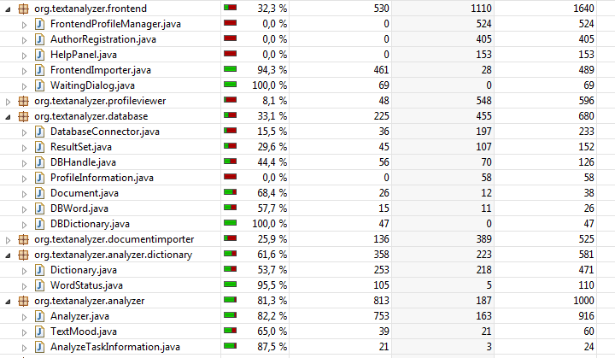

TestFrontendImporter
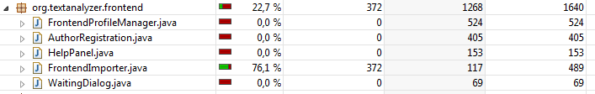
TestProfileManager
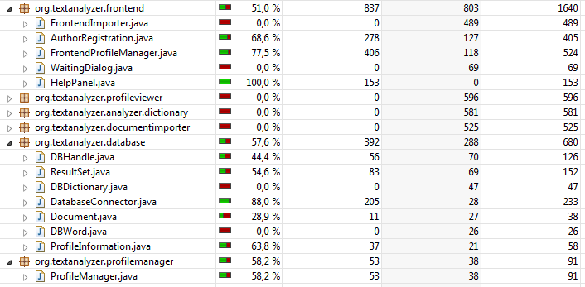

TestProfileViewer
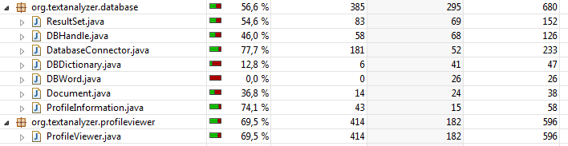

TestReportCreator

TestWaiting Dialog
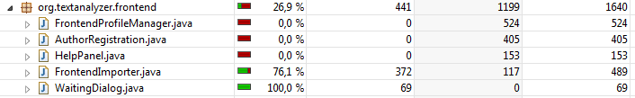

Not yet coveraged: TestDBDictionary, TestDictionary, TestDocument

