CSCI492 Senior Project 2

Technical Specification

***Project Name***

***Beta Version 1***

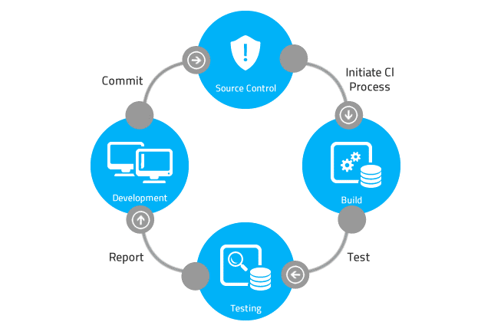

This page intentionally left blank

# Table of Contents

Table of Contents 3

Revision History 5

1 Project Overview 6

2 Requirements 7

2.1 Phase 1 7

2.1.1 Requirement 1: Feature Name 7

2.1.2 Requirement 2: Feature Name 7

2.2 Phase 2 7

2.2.1 Requirement 3: Feature Name 7

2.2.2 Requirement 4: Feature Name 7

3 Technical Specification 8

3.1 Requirement 1: Feature Name 8

3.1.1 Range-Velocity Map Data Packet 8

3.1.2 Track Data Structure 8

3.2 Requirement 2: Feature Name 8

3.2.1 TCP/IP Server Sockets 8

3.2.2 TCP/IP Client Sockets 8

4 Source Code Repository 9

4.1 Repository Location 9

5 BASH Shell Command Line Build 10

5.1 Build Tools 10

5.2 Compiler Command Line 10

5.3 Linker Command Line 10

5.4 Build Log 10

5.5 Compiler Output (--verbose) 10

5.6 Linker Output (--verbose) 10

6 Program Execution 11

6.1 Setting Command-Line Arguments 11

6.2 Client and Server Console Output 11

6.3 Server Console Output 11

6.4 Client Console Output 11

6.5 Packet Captures 11

6.5.1 Wireshark Install 11

6.5.2 Run Wireshark 11

7 Software Configuration 12

8 Package Installer 13

9 Systems Integration Testing 14

9.1 Test Setup 14

9.2 Test 001 14

10 Access and Security 15

10.1 Computer Access 15

11 Schedule 16

12 Appendix 17

12.1 Acronyms 17

12.2 Engineering Terms 17

12.2.1 Embedded Processing 17

13 Notes 17

# Revision History

|  |  |  |  |
| --- | --- | --- | --- |
| Rev. | Date | Authors | Comments |
| 1 | 4/2/2022 | Michael Koepp | 1. Initial release. |
|  |  |  |  |
|  |  |  |  |
|  |  |  |  |
|  |  |  |  |
|  |  |  |  |
|  |  |  |  |
|  |  |  |  |
|  |  |  |  |
|  |  |  |  |
|  |  |  |  |
|  |  |  |  |
|  |  |  |  |
|  |  |  |  |
|  |  |  |  |
|  |  |  |  |
|  |  |  |  |
|  |  |  |  |
|  |  |  |  |
|  |  |  |  |
|  |  |  |  |
|  |  |  |  |
|  |  |  |  |
|  |  |  |  |

# Project Overview

# Requirements

## Phase 1

### Requirement 1: Feature Name

* Implement a …

### Requirement 2: Feature Name

* Implement a ...

## Phase 2

### Requirement 3: Feature Name

* Implement a ….

### Requirement 4: Feature Name

* Implement a ...

# Technical Specification

## Requirement 1: Feature Name

## Range-Velocity Map Data Packet

Contains 2D range-velocity array data for a single beam direction. Transmitted every beam step period, 6.72msec. Only transmitted if the radar is in either BEAM (not yet implemented), SEARCH, or SWT mode, and the port socket is connected. The mean payload data rate is 38108.9 kBytes/sec.

## Track Data Structure

Contains data about active tracks. Transmitted at the user specified track update rate in the range (0.0,5.0] per second default is 200 milliseconds. Only transmitted if the radar is in SWT mode and the port socket is connected. The number of

tracks included in the packet varies and so does the packet length. If there are no active tracks, only the NULL Tracks Packet is transmitted. The maximum mean payload data rate is 12.6953125 kBytes/sec.

## Requirement 2: Feature Name

## TCP/IP Server Sockets

Description…

## TCP/IP Client Sockets

Description…

# Source Code Repository

## Repository Location

Location…

# BASH Shell Command Line Build

## Build Tools

## Compiler Command Line

## Linker Command Line

## Build Log

## Compiler Output (--verbose)

## Linker Output (--verbose)

# Program Execution

## Setting Command-Line Arguments

Project→ Properties → Run/Debug Settings → (Select Project) → Edit → Arguments

## Client and Server Console Output

## Server Console Output

Listening for client connections...

Received client connection request...

Sending data to client connection...

Sent data to client connection...

Closing client connection...

Closed connection to client...

Listening for client connections...

## Client Console Output

Connection to server established...

Reading data sent from server...

Byte count read from server...40

Closed connection to server…

## Packet Captures

### Wireshark Install

$ sudo apt-get install wireshark

$ sudo dpkg-reconfigure wireshark-common

$ sudo usermod -a -G wireshark $USER

$ sudo reboot

### Run Wireshark

$ sudo apt-get install wireshark

# Software Configuration

# Package Installer

# Systems Integration Testing

## Test Setup

## Test 001

# Access and Security

## Computer Access

# Schedule

|  |  |  |  |
| --- | --- | --- | --- |
| Task | Hours | Developer | Comments |
|  |  |  |  |
|  |  |  |  |
|  |  |  |  |
|  |  |  |  |
|  |  |  |  |
|  |  |  |  |
|  |  |  |  |
|  |  |  |  |
|  |  |  |  |
|  |  |  |  |
|  |  |  |  |
|  |  |  |  |
|  |  |  |  |
|  |  |  |  |
|  |  |  |  |
|  |  |  |  |
|  |  |  |  |
|  |  |  |  |
|  |  |  |  |
|  |  |  |  |
|  |  |  |  |
|  |  |  |  |
|  |  |  |  |
|  |  |  |  |
|  |  |  |  |
|  |  |  |  |
|  |  |  |  |
|  |  |  |  |
|  |  |  |  |

# Appendix

## Acronyms

* + GCC – GNU Compiler Collection

## Engineering Terms

### Embedded Processing

Some terms related to embedded processing

# Notes

This page intentionally left blank