**Indiana University Southeast**

**2021-22 CSCI Capstone Project**

**Workshop Management Web Application**

**Sponsor: Dr. Suranga Hettiarachchi**

**Test Summary Report**

**James Schlesener**

Application Overview

‘Unified Utility Outage Report’ is an Android application that is targeted to users that have frequent utility outages. These users can view and create reports in the application regarding their outage. These reports can be viewed publicly by other users and also Vendors. The reports that are made have an attached geolocation that can give other users information on a general region of where the outage was reported. There are a few modules like Registration, creating and viewing Outage Reports, Vendors, and map dashboard.

Testing Scope

1. In Scope Functional Testing
   1. Registration
   2. Creating and Managing Outage Report
2. Out of Scope
   1. Performance testing
3. Items Not Tested
   1. Verification of connectivity with the third party system Google Maps API was not tested, as the connectivity could not be established due to some technical limitations.This can be verified during UAT (User Acceptance Testing) where the connectivity is available or can be established

Metrics

1. No. of test cases planned vs executed
2. No. of test cases passed/failed

|  |  |  |  |
| --- | --- | --- | --- |
| **Test Cases Planned** | **Test Cases Executed** | **Test Cases Passed** | **Test Cases Failed** |
| N/A | N/A | N/A | N/A |

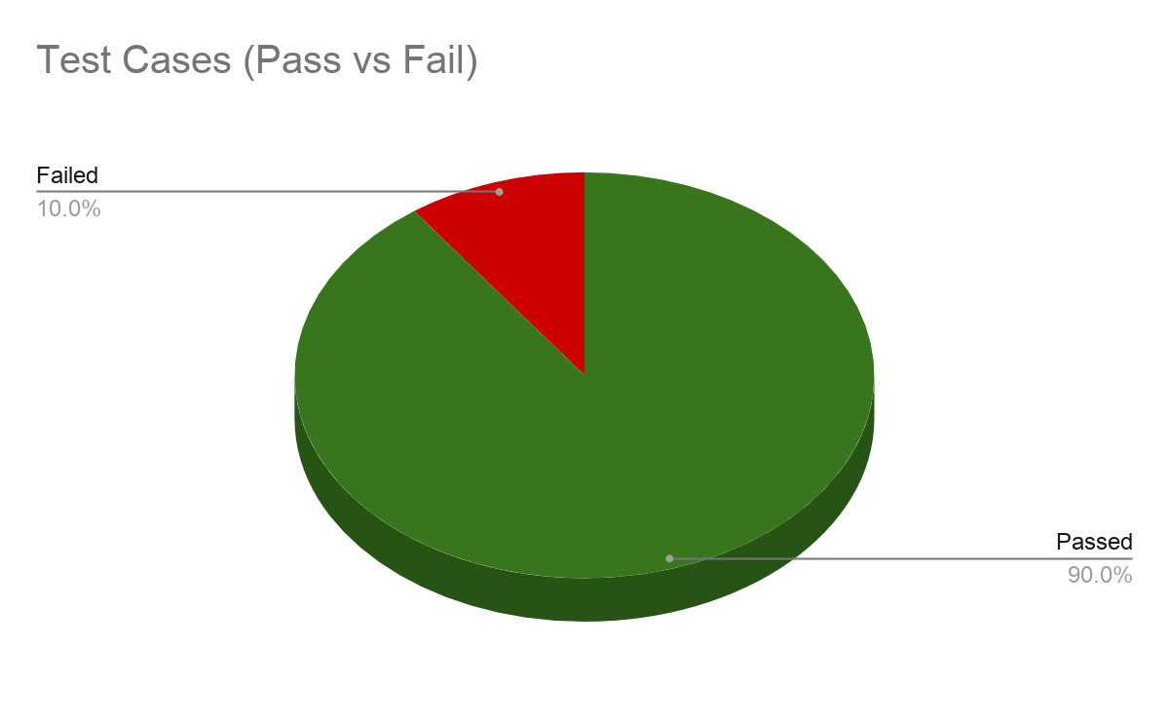

1. Number of defects identified and their Status & Severity

|  |  |  |  |  |  |
| --- | --- | --- | --- | --- | --- |
|  | **Critical** | **Major** | **Medium** | **Cosmetic** | **Total** |
| **Closed** | 25 | 15 | 20 | 0 | 60 |
| **Open** | 0 | 0 | 0 | 5 | 5 |
|  |  |  |  |  | 65 |

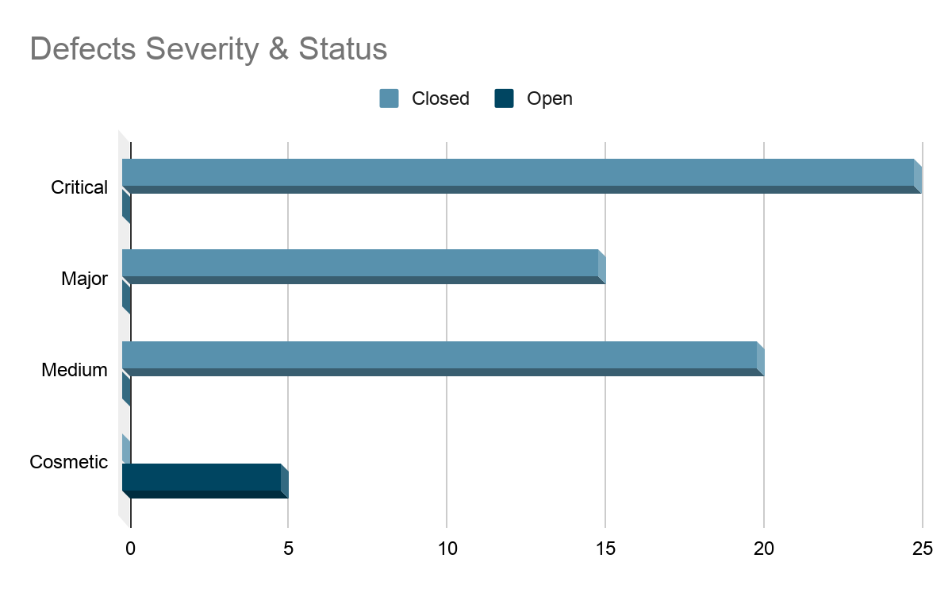

4. Defects Distribution - module wise

|  |  |  |  |  |
| --- | --- | --- | --- | --- |
|  | **Registration** | **Reports** | **Map** | **Total** |
| **Critical** | 10 | 10 | 5 | **25** |
| **Major** | 5 | 5 | 5 | **15** |
| **Medium** | 10 | 10 | 0 | **20** |
| **Cosmetic** | 1 | 3 | 2 | **5** |
| **Total** | **26** | **28** | **12** | **65** |

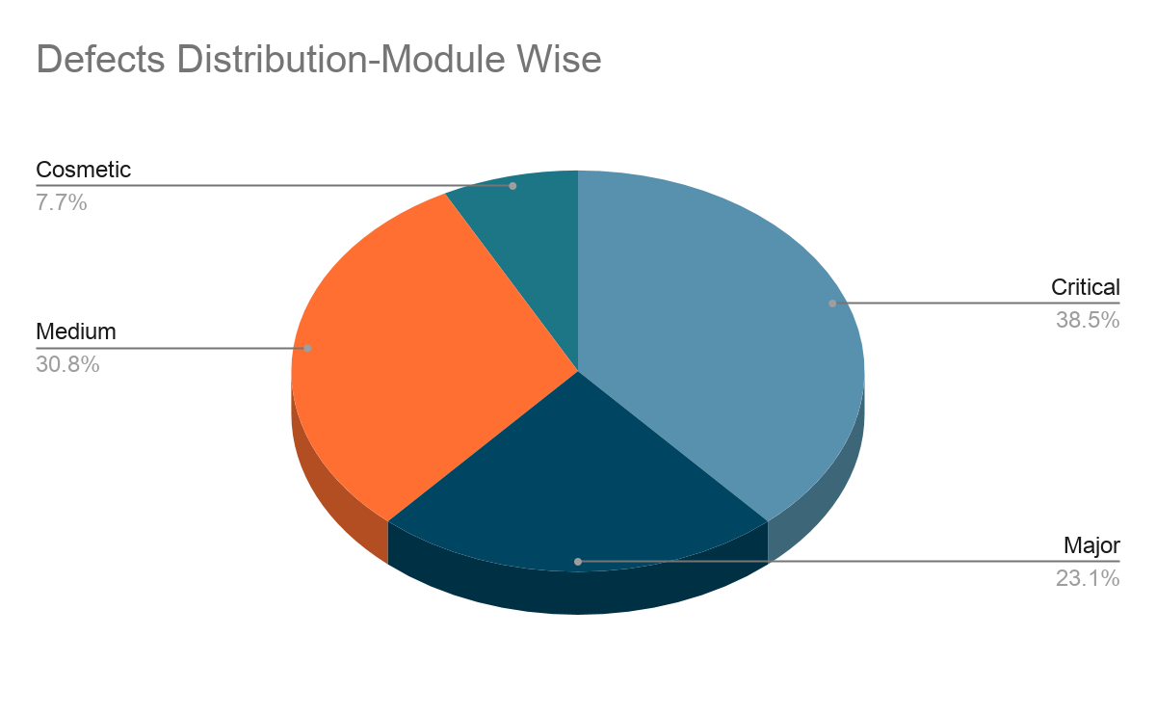

Types of testing performed

1. Unit Testing
   1. This testing is done by testing method(s) by which individual units of source code—sets of one or more computer program modules together with associated control data, usage procedures, and operating procedures—are tested to determine whether they are fit for use.
2. System Integration Testing
   1. This is the Testing performed on the Application under test, to verify the entire application works as per the requirements.
   2. Critical Business scenarios were tested to make sure important functionalities in the application works as intended without any errors.
3. Regression Testing
   1. Regression testing was performed each time a new build is deployed for testing which contains defect fixes and new enhancements, if any.
   2. Regression Testing is being done on the entire application and notjust the new functionalities and Defect fixes.
   3. This testing ensures that existing functionalities work fine after defect fix and new enhancements are added to the existing application.
   4. Test cases for new functionalities are added to the existing test cases and executed

Test Environment & Tools

|  |  |
| --- | --- |
| Application URL | N/A |
| App Server | N/A |
| Database | MariaDB |

Lessons Learnt

|  |  |  |
| --- | --- | --- |
| S. No | Issues Faced | Solutions |
| 1 | Testing from different roles such as admin, reporter, and vendor on the UI | Script automation setup for testing a user as a different role and also setup for regression testing. |
| 2 |  |  |

Recommendations

* Unit test earlier
* Do some more research regarding your targeted audience

Best Practices

* Write unit tests early and often to also help with regression testing

Exit Criteria

Conclusion/Sign Off