August 18, 2016

**DEPARTMENT OF MICROBIOLOGY AND IMMUNOLOGY**

1520A MEDICAL SCIENCE RESEARCH BUILDING I

ANN ARBOR, MICHIGAN 48109-0620

PHONE: (734) 763-3531

FAX: (734) 764-3562



Dear *Microbiome* Editorial Board,

We are happy to submit our manuscript, “DNA from fecal immunochemical test can replace stool for microbiota-based colorectal cancer screening”, for your consideration. Our study used a novel statistical modeling approach to identify a collection of microbiome-based biomarkers in feces that can differentiate between healthy individuals and those with adenomas and carcinomas. Building off of our previous work, the current study shows that we can get models using the buffer from a FIT cartridge that are as predictive as those generated using whole stool samples. We believe that our approach represents a translational application of microbiome research to the important problem of developing non-invasive screens for colorectal cancer. Given the considerable recent interest in the human microbiome we are confident that those interested in the specific problem of colorectal cancer and members of the broader microbial ecology field will be interested in our story.

We suggest the following as potential reviewers because of their knowledge of colorectal cancer biology and microbiome research:

* Christine M. Pierce Campbell – [Christine.PierceCampbell@moffitt.org](mailto:Christine.PierceCampbell@moffitt.org)
* Volker Mai – [VMai@ufl.edu](mailto:VMai@ufl.edu)
* Jacques Izard – [jizard@forsyth.org](mailto:jizard@forsyth.org)

Unfortunately, we must also ask you to exclude Rob Knight, PhD (University of California-San Diego) as a reviewer. Previous interactions indicate that he is unable to provide an unbiased review of our work. Should any questions arise during the review of our manuscript please do not hesitate to contact us.

Finally, a pre-print version of this manuscript has been posted at bioRxiv (http://dx.doi.org/10.1101/048389).

Sincerely,

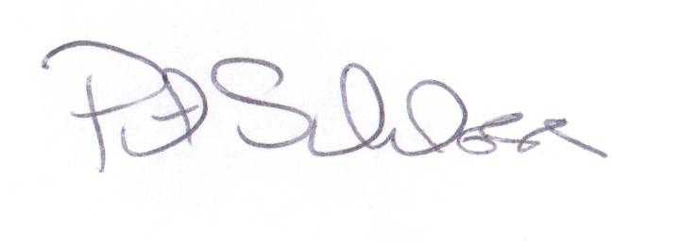

Patrick D. Schloss, PhD

Associate Professor