April 28, 2020

**DEPARTMENT OF MICROBIOLOGY AND IMMUNOLOGY**

1520A MEDICAL SCIENCE RESEARCH BUILDING I

ANN ARBOR, MICHIGAN 48109-0620

PHONE: (734) 763-3531

FAX: (734) 764-3562



Dear Editor,

My colleagues and I are happy to submit for your consideration a Ten Simple Rules manuscript, “**Ten Simple Rules to increase computational skills among biologists with Code Clubs**”. The rules described in this manuscript come out of our experience training bench scientists the skills they need to become better data scientists. We see a Code Clubs as being analogous to Journal Clubs, which are commonly used in research groups to stay current on the scientific literature.

Although the rules described in the manuscript come from our research group, we are aware of other groups that have been inspired by our experience and have gone on to successfully run their own Code Club. We are optimistic that others will be similarly inspired by our experiences.

Sincerely,

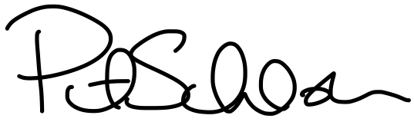

Patrick D. Schloss, PhD

Professor