March 29, 2021

**DEPARTMENT OF MICROBIOLOGY AND IMMUNOLOGY**

1520A MEDICAL SCIENCE RESEARCH BUILDING I

ANN ARBOR, MICHIGAN 48109-0620

PHONE: (734) 763-3531

FAX: (734) 764-3562



Dear Dr. Britton,

My colleagues and I are happy to resubmit our manuscript, **Clearance of *Clostridioides difficile* colonization is associated with antibiotic-specific bacterial changes,** for your consideration at *mSphere*. We have made the suggested language change provided by the reviewer.

Sincerely,

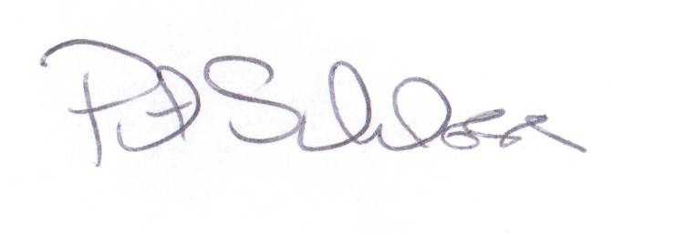

Patrick D. Schloss, PhD

Professor