July 5, 2022

**DEPARTMENT OF MICROBIOLOGY AND IMMUNOLOGY**

1520A MEDICAL SCIENCE RESEARCH BUILDING I

ANN ARBOR, MICHIGAN 48109-0620

PHONE: (734) 763-3531

FAX: (734) 764-3562



Dear Dr. Casadevall,

My colleagues and I are happy to resubmit our manuscript, **Reduced fecal community transplant restores Clostridioides difficile colonization resistance to antibiotic perturbed murine communities,** for your consideration at *mBio*. In this work we colonized antibiotic-treated mice with diluted fecal samples and then challenged the animals with *C. difficile*. The goal was to identify the dilution that restored colonization resistance and to characterize the differences in those dilutions that did and did not restore resistance.

We believe that the manuscript is much improved because of the contributions of the two reviewers and are optimistic that they will find it is now acceptable for publication.

Sincerely,

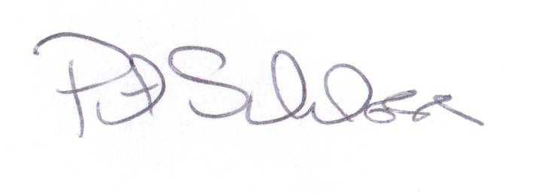

Patrick D. Schloss, PhD

Professor