December 21, 2022

**DEPARTMENT OF MICROBIOLOGY AND IMMUNOLOGY**

1520A MEDICAL SCIENCE RESEARCH BUILDING I

ANN ARBOR, MICHIGAN 48109-0620

PHONE: (734) 763-3531

FAX: (734) 764-3562



Dear Dr. Newton,

I am happy to resubmit the manuscript, ***The Riffomonas YouTube Channel: An Educational Resource to Foster Reproducible Research Practices***, for your consideration. The reviewers were both excited to receive this announcement for my educational resource. They made similar comments encouraging me to provide a summary of the content and analyses covered on the channel. I have added Table 1, which lists the titles of the 20 playlists currently published on the channel. The titles are hyperlinked to the playlists and the number of videos within each playlist are included in the new table.

I hope you and your editors agree that this announcement will be an important contribution to the journal.

Sincerely,

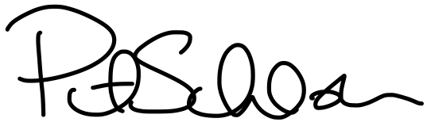

Patrick D. Schloss, PhD

Professor