December 10, 2020

**DEPARTMENT OF MICROBIOLOGY AND IMMUNOLOGY**

1520A MEDICAL SCIENCE RESEARCH BUILDING I

ANN ARBOR, MICHIGAN 48109-0620

PHONE: (734) 763-3531

FAX: (734) 764-3562



Dear Dr. Imperiale,

I am happy to submit my manuscript, **Rarefaction is currently the best approach to control for uneven sequencing effort in amplicon sequence analyses**, for your consideration at *mSphere*. Among studies sequencing 16S rRNA gene fragments, it is common to observe wide variation in the number of sequences sampled from each sample in the study. This manuscript addresses several commonly suggested modern methods for controlling this uneven sampling effort including the controversial approach of rarefaction. Ultimately, the approach with the best performance is rarefaction. This manuscript has been posted to bioRxiv as a preprint (DOI: 10.1101/2023.06.23.546313).

I have also submitted another manuscript to *mSphere* that reassesses the analysis from the paper that originally called into question the practice of rarefaction (**Waste not, want not: Revisiting the analysis that called into question the practice of rarefaction**; DOI: 10.1101/2023.06.23.546312). My reanalysis demonstrates that rarefaction was actually superior to the other recommended methods, which is the same conclusion of this submission albeit by different approaches. Although these manuscripts touch on the same question, they use different approaches. I feel that both stand on their own as independent manuscripts.

Sincerely,

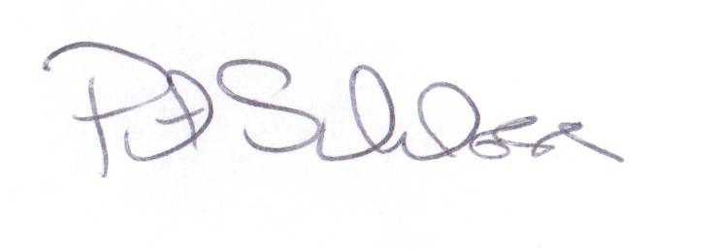

Patrick D. Schloss, PhD

Professor