

**DEPARTMENT OF MICROBIOLOGY AND IMMUNOLOGY**

1120A MEDICAL SCIENCE RESEARCH BUILDING I

ANN ARBOR, MICHIGAN 48109-0620

PHONE: (734) 647-5801

FAX: (734) 764-3562

E-MAIL: pschloss@umich.edu

February 29, 2018

Dear Dr. Casadevall,

I am happy to submit to *mBio* the attached manuscript, ***Reproducible Research Is Really F#$%ing Hard***. This Perspective piece takes a different tone and a deeper discussion than the Editorial that came out of the AAM’s 2015 symposium, entitled “Promoting Responsible Scientific Research”. I am confident that you will find my manuscript will make a meaningful contribution to your and *mBio*’s ongoing interest into areas of research training, impact, reproducibility, rigor, elegance, and the overall approach we take to performing science.

My manuscript takes issue with the conclusions from the symposium, which stated, “the three major causes of lack of reproducibility as (i) sloppy science, (ii) selection and experimental bias, and (iii) misconduct.” I lay out a framework that provides operational definitions of reproducibility, replicability, robustness, and generalizability. Next, I describe the factors that can threaten this framework and approaches microbiologists can take to overcome the threats. Finally, I provide several exercises for individuals and research groups that will help them to obtain a better appreciation the specific threats in their own research. I also remind readers that just because a result is reproducible or replicable does not mean that it is necessarily correct. Conversely, work that lacks reproducibility is not necessarily incorrect – but of course, it slows and hinders the scientific method. Beyond sloppy science, bias, and misconduct, there is much to be learned from failures to validate previous results that will also provide considerable information about microbial life itself. Ultimately, I think readers of my Perspective manuscript will find the problems of the “Reproducibility Crisis” to be more nuanced than what has previously been reported and takes a humbler tone.

Unfortunately, I must request that **Rob Knight (UCSD)** not be included as an editor or reviewer of this manuscript as previous interactions indicate that he is unable to provide an unbiased review of our work.

Thank you very much for your consideration and I look forward to your response.

Sincerely,

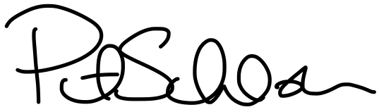

Patrick D. Schloss, Ph.D.  
Frederick G. Novy Collegiate Professor of Microbiome Research