**Antibiotic induced alterations of the murine gut microbiota and subsequent effects on colonization resistance against *Clostridium difficile***

Alterations of the Murine Gut Microbiota that Lead to *Clostridium difficile* Colonization

Infection and Immunity (IAI) is devoted to the advancement and dissemination of fundamental knowledge concerning (i) the molecular basis of infections caused by pathogenic bacteria, fungi, and parasites; (ii) mechanisms of pathogenicity, including virulence factors (such as toxins, adhesins, invasins, and secreted effector molecules) and other microbial products that are or may be related to pathogenesis; (iii) how these virulence factors interact with the host cell to alter cellular processes; (iv) factors involved in host resistance and susceptibility to infection; (v) immunity to pathogenic microorganisms, including the functions of phagocytes, lymphocytes, immunoglobulins, and other factors; (vi) experimental models of infection and the pathological consequences of infection; and (vii) selected aspects of vaccines against pathogens (see below).

IAI will not consider papers that are preliminary, purely descriptive, or case studies. Clinical studies may be suitable for consideration by IAI if they provide novel insights into infectious disease pathogenesis. IAI welcomes studies of the microbiome that relate to host-pathogen interactions. Papers describing methodology are not encouraged; only under unusual circumstances will they be considered for publication.

**ISME:** [**http://mts-isme.nature.com/cgi-bin/main.plex?form\_type=display\_auth\_instructions#format**](http://mts-isme.nature.com/cgi-bin/main.plex?form_type=display_auth_instructions#format)

**5000 words with abstract**

**Science?/PNAS?/Plos Biology**

**BMC journals**

**mBio**

Alyxandria M. Schubert,1 Hamide Sinani,1 Patrick D. Schloss1\*

1Department of Microbiology and Immunology, University of Michigan, Ann Arbor, Michigan

\* Correspondence: pschloss@umich.edu

734.647.5801

Department of Microbiology and Immunology

University of Michigan

1520A Medical Science Research Building I

1150 W. Medical Center Dr.

Ann Arbor, MI 48109

**ABSTRACT**

**250 words**

**INTRODUCTION**

The microbiome, or the diverse community of microorganisms living in and on the body, has an integral role in deterring pathogen colonization and infection. This native protection by the microbiome from invasive pathogenic species is termed colonization resistance. It is well-established that the gut bacterial microbiome is critical in the hosts’ defense against the pathogen *Clostridium difficile*. When this indigenous community is perturbed, this often leads to a loss of resistance. This is especially important in many hospital settings where perturbations such as antibiotics, diet changes, chemotherapy, and other medications render patients susceptible to environmental *C. difficile* spores. In fact, *C. difficile* infections (CDI) are the number one hospital acquired infection in the United States. It is not completely understood how different perturbations affect subsequent colonization resistance, nor do we have a comprehensive view of the taxonomic changes associated with a loss in colonization resistance.

Previous work characterizing the microbiome’s of human and mouse hosts in the context of CDI provide glimpses into potentially protective and alternatively susceptible community structures, i.e. which bacteria are present and their abundance. Cross-sectional investigations have characterized the microbiota of patients in the hospital with and without a *C. difficile* infection (CDI) and compared to healthy controls. These studies found patients with *C. difficile* tended to have a reduction in numbers of Clostridiales Incertae Sedis XI (Vincent et al), Lachnospiraceae, Ruminococcaceae, and *Bacteroides* (Schubert et al). These studies however lack the baseline healthy state of the microbiota, which preclude them from assessing risk of *C. difficile*. Murine models of CDI have the advantage of observing the specific changes that occur before and after controlled perturbations and the introduction of *C. difficile.* Communities with low levels of CR were associated with blooms in either Lactobacillaceae (cefoperazone-induced) (Theriot, 2014, bassis, 2014), Proteobacteria (induced by either clinda+5abx cocktail, clinda alone, or tigecycline) (Reeves, 2011, Buffie, 2011, Bassis 2014). Lachnospiraceae is associated with resistance to *C. difficile* infection (Reeves 2011) and has been directly shown to decrease colonization through mono-colonization studies in germfree mice (Reeves 2012).

Even fewer studies attempt to model these observational changes in the microbiome following perturbation. Using the time series data gathered from the *C. difficile* challenge of clindamycin-treated mice (Buffie 2011), a Lotka-Volterra dyamics-based framework was built which incorporates both time and accounts for external perturbations (Stein 2013). They identified a subset of their network, containing Blautia, Akkermansia, and Coprobacillus, as having a negative relationship with *C. difficile*, while alternatively Enterococcus had a positive relationship.

The purpose of this investigation was to test the effects of an array of perturbations on microbiome CR levels against *C. difficile*. We then used this information to design microbiome-based models for estimating pathogen colonization levels. Through the administration of various antibiotic regimens, we altered the murine gut microbiota and observed these changes using 16S rRNA sequencing. The resultant gut communities were then challenged with *C. difficile* spores. Through correlation and random forest analysis of the starting communities with the subsequent level of *C. difficile* colonization, we built linear models to predict *C. difficile* colonization levels based on a subset of the microbiota. We used experimental data to test the ability of the model.

What we show here.

Alternate Instead of paragraph 2/3: topic – Need more studies that look at the level of the community as a whole in CR over the effect of single bugs. Examples of papers looking at combinations/subsets of bacteria in CR

Lawley with his 6 bug combo, including \_

Pamer-nature paper- designed consortium of protective bugs including *C. scindens* (Lachnospiraceae), *Barnesiella intestihominis* (Porphyromonadaceae), *Pseudoflavonifractor capillosus (*Clostridiales), *Blautia hansenii* (Lachnospiraceae)

Stein—Lotka Volterra dynamics reveal subnetwork of bugs implicated in either susceptibility or protection, containing Blautia, Akkermansia, and Coprobacillus, as having a negative relationship with *C. difficile*, while alternatively Enterococcus had a positive relationship.

Schubert—modeling CD status using human data

**MATERIALS AND METHODS**

**Animal Care**

We used 5-8 week old C57Bl/6 mice for all our experiments. These mice were housed in our SPF room in the animal facility at the University of Michigan. All animal-related protocols and experiments were approved by the University Committee on Use and Care of Animals at the University of Michigan.

**Antibiotic administration**

Mice were administered one of seven different antibiotics, including cefoperazone, vancomycin, metronidazole, streptomycin, ciprofloxacin, ampicillin, and clindamycin. The route of administration depended on the specific antibiotic. Cefoperazone (either 0.5mg/ml, 0.3mg/ml, or 0.1mg/ml), vancomycin (0.625mg/ml, 0.3mg/ml, or 0.1mg/ml), streptomycin (5mg/ml, 0.5mg/ml, or 0.1mg/ml), metronidazole (0.5mg/ml), and ampicillin (0.5mg/ml) were all administered in the mouse drinking water for 5 days. Ciprofloxacin (10 mg/kg) was administered via oral gavage, and clindamycin (10 mg/kg) was administered via IP injection. All antibiotic treated mice were given 24 hours of recovery on regular drinking water prior to *C. difficile* challenge.

***C. difficile* Preparation andChallenge**

In all our experiments we used *C. difficile* strain 630Δerm [cite dena lyras]. The spores used were prepared from a single large batch made following previously established protocols [cite paul?]. Spores were quantified within the week prior to *C. difficile* challenge for each experiment [established protocol I can cite?]. Spores were quantified by boiling a small volume at 65°C for 20 minutes to kill off residual vegetative cells. The volume was then diluted and plated on TCCFA plates. These were incubated at 37°C anaerobically overnight. The next day *C. difficile* colony forming units (CFU) were counted and the concentration of spores in the working stock was back calculated. On the day of challenge, *C. difficile* spores, at a final concentration of 103, were administered to mice via oral gavage. Immediately following this challenge, the remaining *C. difficile* inoculum was diluted in a series and plated to confirm the correct dosage.

**Sample Collection and Plating**

Fecal samples were freshly collected for each mouse immediately prior to the administration of any antibiotic, during any antibiotic recovery days, and days 0 and 1 post *C. difficile* challenge. Each fecal sample on day 1 was weighed and diluted under anaerobic conditions with anaerobic PBS 1:10 based on pellet weight. A dilution series was then plated onto TCCFA plates [cite plates] and incubated at 37°C anaerobically overnight. The colony forming units (CFU) were counted and calculated the subsequent day.

**DNA Extraction and Sequencing**

Total bacterial DNA was extracted from each untreated and day 0 stool sample using the MOBIO PowerSoil®-htp 96 Well Soil DNA Isolation Kit. Sequencing preparation and sequencing was carried out as previously described (Kozich JJ et al. 2013). Briefly, the V4 region of the 16S rRNA gene was amplified, purified, and pooled in equimolar concentrations. These libraries were then mixed with Illumina-prepared PhiX control libraries. Sequencing was performed using Illumina’s MiSeq platform to produce paired 250-nt reads. Mock/error/error of run?

**Sequence Curation**

These sequences were curated using mothur as previously described (Kozich JJ et al and Schloss PD et al). The full pipeline is also demonstrated online at the mother website (<http://www.mothur.org/wiki/MiSeq_SOP>). Sequences were binned into operational taxonomic units (OTUs) using a 3% dissimilarity cutoff. Taxonomic assignments were determined by using a naïve Bayesian classifier with the Ribosomal Database Project (RDP) training set (version 9) requiring an 80% bootstrap confidence score. In order to avoid biases due to uneven sampling, samples were normalized to 1,625 sequences per samples [Schloss, reducing effects]. For those samples with more than 1,625 sequences per samples, the range was \_\_, the mean was \_\_, the median was \_\_, the median absolute deviation was \_\_. All 16S rRNA gene sequence data and the MIMARKS table are available at \_\_.

**Statistical Analysis & Modeling**

Using data from the original antibiotic treatments groups, OTUs were selected for addition into the model following several criteria. First all OTUs were present in abundance at a minimum of 1% in at least one or more samples. Second, these bacteria were the top 5 OTUs with the strongest positive correlation or among the top 10 OTUs with the strongest negative correlation withsubsequent *C. difficile* colonization. Correlation analysis was performed using Spearman’s rank based correlation coefficient, ρ, for non-normally distributed data. Third, we used the random forest feature selection algorithm to determine influential bacteria in predicting *C. difficile* levels. The top 15 OTUs that were not unclassified and had the highest percent increase in MSE (mean squared error) towards the random forest model. Finally, candidates in our model were screened for strong correlations (>0.9) with each other using sparCC [reference]. The highest correlation we observed was 0.84 between OTUs 6 and 7, which dropped off to 0.71 for other OTU pairs. This screening process allowed us to narrow our candidate list down to 19 OTUs for possible inclusion into the linear model.

Next, we used the R package “leaps” in order to determine the top linear models given our candidate list of OTUs as parameters in the model. We set the maximum number of parameters in the model to 10, due to the size of our data set (99 observations). Using the regsubsets() function, we used the exhaustive method for determining the 3 best models for each number of parameters in the model from 1 to 10. Based on these results, we decided on a final model incorporating 5 OTUs. This model was used to predict the outcome of *C. difficile* colonization based on the Day 0 communities from the titration dataset. All statistical analyses were conducted using R version 3.1.2.

**RESULTS**

 All tabular data must be accompanied by either standard deviation values or standard errors of the means. The number of replicate determinations (or animals) used for making such calculations must also be included. All statements concerning the significance of the differences observed should be accompanied by probability values given in parentheses. The statistical procedure used should be stated in Materials and Methods. be sure to cite all figures and tables.

**Levels of colonization resistance are associated with the initial structure of the gut microbiota.** Using untreated mice as well as those treated with seven representatives from six classes of antibiotics (**Table 1**) we generated distinct and reproducible community structures that were assessed for their resistance to *C. difficile* colonization (**Figure 1**). 16S rRNA gene sequencing of the communities sampled from the feces of the mice sampled at the time of *C. difficile* inoculation revealed six distinct community structures (AMOVA, p<0.001). The community structures of the beta-lactam-treated mice (i.e. cefoperazone and ampicillin) were not significantly different from each other (AMOVA, p=0.37). In addition, the untreated and ciprofloxacin-treated microbiota were not significantly different from each other (AMOVA, p=0.12). Although both pairs of treatment groups were not significantly different across the entire community, there did appear to be differences among the low-abundance taxa (**Figure 1**). All other comparisons between the community structures were significantly different from each other (AMOVA, p<0.001). Subsequently, 24 hours after inoculation *C. difficile* was undetectable in the untreated mice or the ciprofloxacin-treated mice; however it had successfully colonized the mice in all of the other treatment groups to similarly high levels (107-108 CFU/g) (**Figure 1**). We calculated the diversity of all of the communities using the Inverse Simpson (**Supplemental Figure 1**) and Shannon indices (data not shown) and observed a significant negative correlation with subsequent *C. difficile* colonization (both p<0.001). These results suggest that multiple microbiota structures are capable of being colonized by *C. difficile* and that diversity may be an important factor in resistance to invasion.

**Correlation analysis reveals potentially protective bacteria.** To identify bacterial taxa that could be associated with resistance or susceptibility to *C. difficile*, we measured the correlation between the relative abundance of each OTU on the day of inoculation with the level of *C. difficile* colonization 24 hours later across all treatment groups (**Figure 2**). OTUs with negative a correlation were associated with providing resistance against *C. difficile* (N=XX) and those with a positive correlation were associated with susceptibility (N=XX). Among various bacterial families, three were consistently negatively correlated with *C. difficile* colonization: Porphyromonadaceae (ρaverage= -0.57), Lachnospiraceae (ρaverage= -0.39), Ruminococcaceae (ρaverage= -0.47). OTUs from one bacterial phylum, the Proteobacteria, had a consistent strong positive relationship with *C. difficile* colonization. These included OTUs associated with the *Pseudomonas* (ρ= 0.31)*,* *Rhodobacter* (ρ= 0.31)*,* and *Escherichia* (ρ= 0.56) genera. Other notable OTUs that were found at the extremes of the distribution of correlation scores included those affiliated with the genus *Lactobacillus* (order Lactobacillales; OTU23, ρ= -0.73), *Alistipes* (order Bacteroidales; OTU20, ρ= -0.78), *Enterorhabdus* (phylum Actinobacterium; OTU29, ρ= -0.70), and *Streptococcus* (order Lactobacillales; OTU78, ρ= 0.36). Overall, these results suggest that several larger groups of related OTUs, particularly within the Firmicutes phylum, may participate in colonization resistance against *C. difficile*, while broadly many members of the Proteobacteria phylum may be involved in susceptibility.

**Smaller perturbations of the microbiota result in maintenance of CR.** Because most of our original treatments resulted in similarly high levels of *C. difficile,* we hypothesized that applying smaller antibiotic perturbations to the microbiota would result in reduced sensitivity to *C. difficile*. To test this, we titrated the doses of cefoperazone, streptomycin, and vancomycin given to the mice (**Supplemental Table 1)**. Colonization levels decreased in the mice receiving lower doses of cefoperazone and streptomycin in support of our hypothesis; while these levels were similar across mice receiving vancomycin, regardless of the dose (**Figure** **3**). Next, we hypothesized that the populations we previously identified as being associated with protection against colonization would be elevated in the mice with decreased colonization and those associated with susceptibility would be less abundant.

The titrated antibiotic doses clearly resulted in distinct community structures that were variations of the original dose (**Figure 3**). The cefoperazone titrations resulted in a shift in dominance from the Bacteroidetes to the Firmicutes phylum with increasing antibiotic dose. Most notable was the increase in OTUs associated with resistance including the Porphyromonadaceae and *Alistipes* and a reduction in OTUs associated with susceptibility including members of the Proteobacteria. The relative abundance of other OTUs associated with protection including the Lactobacillus, Lachnospiraceae, and Ruminococcaceae did not change as expected based on the initial correlation analysis; however, these OTUs were present at levels similar to the untreated mice. The streptomycin titrations did not result in profound shifts in the overall community structure, but did yield increased resistance. Rather, there were individual populations that were gained or lost across the gradient. Notably, mice receiving the lowest dose retained higher levels of *Alistipes* and Lachnospiraceae, which we previously found to be associated with colonization resistance. The relative abundances of the Porphyromonodaceae and Ruminococcaceae were unchanged, but were present at similarly high levels to those found in the untreated mice. Although the vancomycin titration yielded a number of large changes in the abundance of individual populations, there was no recovery of colonization resistance. The relative abundance of many of the populations associated with resistance increased with a decreased vancomycin dosage; however, with the exception of the *Lactobacillus* populations, they did not reach the levels observed in the untreated mice. In addition, all of the vancomycin-treated mice had high levels of OTUs affiliated with the *Akkermansia* and Enterobacteriaceae. Together, these results suggest that individual populations are not sufficient to provide colonization resistance. Rather, resistance is likely a product of the overall composition of the community.

We next wanted to determine whether associations we observed with the seven antibiotics at a single dose were supported by the results we observed in the titration experiments. Using only the new titration groups, we again performed correlation analysis of species level OTUs at inoculation with the *C. difficile* colonization levels the next day (**Figure 4**). Among many of the taxa previously identified as having significant relationships with *C. difficile*, we observed similar trends across the new titration data set, most notably with the titration treatment groups of cefoperazone and vancomycin.

Overall, cefoperazone titration treatments supported the correlation results from the original data set. The most positively correlated OTUs were *Pseudomonas* (OTU65), *E. coli* (OTU11), and *Clostridium* (OTU61), while the top 8 most negatively correlated were all different Porphyromonadaceae OTUs (OTU3, 4, 6, 8, 13, 2, 7, 12). Vancomycin titration treatments also supported the significant correlations found from the original data set. Among those with correlations smaller than -0.80, 7 Porphyromonadaceae OTUs (OTUs 19, 12, 3, 4, 2, 1, 13), Lachnospiraceae OTU39, and *Alistipes* OTU20 supported significant results found in the original data. Similarly, *Escherichia* (OTU11, ρ= 0.84) had the strongest positive correlation with subsequent *C. difficile* levels. In addition, the new vancomycin titration treatment results showed that *Akkermansia* had a strong positive relationship (ρ=0.77). The relative abundance of *Akkermansia*, a member of the Verrucomicrobia phylum, bloomed significantly following treatment with any of the 3 doses from <5% to as much as 50% of the community (p=?, **Figure 4**). Streptomycin titration treatment experiment results had the most sign discrepancies for direction of relationship (positive or negative) compared with the original antibiotic results [quantify?].

However, those discrepancies that were significant were found among the strongest positively correlated OTUs. This included Bacteroidetes OTU16 (ρ=0.61) and *Bacteroides* OTU5 (ρ=0.72). *Akkermansia* OTU10 was also strongly positively correlated (ρ=0.64). *E. coli* OTU11 was near absent from the streptomycin treated communities (**Figure 4**), and thus we did not observe a strong association with *C. difficile* colonization as in most previous antibiotic treatments. Some of the strongest negative correlations were among several Porphyromonadaceae (OTUs 6, 18, 13), *Turicibacter* OTU17 (ρ=-0.70), and *Alistipes* OTU20 (ρ=-0.69). All of the statistically significant negative correlations from the titration results support findings from the original antibiotic treatments.

**Allowing recovery of identified groups restores colonization resistance.** For each antibiotic treatment, a control group of mice receiving antibiotics without inoculation of *C. difficile* was maintained. The microbiota’s of animals treated with metronidazole underwent a drastic shift in the microbiota structure with an additional 5 days of recovery. We observed changes in relative abundance of several OTUs that we previously observed had strong relationships with subsequent *C. difficile* colonization (**Figure 5**). Notably there were increases in overall abundance of the levels of Porphyromonadaceae, Ruminococcaceae, and Lachnospiraceae, and decreases in levels of Enterobacteriaceae. Based on these changes, we hypothesized that delaying *C. difficile* challenge to allow these potentially important changes in microbiota structure to occur would lead to a decrease in colonization. On Day 1 post challenge of these recovered mice, we observed a significant decrease in *C. difficile* level of CFU/g feces (p=?). These results strengthen the importance of Porphyromonadaceae, Lachnospiraceae, Ruminococcaceae, and Enterobacteriaceae in setting up the right environment of negatively and positively correlated bacteria to affect the outcome of *C. difficile* colonization.

**Modeling to predict colonization outcomes.** Given our ability to make general predictions of *C. difficile* colonization based on the microbiota, we next designed a model to calculate expected colonization levels given the relative abundance of a specific OTU subset. We identified this subset using only the original data set to build the initial model. Random forest and correlation analyses were used to determine the best candidate list of OTUs for potential inclusion in the model [Materials & Methods]. These 19 candidates are listed in Supplemental Table 2. We allowed our model to include anywhere from 1 to 10 parameters, given our dataset included 99 observations. Using an exhaustive search to build models, we determined the best 3 models for each number of parameters. Supplemental Figure 2 shows the results of the model building. Interestingly, across the models with highest adjusted R2 values, there are 5 OTUs that are common to each, OTUs 6, 7, 20, 39, and 283. We used a model incorporating these 5 OTUs to predict the level of *C. difficile* CFU/g feces for the titration data set to estimate the performance of the model, and we achieved an adjusted R2 of 0.65.

**DISCUSSION 254-344**

**Dear Pat,**

I know that this section is gibberish and there are missing pieces in the results still, and hence this is not a complete draft. Iknowiknowiknowiknowiknow. I will say that I’m making bigger strides lately, and I’m committed to owning 2015. My thesis is number 1 until I die from it or graduate. I WILL get done by April. Iwilliwilliwilliwilliwill. I WILL get you the discussion and a cleaned up/better results section by Monday.

Alyx

* + Recap major findings, answer to the question

Together these data allowed us to make better predictions about the colonization resistance ability of any given microbiota

Porphyromonadaceae, Lachnospiraceae, Ruminococcaceae, Clostridia, Alistipes, etc were found to have strong potential resistance abilities against *C. difficile*. Conversely, several members of the Proteobacteria phylum, including Pseudomonas, Streptococcus, and especially *E. coli* have strong potential positive impacts for *C. difficile* colonization. These results were supported through experiments in which the original doses of cefoperazone, streptomycin, and (vancomycin) were titrated to alter the overall abundances but not membership of the community from the starting dose. These subtler structural changes allowed for greater range of colonization levels of *C. difficile* as well as further/fine-tuned support for our original results. Furthermore, a known change to occur in important bacterial populations, we were able to reduce the level of colonization by *C. difficile*.

Correlation analyses and modeling techniques statistically confirm these results.

* + How answer supported by results
    - See this by correlation analysis, modeling, supported across several antibiotic regimens

Go into how these findings are similar to other papers/work? Buffie, reeves, theriot, me, etc, see list.

* + How relates to other studies
    - Can I apply my model to my human data?
    - Antonopoulos et al-reproducible community dynamics
    - Antunes et al (finlay)—abx treatment on intestinal metabalome
    - Sekirov—antibiotic induced perturbations of intestinal microbiota
      * “Antibiotics had a dose dependent effect on intestinal microbiota composition”
      * “Change in the compostion alone of the intestinal microbiota (in the absence of significant changes in total numbers of intestinal microbes) prior to Salmonella serovar Typhimurium infection was sufficient to make mice more susceptible to Salmonella serovar Typhimurium, indicating that different subsets of the microbiota may play protective roles or enhance susceptibility to enteric infections.”
      * Streptomycin and vancomycin doses were administered to mice prior to challenge with another gastrointestinal pathogen *Salmonella enterica* serovar Typhymurium (Sekirov 2008). This study showed \_\_\_. Changes in community composition were dose dependent.
      * Strep increases bacteroidetes (CFB), vanc increases firms and then proteo (with increasing dose)
    - Buffie et al (pamer)-single dose clinda
    - Reeves/theriot/robinson—clindamycin/cef/cocktail/antbiotic administration alters the community structure
    - Croswell—prolonge impact of abx on intestinal microbial ecology salmonella
    - Lawley-targeted restoration
    - Rea- effect of broad and narrow spectrum antimicrobials
    - Ferreira—intestinal microbiota plays a role in salmonella induced colitis
    - Reeves with clone libraries and cef
    - Theriot?—at least the metabolome paper—before and after with metabolites and cef, also does she look at anything taxonomically? yup
    - Buffie et al—single dose of clindamycin (diff strain of cdiff, other differences in systems/mice), how do their results compare

Any interesting points about the results? Mechanisms? Competition—ask matt if they are good? Proteobacteria could definitely play a role in susceptibility—creating an environment fit for cdiff… what ways could all those other bugs be making a bad environment for cdiff? Using up bile acids/germinants.., with those bugs gone freeing up sugars, … maybe connecting a lot more to some of caseys metabolome paper, and how mine would fit that

* + Limitations
    - No smaller intervals? Of cdiff levels, or changes in microbiota
    - Porphyromonadaceae is more prevalent in mice… so might not be as relevant for humans
    - Different strains of cdiff have different microbiota requirements to protect?
    - Doesn’t get at function… ?
  + Contribution to the field, positive spins
    - PROBIOTICS
    - Possible global effects? CR against other GI pathogens?

**Many of the relationships we observed in our study between specific bacteria and *C. difficile* are supported in the literature. –see my comments in this section**

Within the Porphyromonadaceae, only OTU505 had a significant positive relationship with subsequent *C. difficile* colonization (ρ= +0.21), which by blastn shares 99% identity with *Coprobacter fastidiosus.* Similarly within the Lachnospiraceae family, only one OTU had a positive relationship with *C. difficile* colonization (OTU174, ρ= +0.22). The Lachnospiraceae group also contained an OTU that had an exceptionally strong negative correlation (OTU39, ρ= +0.77). The Clostridia class was largely composed of the order Clostridiales (n=6), of which only one had a positive relationship with *C. difficile* colonization (OTU154, ρ= +0.26).

Several broader groups of bacteria can work together (in some combination) to provide CR …possible that proteobacteria in general are bad …These results indicate that many related species within the larger/broader bacterial groups may be able to serve in providing colonization resistance against *C. difficile.*

Other taxons in Figure 3 had more species specific correlations. For instance the Actinobacteria phylum included *Enterorhabdus* (OTU29, ρ= -0.70), Coriobacteriaceae (OTU50, ρ= -0.50), *Bifodbacterium* (OTU22, ρ= -0.34), *Actinomyces* (OTU58, ρ= +0.23). The Lactobacillales group is divided into two negatively correlated *Lactobacillus* OTUs (OTUs 23, 21, ρ= -0.73, -0.40 respectively) and two positively correlated *Streptococcus* OTUs (OTUs 78, 79). Similarly, the Bacteroidales group included species at both extremes, for example, an *Alistipes* (OTU20, ρ= -0.78) and a *Bacteroides* species (OTU44, ρ= +0.34). [END sent, all the other bad bugs look more like random smaller level taxonomic classification divisions, as in it’s a genus/species level effect type deal]

**--functional redundancy? Across related large groups like porphyros?**

**--mostly Firmicutes—better competitors with cdiff? Because similar nutrients resources?**

**Also functional redundancy with a highly diverse community… not just about who possibly but also ab being diverse—emphasizes community as a whole**

**Discussion** Do not recapitulate the results, but discuss their significance against the background of existing knowledge, and identify clearly those aspects that are novel. The final paragraph should highlight the main conclusion(s), and provide some indication of the direction future research should take. This section may be divided into subheadings to assist the reader. Results and Discussion may be combined.

OTU39—Eubacterium ventriosum (94%), eubacterium rectale (93%), roseburia intestinalis/hominis/faecis (93%) (positively correlated to differences observed in discordant MZ twins for BMI—more abundant in higher BMI siblings… these are all butyrate producers, also capable of degrading fiber)

FOS—fructooligosaccharides produced by degredation of inulin or polyfructose

**Inulin and fructo-oligosaccharides have divergent effects on colitis and commensal microbiota in HLA-B27 transgenic rats.**

### Abstract

Modulation of intestinal microbiota by non-digestible carbohydrates may reduce inflammation in inflammatory bowel disease (IBD). The aim of the present study was to assess the effects of inulin and fructo-oligosaccharides (FOS) on intestinal microbiota and colitis in HLA-B27 transgenic rats, a well-validated rodent model for IBD. In this study, 4-week-old rats were fed 8 g/kg body weight inulin or FOS for 12 weeks, or not. Faeces were collected at 4 and 16 weeks of age; and caecal samples were collected at necropsy. The effects of inulin and FOS on chronic intestinal inflammation were assessed using a gross gut score, histology score and levels of mucosal IL-1β. Intestinal microbiota were characterised by quantitative PCR and denaturing gradient gel electrophoresis. Colitis was significantly reduced in all FOS-fed rats compared to the control diet, whereas inulin decreased chronic intestinal inflammation in only half the number of animals. Quantitative analysis of caecal microbiota demonstrated that inulin increased the numbers of total bacteria and the Bacteroides-Prevotella-Porphyromonas group, FOS increased bifidobacteria, and both fructans decreased Clostridium cluster XI. In the faecal samples, both inulin and FOS decreased total bacteria, Bacteroides-Prevotella-Porphyromonas group, and Clostridium clusters XI and XIVa. FOS increased Bifidobacterium spp., and mediated a decrease of gene copies of Enterobacteriaceae and Clostridium difficile toxin B in faeces. SCFA concentrations in the faecal and caecal samples were unaffected by the diets. In conclusion, FOS increased the abundance of Bifidobacterium spp., whereas both fructans reduced Clostridium cluster XI and C. difficile toxin gene expression, correlating with a reduction of chronic intestinal inflammation.

It makes sense that many bacteria would play a role in colonization resistance and that it is more about the community composition as a whole *given* that interindividual differences is so great. Two people share no more than \_\_% of their microbiomes. They are unique to individuals and yet all these different profiles of microbiotas are capable of colonization resistance. People do not get *C. difficile* infections without first being exposed to some major purturbation of their microbiome, namely antibiotics. Thus many structures of the microbiome, and many distinct bacterial populations must be capable of contributing to resistance. Identifying/cataloguing a comprehensive profile of those bacteria with potential roles in CR would be an initial step towards personalized/individualized treatments with known mixtures of protective bacteria.

CR is likely a community effect, rather than the effect of any one individual bacterial population. Bacteria within a community setting may act differently in the context of other bacterial species.

**—maybe make a point somewhere about how some whole groups like clostridia/Clostridiales/rumino&lachno, porphyros can appear to be protective, while for positive correlations/bad bugs its more species specific.. coincidence?**

Strong correlations, whether positive or negative, could indicate significant relationships between specific bacterial members and *C. difficile.*

**--also somewhere, ecoli are typically on avg (\_\_% of the community, typically wayyyy outnumbered… whats the avg relabund of all those CR OTUs in an untreated mouse, how does that compare to the abundance of those bacteria I’ve implicated in –CR) …point is that Proteobacteria are usually outnumbered… don’t have a chance, gut is suited to bact/firm (which not surprisingly make up the major players in CR).. I bet those other outlier bad bugs are also in low abund in untreated mice (?). but when the gut environment changes for w/e reason, can give those rarer bad ones/proteo/esp e. coli a chance to take hold. They could just be individually opportunistic or work synergistically with cdiff. If individually opportunistic, it might be that they are facing pretty much a common enemy which is the lach/rum/clos/porphs and end up having similar techniques/niches as a result of that common enemy. Working synergistically—eg. b. theta sialidase where it cleaves off resources for cdiff.**

**-therapeutic: continuously supply probiotics while lowering inflammation of the host (get host side back to normal state in tandem, via drugs? diet)… so attack the issue of CDI from both the microbiota end and host end… microbiota-host-pathogen triangle… …squeeze it out (eg. clindamycin clearance? If compared pathology of host at diff days along 10d for clindamycin vs cef/met/amp (these other ones that are high in cdiff coloniz), is host or toxin diff?... why does clinda clear after being CDhigh but no other ABX?)**

**ACKNOWLEDGEMENTS**

We would like to thank Dena Lyras for providing the 630Δerm strain used in this study***.*** We would also like to thank Mary A. M. Rogers for her assistance with statistical questions. This work was supported by several grants from the National Institutes for Health 1R01GM099514 (PDS), R01HG005975 (PDS), U19AI090871 (VBY, PDS), and P30DK034933 (PDS, VBY). The funding agencies had no role in study design, data collection and analysis, decision to publish, or preparation of the manuscript.

**CONFLICT OF INTEREST STATEMENT**

All authors have no conflict of interest to report.

**REFERENCES**

**References**

Authors are responsible for the accuracy of the references. Published articles as well as those in press (please state the name of the journal and enclose a copy of the manuscript) may be included. In the text of the manuscript, a reference should be cited by author and year of publication eg (Bailey & Kowalchuk, 2006) and (Heidelberg et al, 1994) and listed at the end of the paper in alphabetical order of first author. References should be listed and journal titles abbreviated according to the style used by Index Medicus, examples are given below. All authors should be quoted for papers with up to six authors; for papers with more than seven authors, the first six only should be quoted, followed by *et al*.

**Journal article:**

Cho JC, Kim MW, Lee DH, Kim SJ. (1997). Response of bacterial communities to changes in composition of extracellular organic carbon from phytoplankton in Daechung reservoir (Korea). Arch Hydrobiol 138:559–576.

**FIGURE LEGENDS**

**Supplemental Table 1. Titration amounts for each antibiotic.** The number of animals per group (n) are shown for each antibiotic and dose.

**Figure 4. Levels of *C. difficile* present on Day 1 for each titration treatment.** The amount of *C. difficile* was measured by CFU/gram of fecal sample collected from mice treated with **A)** cefoperazone titrations, **B)** streptomycin titrations, or **C)** vancomycin titrations.

**Figure 5. Relative abundances for titration groups.** Microbiota on Day 0.

**Figure 6. Heatmap comparing correlation analysis between the original data set and titration data sets.** Species level OTUs (3% cutoff) found on Day 0 were correlated with the level of *C. difficile* CFU/g feces on Day 1 using Spearman’s rank based correlation coefficient. Only OTUs with an average abundance of at least 0.1% across all original treatments were considered in the correlation analysis. All correlations shown in this graph are significant (p<0.05). The lowest common classification among bacterial species was used to group bacteria shown….

**Figure 7. Differences in day 0s for metronidazole. –maybe better way to show because it takes up a lot of space**

**FIGURES**

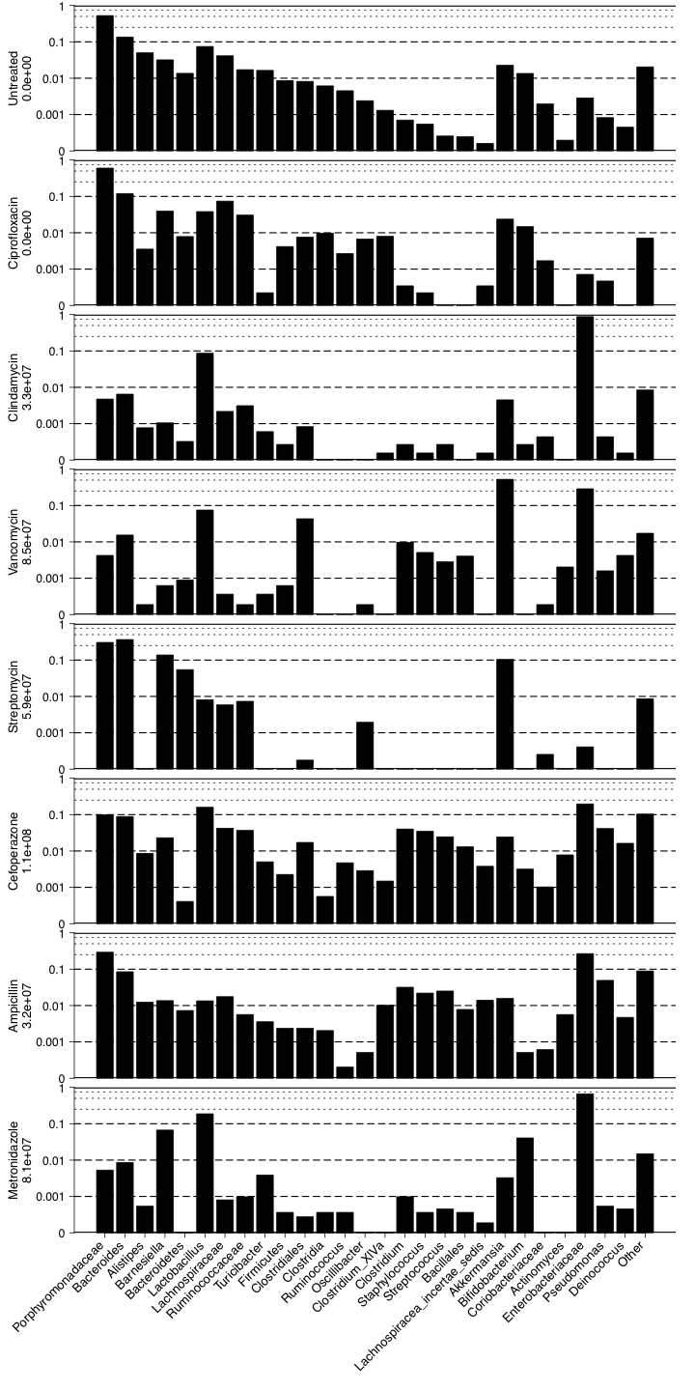

**Figure 1. Microbiome structures following diverse antibiotics.**

Currently is phylotype at the genera level (tx=1).

-Most significant correlations? RF using antibiotic categories for topdose data (family-level)? The 19 candidate OTUs?

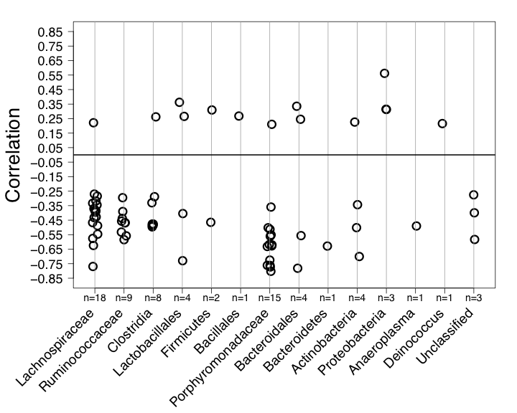

**Figure 2. Correlation analysis of bacterial species present on Day 0 with *C. difficile* levels on Day 1.** Species level OTUs (3% cutoff) found on Day 0 were correlated with the level of *C. difficile* CFU/g feces on Day 1 using Spearman’s rank based correlation coefficient. Only OTUs with an average abundance of at least 0.05% across all original treatments were considered in the correlation analysis. All correlations shown in this graph are significant (p<0.05). The lowest common classification among bacterial species was used to group bacteria as shown on the x-axis along with the number OTUs (n) belonging to that classification.

-also add possibly “with cdiff CFU day 1”on the y and maybe an x label that says “3% level otus on day 0”

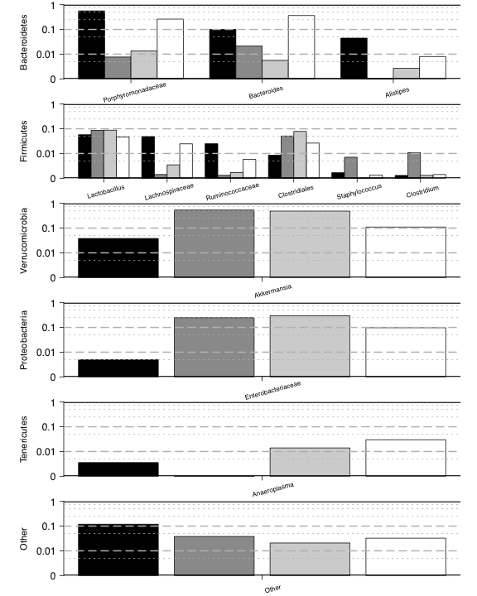

**Figure 3.** The vanc titration graph… need the other 2 titration groups… add section for the cdiff levels so don’t need another graph… fix lines somehow… ask about fixing the widths

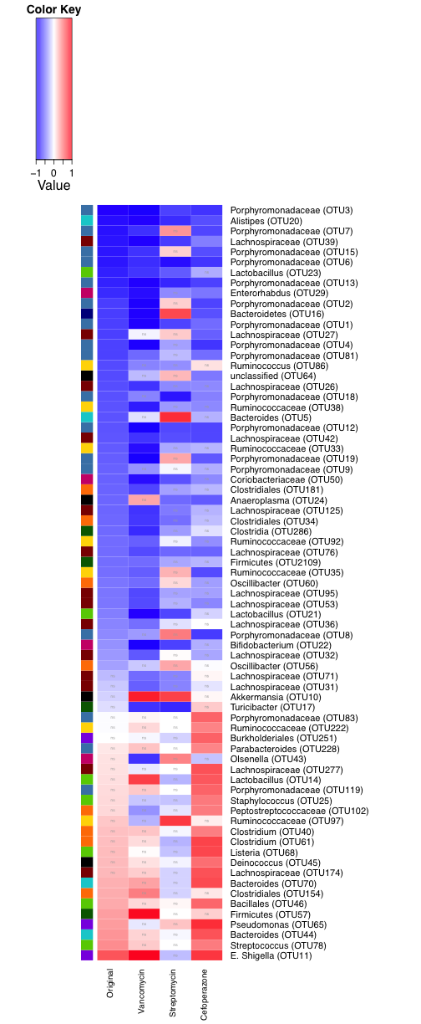

**Figure 4. Heatmap comparing correlation analysis between the original data set and titration data sets.**

**-** Also reorder this by classification and see what happens

**metro_d0s_tx2.pdf**

**Figure 5. Differences in day 0s for metronidazole.**

-colors

-selected taxa

[FIGURE]

**Figure 6. Model figure showing its performance**

**TABLES**

|  |  |  |  |  |  |
| --- | --- | --- | --- | --- | --- |
| **Antibiotic** | **Dose** | **Administration**  **(Route, Time)** | **Class** | **Mechanism** | **Primary Target** |
| Ciprofloxacin (n=5) | 10 mg/kg | Oral gavage, Day -1 | Fluoroquinolone | Inhibits DNA gyrase | Gram +/- |
| Clindamycin (n=11) | 10 mg/kg | IP injection, Day -1 | Lincosamide | Inhibits protein synthesis | Anaerobes |
| Vancomycin (n=6) | 0.625 mg/ml | Ad libitum in drinking water, Days -6 to -1 | Glycopeptide | Inhibits peptidoglycan synthesis | Gram + |
| Streptomycin (n=8) | 5.0 mg/ml | Ad libitum in drinking water, Days -6 to -1 | Aminoglycoside | Inhibits protein synthesis | Gram +/- |
| Cefoperazone (n=4) | 0.5 mg/ml | Ad libitum in drinking water, Days -6 to -1 | Cephalosporin | Inhibits peptidoglycan synthesis | Gram +/- |
| Ampicillin (n=6) | 0.5 mg/ml | Ad libitum in drinking water, Days -6 to -1 | Penicillin | Inhibits peptidoglycan synthesis | Gram +/- |
| Metronidazole (n=7) | 1.0 mg/ml | Ad libitum in drinking water, Days -6 to -1 | Nitromidazole | Incorporates into bacterial DNA, making unstable | Anaerobes |

**Table 1. Description of Antibiotics used in this study.** The number of animals per group (n) are shown for each treatment. Days of antibiotic administration are relative to the day of *C. difficile* challenge or Day 0.

**SUPPLEMENTARY INFORMATION**

[graph]

**Supplemental Figure 1.** correlation results of inv simpson. Inverse Simpson (**Supplemental Figure 1**) and observed a significant negative correlation with subsequent *C. difficile* colonization (both p<0.001).

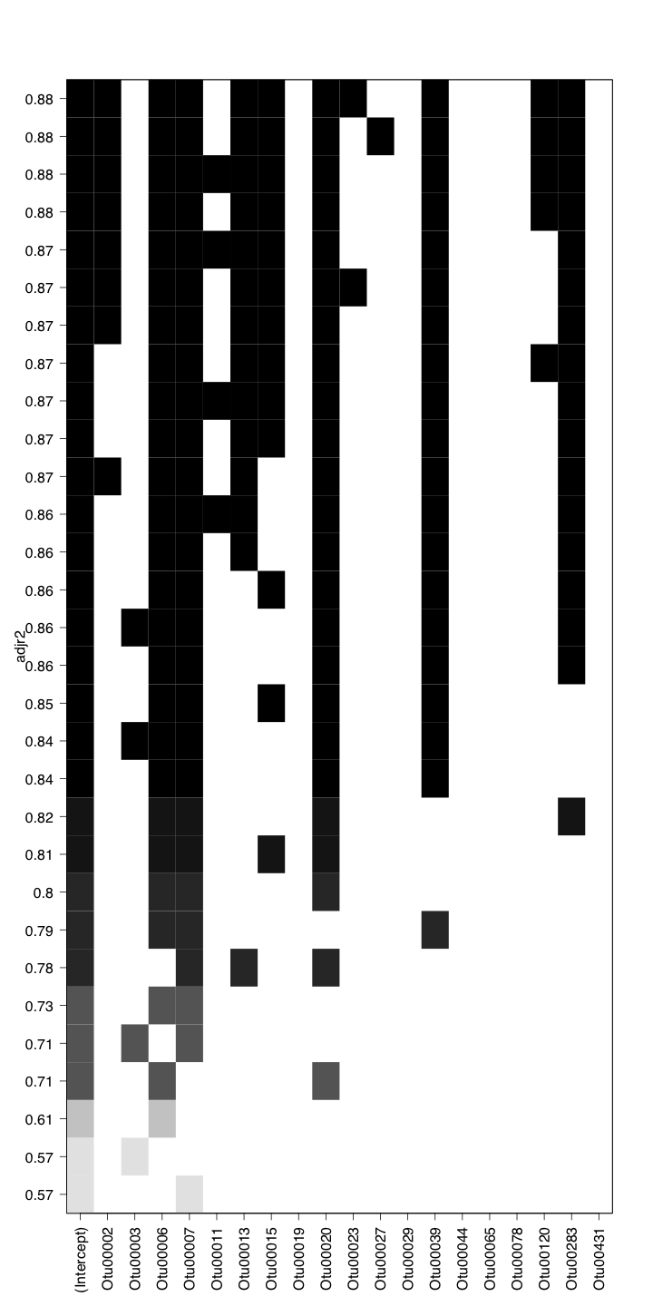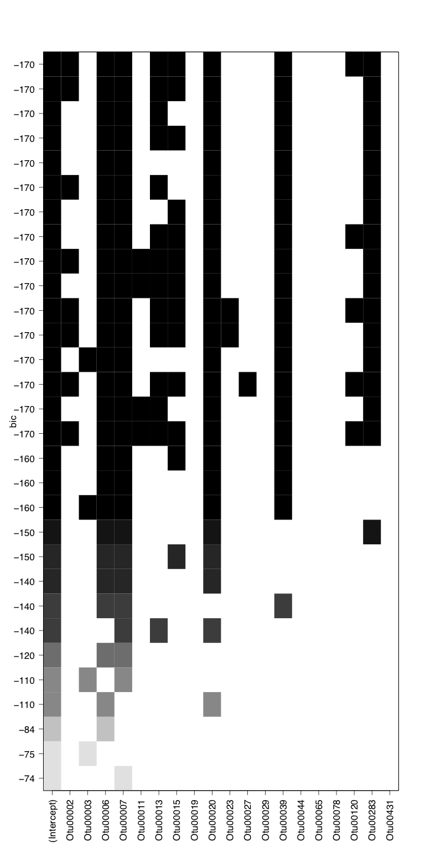

**Supplemental Figure 2.** Shows the adjusted R2 and the BIC values for models tested.

|  |  |  |  |  |
| --- | --- | --- | --- | --- |
| **Antibiotic** | **Administration**  **(Route, Time)** | **Original Dose** | **Titration Doses** | |
| Cefoperazone | Ad libitum in drinking water, Days -6 to -1 | 0.5 mg/ml (n=4) | 0.3 mg/ml (n=12) | 0.1 mg/ml (n=6) |
| Streptomycin | Ad libitum in drinking water, Days -6 to -1 | 5.0 mg/ml (n=8) | 0.5 mg/ml (n=9) | 0.1 mg/ml (n=10) |
| Vancomycin | Ad libitum in drinking water, Days -6 to -1 | 0.625 mg/ml (n=6) | 0.3 mg/ml (n=8) | 0.1 mg/ml (n=9) |

**Supplemental Table 1. Titration amounts for each antibiotic.** The number of animals per group (n) are shown for each antibiotic and dose. Days of antibiotic administration are relative to the day of *C. difficile* challenge or Day 0.

**[TABLE]**

**Supplemental Table 2. Description of the 19 candidate OTUs for consideration in the model.**