February 20, 2020

**DEPARTMENT OF MICROBIOLOGY AND IMMUNOLOGY**

1520A MEDICAL SCIENCE RESEARCH BUILDING I

ANN ARBOR, MICHIGAN 48109-0620

PHONE: (734) 763-3531

FAX: (734) 764-3562



Dear Dr. Newton,

We are happy to resubmit a resource announcement, ***Coding-complete RNA Virus Genomes Assembled from Murine Cecal Metatranscriptomes***, for your reconsideration. In this announcement, we report on the assembly, annotation, and phylogenetic placement of 6 RNA viruses that were identified within a previously published metatranscriptomic dataset from my research group (doi: 10.1128/mSystems.00063-17 and 10.1128/mSphere.00261-18). We have reviewed the appropriate checklists and are confident that we have satisfied the necessary criteria. We have also provided a point-by-point response to the two reviewers’ comments and a marked-up version of the manuscript.

We look forward to your feedback.

Sincerely,

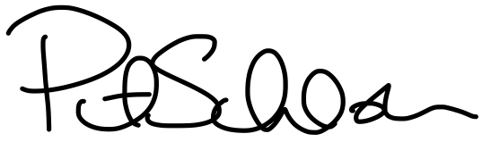

Patrick D. Schloss, PhD

Professor