August 14, 2017

**DEPARTMENT OF MICROBIOLOGY AND IMMUNOLOGY**

1520A MEDICAL SCIENCE RESEARCH BUILDING I

ANN ARBOR, MICHIGAN 48109-0620

PHONE: (734) 763-3531

FAX: (734) 764-3562



Dear Drs. Ravel and Wellington,

We are happy to resubmit our manuscript, “Normalization of the microbiota in patients after treatment for colonic lesions” for your consideration. As you will notice, we have changed the title to better focus the substance of the study. Previously, it was titled, “The effect of treatment on the microbiota of patients diagnosed with colonic lesions”. We have incorporated the feedback we received from the two reviewers and are hopeful that you will agree that the manuscript is significantly improved.

Should any questions arise during the review of our manuscript please do not hesitate to contact us. All authors have approved the manuscript for submission and we declare that we have no potential competing interests. Finally, a pre-print version of this manuscript has been posted on the bioRxiv preprint server; however, the manuscript has not been published, or submitted for publication elsewhere

Sincerely,

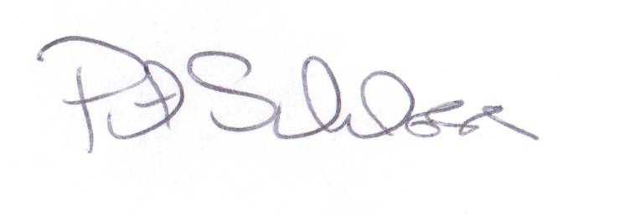

Patrick D. Schloss, PhD

Associate Professor