
June 22, 2026
DEPARTMENT OF MICROBIOLOGY AND IMMUNOLOGY
1520A MEDICAL SCIENCE RESEARCH BUILDING I
ANN ARBOR, MICHIGAN 48109-0620
PHONE: (734) 763-3531
FAX: (734) 764-3562

Dear Dr. Newton,

We are happy to submit our manuscript, strollur: An R package for working with amplicon sequence data in R, for your consideration at Microbiology Resource Announcements. The announcement describes a new R package that is available on CRAN. We think this will be an important contribution. We would be delighted to have it included in the special issue MRA is preparing for software tool announcements.

Sincerely,
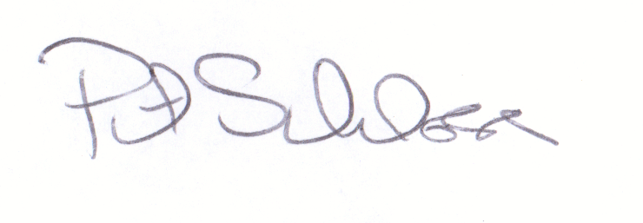
Patrick D. Schloss, PhD
Professor

