Analysis of the PlantGrowth Dataset
Paul Schmidt
2026-02-27

Introduction
This report analyzes the PlantGrowth dataset, which contains results from an experiment comparing plant yields under three different conditions: a control group (ctrl) and two treatment groups (trt1 and trt2). The goal is to determine whether there are notable differences in dried plant weight between the groups.

Data Overview
The dataset contains 30 observations across three groups with 10 plants each.

Summary statistics by treatment group.
Group | Mean | SD | n
ctrl | 5.03 | 0.58 | 10
trt1 | 4.66 | 0.79 | 10
trt2 | 5.53 | 0.44 | 10

Visualization

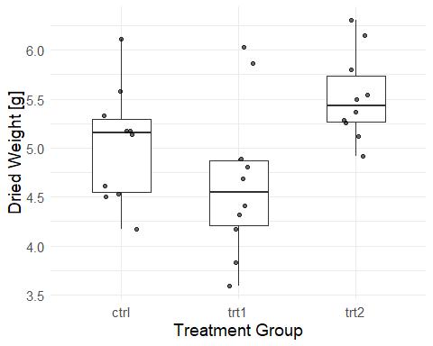
Figure 1: Distribution of dried plant weight by treatment group.

Conclusion
The descriptive statistics and boxplot suggest that treatment group trt2 tends to produce slightly higher dried plant weights compared to trt1 and the control. However, the groups overlap considerably, and a formal statistical test would be needed to confirm these observations.

