Analysis of the PlantGrowth Dataset
Paul Schmidt
2026-02-14

Introduction
This report analzes the PlantGrowth dataset, which contains results from an experiment comparing plant yields under three different conditions: a control group (ctrl) and two treatment groups (trt1 and trt2). The goal is to determin whether there are statistically significant differences in dried plant weight between the groups.

Data Overview
The dataset contains 30 observations across three groups with 10 plants each.
data(PlantGrowth)
group_summary <- aggregate(
weight ~ group,
data = PlantGrowth,
FUN = function(x) c(mean = mean(x), sd = sd(x), n = length(x))
)
summary_df <- data.frame(
Group = group_summary$group,
Mean = round(group_summary$weight[, "mean"], 2),
SD = round(group_summary$weight[, "sd"], 2),
n = group_summary$weight[, "n"]
)
knitr::kable(summary_df, caption = "Summary statistics by treatment group.")
Summary statistics by treatment group.
Group | Mean | SD | n
ctrl | 5.03 | 0.58 | 10
trt1 | 4.66 | 0.79 | 10
trt2 | 5.53 | 0.44 | 10

Visualization
library(ggplot2)
ggplot(PlantGrowth, aes(x = group, y = weight)) +
geom_boxplot(width = 0.5, outlier.shape = NA) +
geom_jitter(width = 0.15, alpha = 0.6) +
labs(
x = "Treatment Group",
y = "Dried Weight [g]"
) +
theme_minimal()
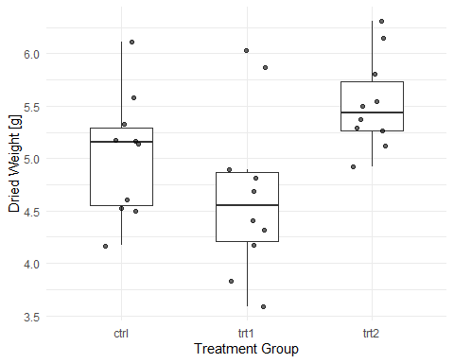
Figure 1: Distribution of dried plant weight by treatment group.

Statistical Analysis
We use a one-way ANOVA to test whether the group means differ significantly, followed by Tukey’s HSD test for pairwise comparisons.
model <- aov(weight ~ group, data = PlantGrowth)
summary(model)
Df Sum Sq Mean Sq F value Pr(>F)
group 2 3.766 1.8832 4.846 0.0159 *
Residuals 27 10.492 0.3886
---
Signif. codes: 0 '***' 0.001 '**' 0.01 '*' 0.05 '.' 0.1 ' ' 1
TukeyHSD(model)
Tukey multiple comparisons of means
95% family-wise confidence level
Fit: aov(formula = weight ~ group, data = PlantGrowth)
$group
diff lwr upr p adj
trt1-ctrl -0.371 -1.0622161 0.3202161 0.3908711
trt2-ctrl 0.494 -0.1972161 1.1852161 0.1979960
trt2-trt1 0.865 0.1737839 1.5562161 0.0120064

Conclusion
The ANOVA indicates a marginally significant effect of treatment group on plant weight. Tukey’s HSD test reveals that the difference between trt2 and trt1 is statistically significant, while neither treatment group differs significantly from the control.

