Lab 4

By: Tyler Schmidt



1. **Introduction**

In this lab we were tasked with creating an android app that would implement a database, sensor and API. These have all been taught to us over the past few weeks in the course. Hopefully at the end of this lab you will know how android studio features work and feel you have learned something.

1. **Approach**

The approach that I took for my assignment involved using firebase as a database that would store peoples username and password. This database would allow a user to then log into the app which would open the camera up automatically. I designed my app to be similar to snapchat and try to compete with it but with a more open interface. As stated above I used the camera sensor for part II of this assignment. For the API I used a google log in. I wanted to do this because I found that when I use snapchat it would be nice if it had an option to send a photo other than having to use the app. Such as if you had a photo that you really liked and wanted someone who didn’t own the app to see it you could then send it by email to them. By allowing you to sign in with google it also gives a permission to send an email. Although due to time constraints I was unable to add this piece of code into the project.

1. **Workflow**

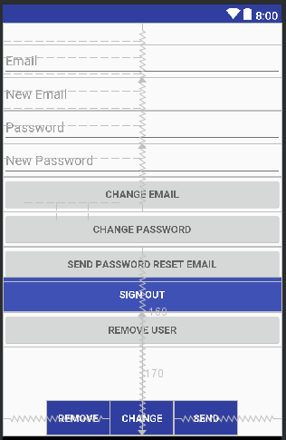

I first started off by creating a firebase dataset. By doing this I had to go to firebase and create a dataset then link it to my android app. After creating the database I then created multiple activities. The first one called MainActivity held everything inside of that needed to be referenced (such as name, email, creating of new account ect.) Then I created my loginActivity this had only referenced the email and password it also has the button that would be need inside of the layout activity. After that I created a signup activity that would ask you for your email and password. Then I created an activity that would allow you to reset your password which would then send the user an email to reset the password that is in the firebase database.

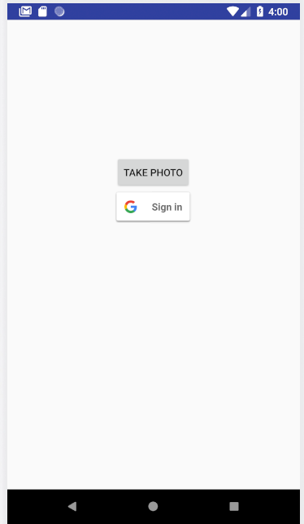

If the user didn’t want to create an account, then they could just use their google email and log in that way. This was created by going to google and creating a database and linking it to the app. Once the user is logged into the app the camera will open and allow for a photo to be taken. Although in my code that I have produced the firebase application does not work and will freeze my computer if running. I did go around this and make another app that has google API and camera sensor in it to show that those two are working.

1. **Evaluation and Discussion**

Overall this assignment did seem to not work in my favor as my computer froze many times and my firebase for some reason wouldn’t work properly. I do believe that if given more time and asking a few questions I could get this app to work

1. **Conclusion**

In conclusion this app had been modified to work partially due to time constraints.