Spending Stats

Tyler Schmidt

University of Missouri – Kansas City

Table of Contents
Vision Statement 3
Requirements 4
Product Backlog 5
Sprint #1 6
Review 6
Retrospective 6
Sprint #2 7
Review 7
Retrospective 7
Sprint #3 8
Review 8
Retrospective 8
Sprint #4 9
Review 9
Retrospective 9
Sprint #5 10
Review 10
Retrospective 10
Sprint #6 11
Review 11
Retrospective 11

Vision Statement
The vision for my app is for it to help individuals keep an eye on what they are spending monthly. It will allow a user to input an item, the price of the item and the category that he item is in. When this is put into the app it will save the data for that user and then display in in a chart showing where the money is being spent and what percentage is being spent. The app will also have a feature for inputting your monthly income and adding if you are wanting to create a saving and what it will leave for you to spend monthly. This app will be useful to someone who is trying to have better money management and figure out where their money is going. Future goals for this app would include the user to be to set alarms for when items need to be paid and are not set to automatically come out of your bank account. It will also track to see if there is a pattern and give an option for putting that into future money planning. At immediate release it will be a basic app that will record the data and show where money is being spent.

Requirements
A discussion of what your application is required to have in functionality. It should identify user roles and goals/actions, and what the key features of the app should be.
Actor | Goal
System | Store login information
User | Input place money is being spent.
User | Input amount of money.
User | Input category.
System | Store money data
System | Create a chart with data
User | Reset all info
User | Change layout of app
User | Set up alerts.
System | Store alerts then send them to user.
System | Find a pattern in data and suggest automatic monthly deductions
User | Input monthly income.

Product Backlog
This will be updated throughout the semester as new PBIs are added, larger items are broken into smaller ones, and completed items removed.

Story ID | Story | Story Points  (in est. hours) | Priority | Status
1 | Create in phone storage that will store user’s information. | 4hrs | High | Incomplete
2 | Create in phone storage that will store users money management and set category. | 5hrs | High | Incomplete
3 | Create a chart that will show where money is being spent. | 1hr | High | Incomplete
4 | Create layout of app | 2hr | High | Complete
5 | UI | 1hr | High | Incomplete

Sprint #1

Sprint Backlog
Story ID | Story / Task | Estimated  Hours | Actual  Hours
4 | Create layout | 2 | 1:30

Review

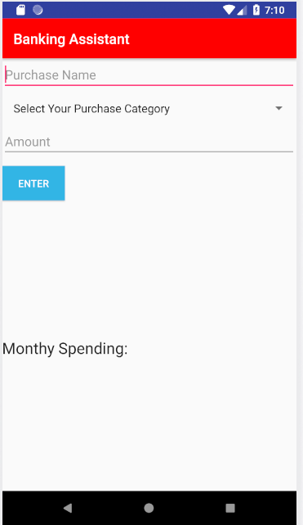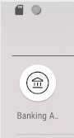
In this sprint I ran into a hiccup with android studio gradle not working properly and having to debug that for me to be able to actual start coding this process took around 3-4hr of looking online and finally finding the resolution. I ended up making a few changes to the project as well. After reviewing what the apps main purpose was and talking with a few peers of mine I decided that a database storage was not necassry for this app since it doesn’t need to be transferable on devices. Since the main purpose of this app is just to help money management it can be using phone storage only. With that being said I took off database creation from the backlog and activites and changed it with the persistent storage. This sprint I had hoped to get all the persistent storage and layout done but was unable to due to android studio not working. I did however get the layout finished and for the next sprint will just have to get the storage done then add some features in the app as well such as notes, suggestions and just make the app more user friendly all together. Nothing on this app is shippable yet that will be next sprint.

Retrospective
This sprint the overall building and design of the app went well and I am looking forward to hopefully being able to continue that past for the next sprint. I think looking online for help and watching some youtube videos led me in the right direction and hopefully can help later on as well. I can say that androids gradle not working did slow me down significantly and now that it is fixed it shouldn’t be an issue in the next sprint. I plan on giving more time to the next sprint so that if an issue does happen it wont set me back like it did this sprint.

Sprint #2

Sprint Backlog
Story ID | Story / Task | Estimated  Hours | Actual  Hours
1 | Create persistent Storage for User Info | 4 | 5

Review
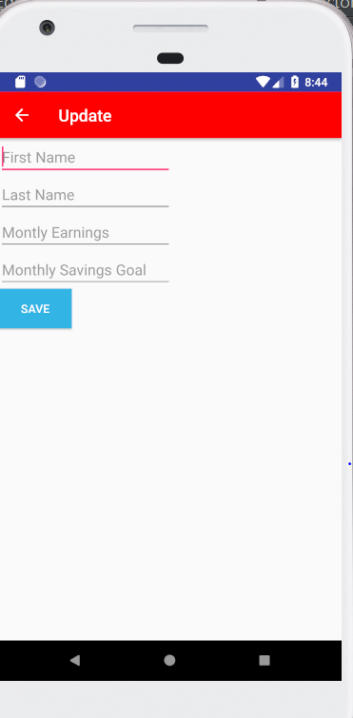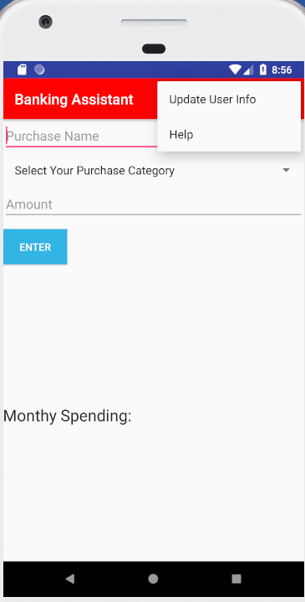
During this sprint I was able to get the backlog I had planned out for the week done such as creating an user info storage I was also able to start and get a better idea of how the layout of the app will end up being throughout the rest of the project. Overall this sprint took longer than anticipated due a few issues with getting android studio to work and having a few errors in getting my drop-down menu to work which is where the update is. At this point the product is not shippable yet but I am confident in it being able to be shippable after the next sprint. The change I made on this sprint was that instead of the app starting up with a login or asking any information about the user it goes straight to the interface with a drop-down that will let you enter in your information along with a help page. The drop down will be getting more things added to it over the course of development such as settings and it may be were the reset info goes as well.

Retrospective
This sprint many things went well comparted to first one. No gradle issues made coding much easier and for me to get more work done. I do think that I was able to put good time to this project and it doesn’t just show on the code as I was having to think about a lot of things before being able to put it in code. I do think how ever I could be getting more details in the app to make it look nicer and that is one thing I would like to start adding at each sprint so that it can be shippable at any moment. As I just said the change that I will be making next sprint is making sure the app is shippable at the next sprint which would include the looks and functionality of the app and no this would not mean the app is done but it could be used.

Sprint #3

Sprint Backlog
Story ID | Story / Task | Estimated  Hours | Actual  Hours
2 | Creating money storage | 5 | 12

Review
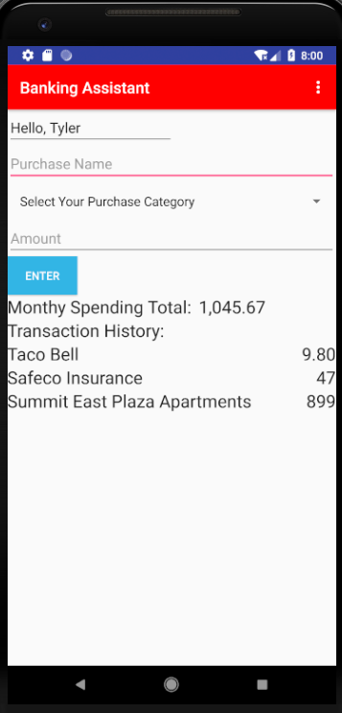
In this sprint I had completed the money storage system that will track what people had entered into the spent category. It is saved using sharedPrefrences. I am showing the 3 most recent transactions and the total spent for the month. I used a function to do the math for creating the total spent for month then called it into my textview. I also added at the top the name of the user for the app to feel more personalized. This product is now shippable as it can be used for its purpose. But there will be many updates to the product as it is released, and a lot is still not done.

Retrospective
I ran into many issues this sprint the first was a silly one that I didn’t understand since I am new to android studio and it was because I didn’t open the project from “app” but just from its name so it wouldn’t let me view any files or edit anything this was frustrating and took a while to resolve. The second issue was my emulator stopped working and said something was wrong with the file and I needed to delete some stuff so I did that, but it then wouldn’t let me open the emulator at making me have get a new one. As far as what went well for this sprint I was still able to accomplish the goal and the app is coming along well. I would like to add more detail in the app it functions properly but still doesn’t really grab anyone’s eyes so I am going to start adding some looks to it. The next sprint I would like to create a pie chart on the spending for that month.

Sprint #4

Sprint Backlog
Story ID | Story / Task | Estimated  Hours | Actual  Hours
5 | UI | 1 | 4

Review
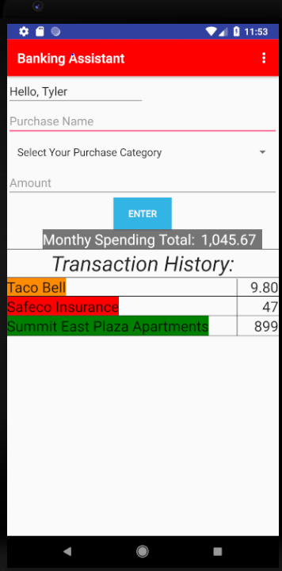
In this sprint I worked on the UI and it took awhile to decide what to and I tested many options for the app such as a rounded corner for the transaction history but that did not look good and it made it cut off jus a little of the text. I was planning on creating the pie chart for the app but instead did this that way when the pie chart is created you will know what each piece is to such as food, rent, or other monthly payments you have and the category you select to put it in. The product is still shippable at this point as well. I was unable to do the pie chart as I did not have time to finish it and I spent too much time trying to get my app design better.

Retrospective
The overall layout I am happy with I would like there to possibly be more to the app such as maybe graphics next to each transaction and that graphic would show up on the graph. I did have issues as well designing the app because I didn’t know really how to do it and tried many different things. I do want to add the pie chart next sprint and maybe try to add more UI to the app. This design may be the 1.0 and I will update as app goes on but wanted to keep app shippable so didn’t do too much that would cause it to not be shippable anymore.

Sprint #5

Sprint Backlog
Story ID | Story / Task | Estimated  Hours | Actual  Hours
3 | Pie Chart | 1 | 7

Review
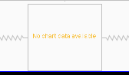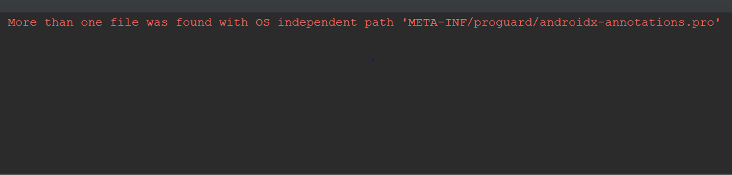
In this sprint I added a piechart to do this I used the github repository MPAndroidchart and was able to then link all the variables to the chart. The plan for this sprint was to create this pie chart and I was able to successfully do that. The next sprint I will spend doing some more UI as I am still not too pleased with it

Retrospective
What went well this sprint was adding the pie chart and the repository needed to do that. I would like to mess around more with the pie chart and see if there are any designs that I can change it to once I am able to see it. What didn’t go well this sprint was me being unable to run the code due to an error. I have spent around 4-5 hours trying to fix the error and changing many things around. I am hoping to be able to talk to the professor after break and see if I can find the error in the code or what I need to do. The error I got was “More than one file was found with OS independent path 'META-INF/proguard/androidx-annotations.pro'. I would like to fix this error next sprint and complete UI.

Sprint #6

Sprint Backlog
Story ID | Story / Task | Estimated  Hours | Actual  Hours
3 | Piechart | 1
5 | UI | 3

Review

[Screenshots, etc go here. This is where you discuss the product, describing what was done this sprint (potentially shippable product increment) and what was planned for the sprint but was not done. ]

Retrospective
[This is where you discuss the process. What went well (and are you planning to do more of that?) What didn’t go so well (and do you have a way to do less of that)? What changes are you planning to make in how you plan & carry out the next sprint?]

