TextVenturer

Use-Case Specification: Combine

Version <1.0>

Revision History

|  |  |  |  |
| --- | --- | --- | --- |
| **Date** | **Version** | **Description** | **Author** |
| <01/NOV/16> | <1.0> | First upload | André Schmitt, Dominik Vogel |
|  |  |  |  |
|  |  |  |  |
|  |  |  |  |

Table of Contents

1. Use-Case Name 4

1.1 Brief Description 4

2. Flow of Events 4

2.1 Basic Flow 4

3. Special Requirements 4

4. Preconditions 4

5. Postconditions 4

6. Extension Points 4

# Use-Case Name

## Brief Description

This is our UC Diagram which starts if you type in “combine $itemA with $itemB”

# Flow of Events

## Basic Flow



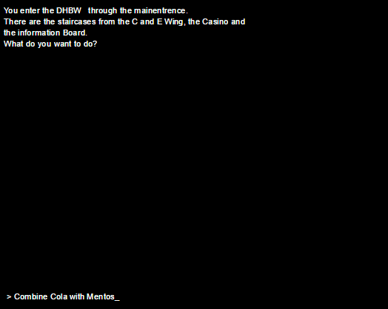

# Special Requirements

n/a

# Preconditions

n/a

# Postconditions

Show name of new Item

# Extension Points

n/a