

Bachelor Thesis

**Empirical studies on Forward   
Looking Analyses of Trading Systems** Manuel Sonnleithner

Date of Birth: 09.08.1994  
Student ID: 1451386

**Subject Area:** Algorithmic Trading  
**Studienkennzahl:** 1634  
**Supervisor:** Dipl.-Ing.Mag.rer.soc.oec. Riccardo Gismondi  
 em.o.Univ.Prof. Dkfm.Dr.rer.comm. Wolfgang Janko  
**Date of Submission:** tba

*Department of Information Systems and Operations, Vienna University of Economics and Business, Welthandelsplatz 1, 1020 Vienna, Austria*



Contents

1 Introduction 4

1.1 Research problem 4

1.2 Research question 4

1.3 Research method 5

2 Trading System 6

2.1 Technical Chart Analysis 6

2.2 The SuperTrend Indicator 6

2.3 Trading Strategy 7

3 Forward Looking Analysis 8

3.1 Introduction 8

3.2 Advantages 8

3.3 Disadvantages 8

4 Software / Research Tools 9

4.1 MatLab 9

5 Working Plan 10

6 Literature 11

**Abstract**

To be continued

1. Introduction
   1. Research problem

The Forward Looking Analysis (FLA, page 8, 3.1) is seen as the most valid evaluation process of the future performance and risk of a trading strategy. Although its results are the statistical most relevant data you can get for your strategy, the strategist has to make some assumptions and settings for the FLA, which can have enormous (distorting) effects on the results.

Even if you test your strategy using FLA very carefully and correctly, it can happen, that after many successful years of trading with this strategy and continuously re-optimizing and analyzing using FLA, the real-time performance suddenly starts to diverge from the predicted results of the FLA. The market conditions did not change certifiably and also no other causes can be easily determined, why this diverge occurs.   
The critical part is the initial setting of the window-lengths, as this parameter defines how often a strategy is re-optimized. What is more, this setting influences, if the optimization process contains all different market conditions, what is vital for correct optimization. We will discuss this later in much more detail.

Seeing the length of the in-sample and out-of-sample time-segments as the one major setting responsible for continuously valid FLAs, it is worth to investigate, if the prediction-power of a FLA can be optimized by optimizing the window-lengths and therefore situations - like the above described sudden stop of valid FLA results – can be minimized as much as possible.

* 1. Research question

As already mentioned, one of the most critical input parameters of a FLA is the size of the window-lengths of the in-sample and out-of-sample time periods. Past work is seeing the optimal window-lengths as a static function of available data, style of trading strategy, pace of trading strategy, relevancy of data and shelf-life of the trading strategy’s parameters (Pardo, 2008).

All past work focused on static window length, but as market conditions are changing continuously, it would make sense to look at the window-lengths as dynamic values.

The major aim in this thesis is to investigate, if there can be found any patterns for the relation between the in-sample and out-of-sample window-lengths and thus be able to develop a dynamic model for the window-lengths calculation, which improves the prediction power of any FLA.

* Which input parameters should affect the dynamic window lengths?
* Can the prediction power of a FLA be optimized by using dynamic window lengths?
  1. Research method

To be able to analyze and research the mentioned questions, a trading strategy will be developed, as well as an automated FLA-process using MatLab (page 9, 4.1).

Afterwards a real-world case-study will be examined, in which the research problem has been observed while using the developed SuperTrend - trading strategy (page 7, 2.3) in the Forex (Foreign Exchange) markets.

The first optimization-attempt will be implemented with static window-lengths, where the goal is to find valid patterns on the ratio of the window-lengths which could have avoided the plunge of the prediction power of the FLA.

If there can be found any reasonable ratios they will further be tested on various markets to be able to evaluate, if the discovered static ratios are representing a valid model.

The second optimization-attempt will go one step further by trying to develop a dynamic model which determines new window-lengths on each round of the FLA-calculation process. Which parameters finally control the dynamic model as well as if also the length and the ratio between the lengths should be part of the dynamic adjustment-procedure needs to be accurately investigated.

Again, any newly discovered ratios and models will be tested on multiple markets and asset classes to be able to prevent any wrong assumptions.

1. Trading System
   1. Technical Chart Analysis

Technical chart analysis tries to compute relevant information of future price development, where the main input for those calculations is the price-data of a financial instrument.   
The used strategy for all further empirical studies is based on the so called SuperTrend indicator.

* 1. The SuperTrend Indicator

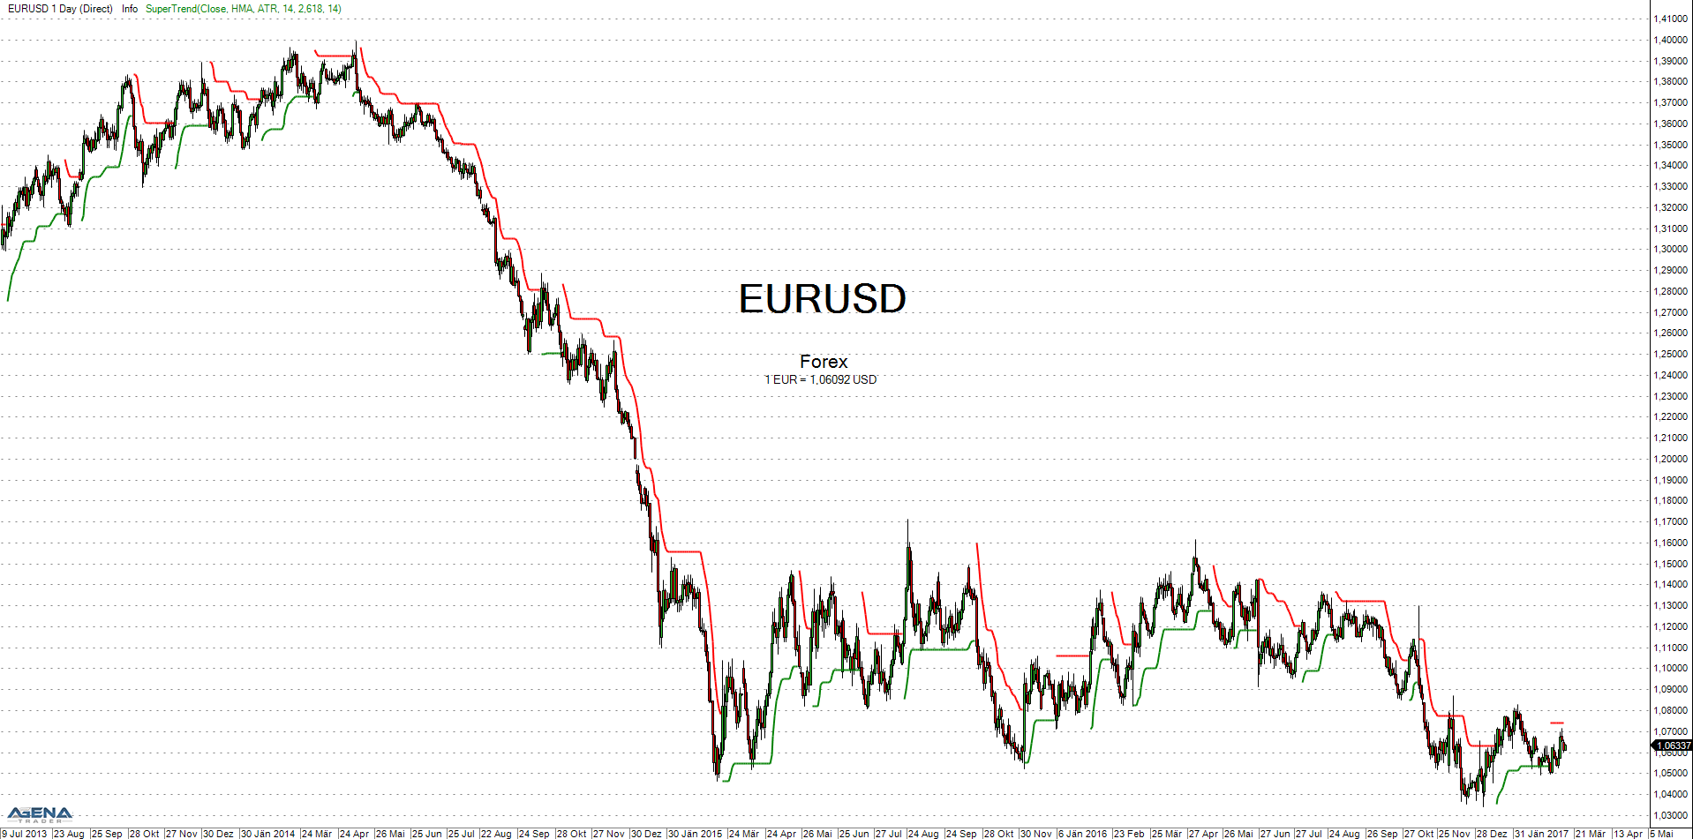The SuperTrend indicator belongs to the family of trend-following indicators for technical chart analyses. The basic idea of trend-following indicators is that prices tend to continue an up move of one period also in the next period. However, there will be reversals within larger trends, and the key to successful trend following is to discover when a trend starts and ends, and not be taken in too often by false signals (James, 2003).   
Initially the SuperTrend was first published on the MQL4 codebase (Robinson, 2008) and described in more detail by Kolier Li (Kolier, 2010). The indicator includes an upper and lower border which are calculated by the Average True Range (ATR) added/subtracted to/from the current instrument’s price. The ATR is a measure of volatility introduced by Welles Wilder (Wilder, 1978) by computing an (exponential) moving average of the true range. Basically, the SuperTrend gives a signal if sudden price movements exceed the expected market movements (Schmidt, 2011).

Figure 1 - SuperTrend indicator, Parameters: Input=Close, Average=HMA, Method=ATR, ATR-period=14, Multiplier=2.618, Smooth-period=14, Source: AgenaTrader

* 1. Trading Strategy

A long trade will be entered whenever the SuperTrend indicates a change from a short trend to a long trend. This happens when the price of a financial instrument crosses above the SuperTrend’s upper border (red line). Additionally, the SuperTrend will shift from short- to long-mode until the price of the instrument again crosses below the SuperTrend’s lower border (green line). Further, this occurrence evokes the close of the long trade and as well the open of a new short position.

Summary of entry conditions:

* Enter Long: Price crosses above the SuperTrend’s upper border (red)
* Enter Short: Price crosses below the SuperTrend’s lower border (green)

Summary of exit conditions:

* Exit Long: Price crosses below the SuperTrend’s lower border (green)
* Exit Short: Price crosses above the SuperTrend’s upper border (red)

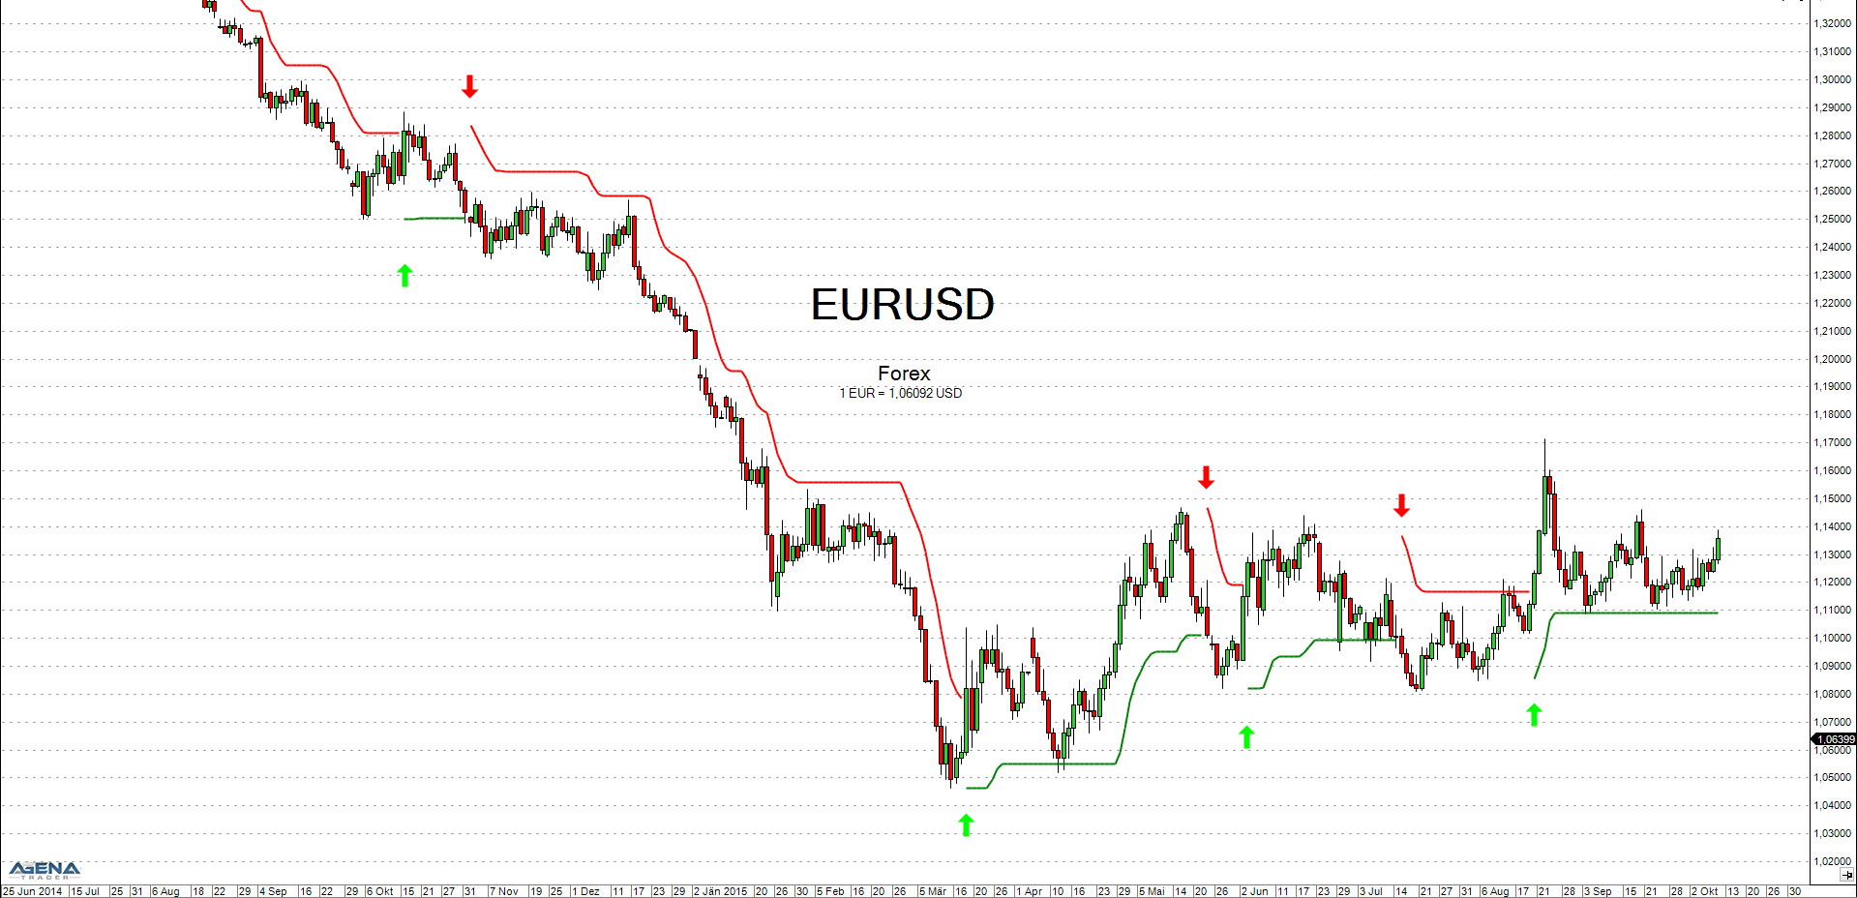

Figure 2 - SuperTrend strategy, Parameters: Input=Close, Average=HMA, Method=ATR, ATR-period=14, Multiplier=2.618, Smooth-period=14, Source: AgenaTrader

1. Forward Looking Analysis
   1. Introduction

A Forward Looking Analysis (FLA) is a technique in which the parameter values on a past segment of market data are optimized (in-sample data optimization) and subsequently verified by testing forward in time on data following the optimization segment (out-of-sample data testing).  
This process is then repeated many times over successive time segments. As a result of each singe round of the analysis an equity curve for the performance of the out-of-sample time segment is created. The final outcome of a FLA is an equity-curve compounded of each single equity curve, which are stuck together continuously.

Ultimately this FLA equity-curve tries to answer the following question:

* “Dows the trading strategy have life after optimization?”
* “Is it a real and robust trading strategy or a curve-fit delusion?”
* “Will it make money in real-time?” (Pardo, 2008)
  1. Advantages

A Forward Looking Analysis evaluates the performance of a trading strategy solely on basis of post-optimized out-of-sample trading. This means that the out-of-sample data was never part of the optimization process and can be therefore seen as a much more valid base for judgments on the performance-metrics of any trading strategy compared to simple historical backtesting. Thus, this unique approach can be seen as the major strength and critical advantage of a Forward Looking Analysis over any other strategy-analyzing method.

* 1. Disadvantages

One possible disadvantage one can mention regarding FLA is that it is still not a perfect backtesting method, because of many input parameters a strategist still have to set before running a FLA (strategy, window-length, borders for parameter-optimization, market, timeframe).   
But to be fair, those limitations also are true for any other backtesting method, so this argument cannot really be seen as a disadvantage characteristic to FLA.

1. Software / Research Tools
   1. MatLab

MatLab is a high-level language and interactive environment for algorithm development, data visualization, data analysis, and numeric computation. (Mathworks Matlab, 2017). Due to its outstanding speed of data processing Matlab is heavily used of in the professional algorithmic trading world. Mathworks additionally offering Toolboxes (Mathworks Trading Toolbox, 2017) especially designed to optimize the process of developing trading strategies and models to analyze financial markets.   
For those reasons, all coding and computing tasks in this thesis are realized and performed in MatLab.

1. Working Plan

|  |  |  |  |
| --- | --- | --- | --- |
| Nr. | Task | Duration | Deadline |
| (1) | Develop SuperTrend indicator in MatLab | 1 | 02.04.2017 |
| (2) | Develop SuperTrend trading- strategy in MatLab | 1 | 10.04.2017 |
| (3) | Automatize Forward Looking Analysis for variable window-lengths with MatLab | 10 | 30.04.2017 |
| (3.1) | Develop historic backtesting for in-sample testing in MatLab | 5 | 23.04.2017 |
| (3.2) | Develop automatic trading-strategy optimization for in-sample optimization | 5 | 30.04.2017 |
| (4) | Research with static window lengths | 15 | 01.06.2017 |
| (6) | Research with variable window lengths | 15 | 26.06.2017 |
| (7) | Conclusion of possible optimizations of the window-lengths | 5 | 09.07.2017 |
| (8) | Composition of reports | 15 | August 2017 |
| (9) | Buffer | 1 month | x |
| (10) | Final release | x | Autumn 2017 |

Table 1 - Working plan

1. Literature

* Carr, M. (2016, September 27). *Investopedia*. Retrieved from Measure Volatility With Average True Range: http://www.investopedia.com/articles/trading/08/average-true-range.asp
* James, D. J. (2003). *Trend Models: can simple trend strategies work long term?* London: Citigroup - CitiFX Risk Advisory Group. Von http://www-stat.wharton.upenn.edu/~steele/Courses/434/434Context/Momentum/TrendFollowing/citigrouptrendfollowing.pdf abgerufen
* Kolier, L. (2010). *How Super Trend works.* Retrieved from http://kolier.li/indicator/how-supertrend-mq4-works-logic-of-supertrend-indicator-created-by-jason-robinson-jnrtradin
* *Mathworks Matlab*. (2017). Retrieved from https://de.mathworks.com/products/matlab.html?s_tid=hp_products_matlab abgerufen
* *Mathworks Trading Toolbox*. (2017). Retrieved from https://de.mathworks.com/products/trading.html
* Pardo, R. (2008). *The Evaluation and Optimization of Trading Strategies.* Hoboken, New Jersey: John Wiley & Sons Inc.
* Robinson, J. (2008). *Super Trend Source Code.* Codebase MQL4. Retrieved from https://www.mql5.com/en/code/7816
* Schmidt, S. O. (2011). *Evaluation of Super-Trend indicator's parameters for major FOREX pairs over 12 years.* Munich: VTAD. Retrieved from http://www.vtad.de/sites/files/forschung/Schmidt_2011_Evaluation_of_params_supertrend_daily_VTAD.pdf
* Wilder, W. J. (1978). *New Concepts in Technical Trading Systems.* Trend Research.

List of Tables

Table 1 - Working plan 10

List of Figures

Figure 1 - SuperTrend indicator, Source: AgenaTrader 6

Figure 2 - SuperTrend strategy, Source: AgenaTrader 7