Poco — Preserve Originals, Conceal Only  Privacy-first PII anonymisation for LLM workflows, with a fully automated multi-environment DevOps pipeline | SWE40006 Software Deployment and Evolution  Group CL01_G01 | Tutorial: Wednesday 10:30  Jamie Soo (104559690) · Timothy Schabel (105334128) · Sahil (105295665)

The Problem  Every day, people paste contracts, medical notes, and CVs into ChatGPT. Once they do, names, addresses, and financial details are outside their control. Poco makes that safe.  How Poco Works  Poco detects personal information, replaces each value with a reversible token like [PERSON_1] or [EMAIL_1], and stores the mapping in an encrypted session vault. The redacted text is sent to any LLM, and the response is restored to its original form when it returns.  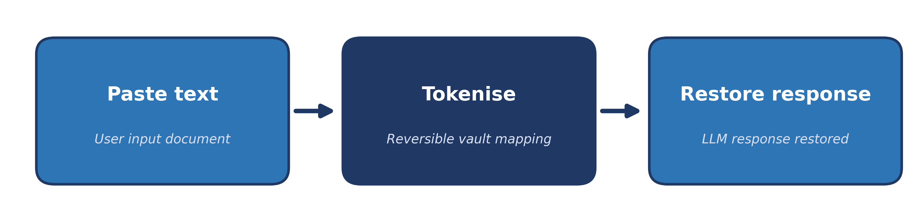  Architecture  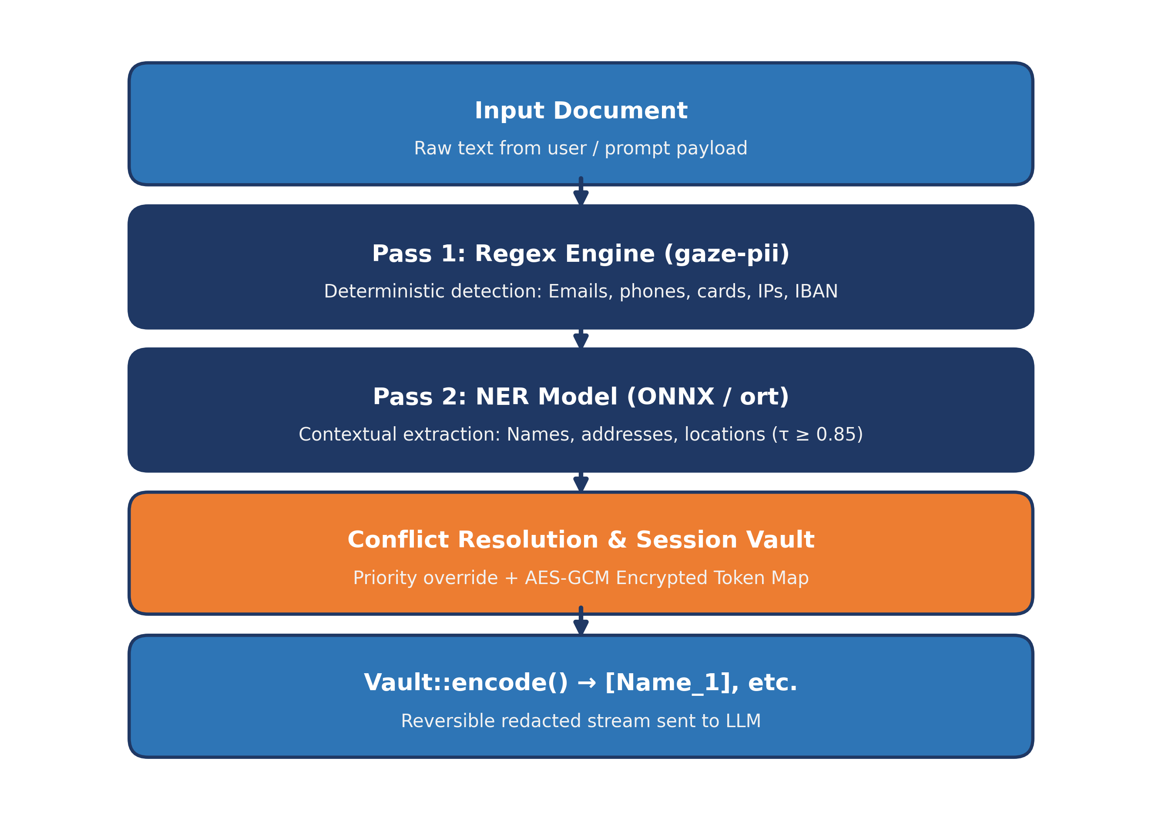  Figure 1. Two-pass hybrid PII detection engine.  DevOps Pipeline  Every code change flows through GitHub Actions, which builds the Rust backend inside the Cargo Lambda container, runs unit, integration, and browser acceptance tests, and deploys to four isolated AWS environments (Development, Testing, Staging, Production). Failed tests block promotion.  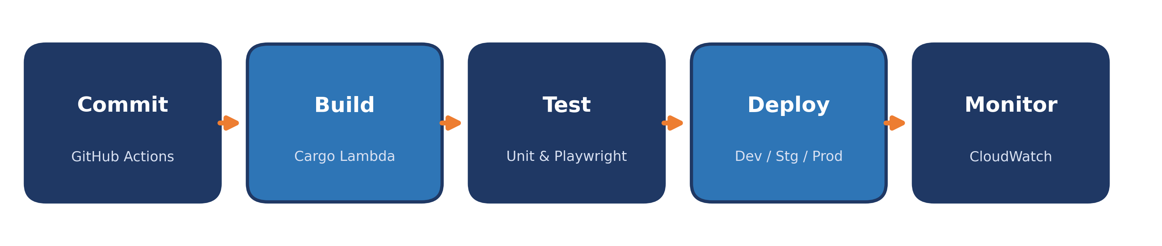  Demo  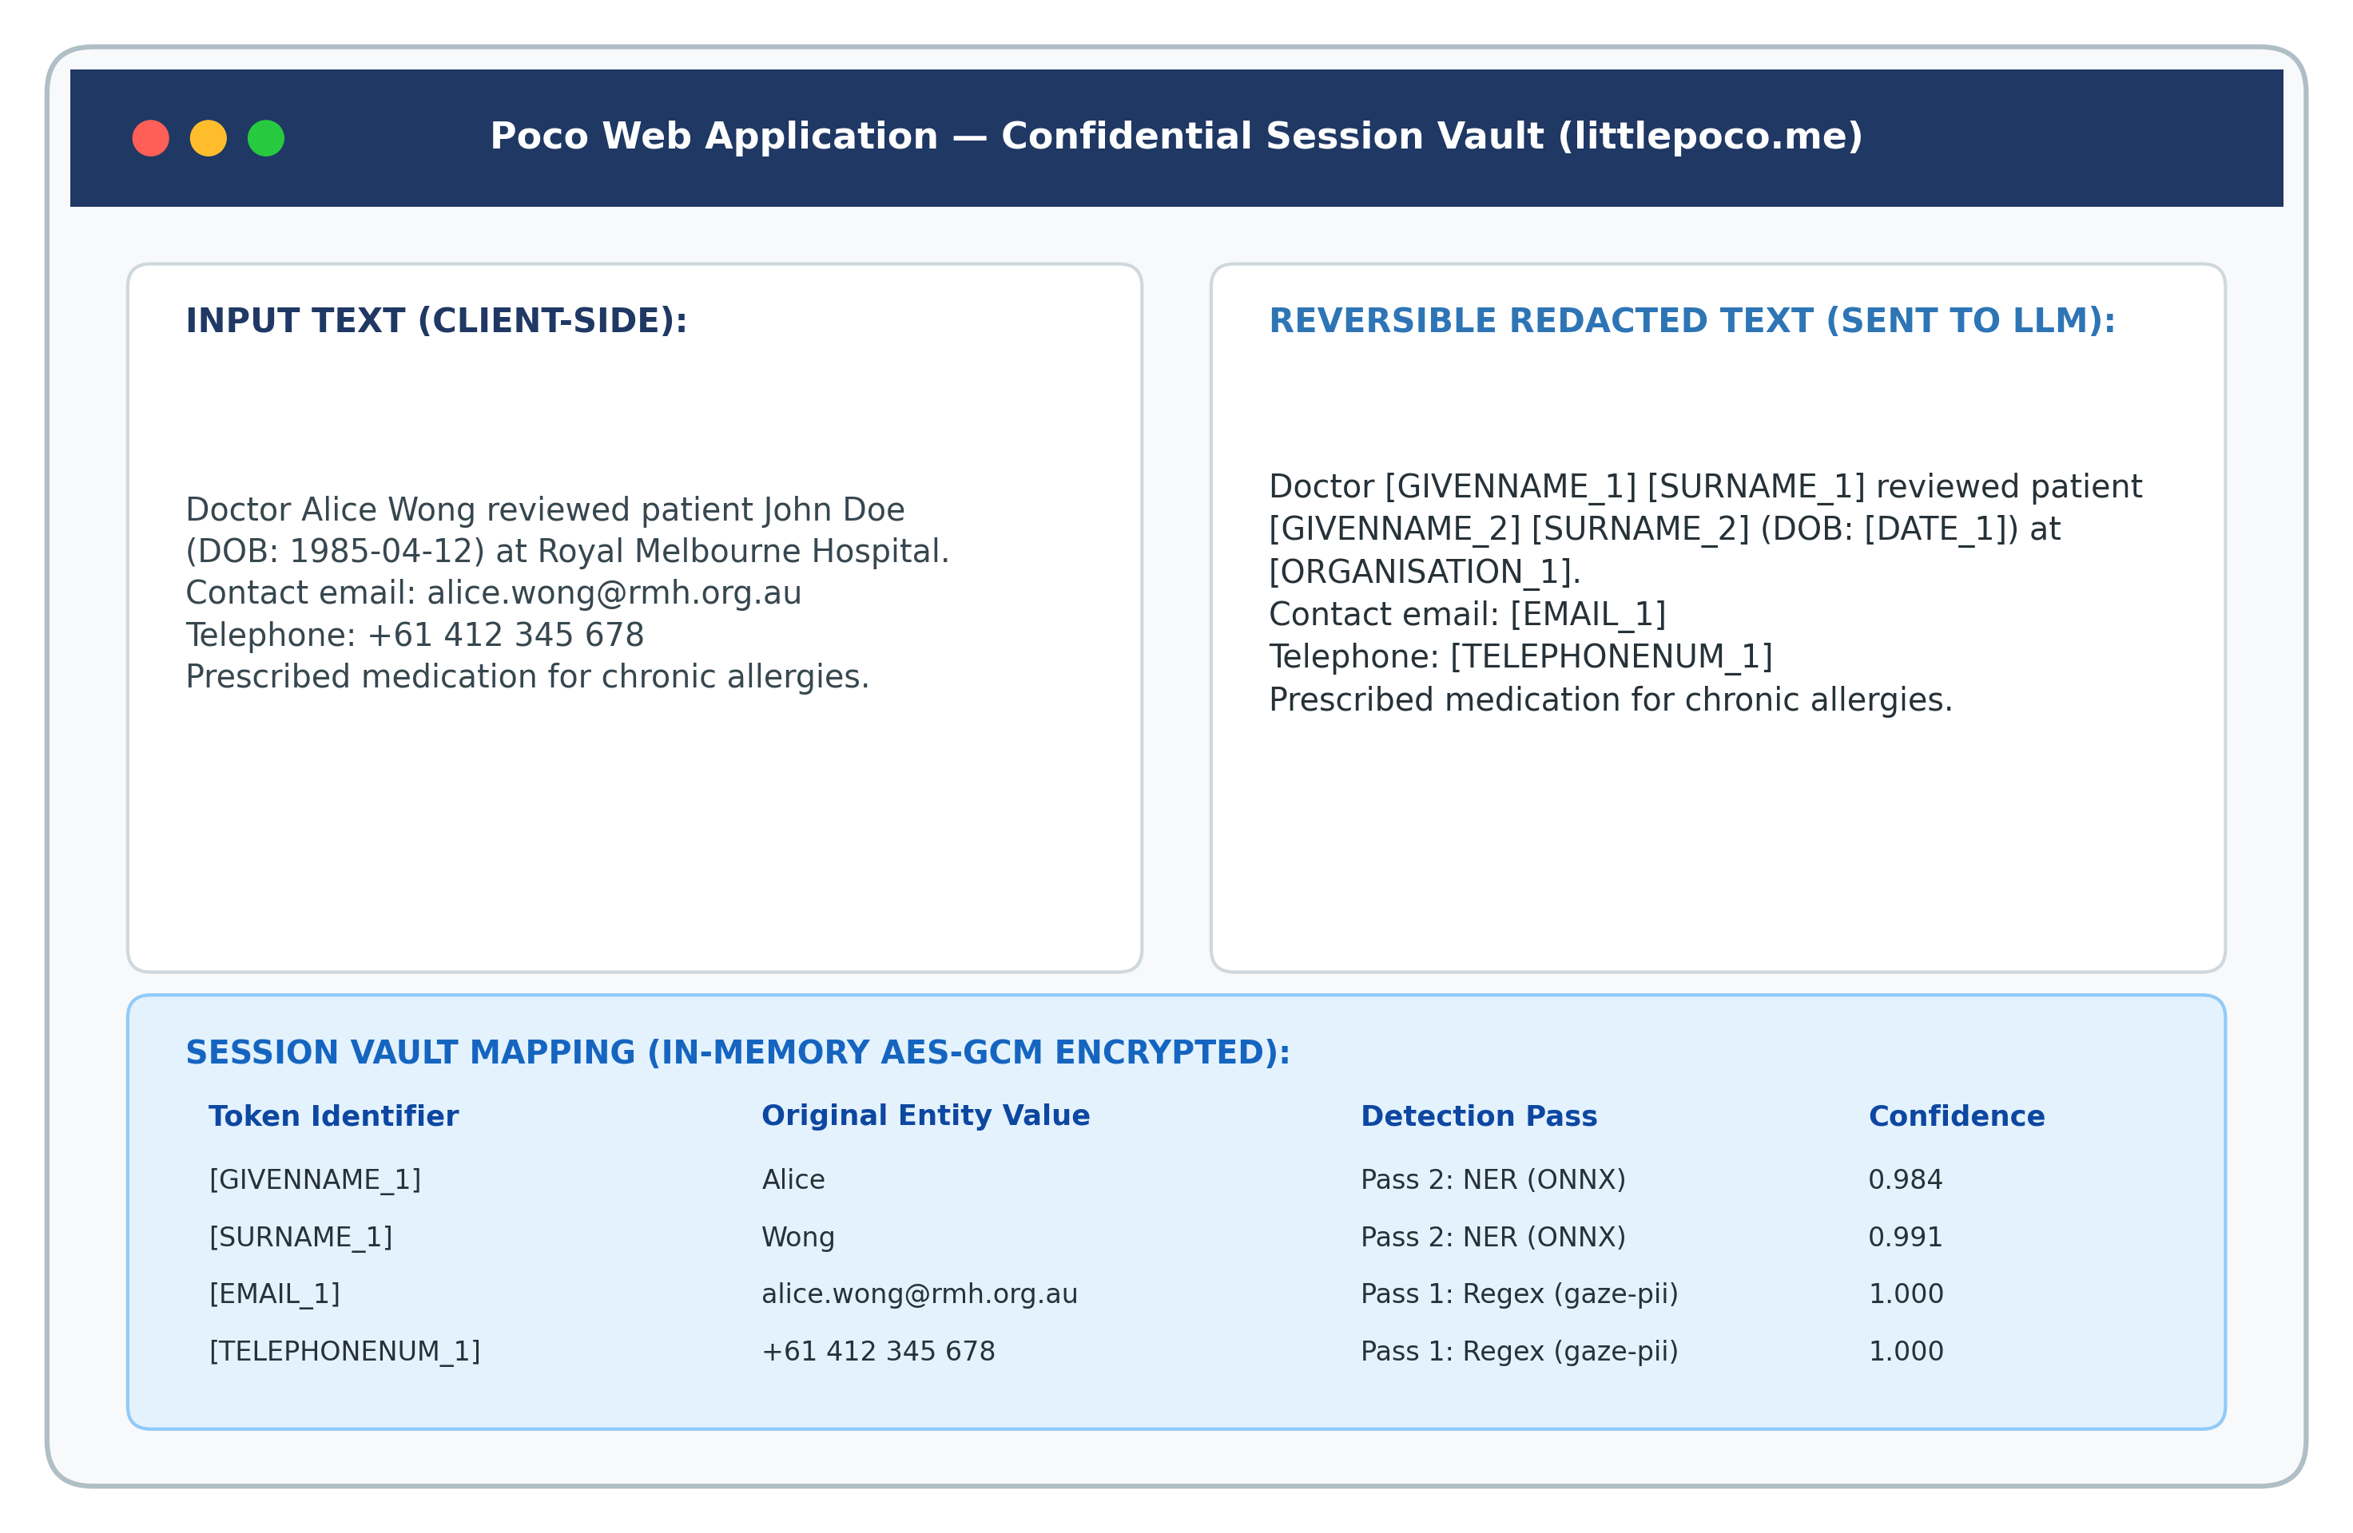  Figure 2. Poco encode view with coloured token highlighting. | Dataset: AI4Privacy OpenPII 1.5M  Analysis of 1,636,375 multilingual documents across 30 languages, 11.9 million PII annotations, and 43 discovered PII entity classes. Full-corpus census completed and cached to Parquet.  Label Distribution  Class Viability  Only 20 of the 43 discovered labels are viable for supervised training. 4 are marginal, and 19 are unviable (<100 corpus annotations, down to single occurrences). The unviable labels are handled by deterministic regex in Poco.  Language Coverage  Document Lengths  Entity Span Lengths & Co-occurrence | Per-Language Composition  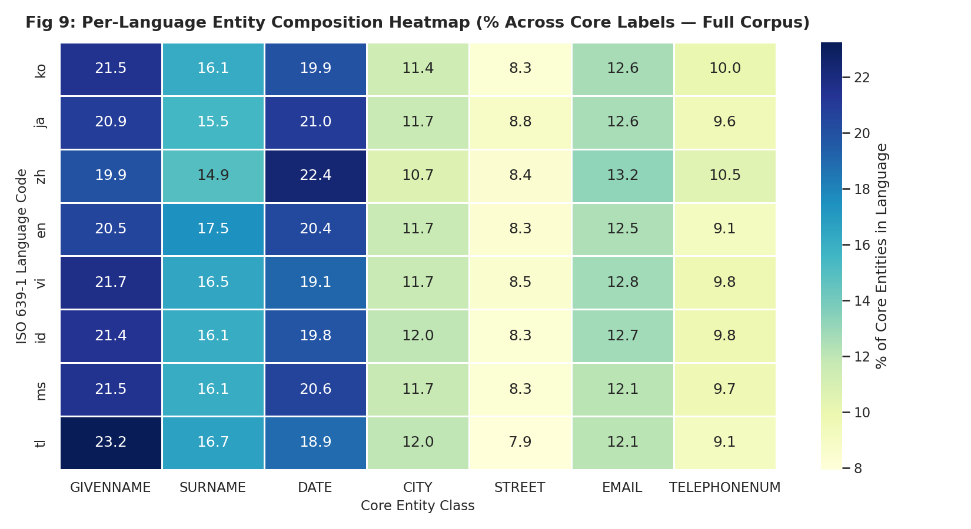  Figure 10. Per-language entity composition across 8 Asia-Pacific languages.  Chi-square p < 10⁻³⁰⁰, but Cramér's V = 0.017 shows the effect is negligible — the synthetic generator produces uniform proportions.  Data Quality  Normalisation & Correlation  Tokenizer Expansion & Split Parity  Full-corpus census confirmed that all 20 viable classes follow the 80.05% / 19.95% train/val split with |Δ| < 0.08%.  Key Findings  1. 20 of 43 discovered labels are viable for supervised training  2. 8 labels have zero validation instances — Vault manual mapping is not optional, it's required  3. Chinese text consumes 2.4× more tokens per character than Latin  4. Class imbalance is 73:1 between GIVENNAME and TIME  5. Perfect 80/20 train/val parity on all viable labels
   | Live demo:  littlepoco.me
  1,636,375  Total examples | 11,887,370  Total annotations | 43  PII entity classes | 30  Languages
  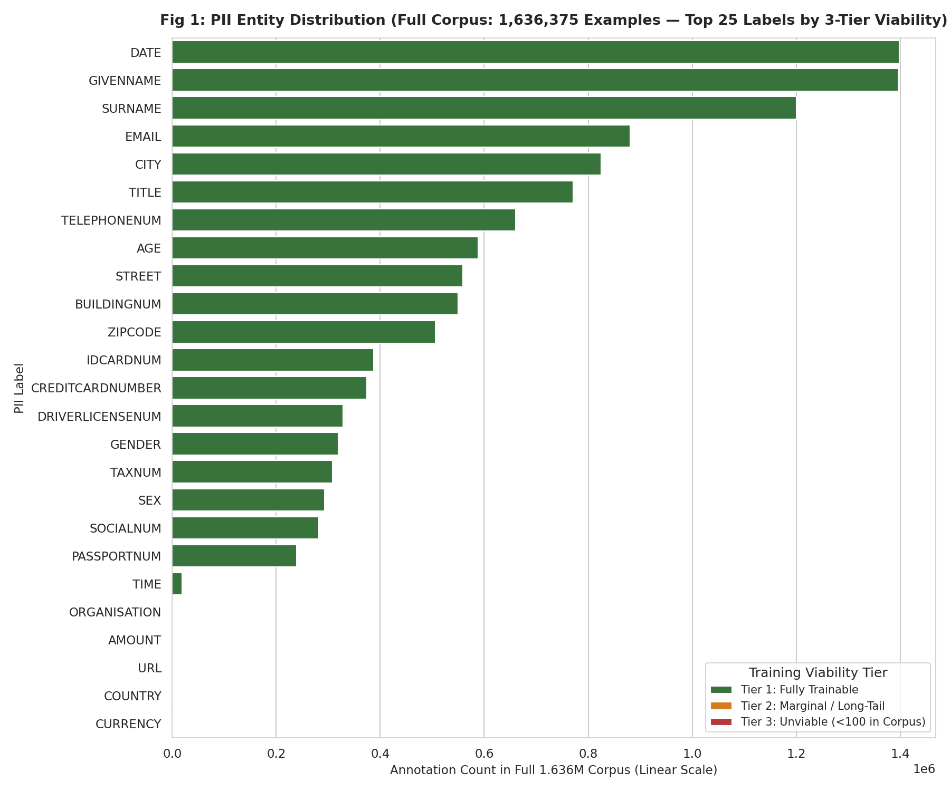  Figure 3. Top 25 PII labels, colour-coded by training viability tier. | 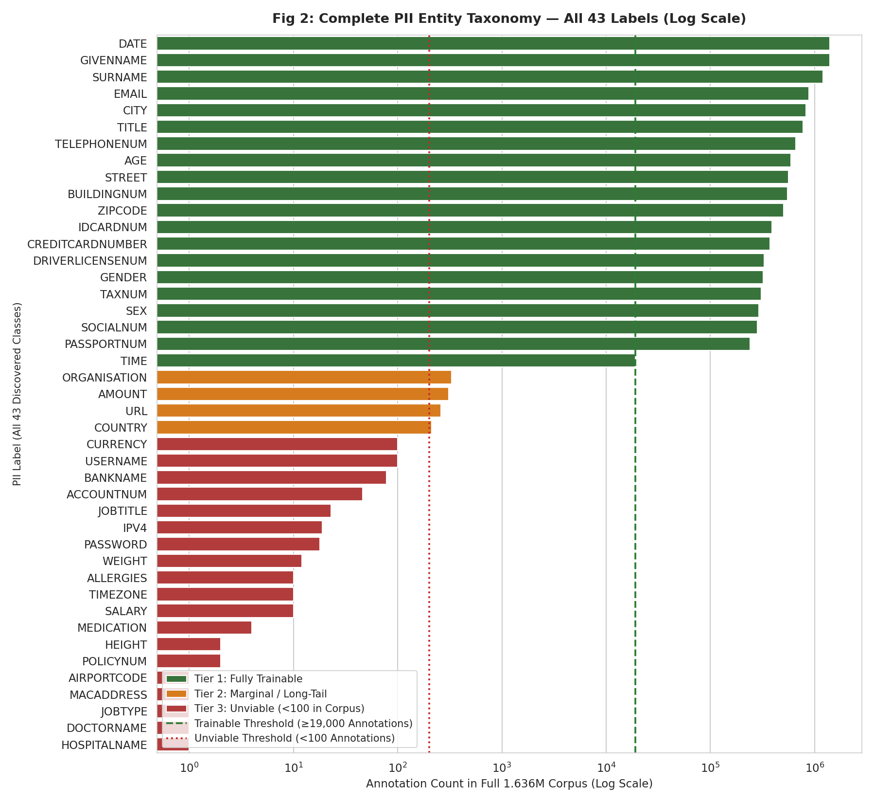  Figure 4. Complete 43-label taxonomy on log scale.
  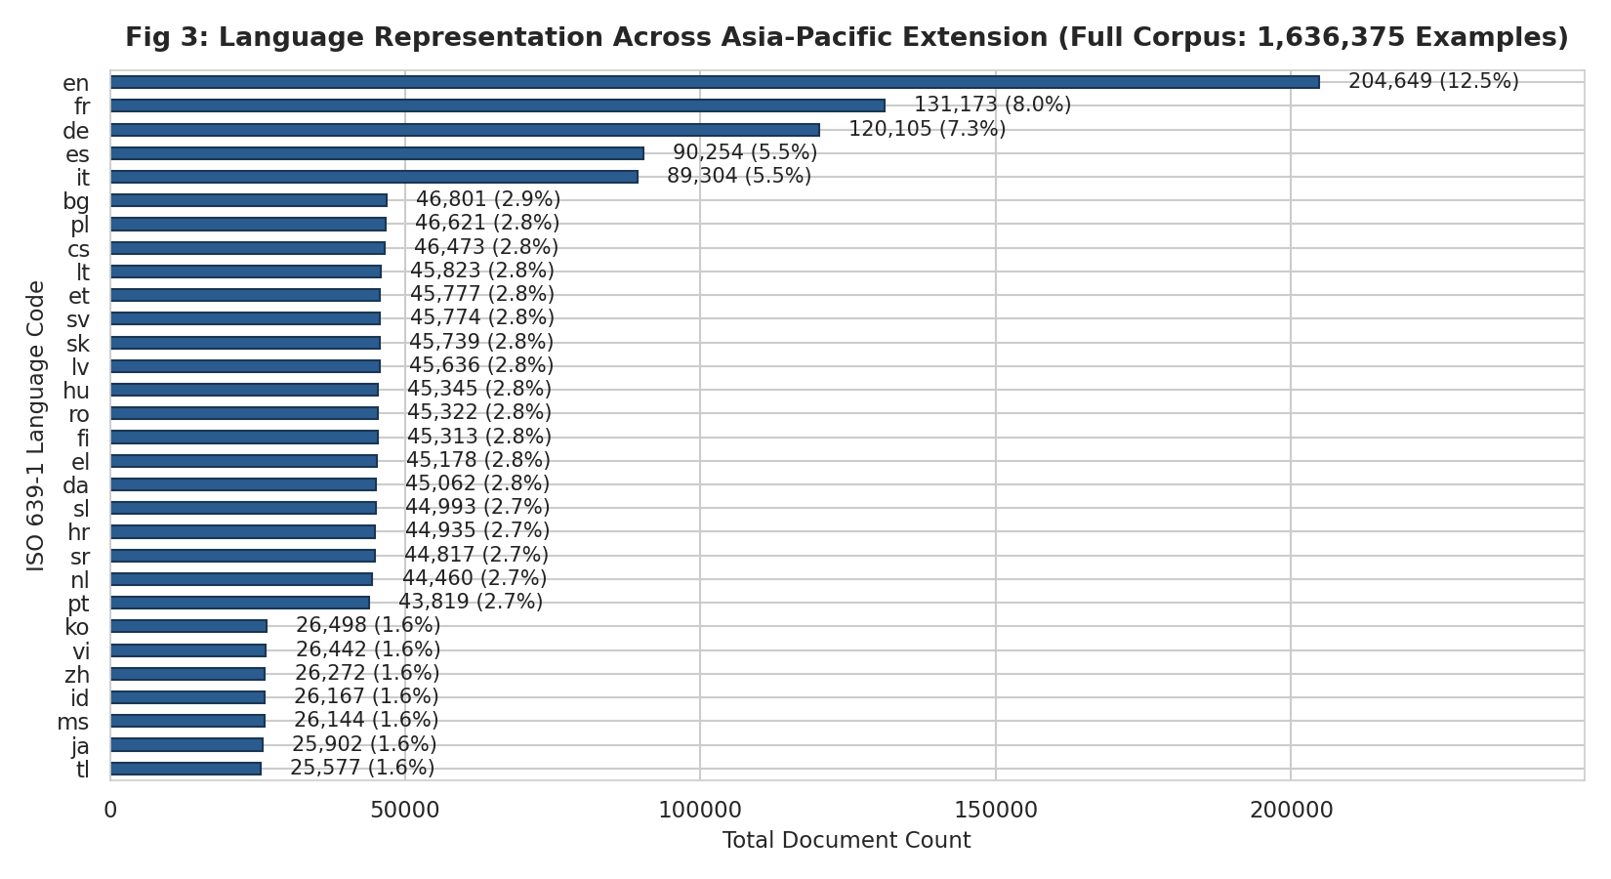  Figure 5. Full-corpus language representation across 30 languages. | 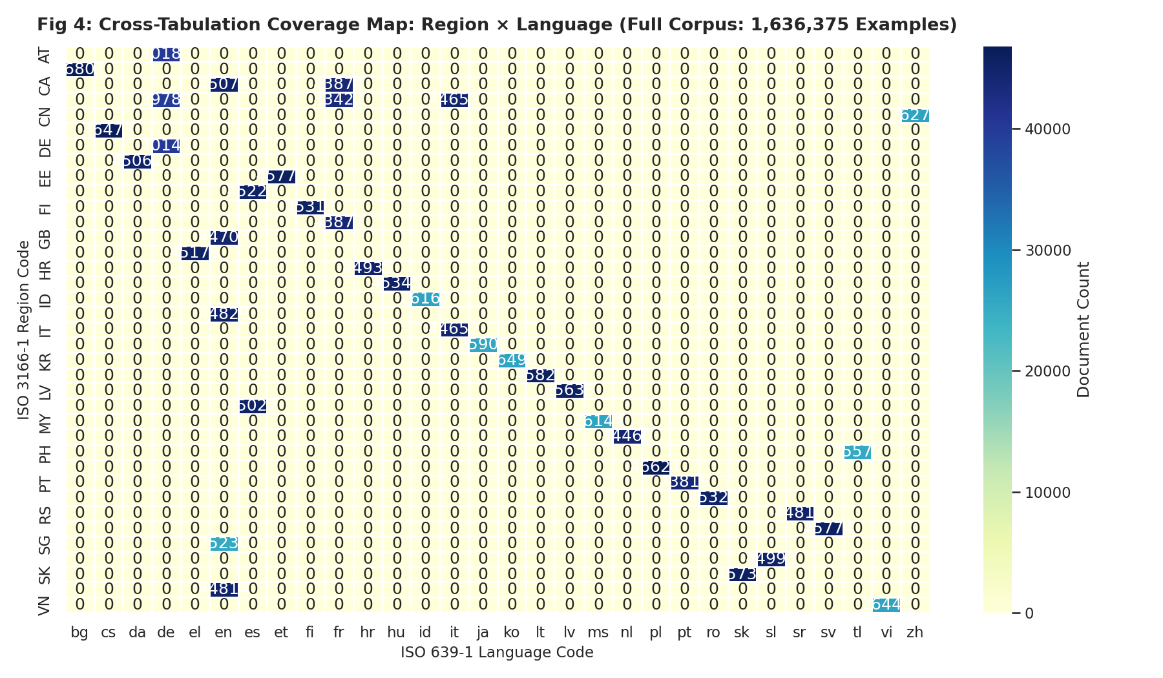  Figure 6. Region × language cross-tabulation.
  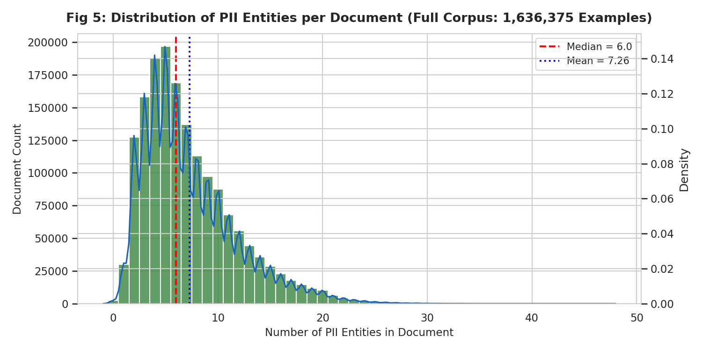  Figure 7. PII entities per document distribution. | 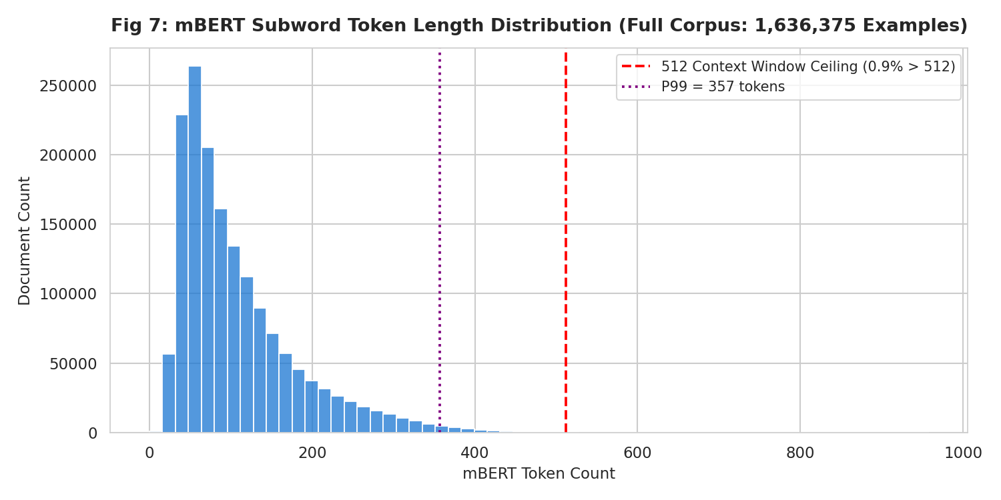  Figure 8. mBERT token length distribution with 512-token ceiling.
  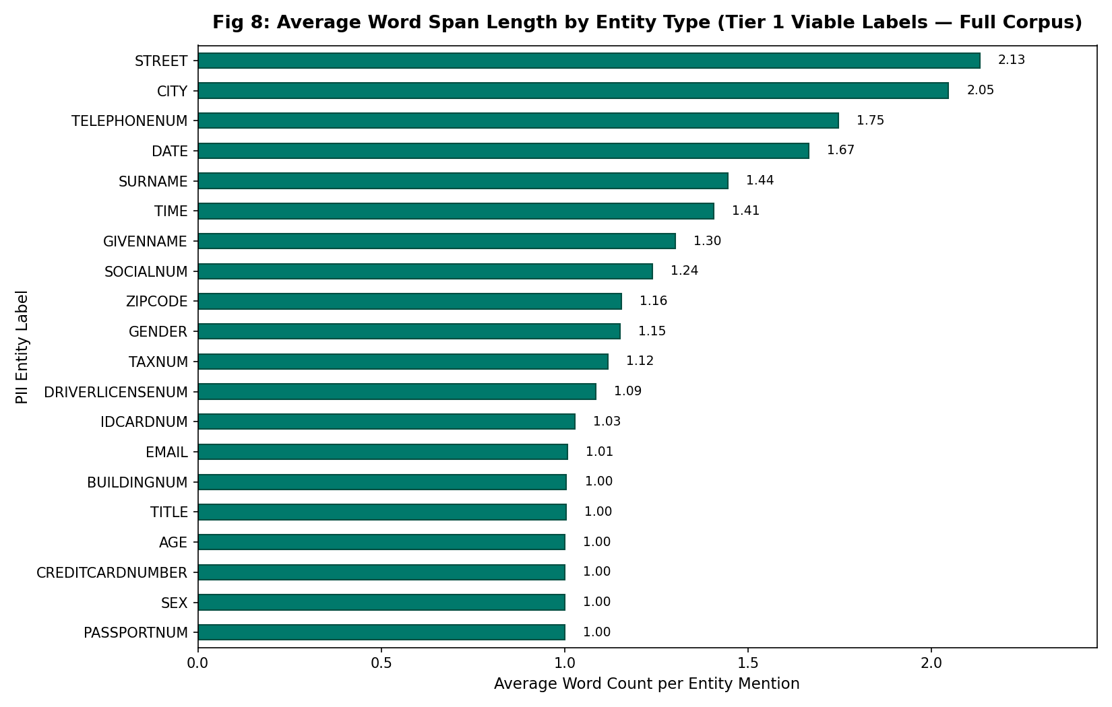  Figure 9. Average word span length by entity class. | 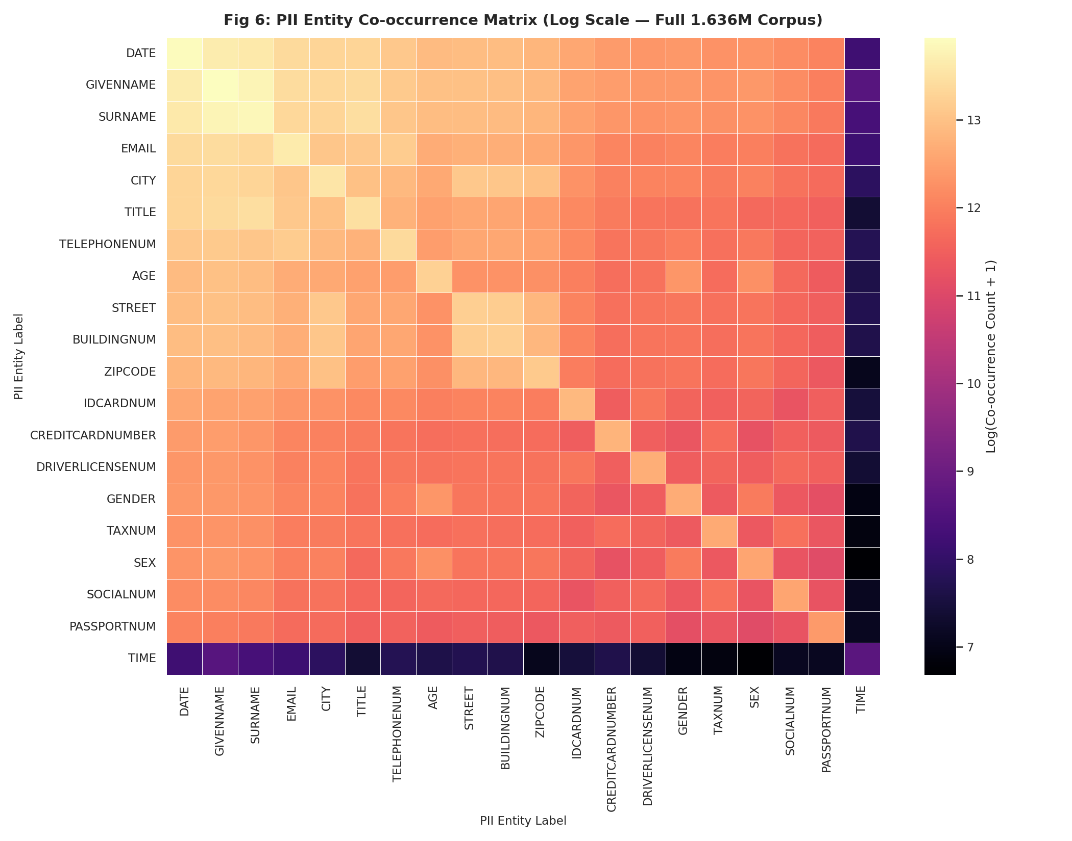  Figure 9b. Multilingual PII entity co-occurrence matrix (full corpus).
  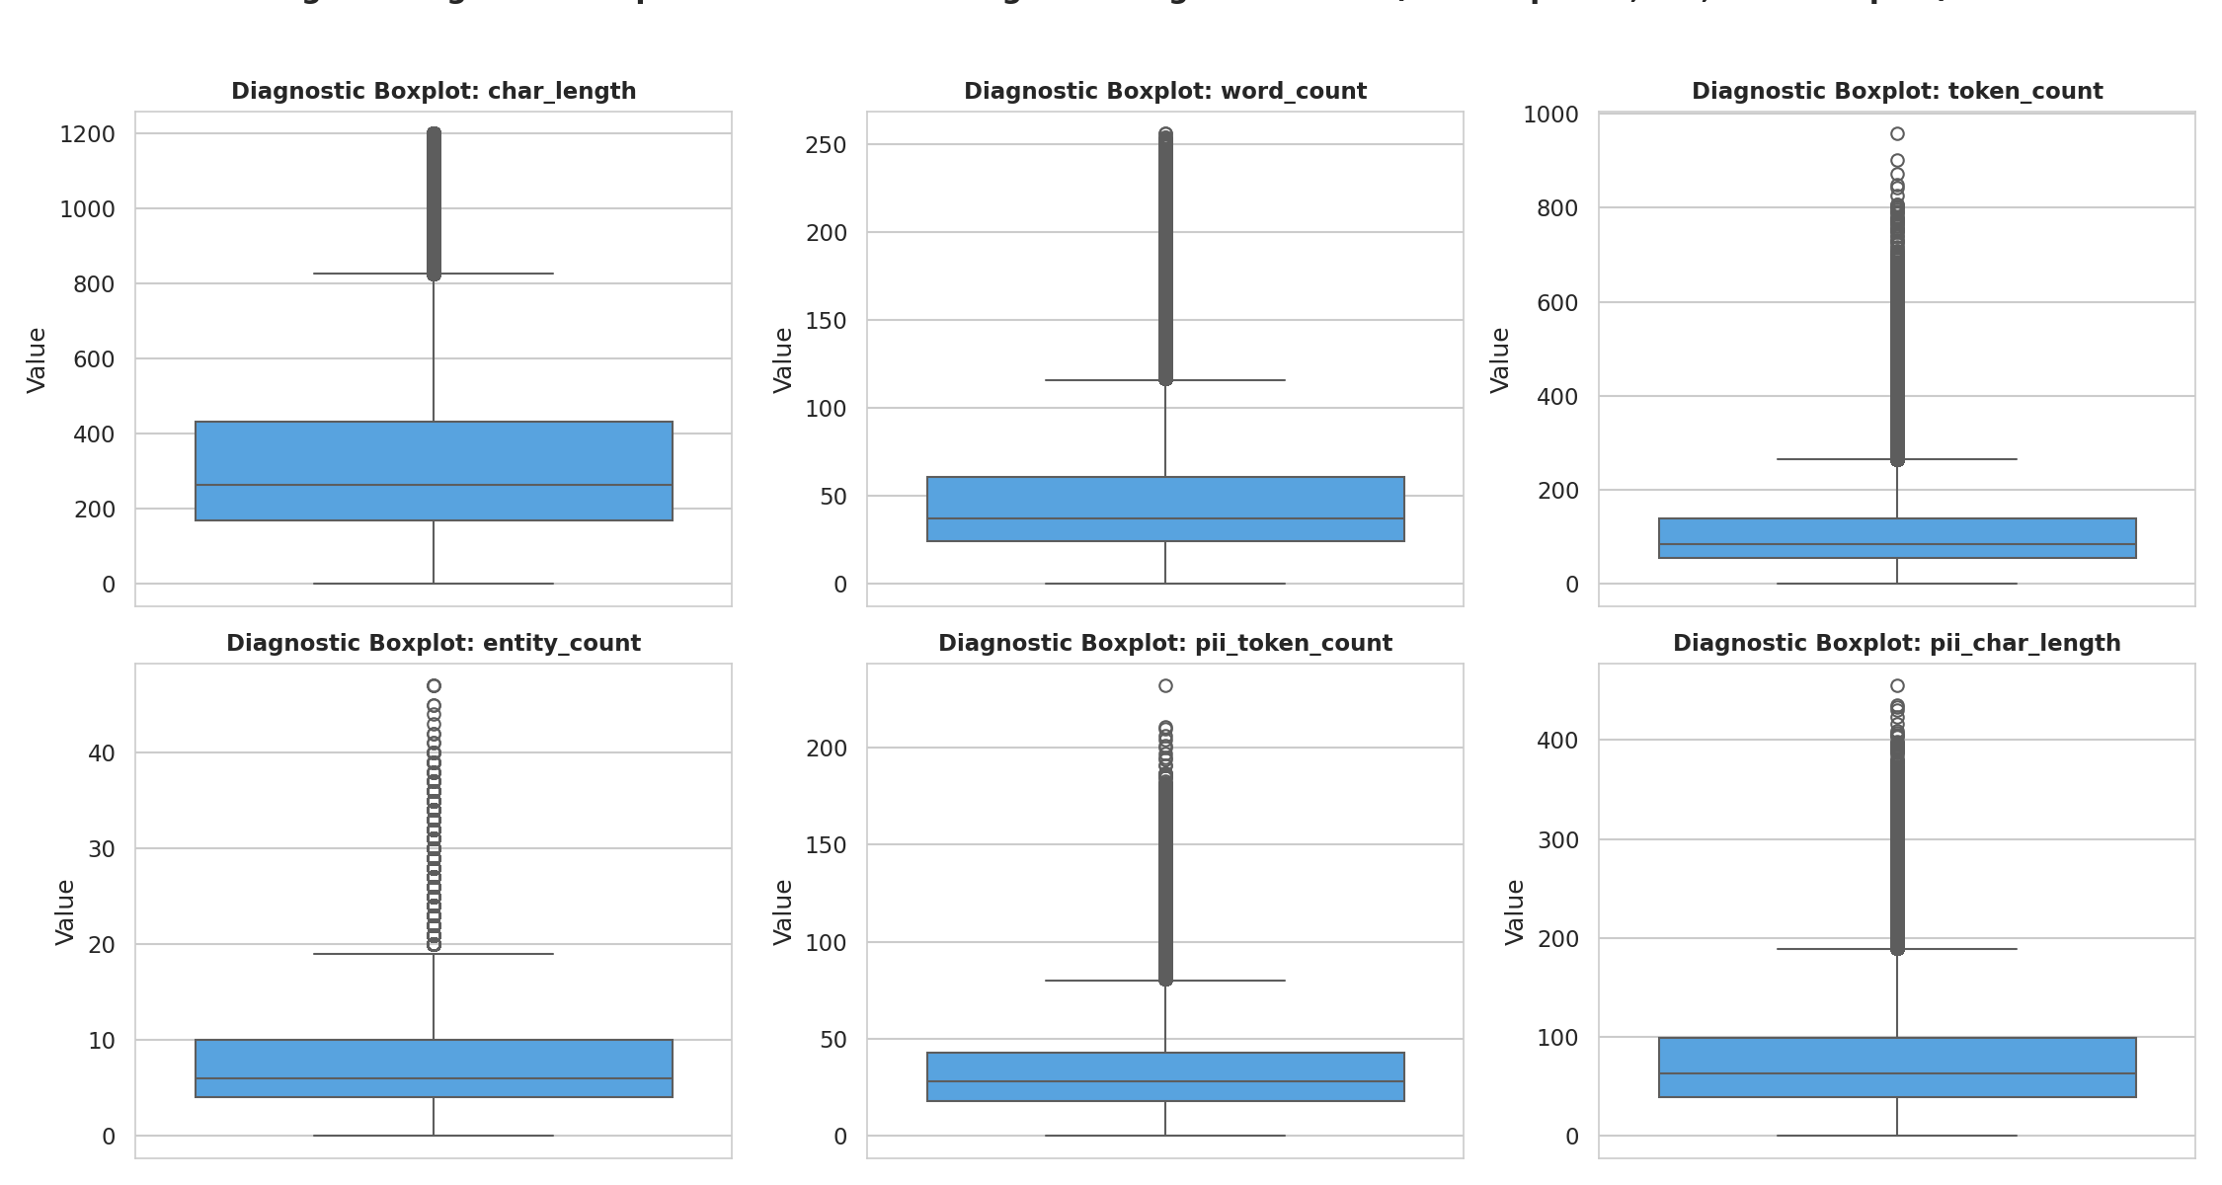  Figure 11. Diagnostic boxplots. | 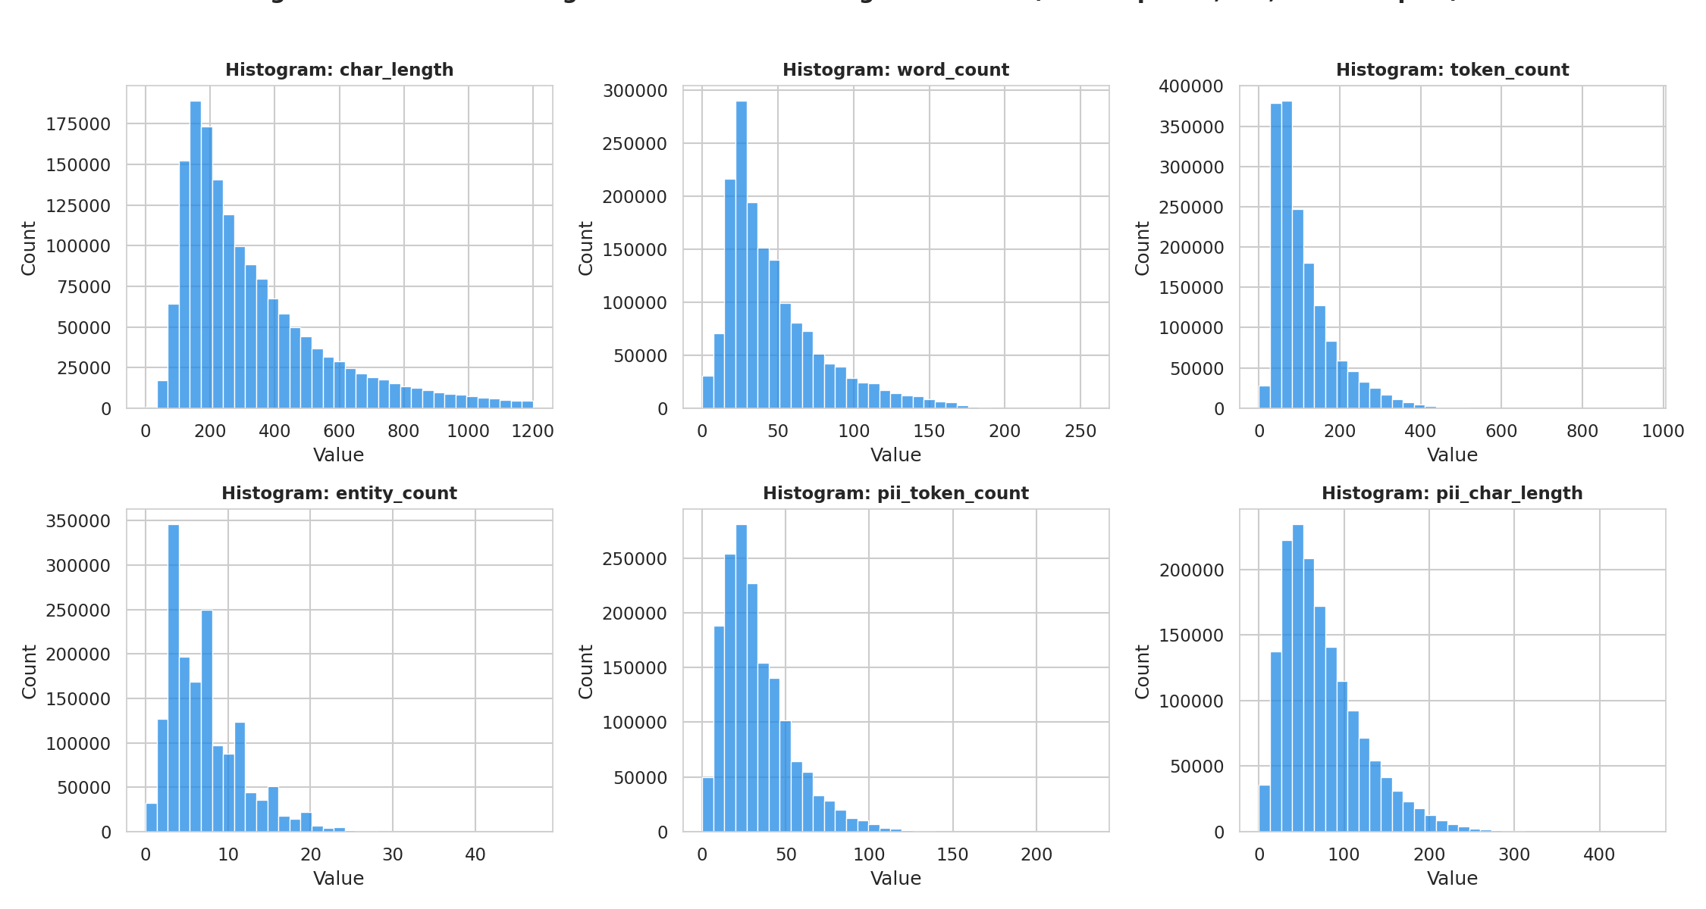  Figure 12. Distribution histograms.
  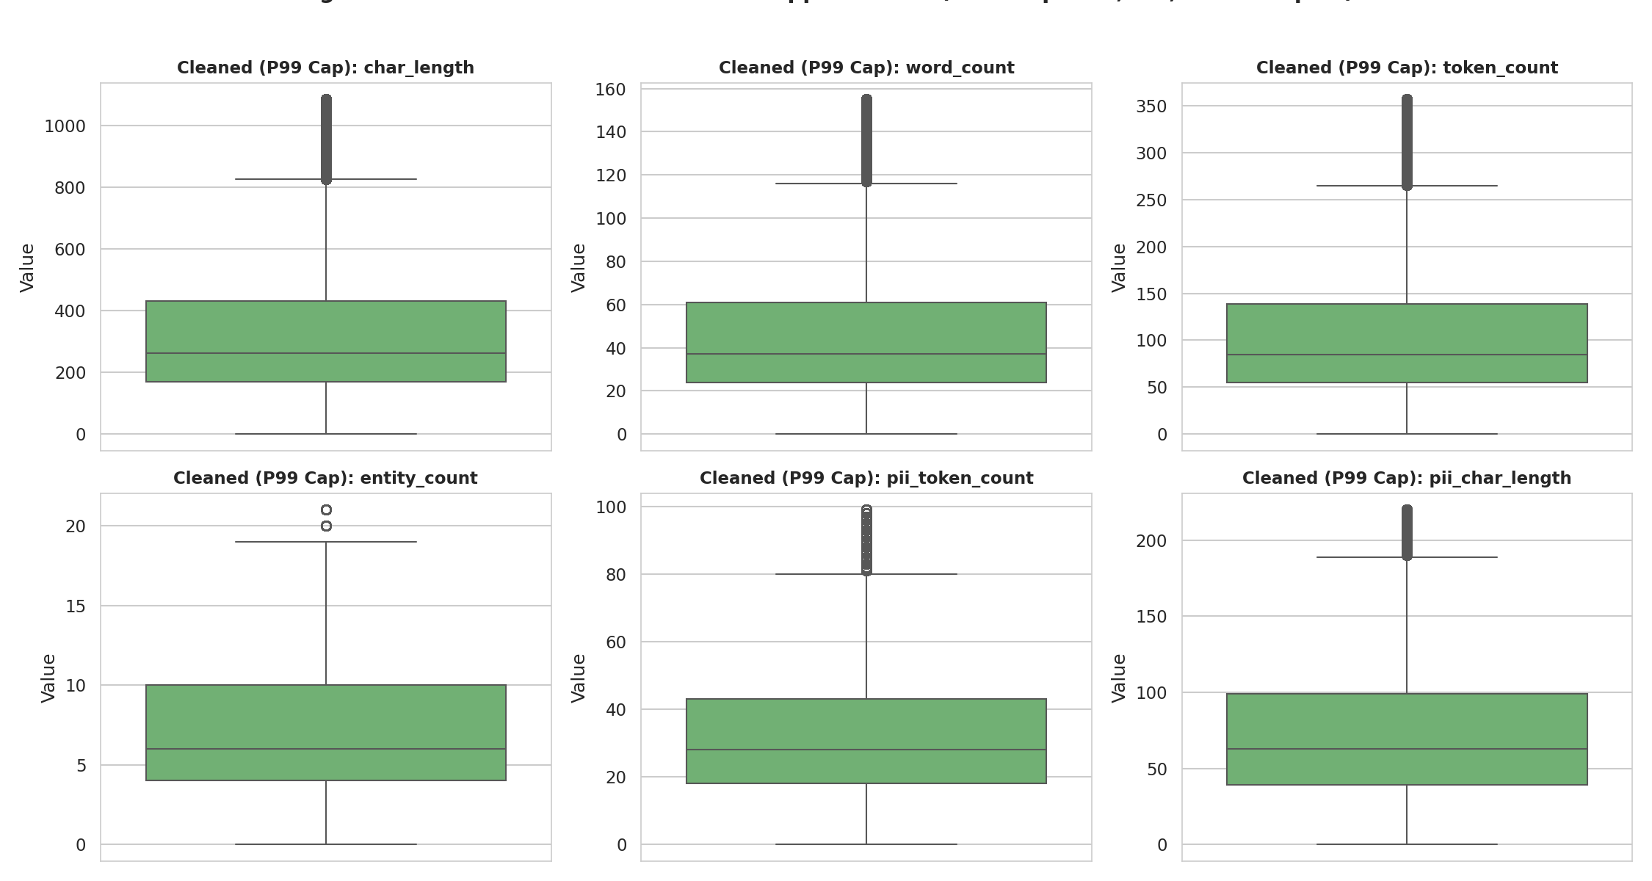  Figure 13. Winsorised boxplots at P99. | 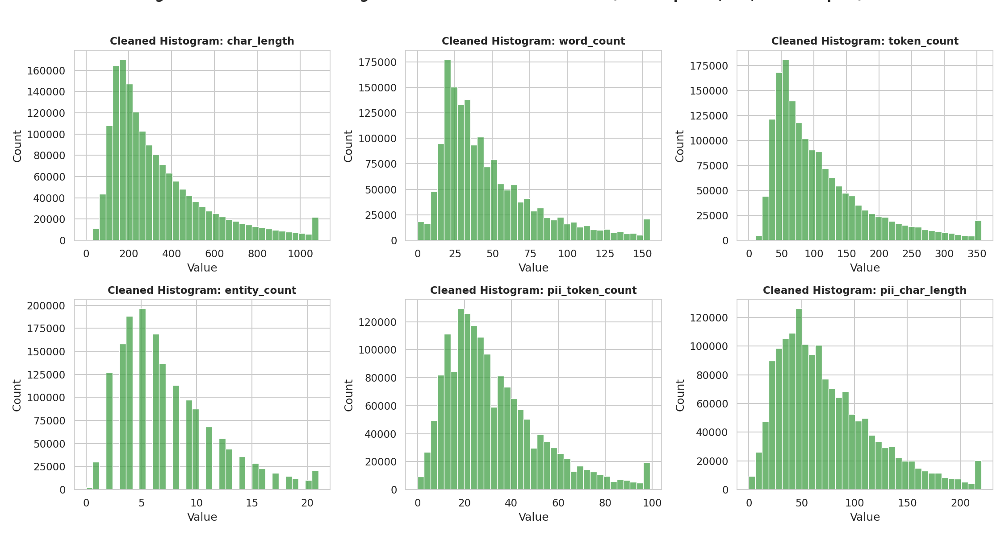  Figure 14. Cleaned histograms.
  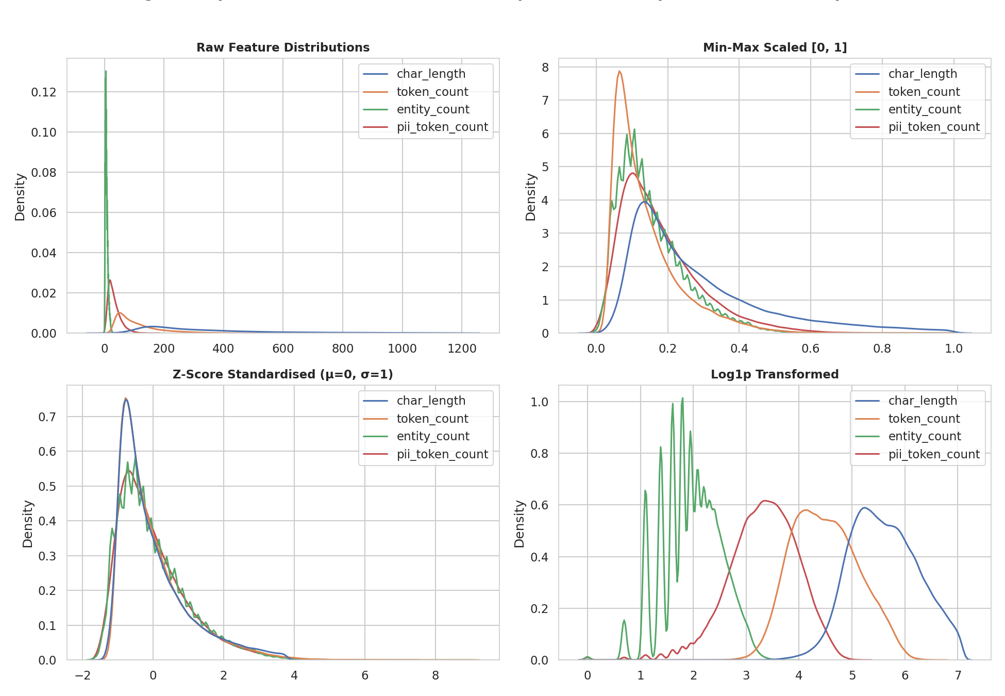  Figure 15. Raw vs MinMax vs Z-score vs Log1p. | 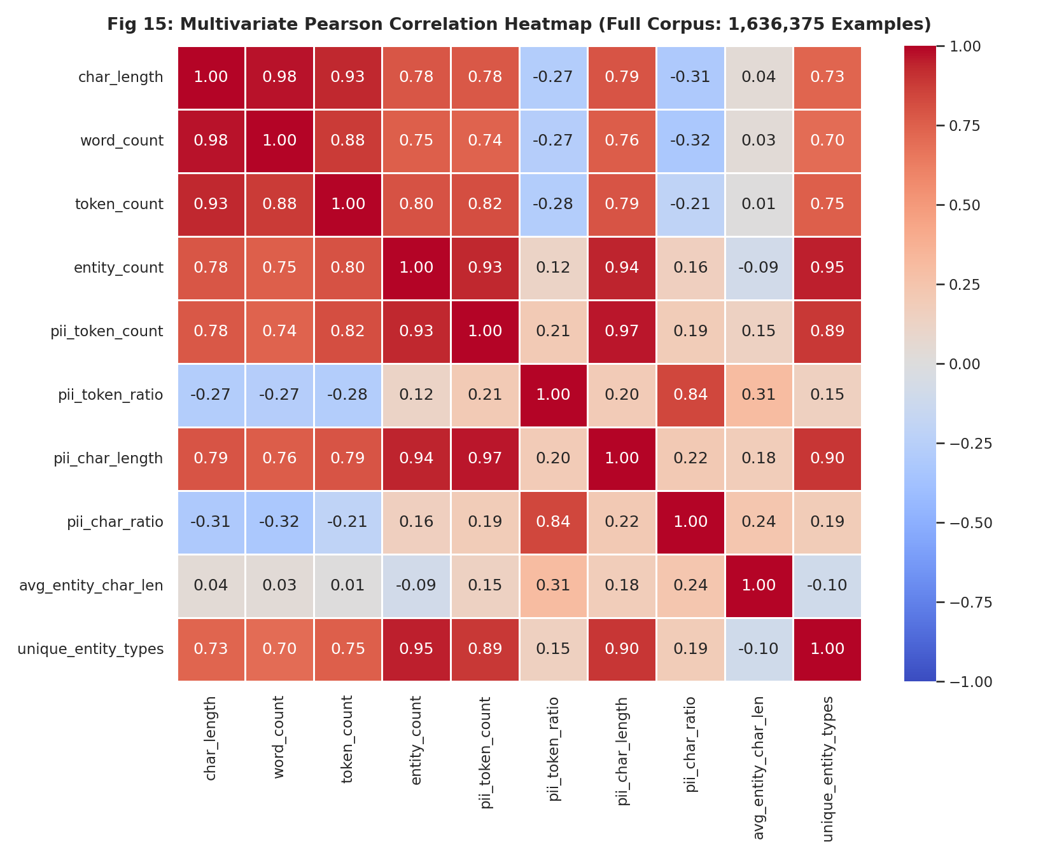  Figure 16. Multivariate Pearson matrix.
  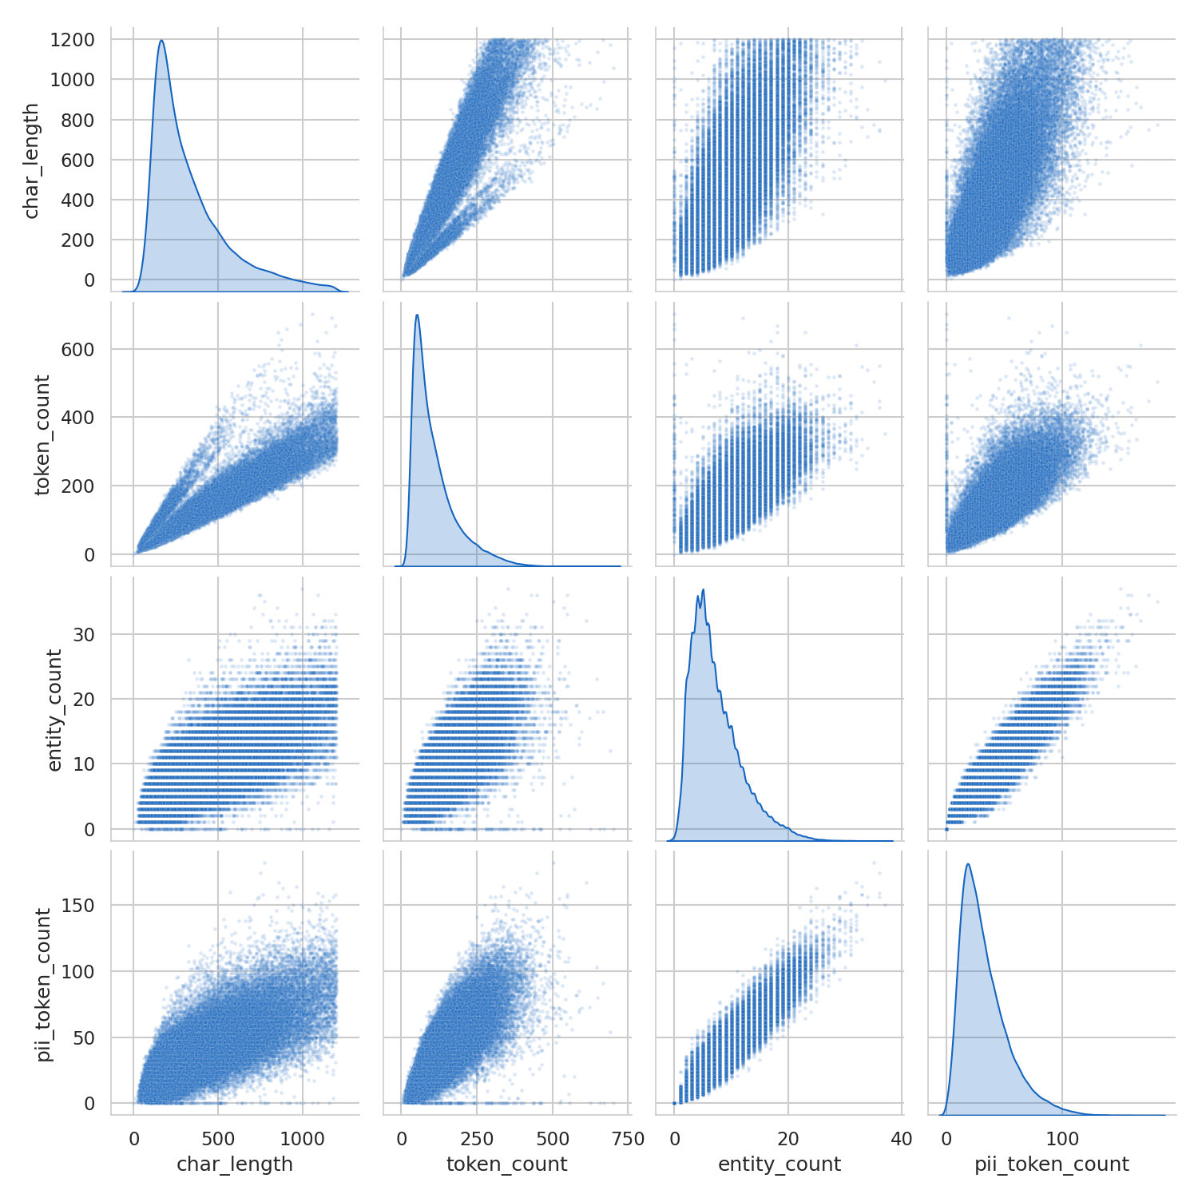  Figure 17. Bivariate relationships. | 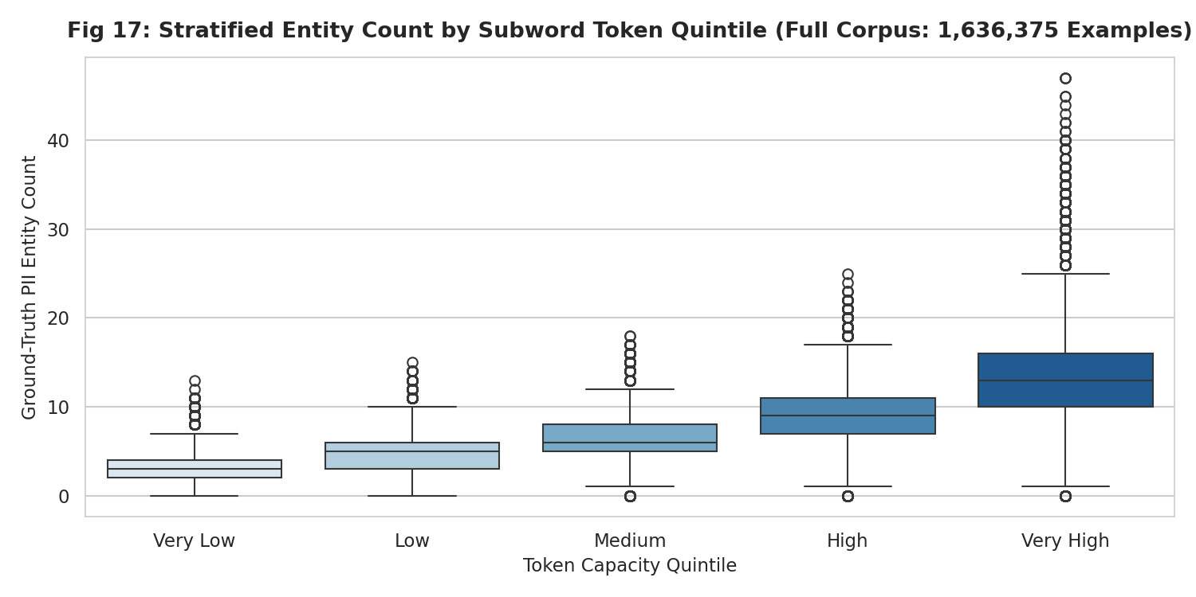  Figure 18. Entity count by quintile.
  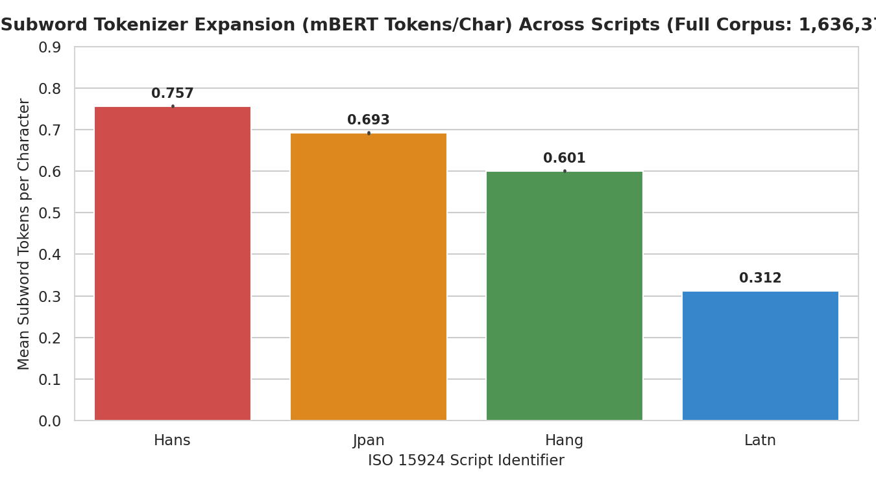  Figure 19. CJK expansion (2.4×). | 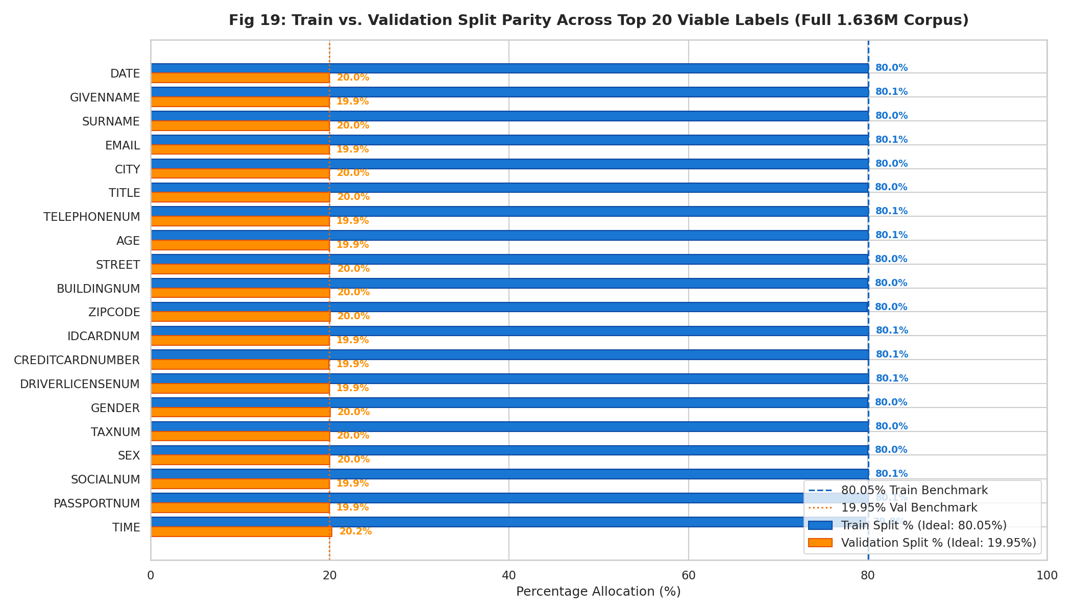  Figure 20. Split parity. | 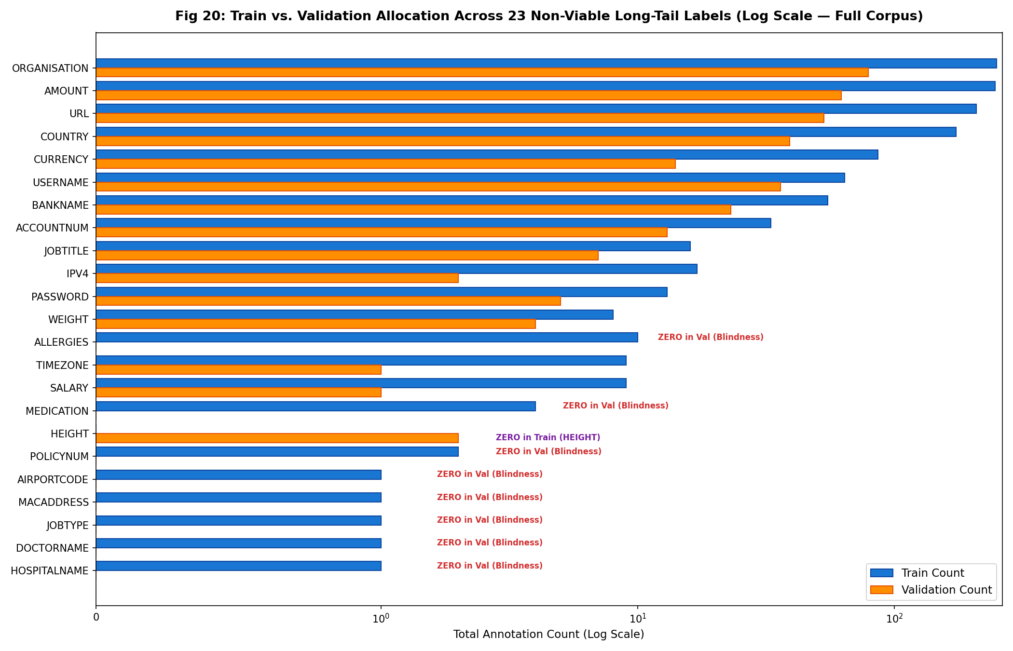  Figure 21. Validation blindness.

 |  | Poco — Preserve Originals, Conceal Only  SWE40006 | CL01_G01 | October 2026
   | Repository:  github.com/Schnitze1/SWE40006-Group-Project
   | Full EDA Report:  huggingface.co/datasets/woojin1069/pii-masking-openpii-1.5m

