Poco — Preserve Originals, Conceal Only
Privacy-first PII anonymisation for LLM workflows, with a fully automated multi-environment DevOps pipeline
20 / 43  PII labels viable for training | 8  labels with zero validation instances | 2.4×  more tokens per character for Chinese | 73:1  class imbalance (GIVENNAME : TIME) | 99.99%  of annotations in viable labels

The Problem  Every day, people paste contracts, medical notes, and CVs into ChatGPT. Once they do, names, addresses, and financial details are outside their control. Poco makes that safe.  How Poco Works  Poco detects personal information, replaces each value with a reversible token like [PERSON_1] or [EMAIL_1], and stores the mapping in an encrypted session vault. The redacted text is sent to any LLM, and the response is restored to its original form when it returns.  Architecture  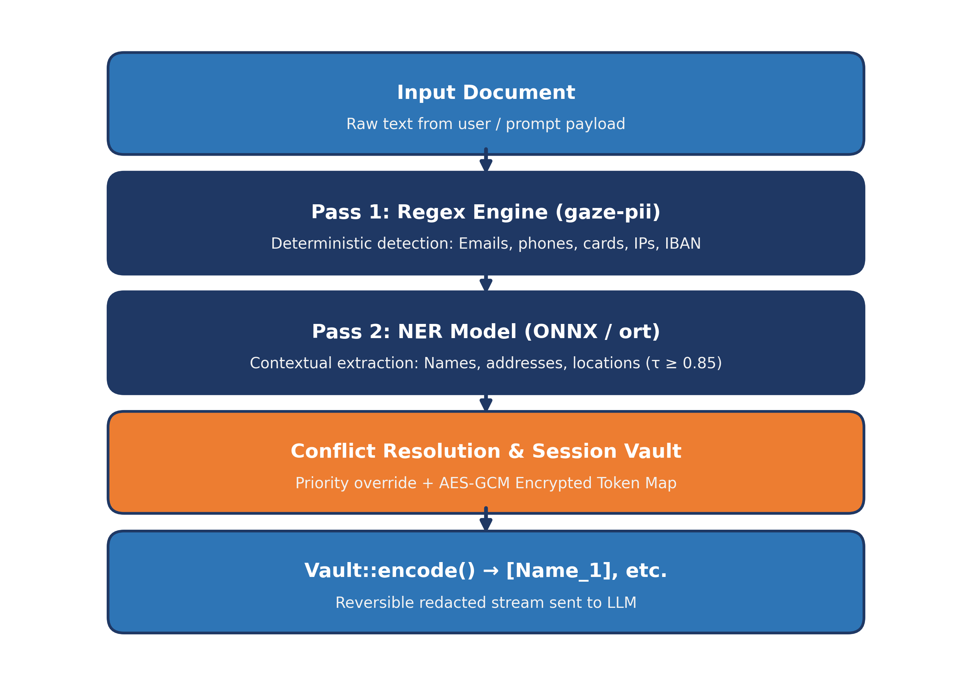  Figure 1. Two-pass hybrid PII detection engine.  DevOps Pipeline  Every code change flows through GitHub Actions, which builds the Rust backend inside the Cargo Lambda container, runs unit, integration, and browser acceptance tests, and deploys to four isolated AWS environments. Failed tests block promotion.  Live Demo  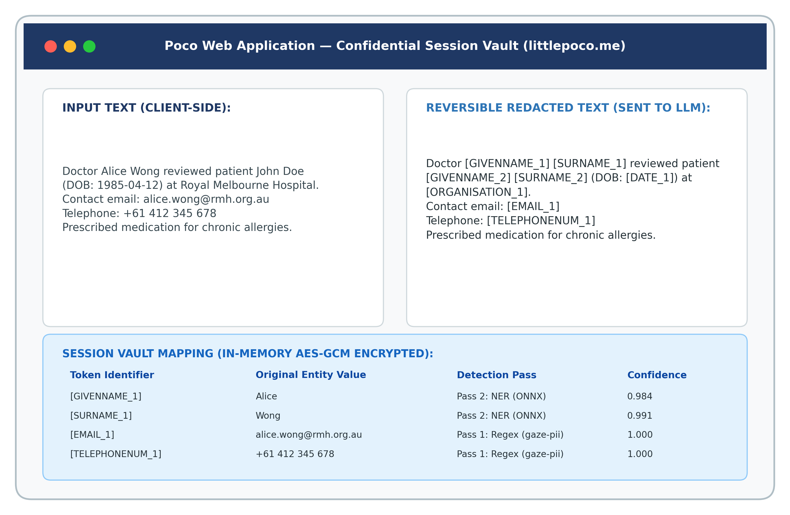  Figure 2. Poco encode view with coloured token highlighting. | Dataset Overview  Analysis of 1,636,375 multilingual documents across 30 languages, 11.9 million PII annotations, and 43 discovered PII entity classes.  Label Distribution  Class Viability  Only 20 of 43 discovered labels are viable for supervised training. 4 are marginal; 19 are unviable (<100 corpus annotations, down to single occurrences). The unviable labels are handled by deterministic regex in Poco.  Language Coverage  Document Lengths  Entity Characteristics | Per-Language Composition  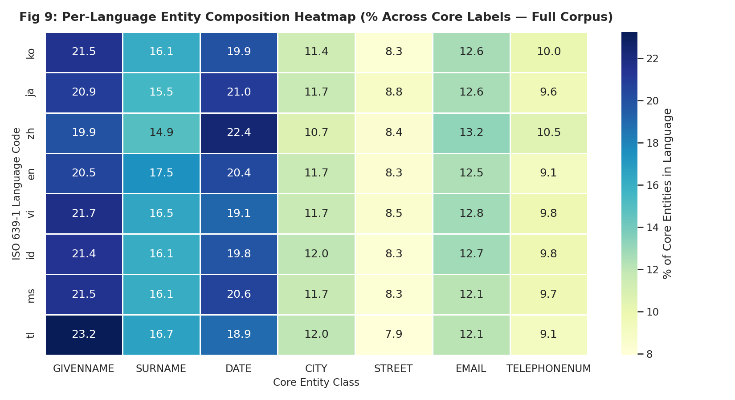  Figure 11. Per-language entity composition across 8 Asia-Pacific languages.  Chi-square p < 10⁻³⁰⁰, but Cramér's V = 0.017 shows the effect is negligible — the generator produces uniform proportions.  Data Quality  Normalisation & Correlation  Tokenizer Expansion & Split Parity  Full-corpus census confirmed that all 20 viable classes follow the 80.05% / 19.95% train/val split with |Δ| < 0.08%.
  Paste text  User input document | → | Tokenise  Reversible vault mapping | → | Restore response  LLM response restored
  Commit  GitHub Actions | → | Build  Cargo Lambda | → | Test  Unit & Playwright | → | Deploy  Dev · Staging · Prod | → | Monitor  CloudWatch
   | littlepoco.me  Confidential session vault
  1,636,375 | 11,887,370 | 43 | 30
  Examples | Annotations | PII classes | Languages
  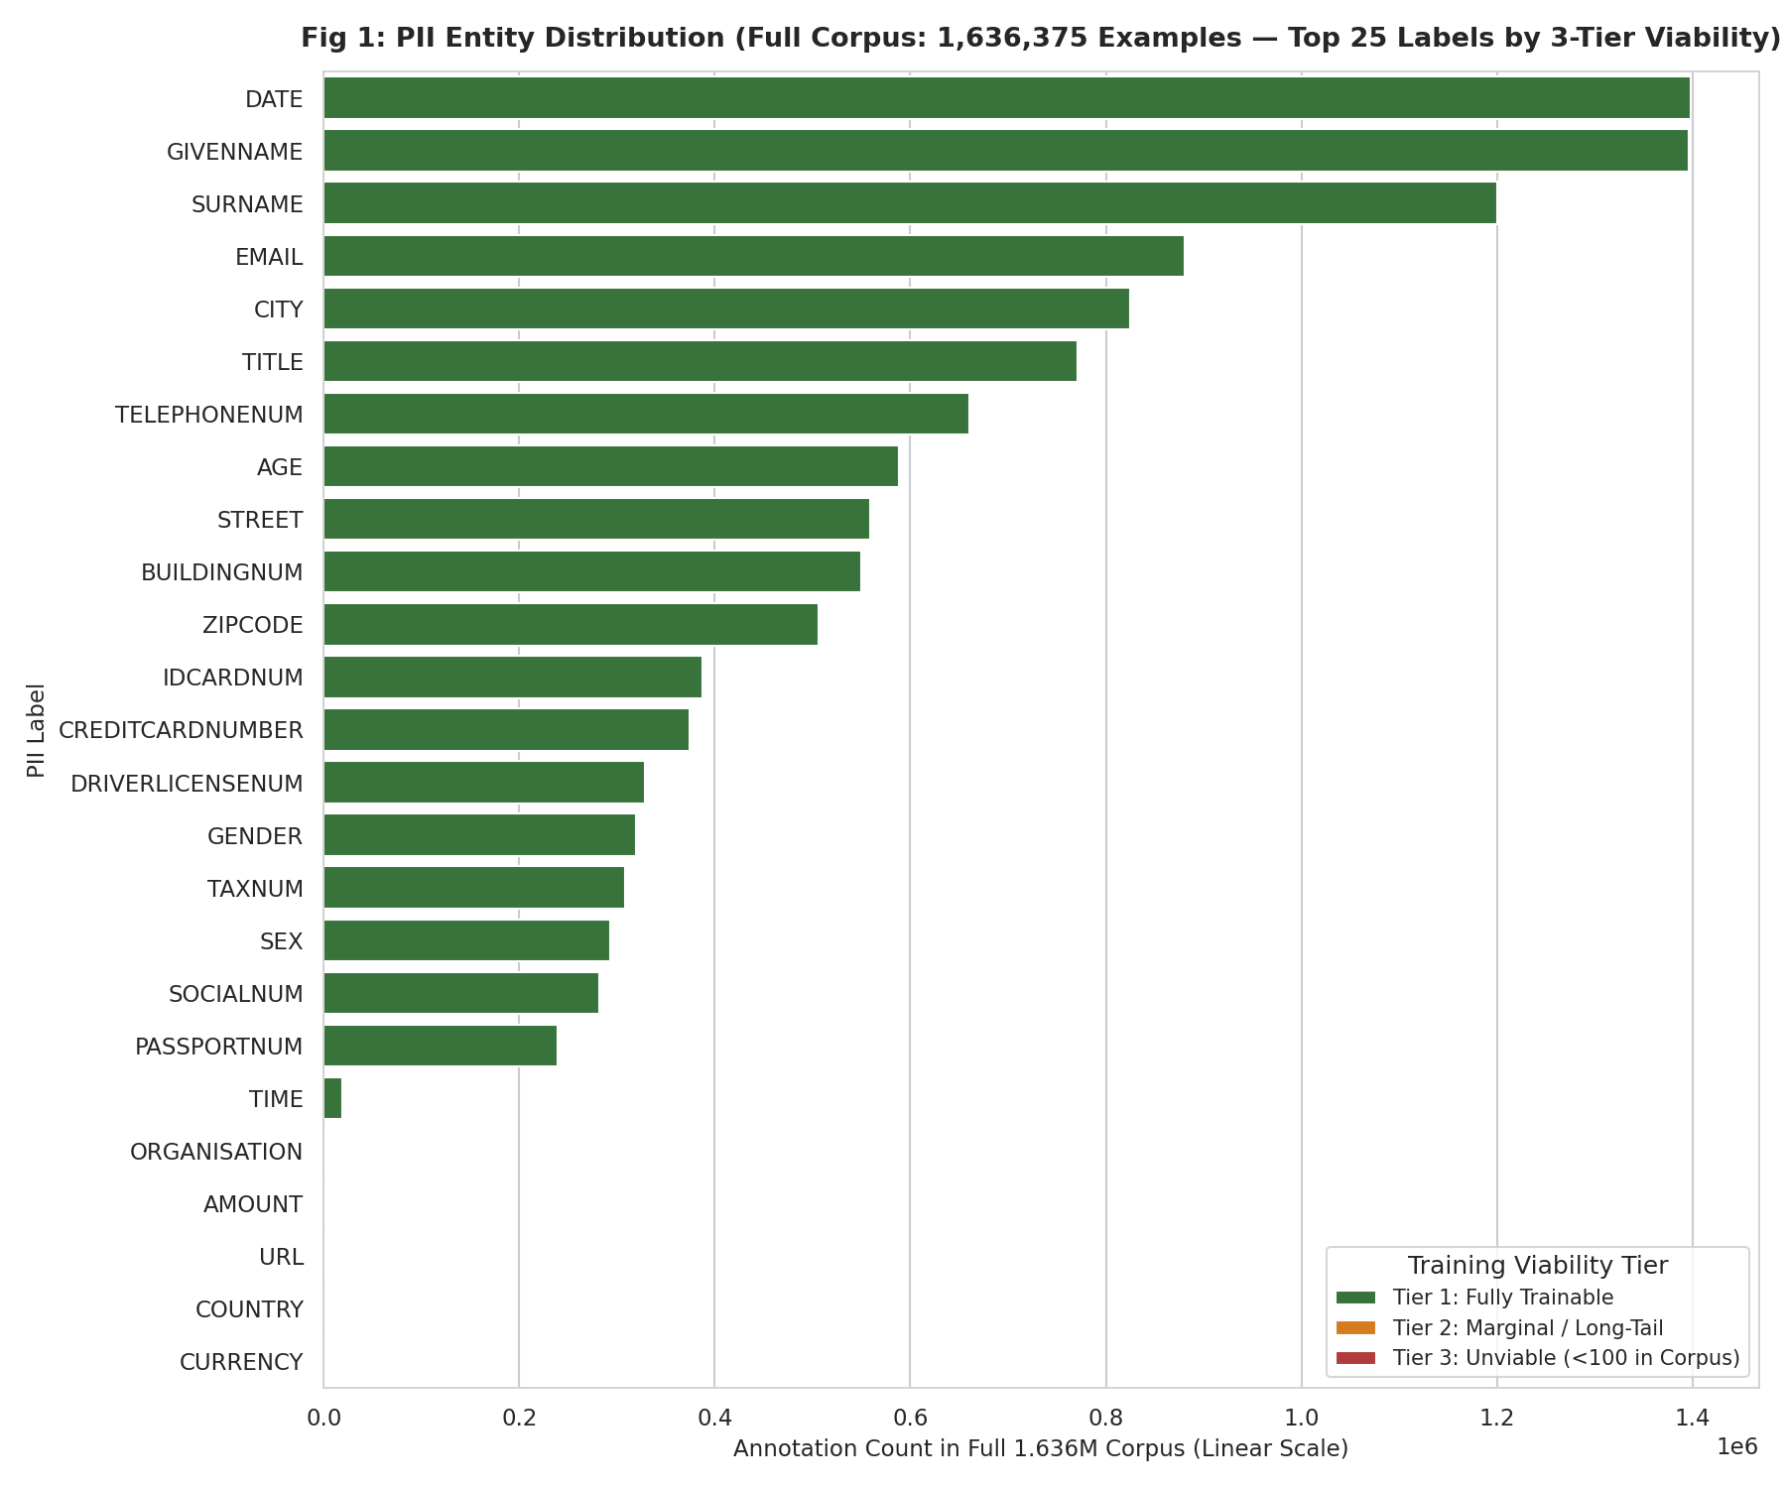  Figure 3. PII entity distribution across top 25 labels, colour-coded by viability tier. | 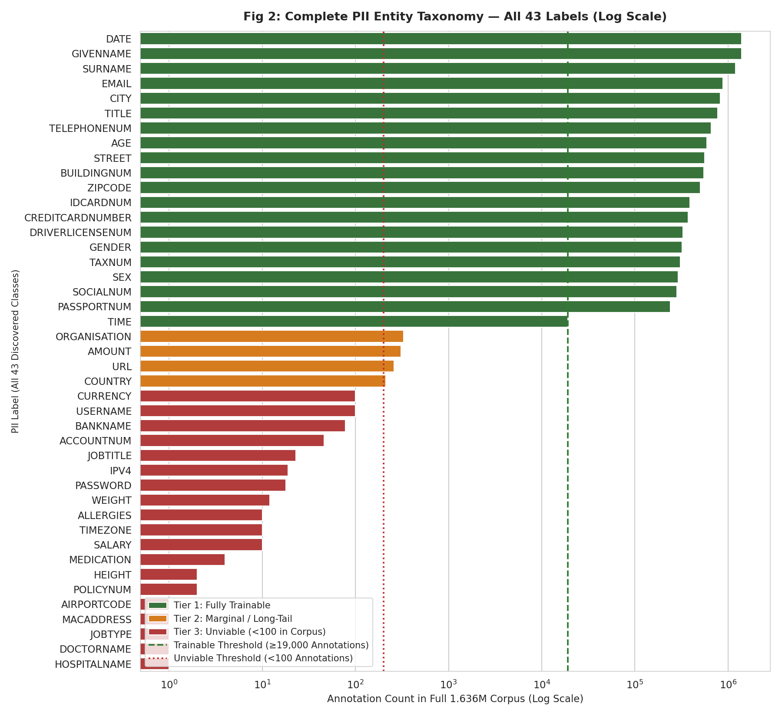  Figure 4. Complete 43-label taxonomy (log scale).
  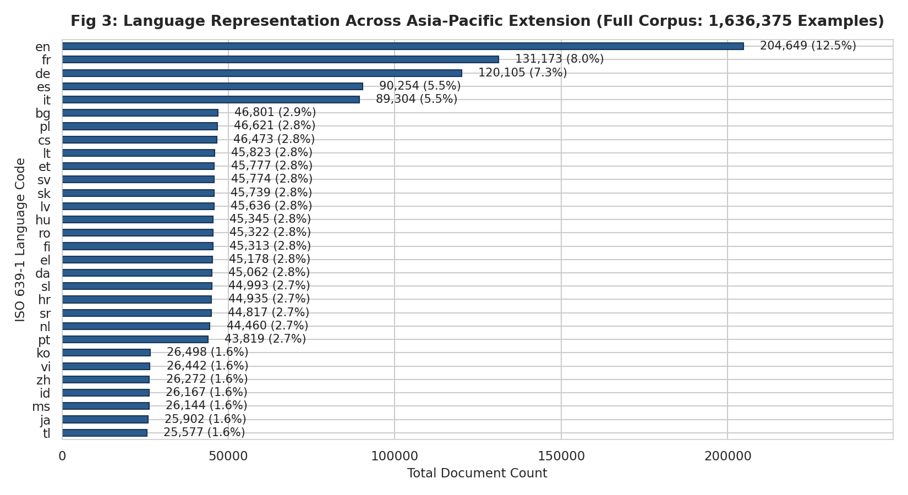  Figure 5. Full-corpus language representation across 30 languages. | 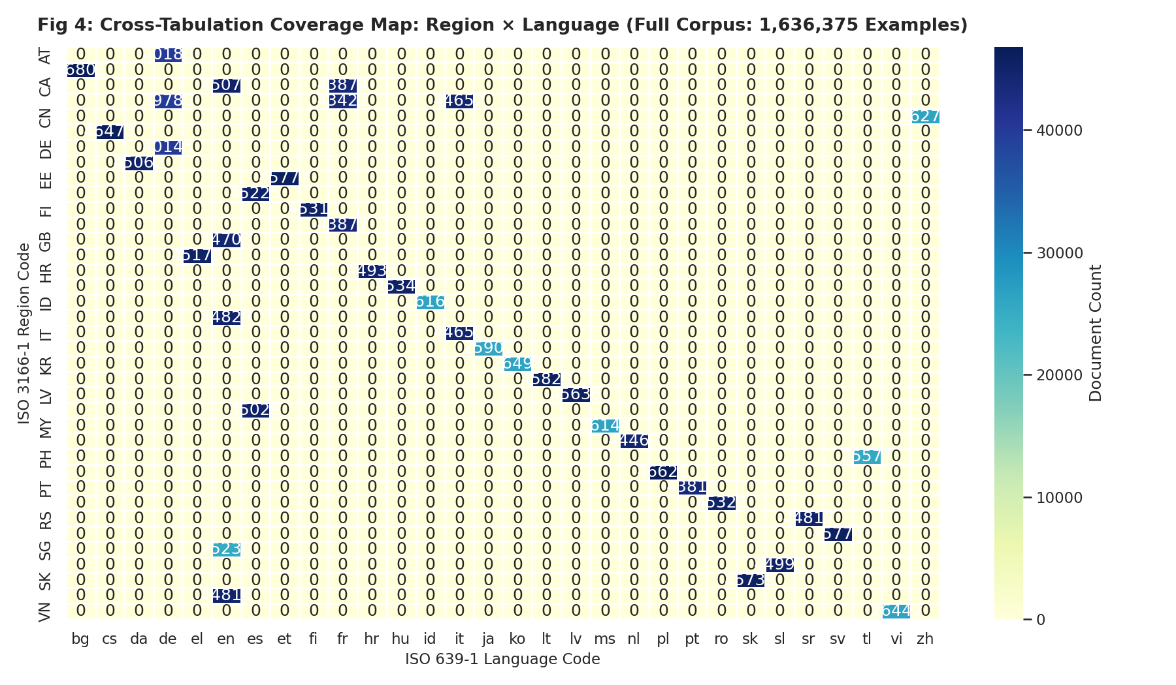  Figure 6. Region × language coverage map.
  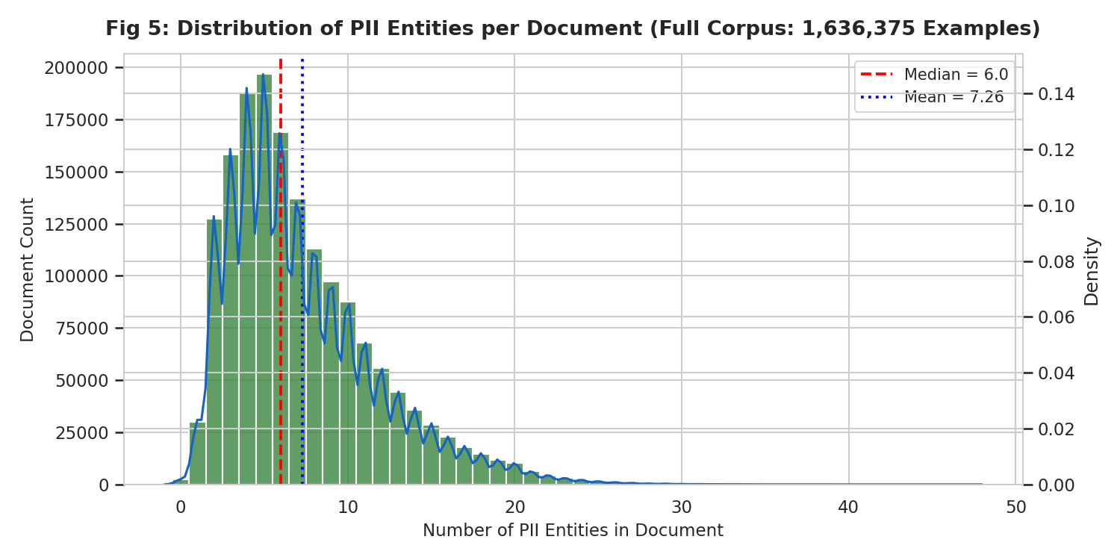  Figure 7. PII entities per document distribution. | 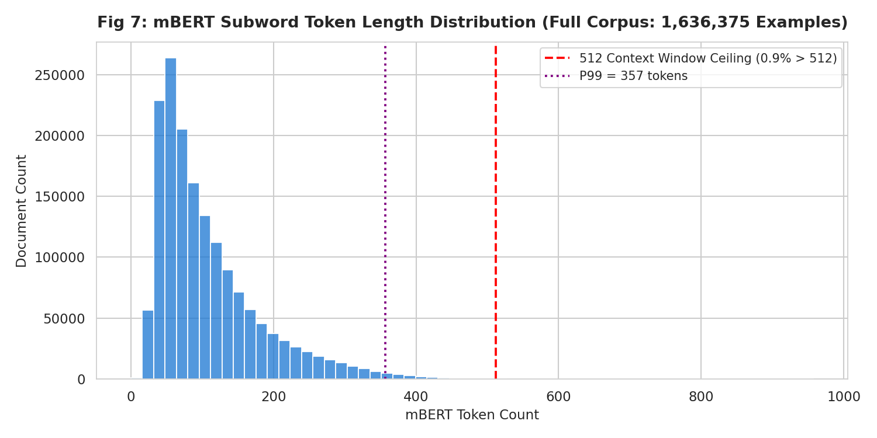  Figure 8. mBERT token length distribution with 512-token ceiling.
  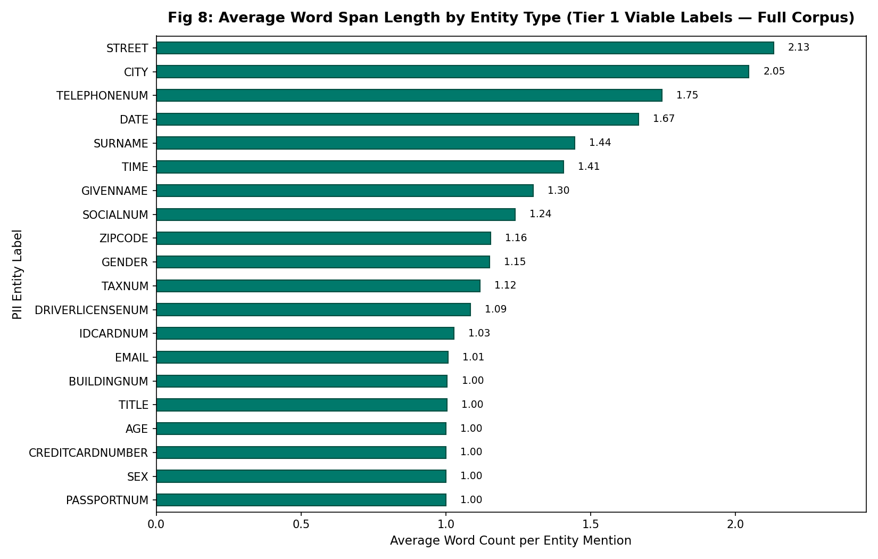  Figure 9. Average word span length by entity class. | 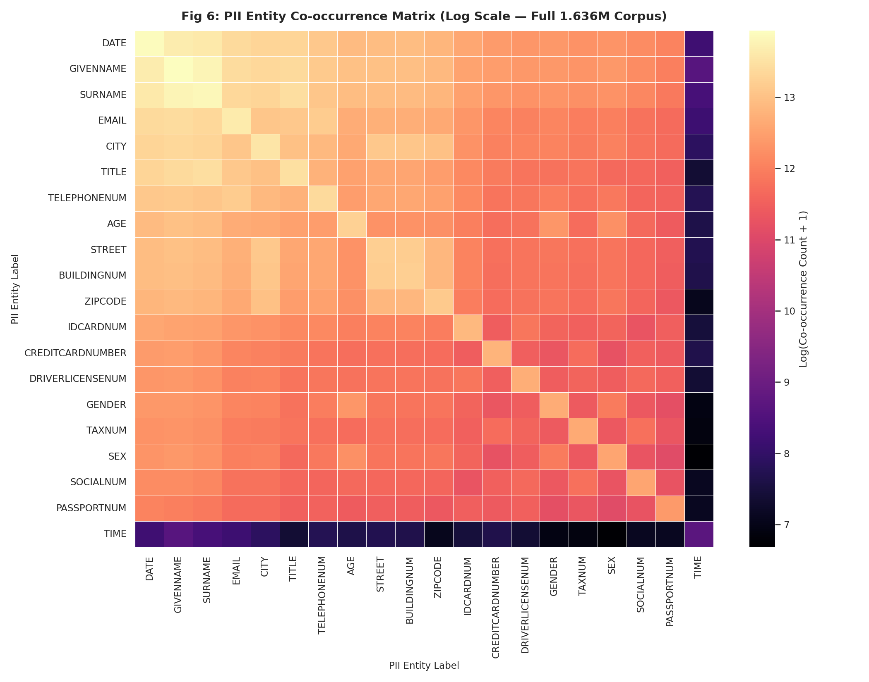  Figure 10. Entity co-occurrence matrix (log scale).
  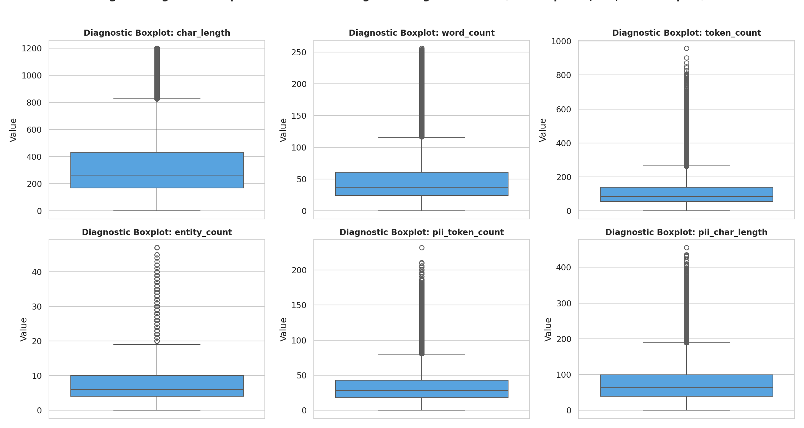  Figure 12. Diagnostic boxplots of document lengths. | 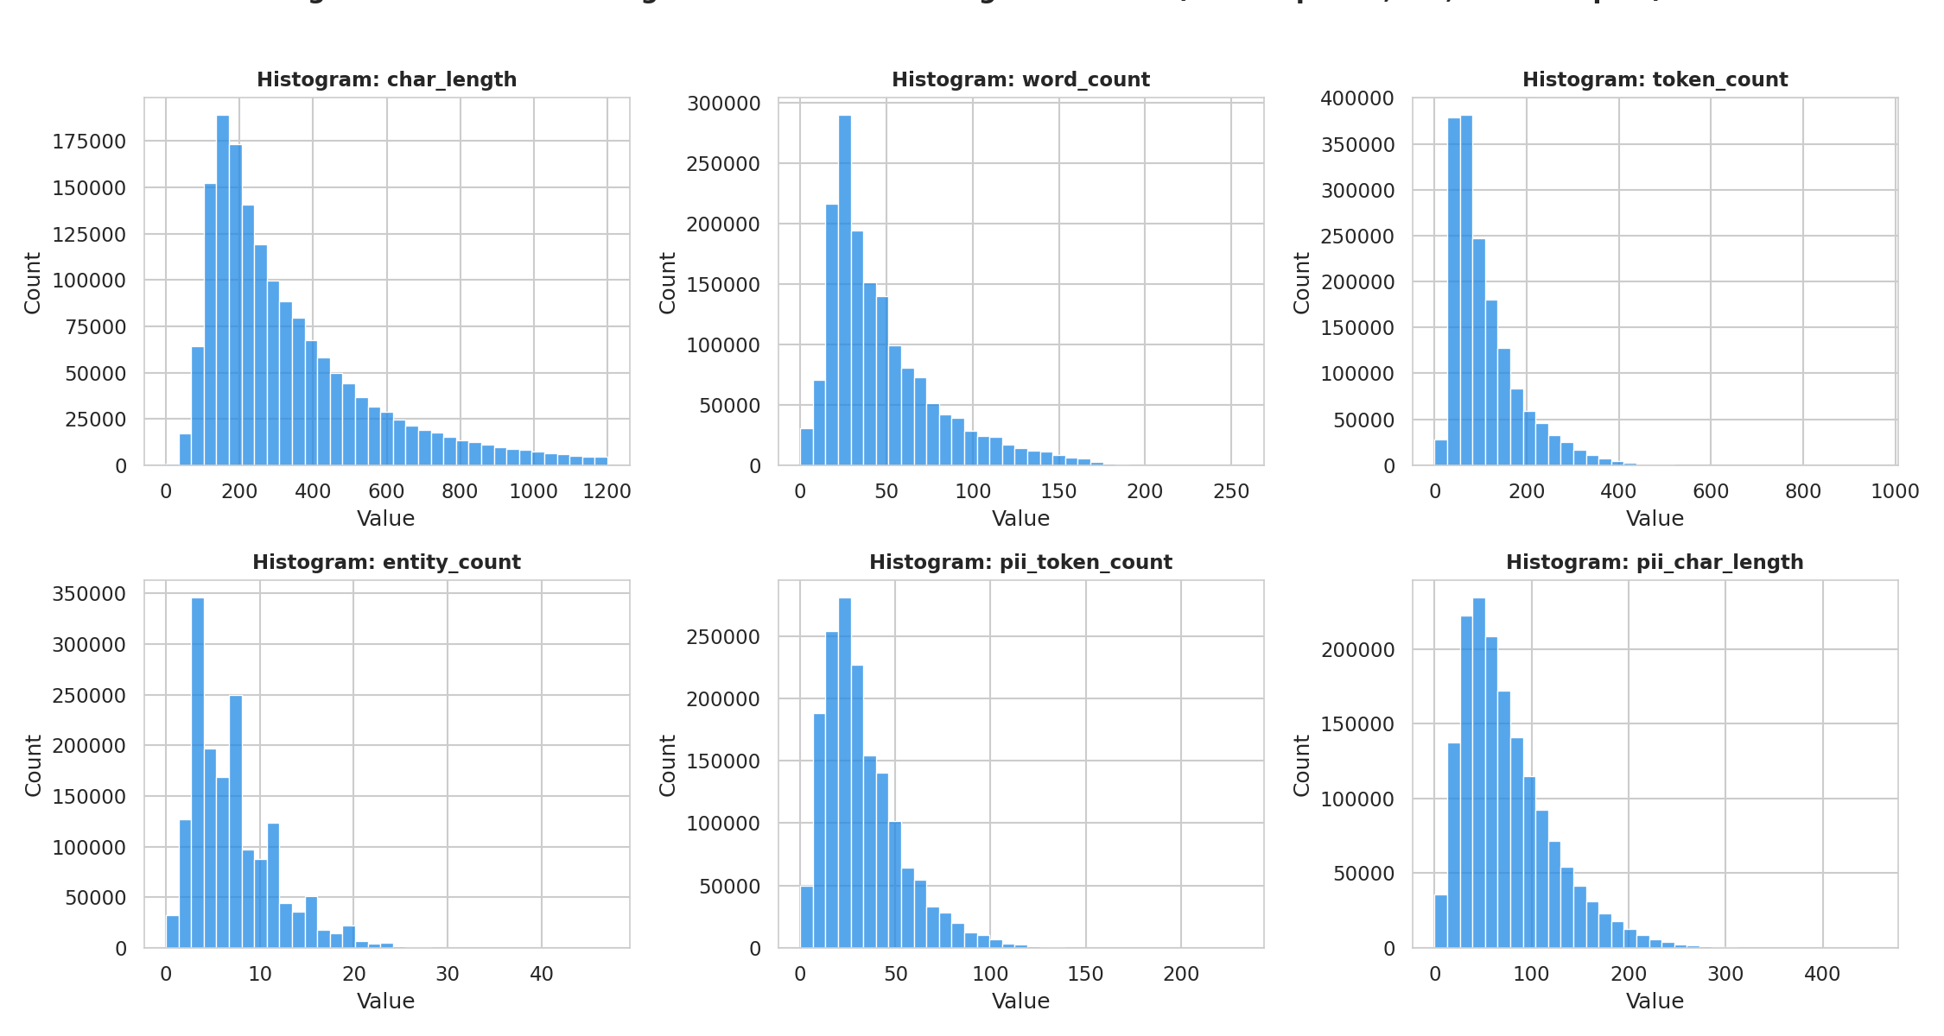  Figure 13. Pre-cleaning distribution histograms.
  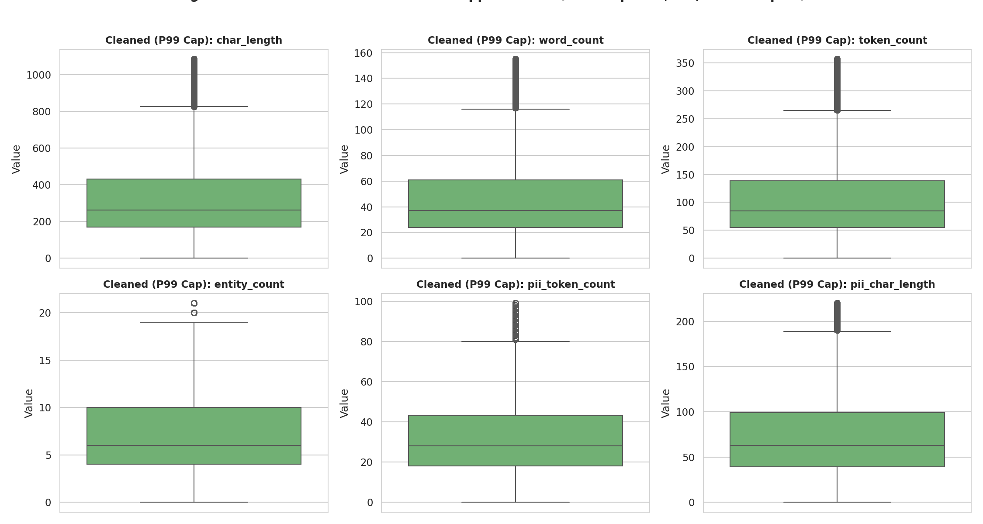  Figure 14. Winsorised boxplots at P99. | 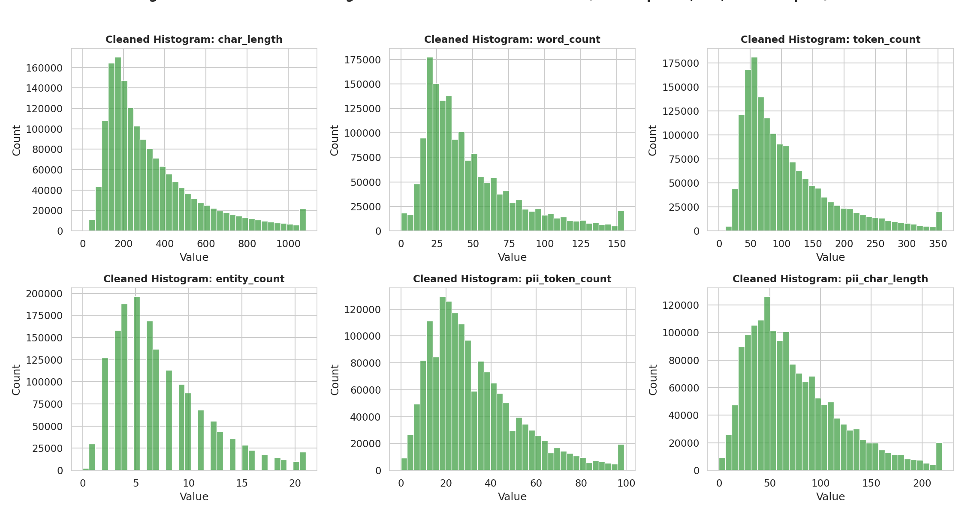  Figure 15. Cleaned distribution histograms.
  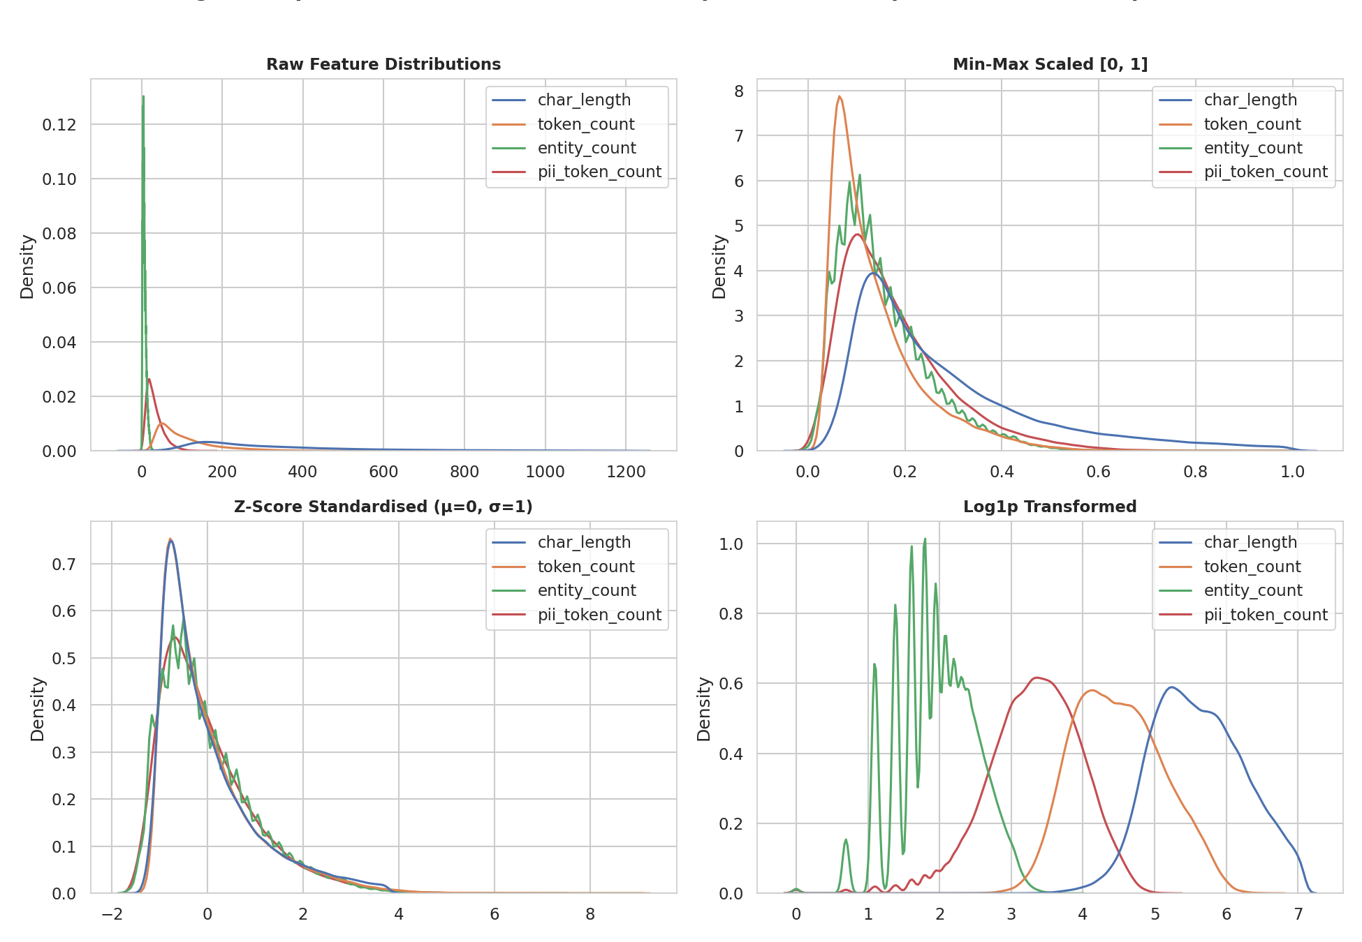  Figure 16. Raw vs MinMax vs Z-score vs Log1p transform. | 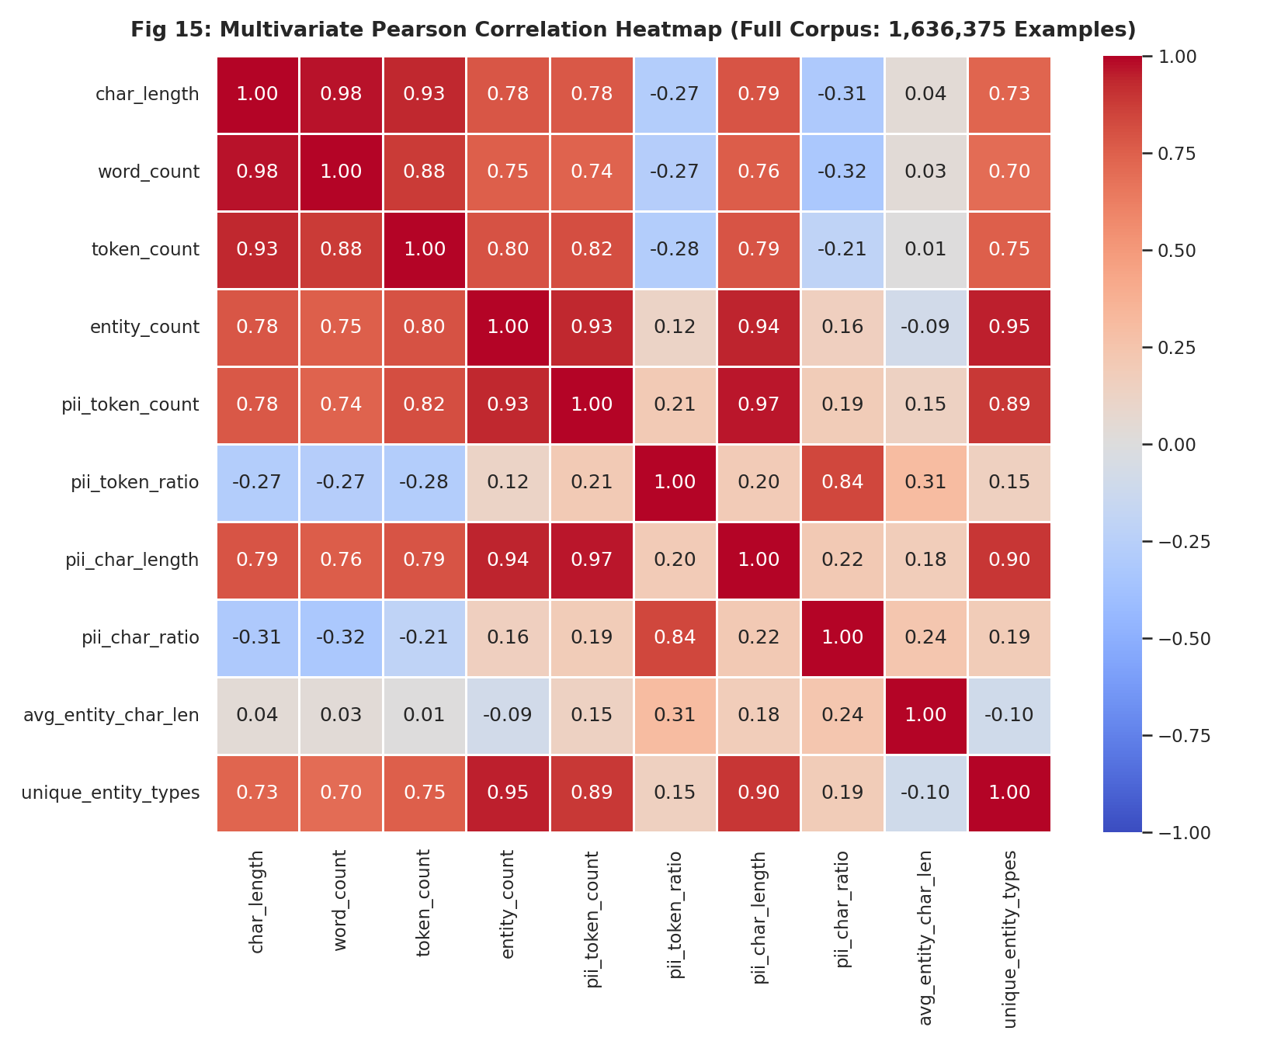  Figure 17. Multivariate Pearson correlation matrix.
  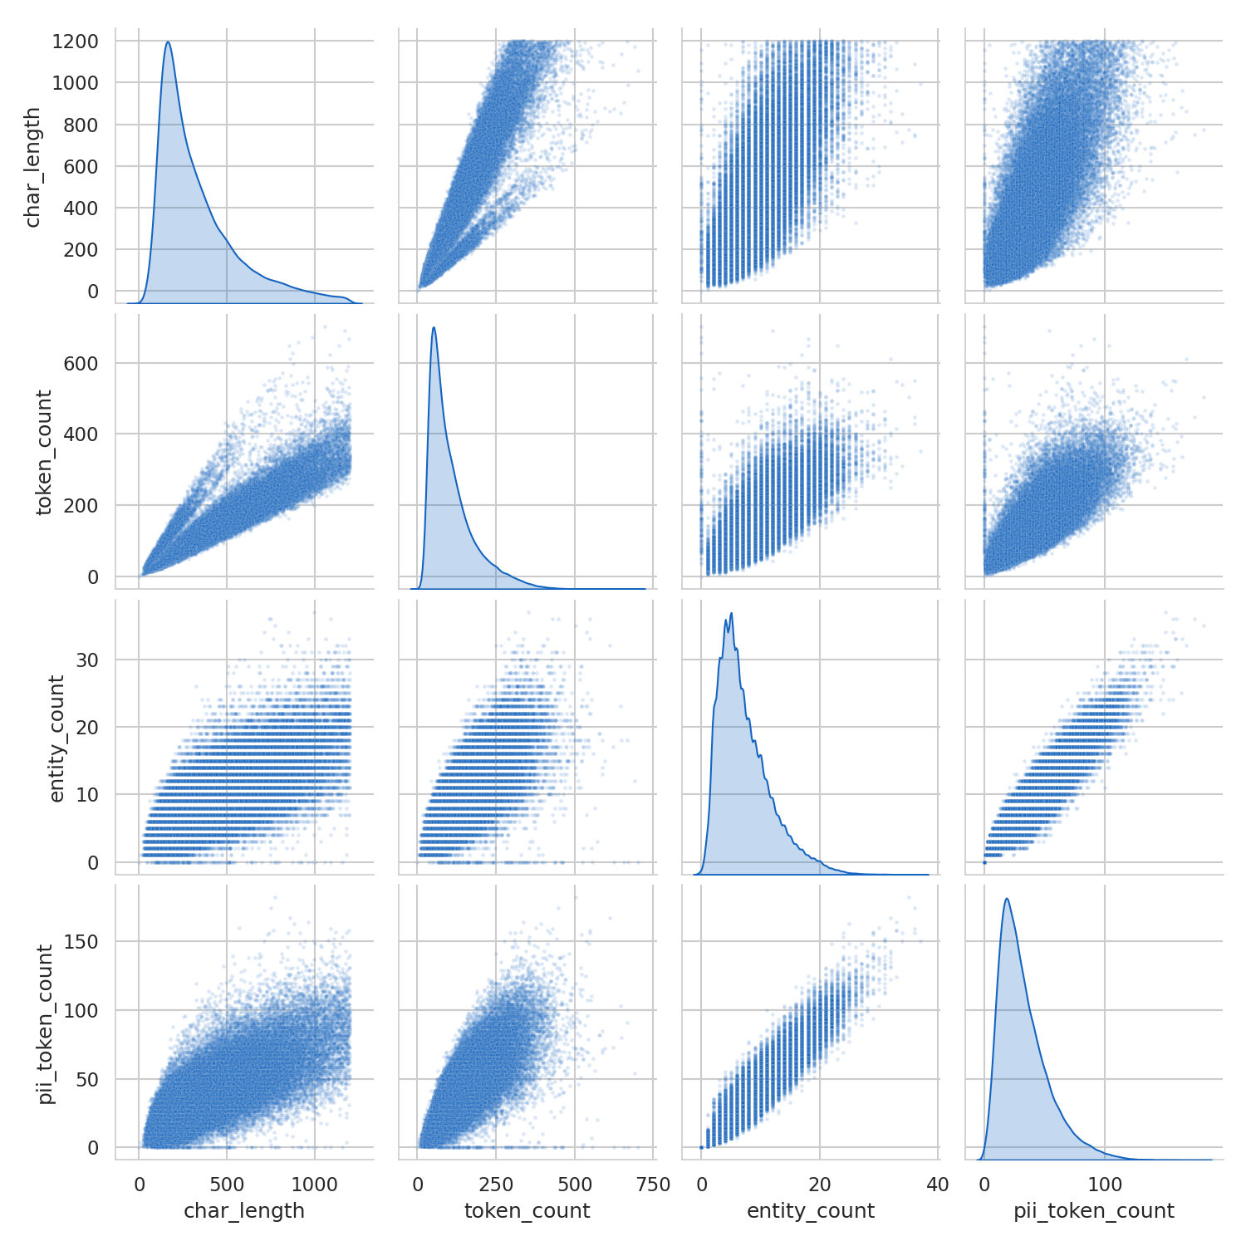  Figure 18. Bivariate pair plot (100k subsample). | 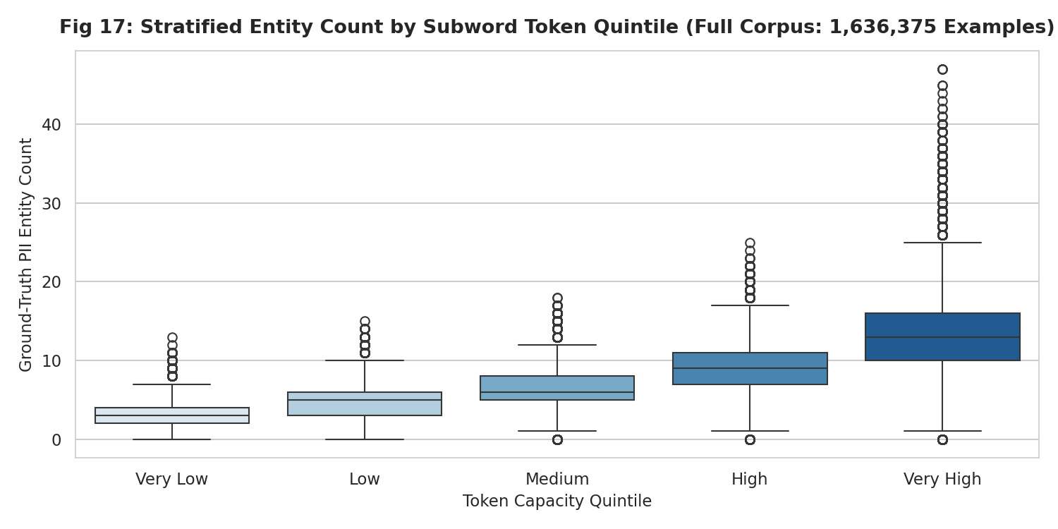  Figure 19. Entity count by token capacity quintile.
  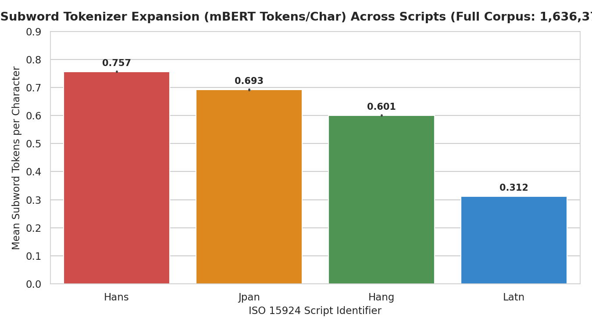  Figure 20. CJK vs Latin subword expansion (2.4× for Chinese). | 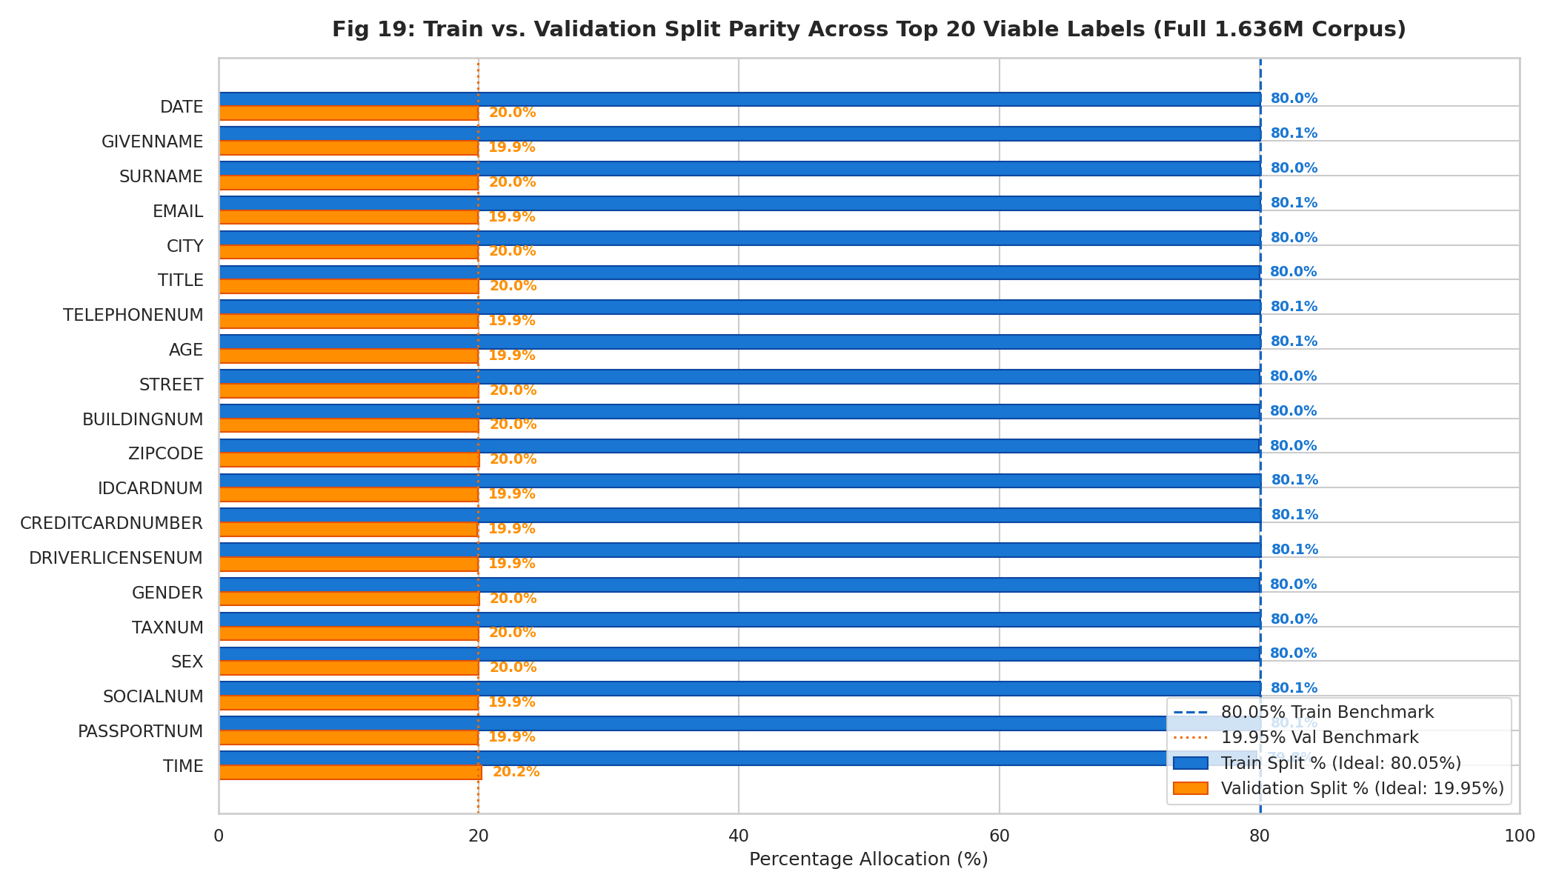  Figure 21. Train/val split parity across viable labels. | 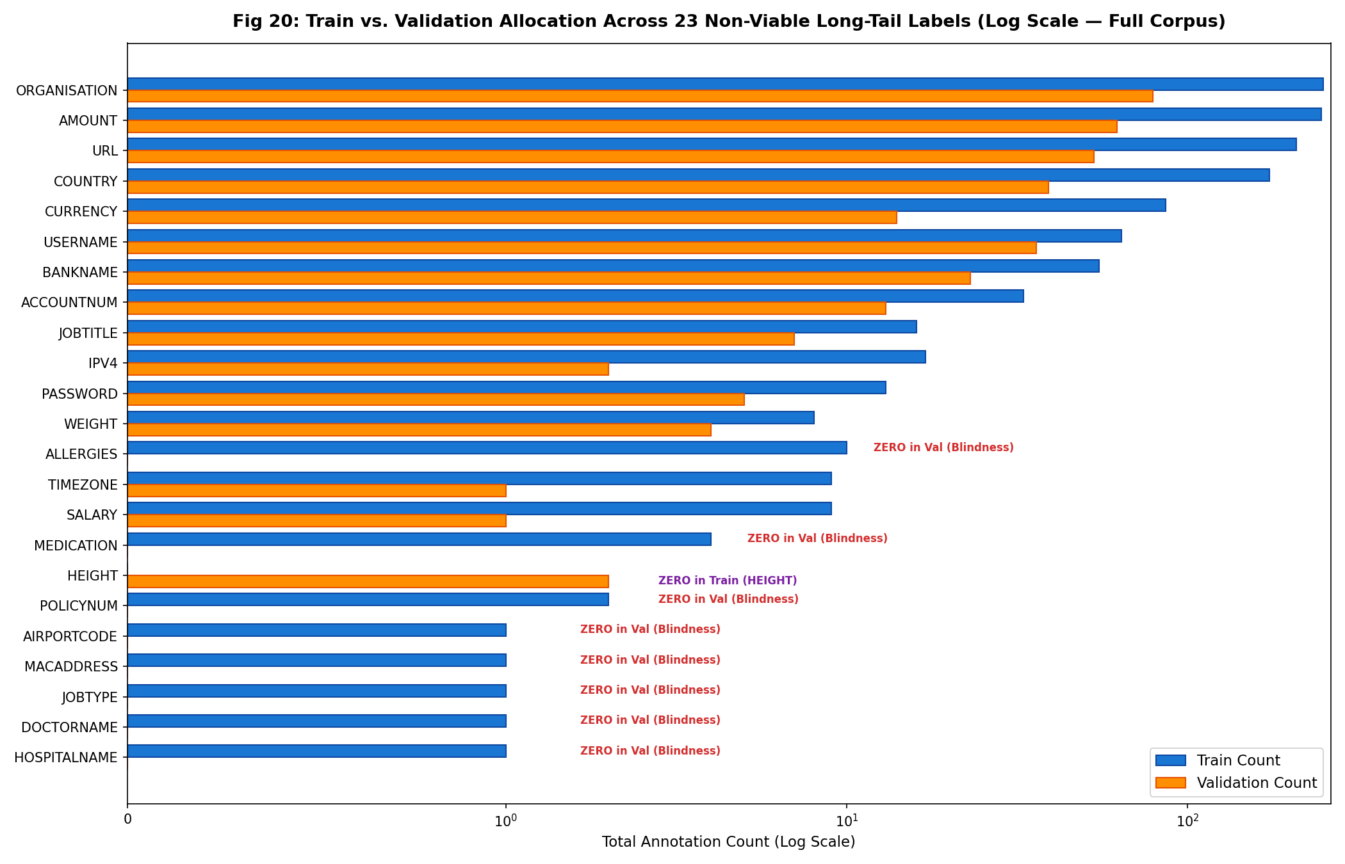  Figure 22. Validation blindness on 23 long-tail labels.
   | Repository  github.com/Schnitze1/Poco
  Live Demo
  littlepoco.me
   | Full EDA Report  Scan for full-corpus analysis

Poco — Preserve Originals, Conceal Only | October 2026

