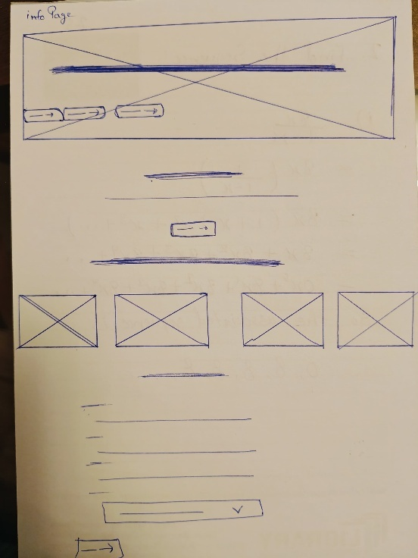**Info page wireframe for desktop**

**Info page wireframe for mobile**

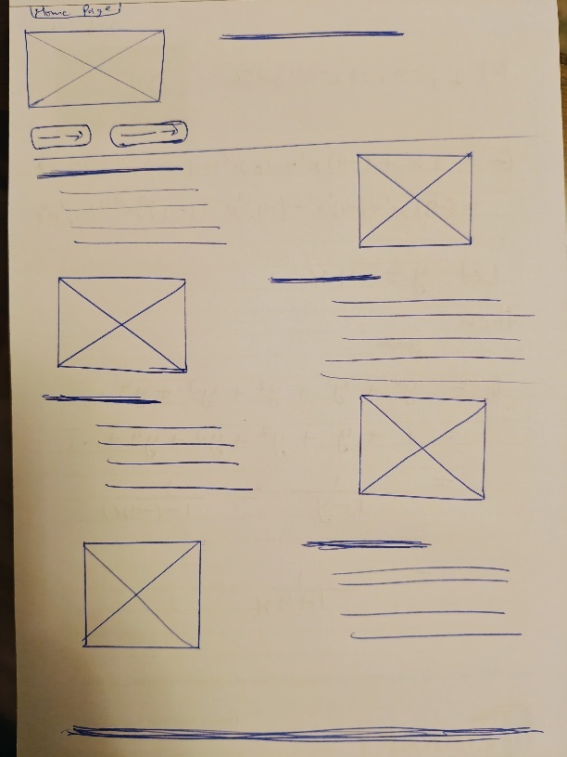**Home page wireframe for desktop**

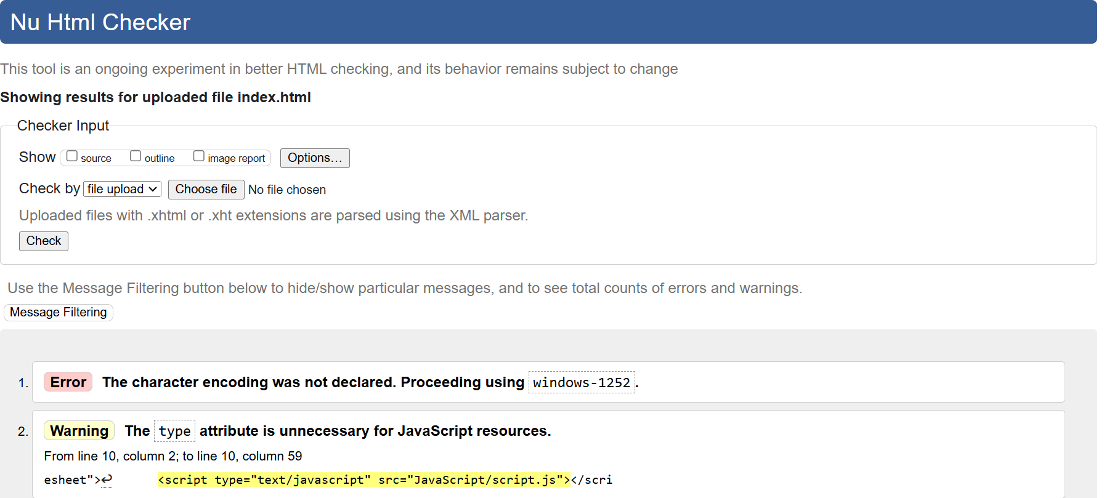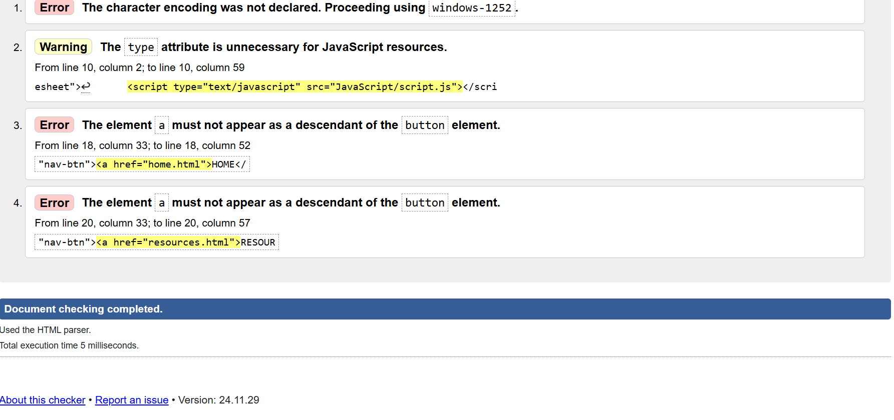

**HTML validation screenshot for index page**

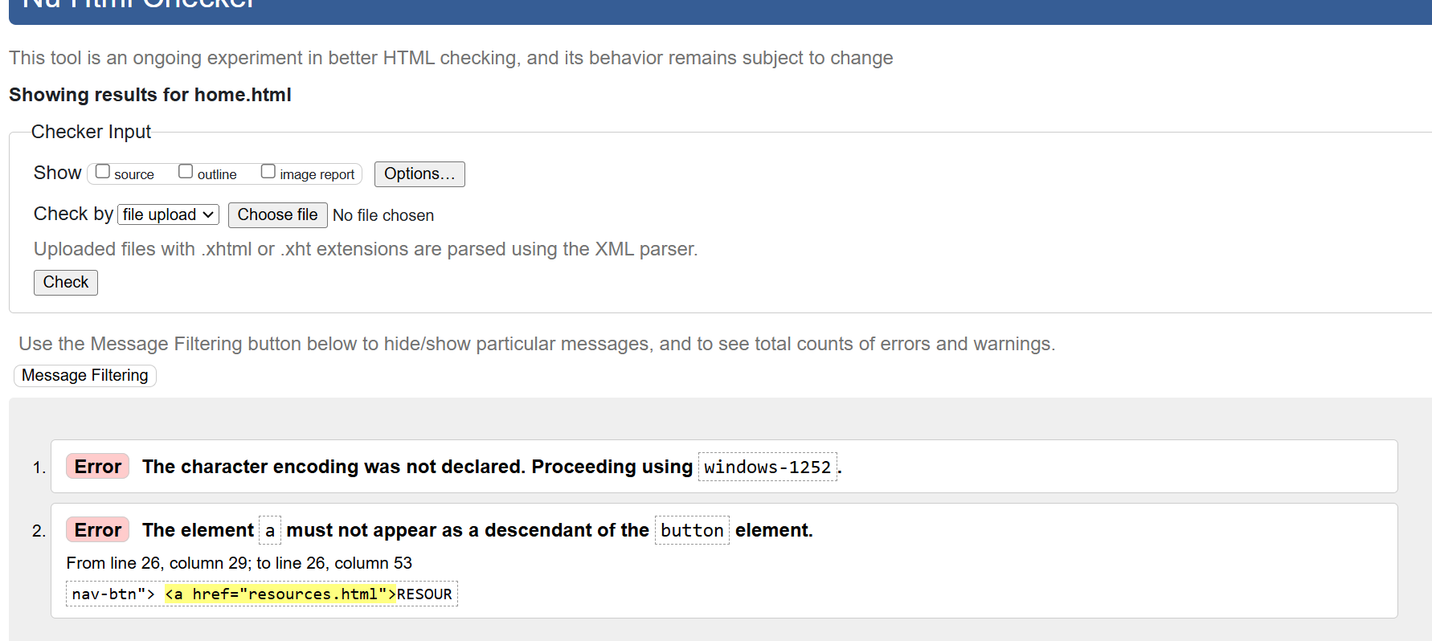

**HTML validation for home page**

**References**

**https://www.classvr.com/blog/use-of-technology-in-education-a-complete-guide/**

**Github  
https://github.com/Schnoig/group-project**