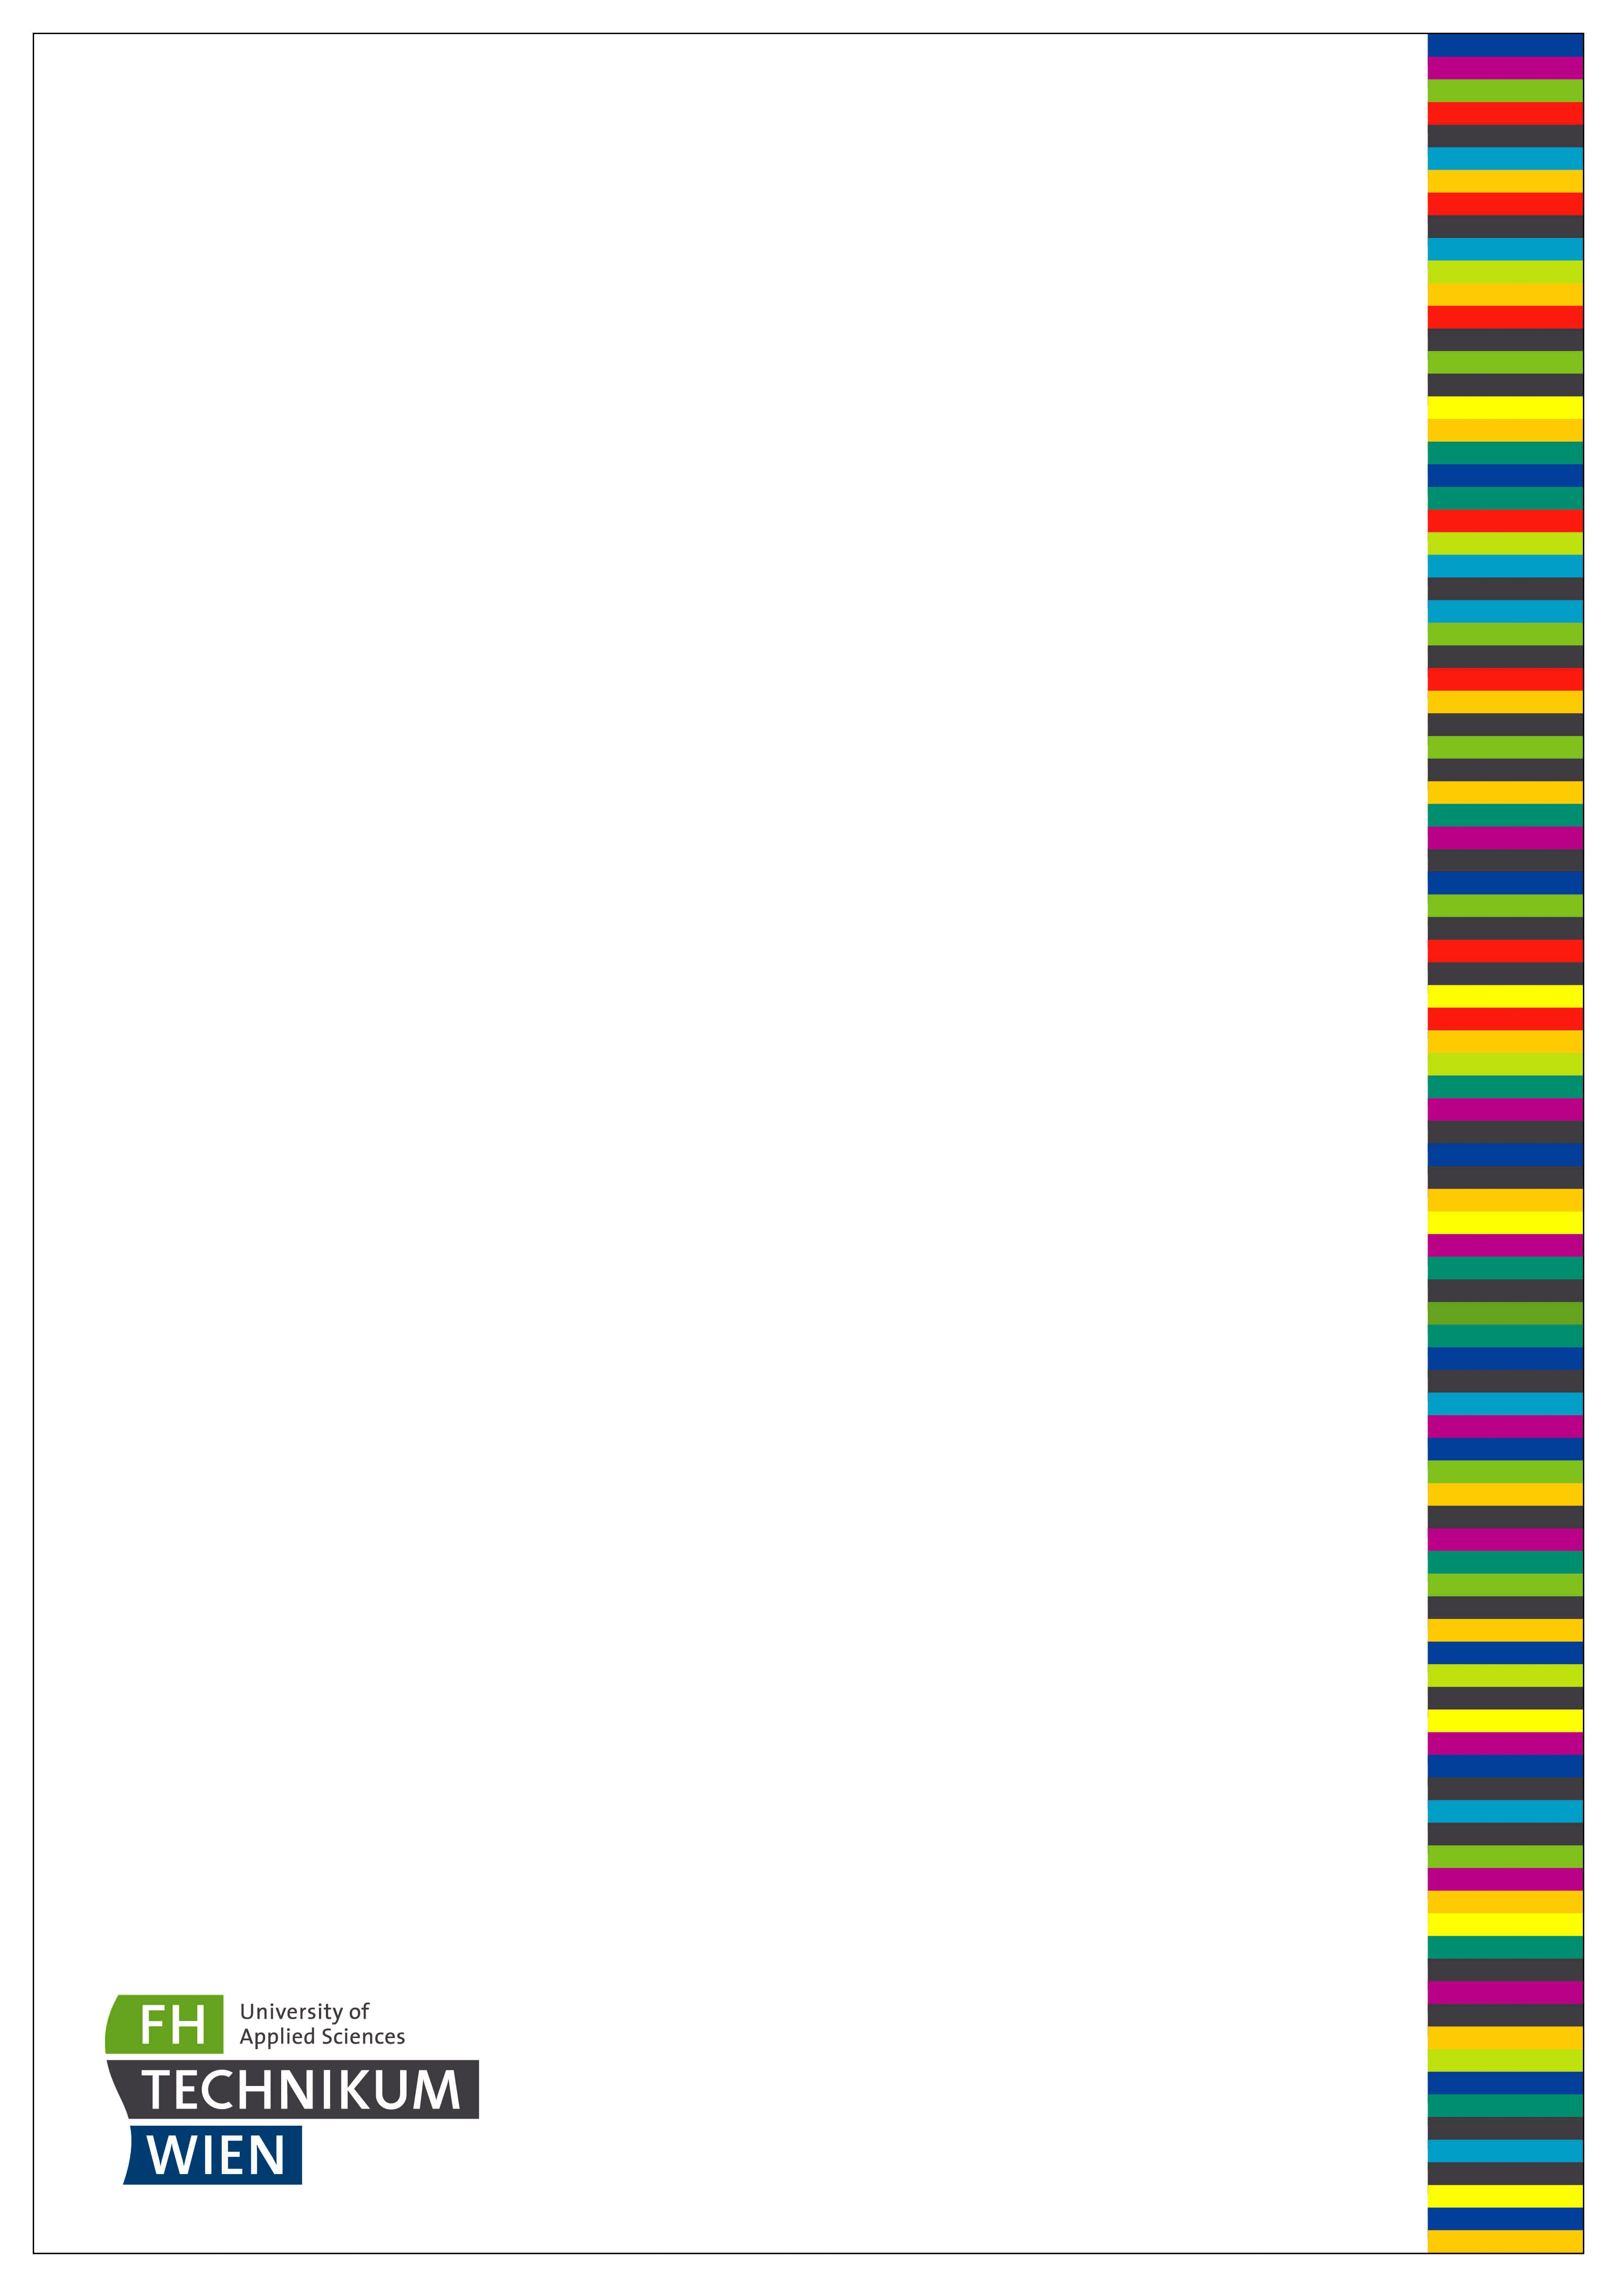

MASTER THESIS

Thesis submitted in partial fulfillment of the requirements for the degree of Master of Science in Engineering at the Univer-sity of Applied Sciences Technikum Wien - Degree Program Game Engineering and Simulation Technology

Using LLVM/Clang to abide cache conscious data layout principles, yet maintain the ab-straction level of Object Oriented Program-ming

How compiler technology could possibly build a bridge between conflicting programming paradigms

By: Julian Müller, BSc.

Student Number: 1610585015

Supervisor: Stefan Reinalter, Dipl.-Ing.

Second Supervisor: Alexander Hofmann, FH-Prof. Dipl.-Ing.

Wien, May 7, 2019

Declaration

“As author and creator of this work to hand, I confirm with my signature knowledge of the rele-vant copyright regulations governed by higher education acts (see Urheberrechtsgesetz /Aus-trian copyright law as amended as well as the Statute on Studies Act Provisions / Examination Regulations of the UAS Technikum Wien as amended).

I hereby declare that I completed the present work independently and that any ideas, whether written by others or by myself, have been fully sourced and referenced. I am aware of any con-sequences I may face on the part of the degree program director if there should be evidence of missing autonomy and independence or evidence of any intent to fraudulently achieve a pass mark for this work (see Statute on Studies Act Provisions / Examination Regulations of the UAS Technikum Wien as amended).

I further declare that up to this date I have not published the work to hand nor have I presented it to another examination board in the same or similar form. I affirm that the version submitted matches the version in the upload tool.“

Wien, May 7, 2019 Signature

Abstract

This work will prospect the possibility of using compiler technology as a mediator between the conflicting programming paradigms/philosophies OOP and DoD.
While Object-oriented programming is often praised for its benefits on abstraction and main-tainability, it encourages programmers to design inefficient datalayouts. Specifically in game engineering, where performance is a constitutive factor for a product’s success, data oriented solutions and influences are on the rise. While it is debated, whether or not performant data layouts inevitably entail challenging maintenance, surely the base concepts of objects are well observable in a game. Therefore this will be an attempt to make object-oriented programming a valid option for ever rising demands on performance.

To do so this thesis will investigate key concepts of both paradigms, as well as hardware specifics in modern computer architectures to explicate the reasons for their good/bad inter-action with the hardware.
A prototypical implementation of a source-to-source transformation tool called COOP (Cache friendly Object Oriented Programming), developed in Clang’s LibTooling environment, will de-termine whether or not compiler technology can be used to achieve a performance optimization on a classically OOP abidant target code base.

Keywords: Object Oriented Programming, OOP, Structure Of Arrays, SOA, Data Oriented Design, Compiler, LLVM, Clang

Acknowledgements

Special thanks for proof reading, support and guidance goes to Stefan Reinalter, Sonia Müller

and the active community of the LLVM/Clang mailing lists.

Contents

1 Conflicting Paradigms |  |  | 1
1.1 | Object Oriented Programming / AOS . . . . . . . . . . . . . . . . . . . . . . . . . |  | 1
1.2 | CPU Caches and why they don’t fit objects . . . . . . . . . . . . . . . . . . . . . |  | 3
 | 1.2.1 | Common data access patterns vs. Monolithic class definitions . . . . . . | 3
 | 1.2.2 | A brief history of memory . . . . . . . . . . . . . . . . . . . . . . . . . . . | 4
 | 1.2.3 Cache modules and types . . . . . . . . . . . . . . . . . . . . . . . . . . . |  | 6
 | 1.2.4 | The CPUs cache utilization . . . . . . . . . . . . . . . . . . . . . . . . . . | 7
1.3 | Data Oriented Design . . . . . . . . . . . . . . . . . . . . . . . . . . . . . . . . . |  | 9
 | 1.3.1 | OOP and bad abstraction . . . . . . . . . . . . . . . . . . . . . . . . . . . | 9
 | 1.3.2 | Normalization of Data . . . . . . . . . . . . . . . . . . . . . . . . . . . . . | 12

- Structure of Arrays / SOA . . . . . . . . . . . . . . . . . . . . . . . . . . . 13

- Regarding temporal- and spatial locality . . . . . . . . . . . . . . . . . . . 16

2 Motivation | 22

- Native language support for DoD principles / ISPC / JAI . . . . . . . . . . 23

- High level abstraction hiding DoD . . . . . . . . . . . . . . . . . . . . . . . 24

3 | Compiler technology as a mediator between OOP and DoD |  | 25
 | 3.1 | A compiler’s understanding of the program . . . . . . . . . . . . . . . . . . . . . | 25
 | 3.2 | A useful interface / LibTooling . . . . . . . . . . . . . . . . . . . . . . . . . . . . . | 26
4 | A prototypical implementation for a source-to-source transformation tool gen-
 | erating cache friendly code / COOP |  | 29

- Stand Alone Tool . . . . . . . . . . . . . . . . . . . . . . . . . . . . . . . . . . . . 30

- Automated split-candidate evaluation through static analysis . . . . . . . . . . . . 32

4.2.1 | Data aggregation . . . . . . . . . . . . . . . . . . . . . . . . . . . . . . . . | 33
4.2.2 | Metric for evaluation of field usages . . . . . . . . . . . . . . . . . . . . . | 34

4.2.3 Field weight heuristics . . . . . . . . . . . . . . . . . . . . . . . . . . . . . 40

- COOP’s affect on the data layout . . . . . . . . . . . . . . . . . . . . . . . . . . . 50

4.3.1 Hot data allocations we want to adapt . . . . . . . . . . . . . . . . . . . . 52

- Customized memory management for split records / COOP’s free list . . . 53

- Structure Padding and field reordering . . . . . . . . . . . . . . . . . . . . 59

5 Source transformations and pitfalls of semantic integrity | 62
5.0.1 Redirecting cold field access to the externalized subset . . . . . . . . . . | 64

