Networking with the BDFP1 A8SD
(Embedded Compact 7 (EC 7.0))

Networking means:
a)
With the BDFP1 program management menu a user is able to read and write sewing program files to and from a network file server drive over an ethernet LAN connection.

b)
Additional with the VNC Server / Client Tools it is possible to redirect the BDF P1 screen and Touch keys to any remote PC for remote maintenance reasons.

BDFP1 program manager
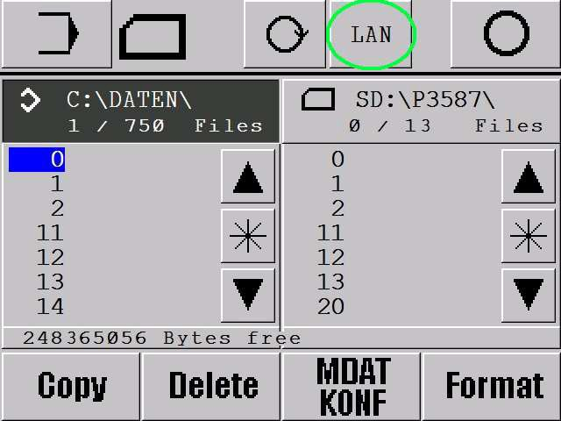
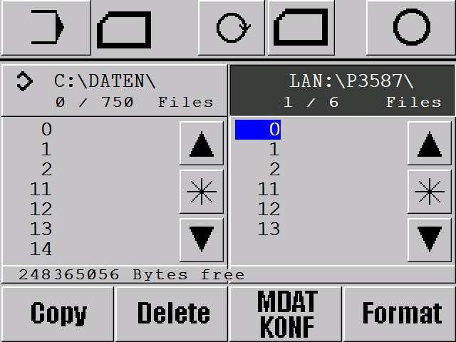

After pressing the LAN Button you will see on the right side the network folder with the sewing programs.

For this the following network infrastructure is necessary:
A LAN (TCP IP) based Network with an unblocked folder (free file server folder). Microsoft Windows File Server with Microsoft Active Directory.
or
Linux File server with Microsoft Active Directory emulation (SAMBA with SMB-Protokoll)
or
Any other File server which supports Microsoft Active Directory (SAMBA with SMB-Protokoll)

It is possible to choose between:

- All machines use the same common network folder where all program files are stored for all.
- Every machine uses their individual network folder for the programs. To achieve this the following network data are necessary:
Static or dynamic via DHCP IP address assignment ?

IP address of the default gateway IP address of the DNS name server
The domain name that is used by the network to which the device is connected IP address of the device (Bdf-P1)
The subnet masks to be used with the IP interfaces bound to the adapter IP address of the WINS name server
Now it would be a good idea to test the network connection unter WinCE first before all this data are entered into the machine *.ini files for the software application.

To use the WinCE or Embedded Compact 7 OS functions you can connect an USB mouse to the BDFP1 and press then the right mouse button after power on is finished.
Now you are able to choose the WinCE functions.
First terminate the BDFP1.exe by pressing Datei beenden cancel.

In the WinCe command Prompt (Start.Programs.Command Prompt) you can type text via the virtual mouse keyboard (this can be found on the lower right corner).

!!!! All netwok payload data are only an example of course !!!!!

ping 192.168.10.1 // testing the Gateway or server IP Adress

ping filesrv01 // testing the DNS Name Server function

net use Public \\filesrv01\public /user:pfaff\bdfp1 /password:pfaff1 // testing the file server access net use Public /d // testing disconnecting

After all command Prompt tests are successful, we can input the verified network data into the application ini files which are used by the machine software.

The *.ini files controls the network behaviour of the BDF-P1.exe These files are all stored in the folder \\SD Memory\NOR Flash\*.ini

BdfP1_1.ini (SD Card path and network path).
Netzwerk.ini (optional) network settings
NoDhcp.ini (optional) If static IP address is wanted. If not existing then DHCP is selected.

You can edit these files in the WinCE Microsoft WordPad or you can edit these files on any PC and copy them back into \\SD Memory\NOR Flash\*.ini.

After every manipulation of files you have to wait 3..5s before switching off the BDFP1. WinCE needs some seconds to flash the changes in the background into the flash Memory.

Example: BdfP1_1.ini
\SD Memory2
\network\public\maschine
\

SD Memory is the path to the SD Card Reader.
network\public\maschine is the path to the start directory of the network.
public is the local alias name of the remote file server drive. maschine is the remote directory in the file server.
Netzwerk.ini

pfaff\bdfp1 pfaff1 Public
\\filesrv01\public
// Row 1: username of the device in the
// Row 2: password to be used for the network
// Row 3: local network alias name (on the Bdf-P1 side)
// Row 4: network path in the network (for the local alias name)

Pfaff\bdfp1 Network Login user: Pfaff is the domain name (optional) and bdfp1 is the username
Pfaff1 Network Login password:
Public is the local alias name of the remote file server drive
\\filesrv01\public Servername and remote network drive name

NoDhcp.ini

192.168.10.1
192.168.10.1
pfaff 192.168.11.75
255.255.254.0
192.168.10.5
// Row 1: IP address of the default gateway
// Row 2: IP address of the DNS name server
// Row 3: the domain name that is used by the network to which the device is connected
// Row 4: IP address of the device (BDF-P1)
// Row 5: the subnet masks to be used with the IP interfaces bound to the adapter
// Row 6: IP address of the WINS name server (Windows Internet Naming Service)

If this file is present, then the IP address assignment is static
If this file is not present, then the IP address assignment is dynamic (DHCP)

VNC Server

With the VNC Server / Client Tools it is possible to redirect the BDF P1 screen and Touch keys to any remote PC for remote maintenance reasons.

For this the two files: CeVncSvr.exe and vncconfig.exe have to be copied to the BDFP1 folder
\SD Memory\*.exe

It is necessary to start vncconfig.exe with the mouse for password a setting. This must be done only once.

On the PC side UltraVNC_1.0.9.6.2_Setup.exe (VNC Client) has to be installed. The VNC Client requires the IP Address of the appropriate BDFP1.
On the BDFP1 side the CeVncSvr.exe (server) has to be started.

Both can be found and done in our machine application in the Info menu see below:

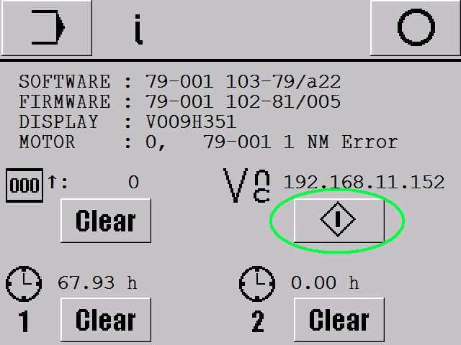

The seen IP address is the actual BDFP1 assigned IP address. With the Start button the BDFP1 VNC Server is started. After pressing this button again the VNC Server is stopped.

