**Impact of multidimensional parameters on the area of applicability (AOA) for machine learning based classifications**

The impact of training design and predictor variables on the prediction and AOA

**Master Thesis**

Andreas Schönberg B.Sc.1

1 Master student at the department of Geography, Philipps University of Marburg, Germany

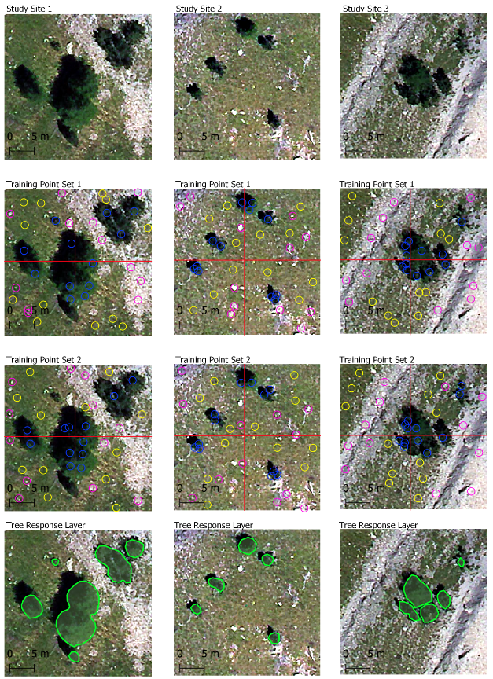

First supervisor: Dr. Chris Reudenbach2  
Second supervisor: Dr. Dietrich Göttlicher2

2 University lecturers at the department of Geography, Philipps University of Marburg, Germany

Submitted 31.03.2021