- All of the depth vs entity plot should like well log track with white tract (conventional plots where vertical scale is more)
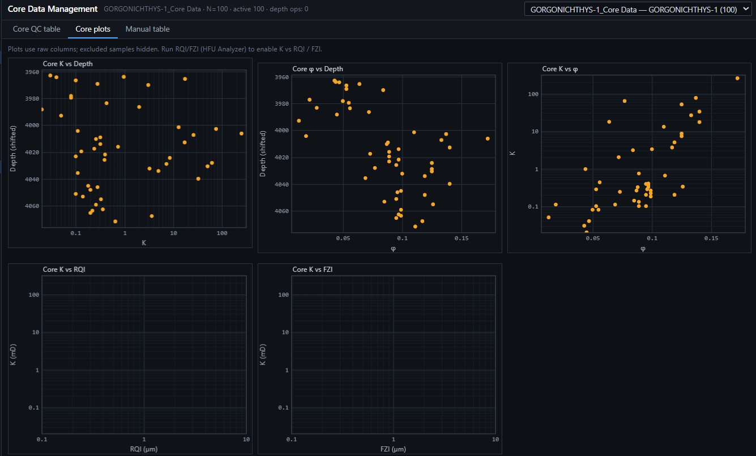
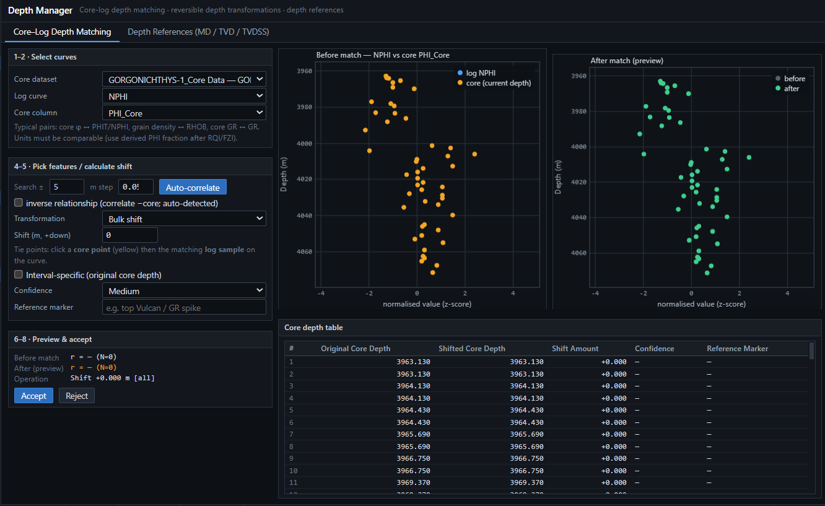
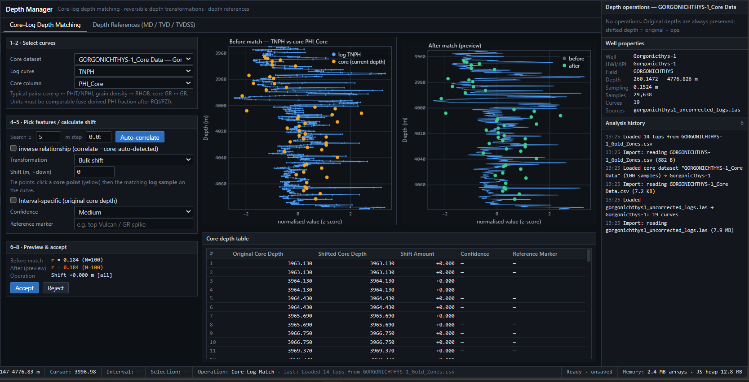
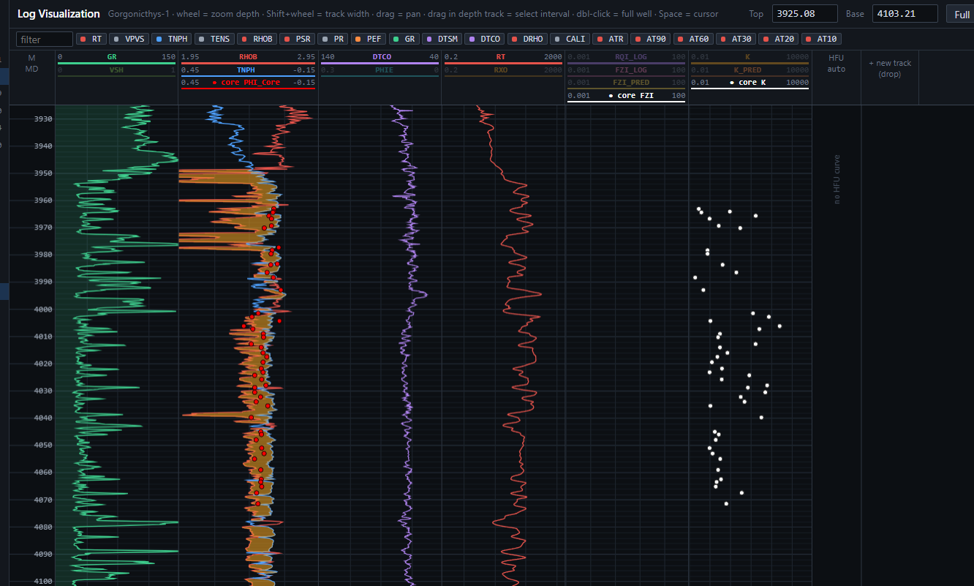

- I will add reservoir depth interval we will perform HFU analysis only in that reservoir. Not for all the zones where I have data.
- For zonation (in that csv file we have formation names and their depth as well)