User Api Screenshot(GET PUT POST)
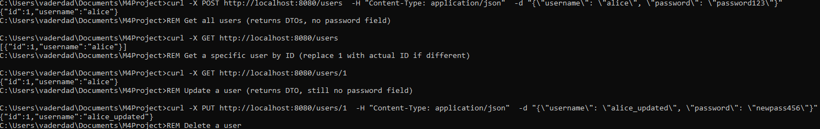
Task API Screenshot (GET PUT POST)
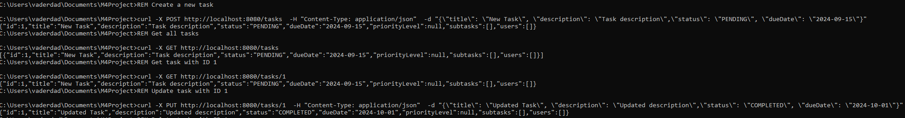
Task Relationships (Priority and Subtask)
Task Relationships (Many-to-Many)
Subtask API Screenshot(GET PUT POST)
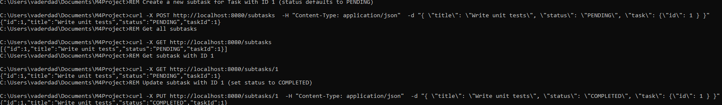
Subtask API Deletion Screenshot

