Addes Pizzas:
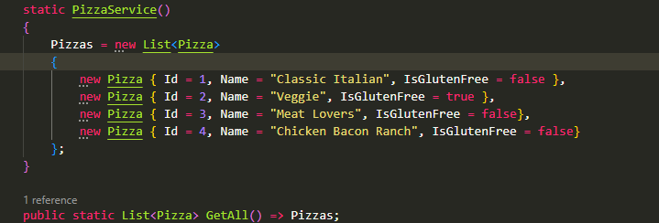
Get all:
GET {{ContosoPizza_HostAddress}}/pizza/
Accept: application/json
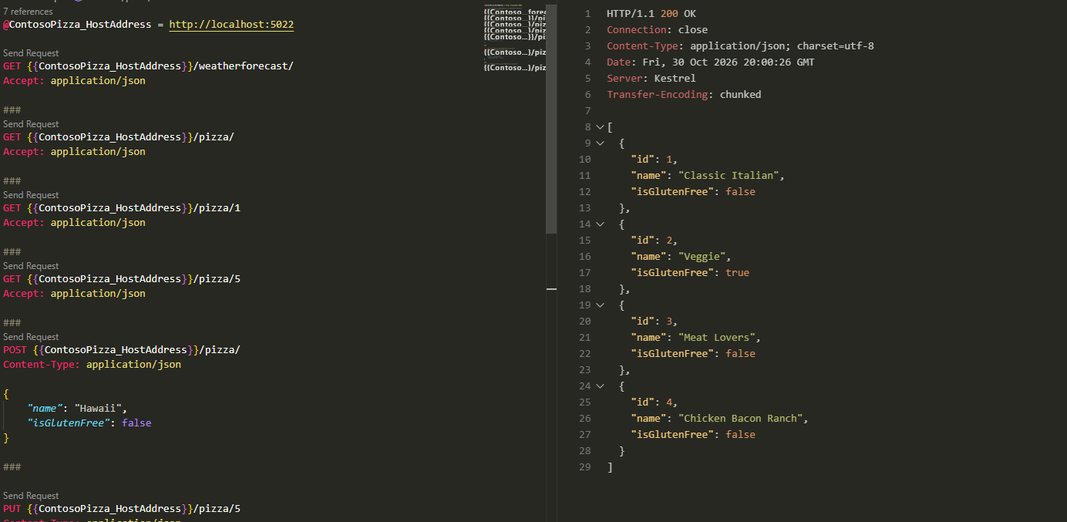

POST:
POST {{ContosoPizza_HostAddress}}/pizza/
Content-Type: application/json

{
"name": "Hawaii",
"isGlutenFree": false
}
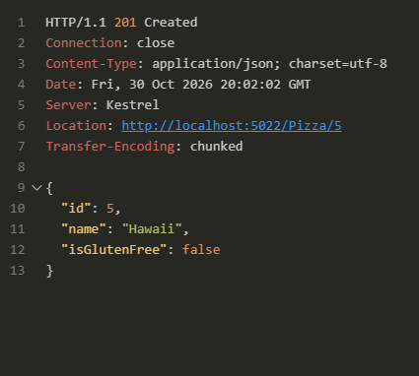

PUT:
PUT {{ContosoPizza_HostAddress}}/pizza/5
Content-Type: application/json

{
"id": 5,
"name": "Hawaiian",
"isGlutenFree": false
}
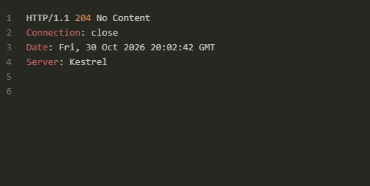

DELETE:
DELETE {{ContosoPizza_HostAddress}}/pizza/5
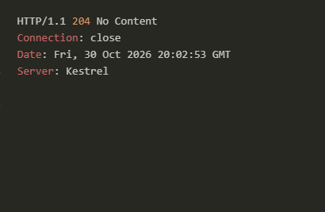

additional function to the Work with files and directories in a .NET app module:
void GenerateSalesSummaryReport(IEnumerable<string> salesFiles, double salesTotal, string reportPath)
{
StringBuilder report = new StringBuilder();

report.AppendLine("Sales Summary");
report.AppendLine("----------------------------");
report.AppendLine($" Total Sales: {salesTotal:C}");
report.AppendLine();
report.AppendLine(" Details:");

foreach (var file in salesFiles)
{
string salesJson = File.ReadAllText(file);
SalesData? data = JsonConvert.DeserializeObject<SalesData?>(salesJson);

report.AppendLine($" {Path.GetFileName(file)}: {data?.Total ?? 0:C}");
}

File.WriteAllText(reportPath, report.ToString());
}

