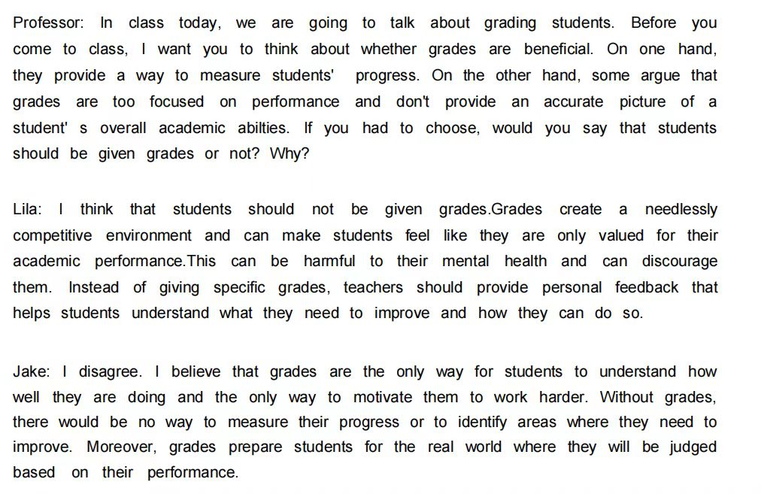

Lila presents an argument in favor of students should not be given grades.Jake poses a contrary opinion.Admittedly,Some students could feel discouraged and even suffer from psychological disorders because of their poor academic performance.However,considering in huge benefits brought by establishing beneficial evaluation standards,I am inclined to prioritize that we should establish a self-contained standard for each students.A complete judgement can improve comprehensive students’ quality instead of only academic grades.For example, social volunteering time is not a standard we should take lightly.If a student only study but not volunteer in their spare time ,they may can’t apply what they learn from the textbook to the reality.Only use academic performance to judge anyone doesn’t match the multiple evaluation system.Therefore,I firmly believe that give students an overall and well-established grades is a wiser decision.

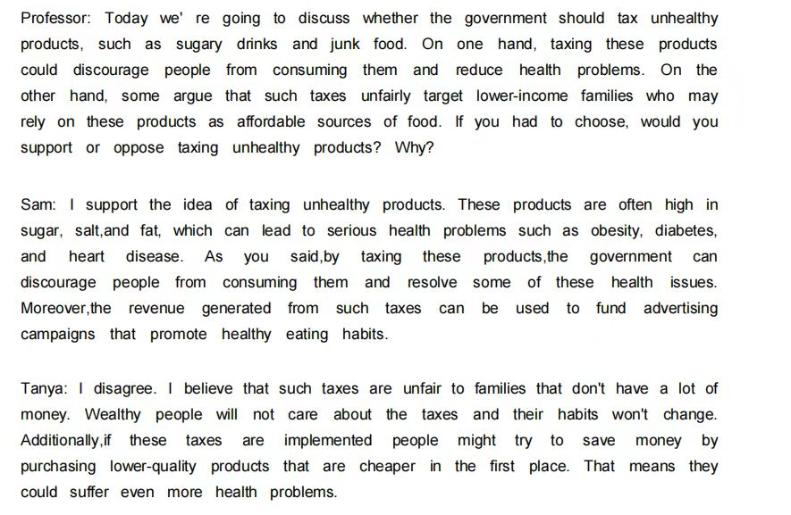

Sam presents an argument in favor of the idea of taxing unhealthy products.Tanya poses a contrary opinion.Admittedly,these unhealthy products are often high in sugar,salt,and fat,which can lead to serious health problems.However,considering in our original aim is to maintain people’s health,I am inclined to prioritize that government shouldn’t tax unhealthy products.As we all know, it is mostly the poor people that eat these unhealthy food .Only tax unhealthy products can’t figure out the problem but make poor people suffer even more health problems.The fundamental way to solve this problem is to boost income of poor people.In my opinion ,Encouraging work and rewarding companies for job creation can reduce inequality.When poor people earn more money ,they will not eat unhealthy food that often and they become more health.Therefore,I firmly believe that don’t tax unhealthy products is a wiser decision.

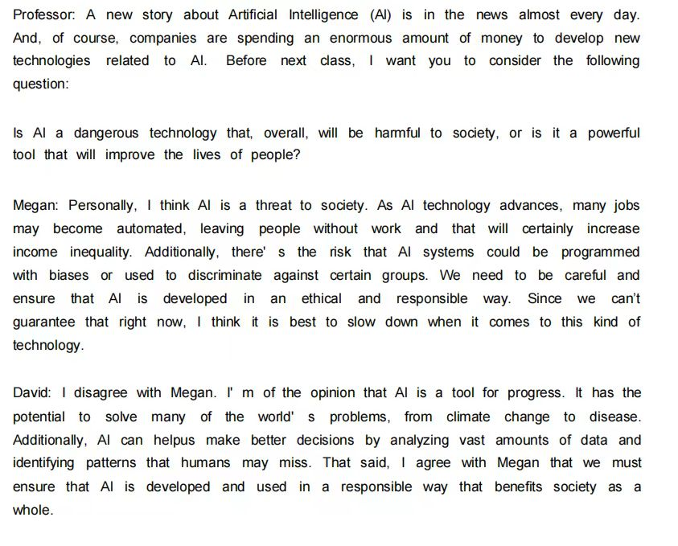

Megan presents an argument in favor of Al is a threat to society.Admittedly,many jobs may become automated,leaving people without work.However,considering in huge benefits brought by AI,I am inclined to prioritize that AI is a powerful tool that will improve the lives of people.In my opinion ,many jobs may become automated is not a negative phenomenon.People ,in that case ,should learn and improve themselves to competent for a new job,which has higher salary and technology than before .As the implement of deep learning and machine learning,AI has surpass people in some cases.Take ChatGPT

as an example,I usually ask it questions that confuse me in academic field and it can work out my problems perfectly and quickly .Sometimes, we have to learn from AI in some subjects such as the game of go.Therefore,I firmly believe that we should spend an enormous amount of money to develop new technologies related to Al.