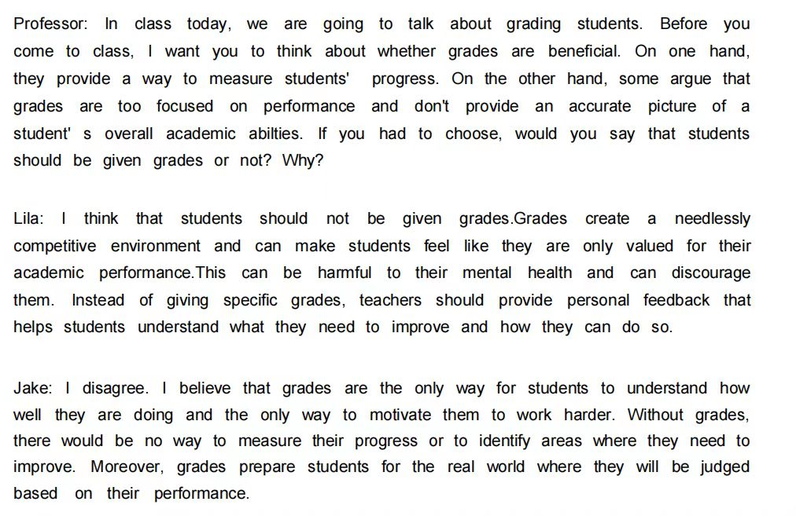

Lila presents an argument in favor of students ~~should~~ not being given grades. ~~Jake poses a contrary opinion.~~ Admittedly, some students could feel discouraged and even suffer from psychological disorders because of their poor academic performance. However, considering ~~in~~ huge benefits brought by establishing beneficial evaluation standards, I am inclined to prioritize that we should establish a self-contained standard for each student~~s~~. A complete judgement can improve ~~comprehensive~~ students’ comprehensive quality instead of only academic grades. For example, social volunteering time is not a standard we should take lightly. If a student only (concentrates on) study but not volunteer in their spare time, they ~~may~~ can’t apply what they have learned from the textbook to the reality. Only using academic performance to judge anyone doesn’t match the multiple evaluation system. Therefore, I firmly believe that give(giving) students an overall and well-established grades is a wiser decision.

Sample Answer: I strongly agree with Lila' s idea that grades can create an overly competitive environment and may not accurately reflect a student' s progress. I' d add that grades can lead to a focus on test-taking strategies rather than true learning, and as a result, students may not fully engage with the material. Jake raised the relevant point that grades are the only way to identify the specific areas where students are weak, but he didn't mention that teachers can study samples of their students' work to find their weaknesses without actually grading the work. For example, they could look at a student's essay, see that he is weak when it comes to grammar and tell him that in person. Overall, then, I would say that students don't actually need to be graded.

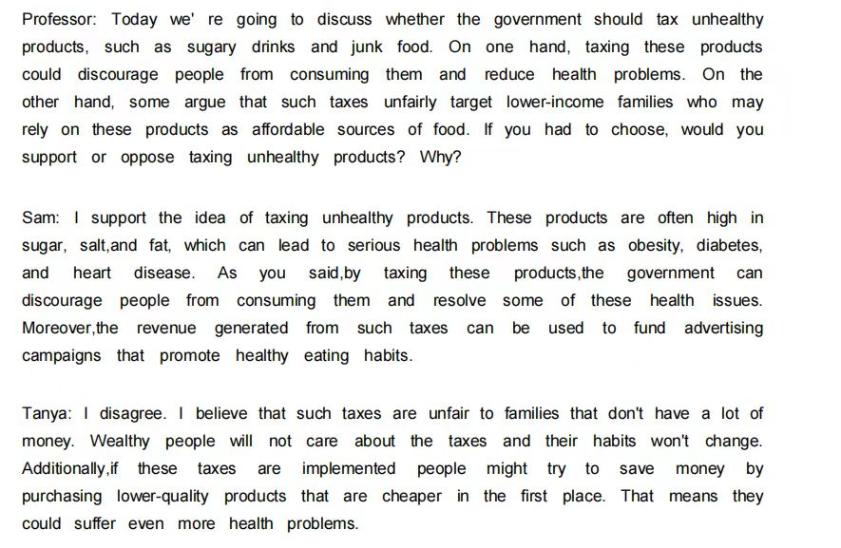

Sam presents an argument in favor of ~~the idea of~~ taxing unhealthy products. ~~Tanya poses a contrary opinion~~. Admittedly, these unhealthy products are often high in sugar, salt, and fat, which can lead to serious health problems. However, considering ~~in~~ our original aim that is to maintain people’s health, I am inclined to prioritize that government shouldn’t tax unhealthy products. As we all know, it is mostly the poor people that eat these unhealthy foods since they cannot afford expensive nutritious food. ~~Only~~ taxing unhealthy products can’t figure out the problem but only to make poor people suffer even more health problems. The fundamental way to solve this problem is to boost income of poor people. In my opinion, encouraging work and rewarding companies for job creation can reduce inequality. When poor people earn more money, they will not eat unhealthy food that often and they become more health(healthier). Therefore, I firmly believe that don’t tax(not taxing) unhealthy products is a wiser decision.

Sample Answer: I strongly agree with Sam's idea that taxes on unhealthy products can reduce the prevalence of serious health problems in society. I' d add that the government already spends an enormous amount of money treating people with such illnesses and can't afford to keep doing that forever. Tanya raised the relevant point. that people might turn to lower-quality products to save money, but she didn’t mention that the government can prevent this by using the money from the tax to help people make healthy choices. For example, they could reduce the taxes on products like fresh fruit and vegetables. Overall, then, I would say that it is probably a good idea to tax certain unhealthy products.

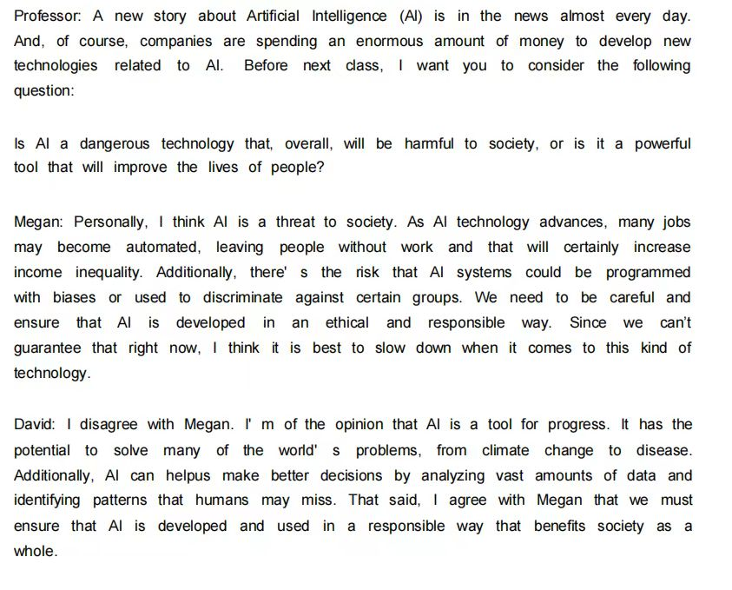

Megan presents an argument in favor of the view that Al is a threat to society. Admittedly, many jobs may become automated, leaving people without work(unemployed). However, considering ~~in~~ huge benefits brought by AI, I am inclined to prioritize that AI is a powerful tool that will improve the lives of people(people’s standard of living). In my opinion, the fact that many jobs may become automated is not a negative phenomenon. People, in that case, should learn and improve themselves to be competent for a new job, which has higher salary and technology(professional) than before. As(with) the implementation of deep learning and machine learning, AI has surpassed people in some cases. Take ChatGPT as an example, I usually ask it questions that confuse me in academic field and it can work out my problems perfectly and quickly. Sometimes, we have to learn from AI in some subjects such as the game of go. Therefore, I firmly believe that we should spend an enormous amount of money to develop new technologies related to Al.

Sample Answer: I strongly agree with David' s idea that Al will help us deal with many serious problems currently affecting society. I' d add that Al has already been used to make driving safer and reduce car accidents, so we already have some proof that Al is helping people around the world. Megan raised the relevant point that Al could eliminate certain jobs, but she didn' t mention that Al is creating new jobs. For example, when new products are invented using Al they still have to be manufactured, which means that new factory jobs are created. Not only that, but Al learning tools can help people increase their skills and make themselves more attractive employees for various companies. Overall, then, I would say that Al will improve our lives.