写作作业1

Professor:Life expectancies are increasing all over the world nowadays.Some of you

probably know someone who is more than 100 years old.Before our next class,I want

you to consider the following question:

What factors do you think have contributed to the increase in life expectancy?Is it due to

advances in medical technology,improvements in public health,changes in lifestyle habits,or something else entirely?

Lisa:I think the main reason why people are living longer nowadays is recent advances in

medical technology.Modern medicine has enabled us to better treat and manage

chronic illnesses,and there have been major breakthroughs in areas such as cancer

treatment and organ transplantation.As a result,people are able to live longer with

diseases that may have been fatal in the past.

John:While medical technology has certainly played a role,I think improvements

In public health have been just as important.We now have access to clean drinking water, sanitation systems,and vaccines that have dramatically reduced the incidence of infectious diseases.Even a century ago,people didn't have access to any of these

things.Additionally,public health campaigns have helped educate people about healthy lifestyle habits such as exercise,healthy eating,and not smoking,which can also contribute to longer lifespans.

John presents an argument that it is improvements in public health that contributes to the increase in life expectancy.Admittedly, public health campaigns have helped educate people about healthy lifestyle habits,which is a problem we shouldn’t taken lightly. However, considering benefits brought by advances in medical technology, I am inclined to prioritize that it is the improvement in medical technology that contributes to the increase in life expectancy.Medical technology has led to the development of vaccines, antibiotics, and other medications that help prevent and treat various diseases. For example, vaccines have virtually cured diseases such as smallpox and significantly reduced the incidence of the virus of COVID-19 like SARS, Alpha,Beta and Gamma. Antibiotics have revolutionized the treatment of bacterial infections, saving countless lives.Therefore, I firmly believe that improvement in medical technology has contributed to the increase in life expectancy.

写作作业2

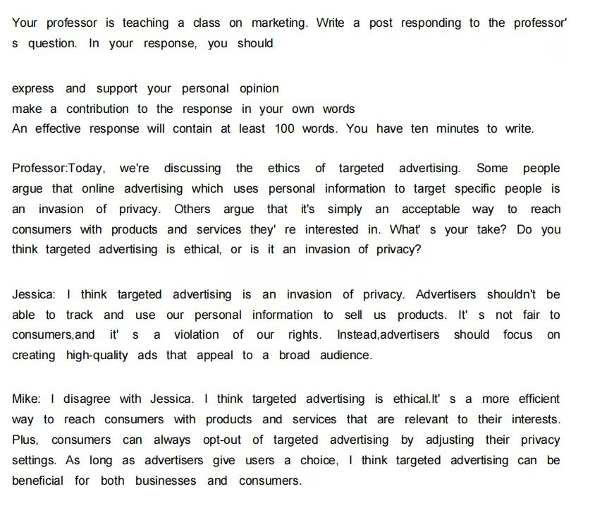

Jessica presents an argument that targeted advertising is an invasion of privacy.Admittedly, Advertisers shouldn't be able to track and use our personal information to sell us products. However, considering huge benefits brought by targeted advertising, I am inclined to prioritize that it's simply an acceptable way to reach consumers with products and services they're interested in.Targeted advertising provides benefits to both consumers and advertisers. For advertisers, by delivering ads that are more relevant to users' interests and needs, targeted advertising can enhance the overall online experience and make advertising more effective. Advertisers can also reach their target audience more efficiently, reducing wasted resources.For consumers,they can find relevant products or services more efficiently, saving time and effort in their search process. Instead of sifting through irrelevant ads or promotional offers, consumers are presented with options that are more likely to meet their needs, leading to quicker decision-making and potentially cost savings.Therefore, I firmly believe advantages brought by targeted advertising is much outweigh the disadvantages.

写作作业3

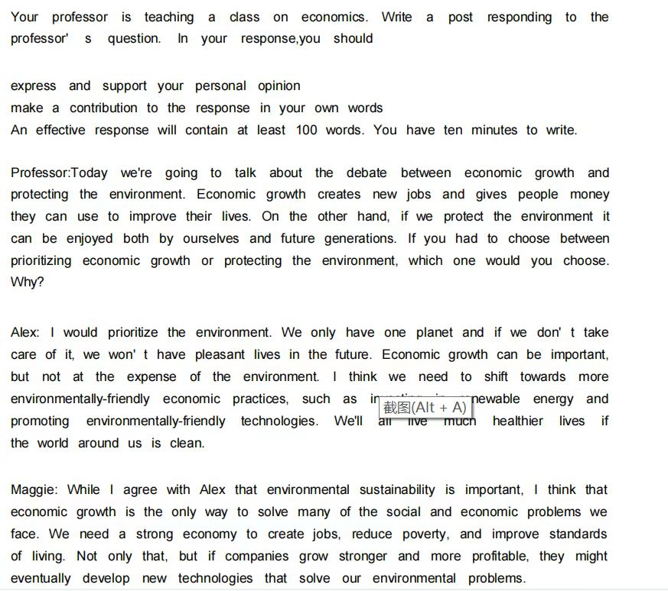

Maggie presents an argument that economic growth is the only way to solve many of the social and economic problems.Admittedly, a strong economy can create jobs,reduce poverty,and improve standards

of living. However, considering huge benefits brought by a harmonious environment, I am inclined to prioritize protecting the environment first.

Prioritizing environmental protection yields long-term benefits that extend beyond immediate economic gains. Preserving ecosystems, biodiversity, and natural landscapes not only enhances quality of life for current generations ,but also ensures the well-being and prosperity of future generations. Sustainable environmental policies contribute to ecosystem services such as clean air ,fresh water and climate regulation, which are essential for human health and economic stability.Therefore, I firmly believe we should prioritize protecting the environment immediately.