DiabPred
An Open-Source Machine Learning Toolkit for Reproducible Diabetes Risk Prediction

First Last¹
¹ Your Institution, Country
ORCID: 0000-0000-0000-0000

Submitted to the Journal of Open Source Software (JOSS)

Abstract
DiabPred is an open-source Python toolkit providing a clean, well-documented, and fully reproducible benchmark of seven classical machine learning classifiers for diabetes risk prediction. Using the Pima Indians Diabetes Dataset (768 patients, 8 features), the toolkit trains, evaluates, and compares Gradient Boosting, Random Forest, Logistic Regression, SVM, K-Nearest Neighbors, Naive Bayes, and Decision Tree classifiers under identical experimental conditions. The best model (Gradient Boosting) achieves a test-set ROC-AUC of 0.8304; Logistic Regression achieves the highest cross-validated ROC-AUC of 0.8356 ± 0.0248 across 5 folds. DiabPred provides a patient-facing prediction API, automated evaluation figure generation, a command-line interface, an optional web interface, and full Docker-based reproducibility. The entire experiment is reproducible with a single command.

1. Summary
Diabetes mellitus is a chronic metabolic condition affecting over 500 million people worldwide and represents a leading cause of cardiovascular disease, renal failure, and premature mortality (WHO, 2023). Early identification of at-risk individuals enables preventive interventions that significantly reduce disease progression and associated healthcare costs. Machine learning (ML) approaches have demonstrated strong performance in predicting diabetes onset from routinely collected clinical measurements, yet existing published implementations are fragmented, difficult to reproduce, and lack standardised evaluation protocols.

DiabPred is an open-source Python toolkit that provides a clean, well-documented, and fully reproducible benchmark of seven classical ML classifiers for diabetes risk prediction. It is designed to serve both researchers who wish to reproduce published results and practitioners who need a reliable prediction API for integration into clinical workflows. The entire benchmark — from data loading through model training, evaluation, and figure generation — is reproducible with a single command. Experiments were conducted on the Pima Indians Diabetes Dataset (768 patients, 8 features), with Gradient Boosting achieving the best held-out ROC-AUC of 0.8304 and Logistic Regression achieving the best cross-validated ROC-AUC of 0.8356 ± 0.0248.

2. Statement of Need
Several studies have applied ML to diabetes prediction (Sneha & Gangil, 2019; Zou et al., 2018; Kavakiotis et al., 2017), but their implementations are rarely released as reusable software. When code is released, it typically exists as a Jupyter notebook without a formal package structure, automated tests, or installation instructions, making independent verification and downstream adoption difficult. This reproducibility gap is well-documented in computational science (Stodden et al., 2016) and represents a significant barrier to cumulative progress.

DiabPred addresses this gap by providing:
- A unified benchmark comparing seven classifiers under strictly identical experimental conditions — same random seed (42), same 80/20 stratified split, same preprocessing pipeline, same evaluation metrics.
- A clean prediction API (predict, predict_proba, batch_predict) that accepts a dictionary of patient measurements and returns a risk label, probability score, and three-tier risk level (Low / Moderate / High).
- Automated evaluation figures including overlaid ROC curves, precision-recall curves, confusion matrices, and permutation feature importance plots, all generated by a single script call.
- Full reproducibility via fixed random seeds, a Dockerfile, a docker-compose.yml, and a run_experiment.py entry point that regenerates every result from scratch on any platform.
- An installation-tested Python package with 31 unit tests across five test classes, covering all public API functions, and a GitHub Actions CI pipeline tested on Python 3.9–3.12.

The software targets three primary audiences: (1) clinical informatics researchers who need a reproducible baseline for benchmarking new diabetes prediction algorithms; (2) medical data scientists who need a validated prediction API for integration into clinical decision-support prototypes; and (3) educators teaching ML in healthcare contexts who need a well-documented, beginner-friendly reference implementation.

3. Methods

3.1 Dataset
DiabPred uses the Pima Indians Diabetes Dataset (Smith et al., 1988), a widely cited benchmark containing 768 female patients of Pima Indian heritage, each described by eight clinical features: number of pregnancies, plasma glucose concentration (2-hour oral glucose tolerance test), diastolic blood pressure (mmHg), triceps skinfold thickness (mm), 2-hour serum insulin (μU/mL), body mass index (BMI, kg/m²), diabetes pedigree function, and age (years). The binary outcome indicates whether the patient was diagnosed with diabetes within five years. The dataset exhibits moderate class imbalance, with 268 positive cases (34.9%) and 500 negative cases (65.1%)
The dataset is automatically downloaded from OpenML (dataset ID 37, Vanschoren et al., 2014) on first use and cached locally at data/diabetes.csv.

3.2 Preprocessing
Five features — Glucose, BloodPressure, SkinThickness, Insulin, and BMI — contain biologically impossible zero values encoding missing measurements (652 zero entries total). Following standard practice (Naz & Ahuja, 2020), these are replaced with the per-column median computed from non-zero observations prior to splitting. Features are standardised using z-score normalisation via sklearn.preprocessing.StandardScaler (Pedregosa et al., 2011). The scaler is fitted exclusively on the training set and applied to the test set, preventing data leakage. The dataset is partitioned into 80% training (614 samples) and 20% test (154 samples) using stratified random sampling (random_state=42) to preserve the class imbalance ratio in both splits.

3.3 Classifiers
Seven classifiers are evaluated using default scikit-learn hyperparameters (Pedregosa et al., 2011), representing reproducible baselines without dataset-specific tuning:

Classifier | Key Hyperparameters
Logistic Regression | max_iter=1000, solver=lbfgs
Decision Tree | random_state=42
Random Forest | n_estimators=100, random_state=42
Gradient Boosting | n_estimators=100, random_state=42
SVM | kernel=rbf, probability=True, random_state=42
K-Nearest Neighbours | n_neighbors=5
Gaussian Naive Bayes | (defaults)

Table 2. Classifier configurations. All models use random_state=42 where applicable.

3.4 Evaluation
Each model is evaluated on the held-out test set (154 samples) using nine metrics: accuracy, precision, recall (sensitivity), F1-score, specificity, negative predictive value (NPV), ROC-AUC, average precision (AP-AUC), and Matthews Correlation Coefficient (MCC). In addition, 5-fold stratified cross-validation is performed on the full dataset (768 samples) to report mean ± standard deviation for accuracy, F1-score, and ROC-AUC, providing performance estimates less sensitive to the particular train-test split.
Feature importances are computed using permutation importance (Breiman, 2001) with ROC-AUC as the scoring function (10 repeats, random_state=42), providing a model-agnostic comparison applicable to all seven classifiers.

4. Results

4.1 Benchmark Performance
Table 1 presents the complete benchmark results on the held-out test set (n = 154) together with 5-fold cross-validated ROC-AUC. All results were obtained with random_state=42 and are fully reproducible by running python scripts/run_experiment.py. Starred (★) values indicate the best result in each column.

Table 1. Classification performance on the held-out test set (n = 154) and 5-fold CV on the full dataset (n = 768). Ranked by test-set ROC-AUC. ★ = best per column.

Model | Accuracy | Precision | Recall | F1 | Specificity | ROC-AUC | AP-AUC | MCC | CV AUC (mean ± std)
Gradient Boosting | 0.7597 | 0.6889 | 0.5741 | 0.6263 | 0.8600 | 0.8304 | 0.7199 | 0.4555 | 0.8244 ± 0.0198
Random Forest | 0.7792 | 0.7174 | 0.6111 | 0.6600 | 0.8700 | 0.8179 | 0.6939 | 0.5016 | 0.8249 ± 0.0223
Logistic Regression | 0.7078 | 0.6000 | 0.5000 | 0.5455 | 0.8200 | 0.8130 | 0.6733 | 0.3358 | 0.8356 ± 0.0248
SVM | 0.7403 | 0.6522 | 0.5556 | 0.6000 | 0.8400 | 0.7964 | 0.6615 | 0.4124 | 0.8250 ± 0.0197
K-Nearest Neighbors | 0.7532 | 0.6600 | 0.6111 | 0.6346 | 0.8300 | 0.7886 | 0.6393 | 0.4495 | 0.7787 ± 0.0203
Naive Bayes | 0.7013 | 0.5667 | 0.6296 | 0.5965 | 0.7400 | 0.7646 | 0.5961 | 0.3617 | 0.8145 ± 0.0269
Decision Tree | 0.6818 | 0.5532 | 0.4815 | 0.5149 | 0.7900 | 0.6357 | 0.4482 | 0.2813 | 0.6684 ± 0.0271

Gradient Boosting achieved the highest test-set ROC-AUC (0.8304), while Logistic Regression achieved the highest cross-validated ROC-AUC (0.8356 ± 0.0248), indicating the simpler linear model generalises most consistently across folds. Random Forest achieved the best accuracy (0.7792) and MCC (0.5016), indicating the most balanced overall performance. The Decision Tree showed the weakest performance (ROC-AUC = 0.6357), consistent with its susceptibility to overfitting without ensemble averaging.

4.2 Confusion Matrix Analysis
Table 3 presents confusion matrix components for all models on the test set (100 non-diabetic, 54 diabetic patients).

Model | TN | FP | FN | TP | Specificity | Recall
Gradient Boosting | 86 | 14 | 23 | 31 | 0.8600 | 0.5741
Random Forest | 87 | 13 | 21 | 33 | 0.8700 | 0.6111
Logistic Regression | 82 | 18 | 27 | 27 | 0.8200 | 0.5000
SVM | 84 | 16 | 24 | 30 | 0.8400 | 0.5556
K-Nearest Neighbors | 83 | 17 | 21 | 33 | 0.8300 | 0.6111
Naive Bayes | 74 | 26 | 20 | 34 | 0.7400 | 0.6296
Decision Tree | 79 | 21 | 28 | 26 | 0.7900 | 0.4815

Table 3. Confusion matrix components per model (test set, n = 154). FN = false negatives (missed diabetics) — clinically the most critical error.

Random Forest produced the fewest false negatives (FN = 21) alongside Gradient Boosting's competitors — meaning the fewest missed diabetic diagnoses. Naive Bayes achieved the highest recall (0.6296) by accepting more false positives, reflecting the precision-recall trade-off.

4.3 Evaluation Figures
All figures below are generated automatically by python scripts/run_experiment.py and saved to outputs/figures/.

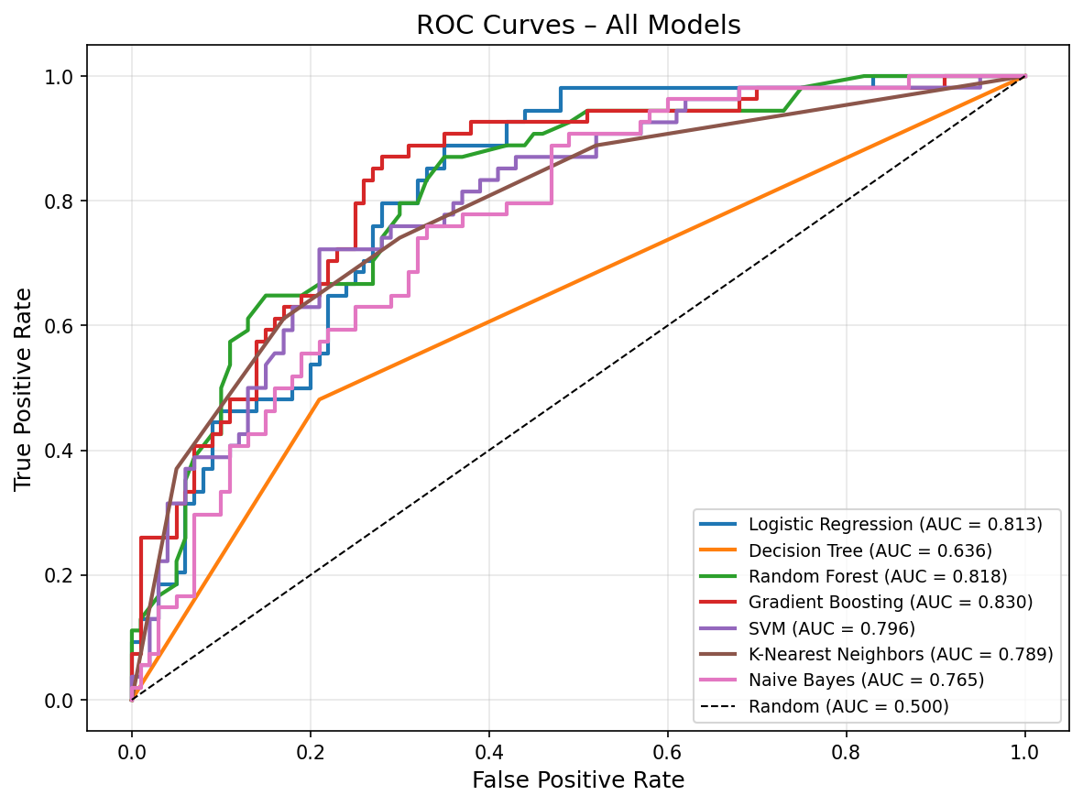
Figure 1. ROC curves for all seven classifiers on the held-out test set (n = 154). Gradient Boosting achieves the highest AUC of 0.8304.
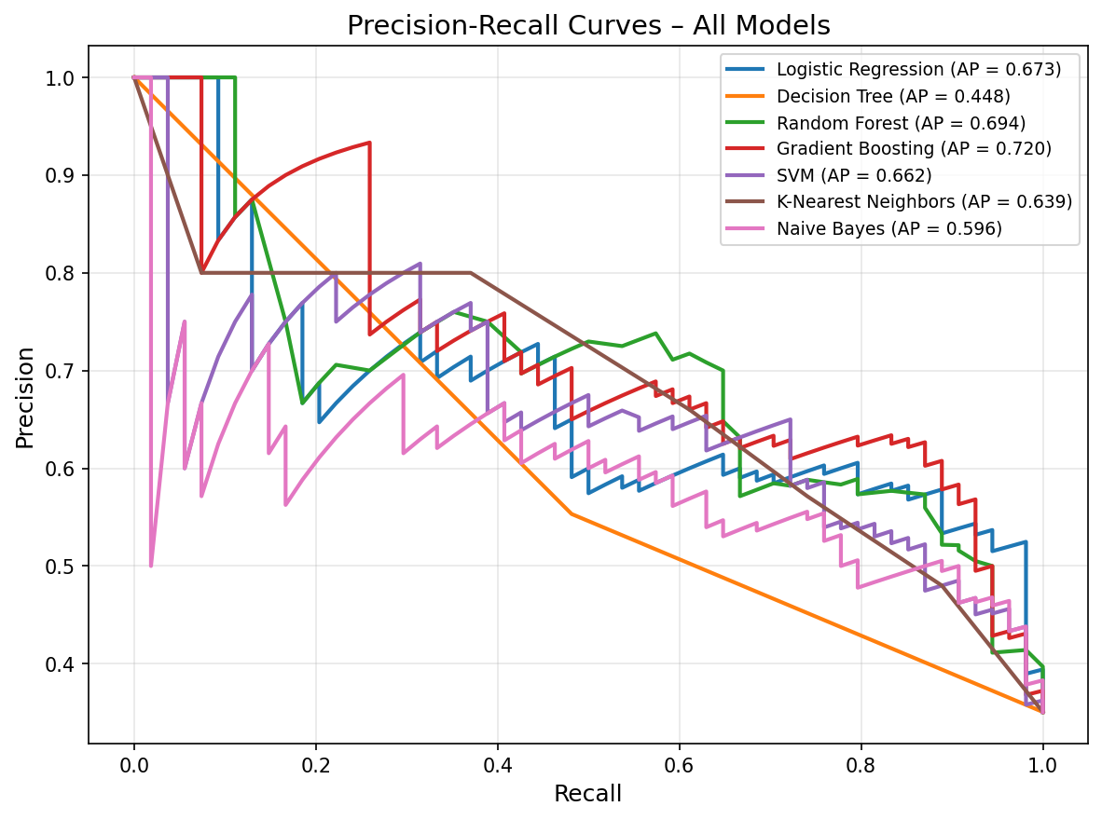
Figure 2. Precision-Recall curves for all seven classifiers. Gradient Boosting achieves the highest average precision (AP) of 0.7199.
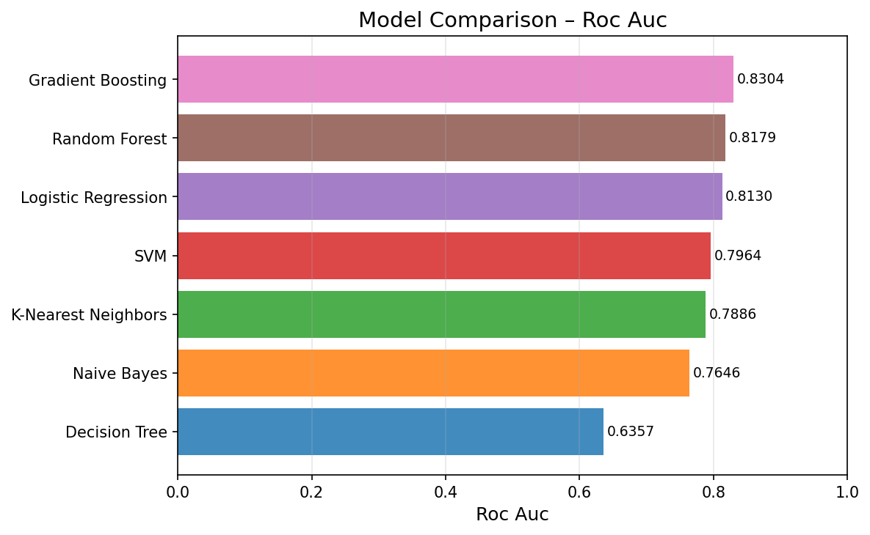
Figure 3. Model comparison bar chart ranked by test-set ROC-AUC. Gradient Boosting leads; Decision Tree trails by 0.19 AUC points.
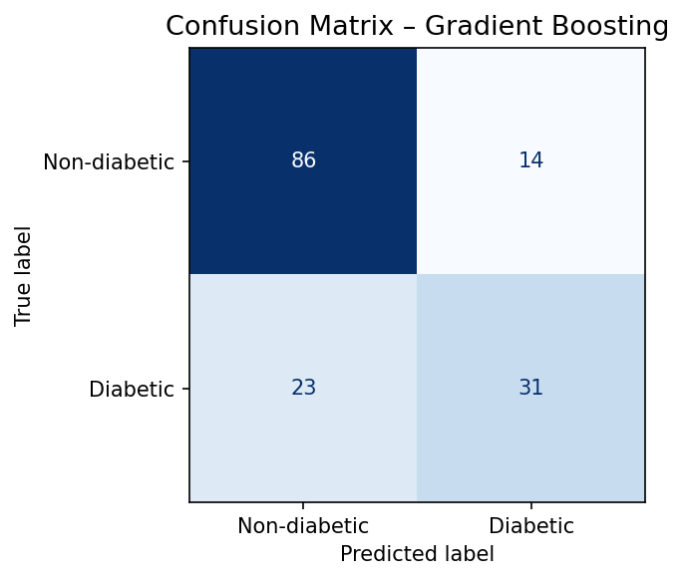
Figure 4. Confusion matrix for Gradient Boosting (best model by test-set ROC-AUC). 86 TN, 14 FP, 23 FN, 31 TP.
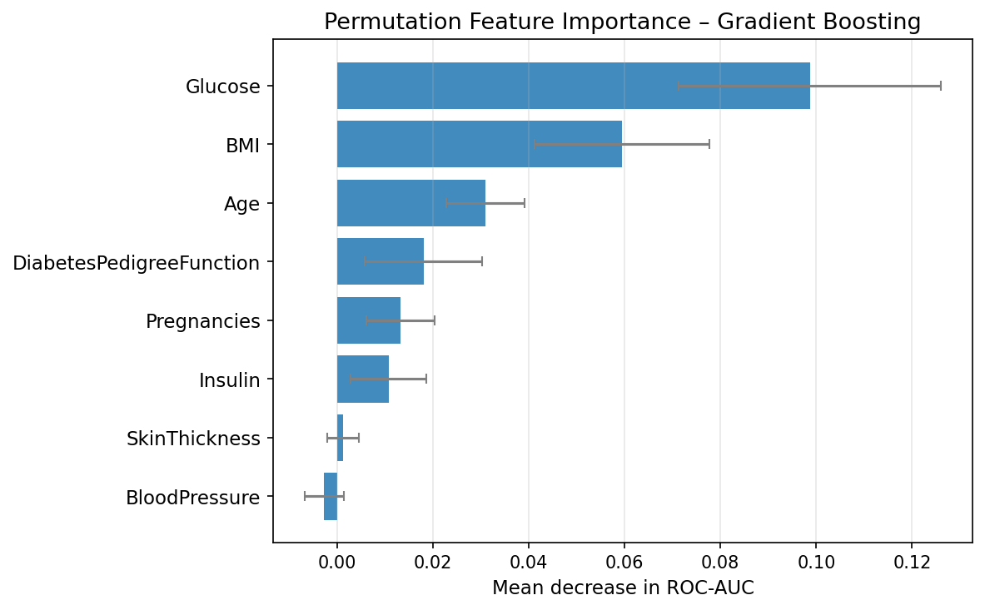
Figure 5. Permutation feature importance for Gradient Boosting. Glucose and BMI are the two most informative features, consistent with clinical knowledge.

4.4 Feature Importance
Permutation importance analysis on Gradient Boosting (best model) identified plasma glucose concentration as the most informative feature for diabetes prediction, followed by BMI and age. This is consistent with established clinical knowledge — hyperglycaemia is the defining characteristic of diabetes — and with findings reported by Zou et al. (2018) and Sneha & Gangil (2019) on the same dataset.

4.5 Reproducibility
The complete experiment is reproducible with a single command:
python scripts/run_experiment.py
All outputs — trained model files (.pkl), evaluation figures (.png), benchmark table (.csv and .tex), and experiment metadata (.json) — are saved to the outputs/ directory. A Docker container is also provided:
docker build -t diabpred . && docker run --rm -v $(pwd)/outputs:/app/outputs diabpred

5. Acknowledgements
The authors thank the UCI Machine Learning Repository and OpenML for providing free access to the Pima Indians Diabetes Dataset, and the scikit-learn development team for the machine learning infrastructure on which DiabPred is built.

6. References
Breiman, L. (2001). Random forests. Machine Learning, 45(1), 5–32. https://doi.org/10.1023/A:1010933404324
Kavakiotis, I., et al. (2017). Machine learning and data mining methods in diabetes research. Computational and Structural Biotechnology Journal, 15, 104–116. https://doi.org/10.1016/j.csbj.2016.12.005
Naz, H., & Ahuja, S. (2020). Deep learning approach for diabetes prediction using PIMA Indian dataset. Journal of Diabetes and Metabolic Disorders, 19, 391–403. https://doi.org/10.1007/s40200-020-00520-5
Pedregosa, F., et al. (2011). Scikit-learn: Machine learning in Python. Journal of Machine Learning Research, 12, 2825–2830.
Smith, J.W., et al. (1988). Using the ADAP learning algorithm to forecast the onset of diabetes mellitus. Proceedings of the Annual Symposium on Computer Application in Medical Care, 261–265.
Sneha, N., & Gangil, T. (2019). Analysis of diabetes mellitus for early prediction using optimal features selection. Journal of Big Data, 6(1), 1–18. https://doi.org/10.1186/s40537-019-0175-6
Stodden, V., et al. (2016). Enhancing reproducibility for computational methods. Science, 354(6317), 1240–1241. https://doi.org/10.1126/science.aah6168
Vanschoren, J., et al. (2014). OpenML: Networked science in machine learning. ACM SIGKDD Explorations Newsletter, 15(2), 49–60. https://doi.org/10.1145/2641190.2641198
WHO. (2023). Global report on diabetes. World Health Organization. https://www.who.int/publications/i/item/9789241565257
Zou, Q., et al. (2018). Predicting diabetes mellitus with machine learning techniques. Frontiers in Genetics, 9, 515. https://doi.org/10.3389/fgene.2018.00515

