To the Editors:

I am writing to submit the manuscript “Assessing the relationship of ancient and modern populations” for publication in Molecular Biology and Evolution.

Ancient DNA is revolutionizing our ability to understand the recent evolutionary past by providing a direct window into the genetic structure of historical populations. By comparing ancient and modern individuals, we can make powerful inferences about the demographic forces that the modern distribution of a population. For instance, we now know that the Neolithic Farmers that spread through Europe with the advent of agriculture largely replaced ancient Hunter Gatherers in the region. This inference would have been extremely difficult to make without ancient samples.

Nonetheless, ancient DNA presents several challenges because of the low quality of DNA obtained from long-dead samples. While significant progress has been made using relatively simple methods for dealing with low coverage data, such as sampling reads at random at polymorphic sites, these approaches often do not make the most of difficult-to-acquire and expensive ancient DNA. We present a novel approach that averages over genotype uncertainty in multiple individuals using raw read data to obtain an estimate of how an ancient population is related to a modern population. This approach is the first to simultaneously deal with low coverage, damaged ancient samples while simultaneously modeling multiple ancient individuals per population.

Through simulations, we showed that sampling multiple ancient individuals, even when sequenced to low coverage, can often be better than sequencing a single individual to high coverage. We found that sequencing multiple low coverage individuals both reduced estimation error of the parameters of the model as well as substantially increased power to reject the null hypothesis that the ancient population is directly ancestral to a modern population of interest. As a test case, we applied this approach to ancient Europeans, and found that none of the currently sampled ancient populations are directly ancestral to modern Europeans. Instead, they seem to be members of off-shoot populations with extremely small effective sizes, consistent with the difficulty of maintaining panmixia in ancient times.

Thank you for your time and consideration of our manuscript. We look forward to hearing back from you.

Sincerely,

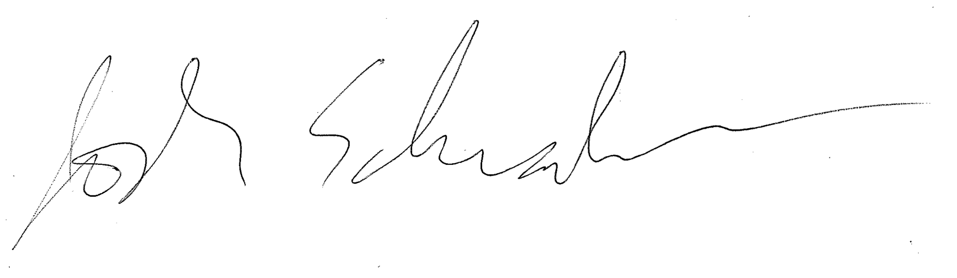

Joshua Schraiber

Department of Biology  
Temple University

Philadelphia, PA