**Question A**

**Question B**

Student (StudentNo, Firstname, Surname, Degree, YearofStudy, Faculty)

Registered (StudentNo, CourseCode, Year, Finalresult, PassOrFail)

ExamMarks (StudentNo, CourseCode, Year, Paper, Mark)

AssignmentMarks (StudentNo, CourseCode, Year, Assignment, Mark)

TestMarks (StudentNo, CourseCode, Year, Test, Mark)

Tutored (StudentNo, CourseCode, Year, HourlyWage, TutorialGroup)

Staff (StaffID, firstname, surname)

Lectured (StaffID, CourseCode, Year, Topic, NoOfLectures)

Administered (StaffID, CourseCode, Year)

Courses (CourseCode, Department)

**Question C**

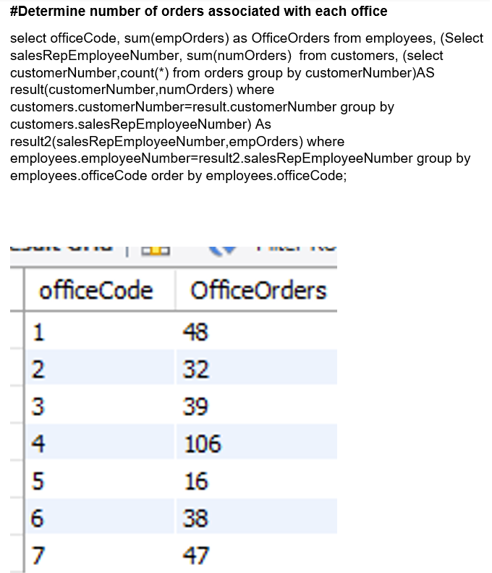

The query shows how many orders each office has done. We know the result is correct as when we sum up the total orders given by each employee under each office we get the same results as printed out by the sql query.

**Question D**

SCHMAT041: Contributed to the activity diagram

RMKYAS002: Contributed to the relational database design and the activity diagram

RMPALL001: Contributed to the SQL query and the activity diagram

RNNZIP001: Contributed to the SQL query and the activity diagram

RSNROW001: Contributed to the activity diagram