# 3D VPython Environment First Runs

## Run 1, No Damping

## Run 2 With Damping on Blue Mass

## Run 3, Double Mass Oscillator

An example when delta_t was too small to avoid divergence behavior (0.01s). This occurred when the blue mass (which started on the left side) moved through the white mass and switched sides. Technically the behavior is still physically correct besides a mass phasing through another mass.

Using 0.001s delta_t:

# Changed Matplotlib to PyQTGraph – 2024/07/10

# Retesting With External Forces

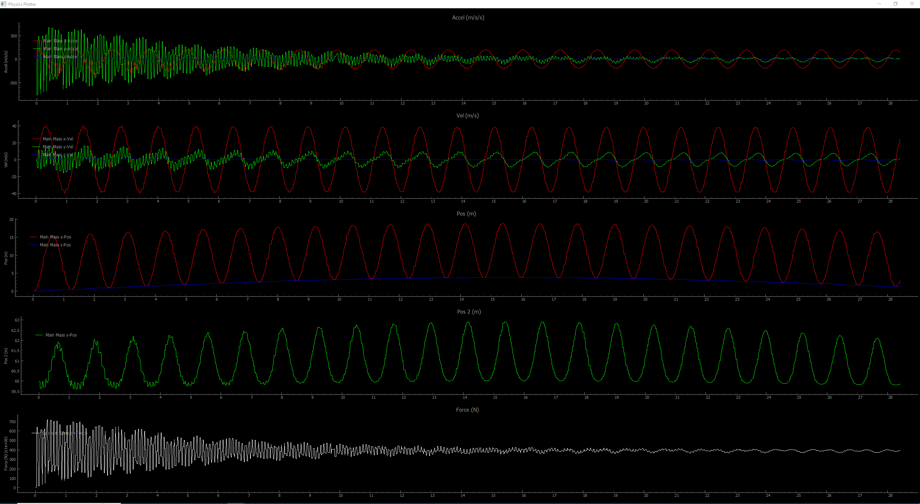

FFT

