SchuBot Manual (Draft)

SchuBot is a Single Page Application that works on Mixer (Adding Twitch Integration soon). The main premise is that you load your bot and have everything you need in a single page without having to toggle between page to find something.

SchuBot consists of a workspace, menu panel and bot modules (which are the objects you place on the screen to perform a specific function).

The SchuBot has virtually the entire window (some of it is occupied by the menu panel) as workspace which you can use to display all the modules you need for your stream and other modules which you may need on a frequent basis. Modules perform one and only one function.

Fig1. SchuBot Workspace - the image below shows an empty workspace (the whitespace) and the menu panel on the right (this is subject to change). By default the bot loads with a few basic modules (described further in the guide).

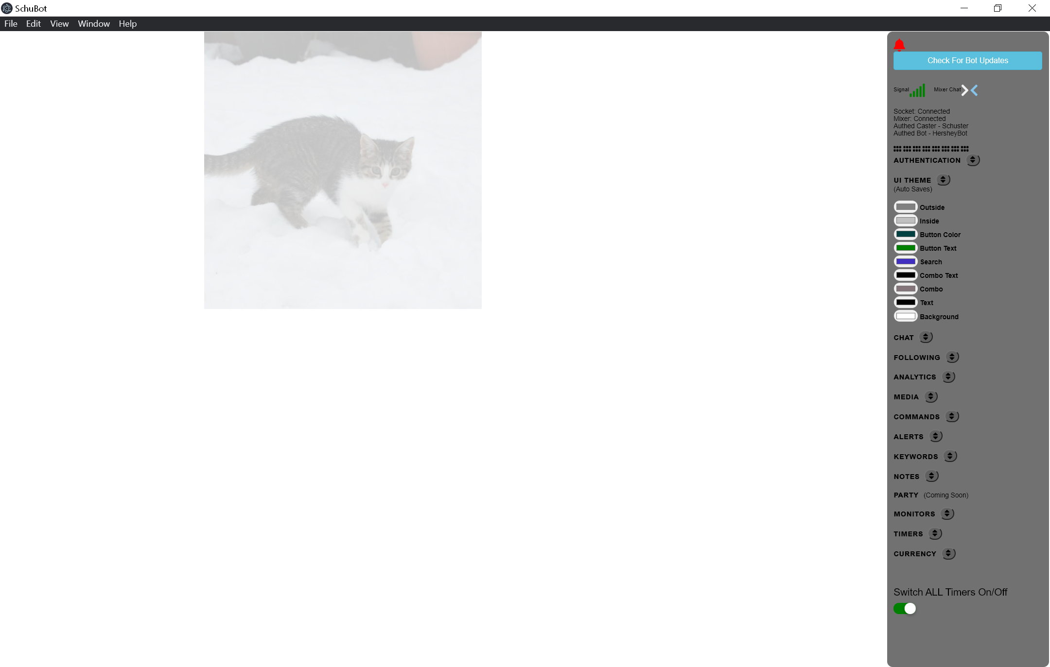

Fig2. Menu Panel.

The Menu Panel is the entry point for all modules. The Menu Panel on the image below shows all module sections collapsed so it fits well on the bot minimal scroll bar. Every module can be switched on or off, minimised and collapsed to show only data tables. More on modules later.
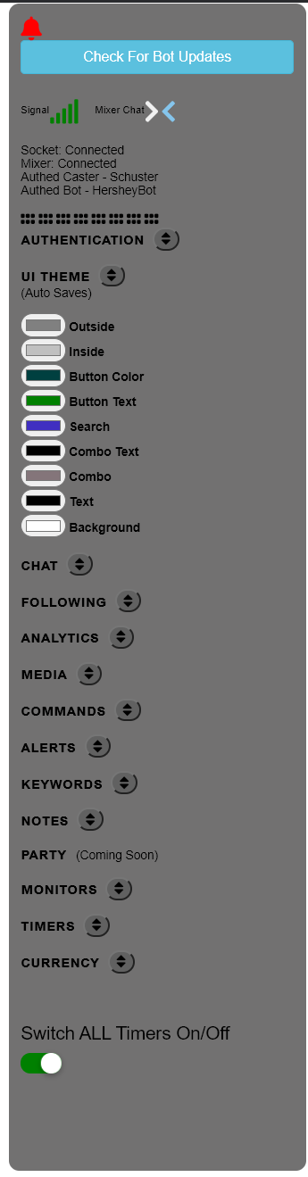
Modules Summary

Modules are objects that are placed on the screen and used to perform a specific function. An example of a module is the chat window. SchuBot currently has the following modules:

- Authentication
- UI Theme – Allows you to change the appearance of UI controls such as buttons, module panels , drop-down controls etc...
- Chat Module Panel – Allows you to see and reply to Mixer/Twitch messages (More functions coming soon)
- Viewer List – To see who is on chat
- Whisper Window – To see your whispers
- Recent Followers List – Shows your recent (last 24hrs) followers
- Following List – Shows a list of the people you follow.
- Follower List – Shows your follower list
- Analytics (Currently under development) – Coming Soon
- Commands List – Allows you to create commands that can be triggered in chat.
- Media Files – To setup your files for alerts
- Alerts – The setup the actual alerts.
- Keywords – These are words that trigger a response from a chat message
- Notes – Allows you to create reminders and/or to be used as a to-do list
- Moderation Monitor – Allows you to see what mods have been up to.
- Timers – Messages sent to chat on specific intervals
- Currency and Rank

Module Details

This section will run through each module and describe its use and purpose.

Authentication

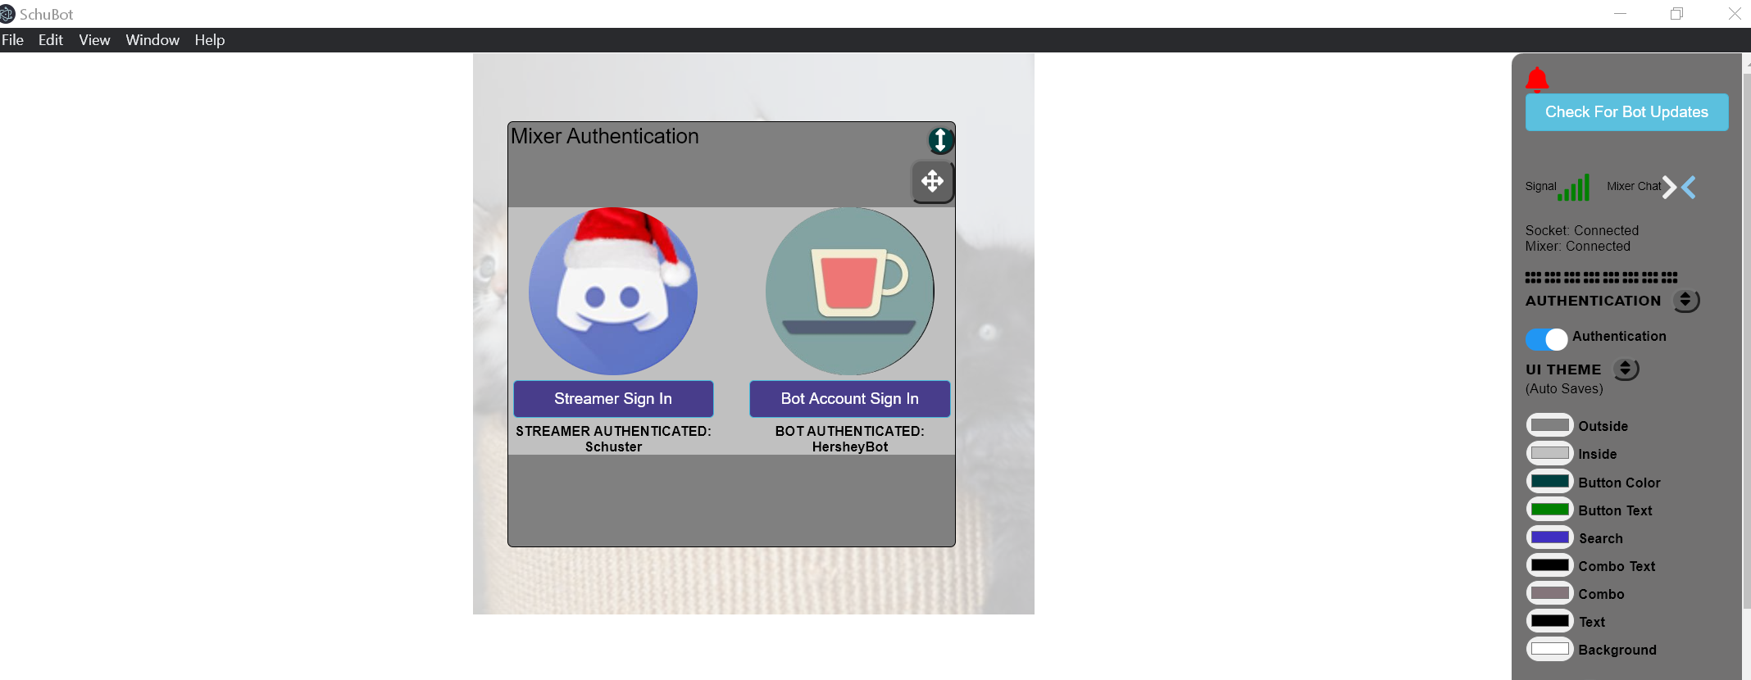

Fig x - UI Theme
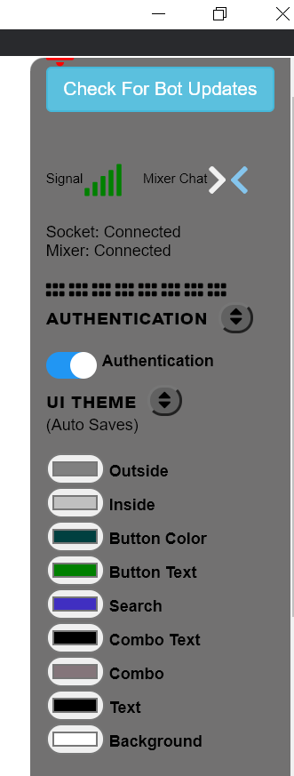

The UI Theme Section allows you to change colours of all the UI
controls. I will demonstrate the theme changes with the
commands module and use a blue shade for all theme options and
highlight where the changes are if its no immediately obvious

The current UI Theme Options are:

- Outside – Changes the outside frame of the Module. (see Fig x)
- Inside – Changes the inside of the module
- Button Colour – Should change the colour of all buttons (There are a couple that don't change at the moment but will be fixed in a future release.
- Button Text – This changes the text colour on the button
- Search – This changes the background colour of the search box. Search boxes are used to find and filter the results of the search on list tables.

Outside Theme -This is the

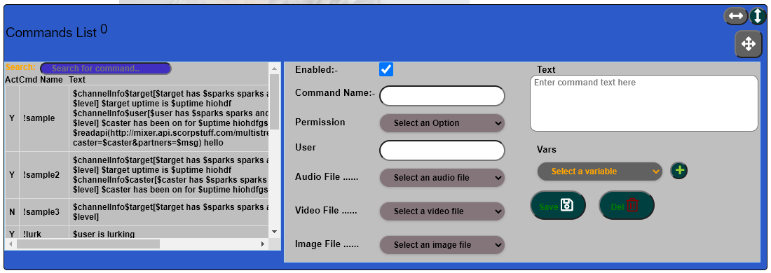

Inside

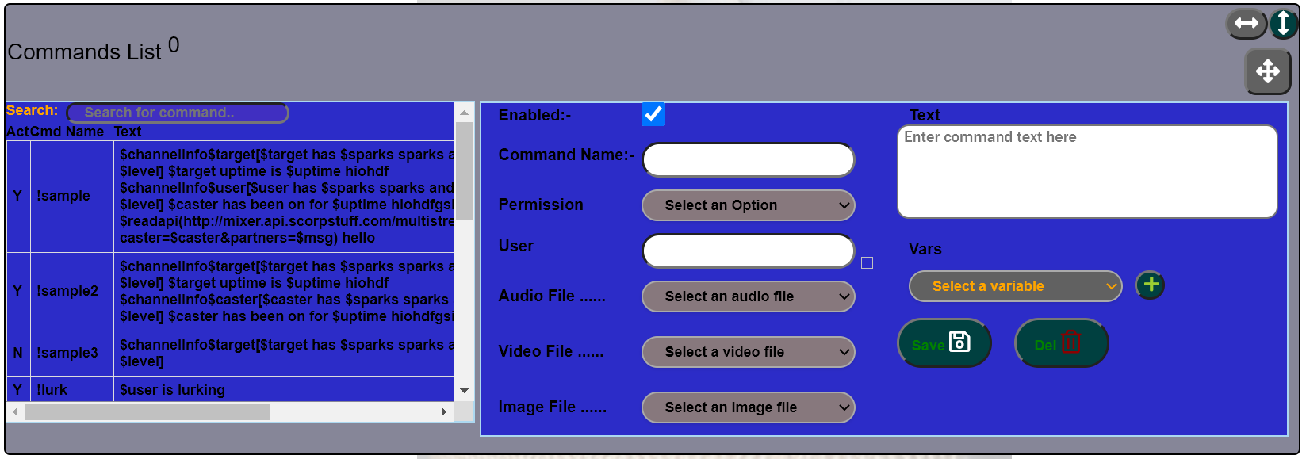

Button Color changes

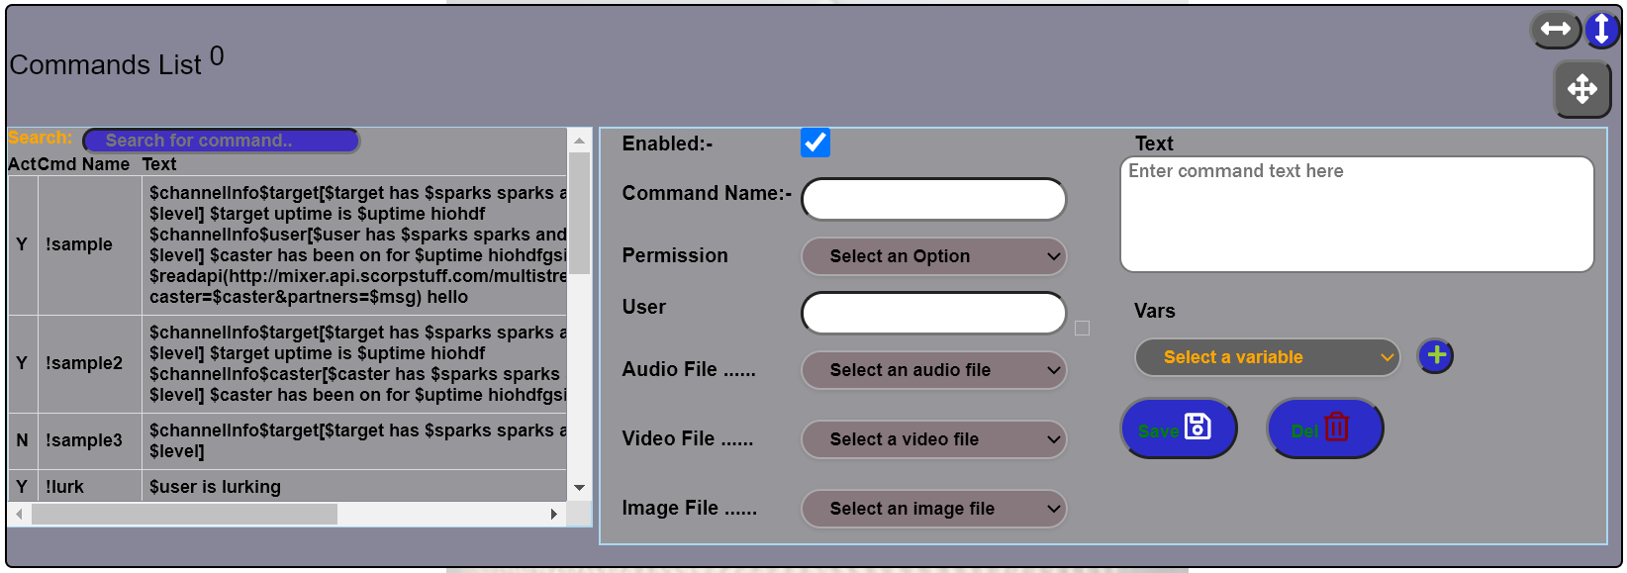

Button Text Change

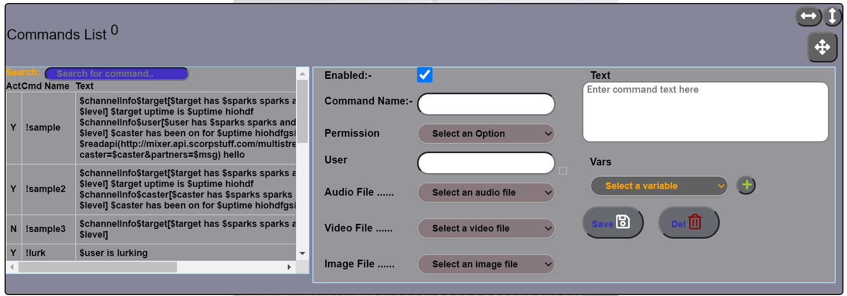

Search UI Theme

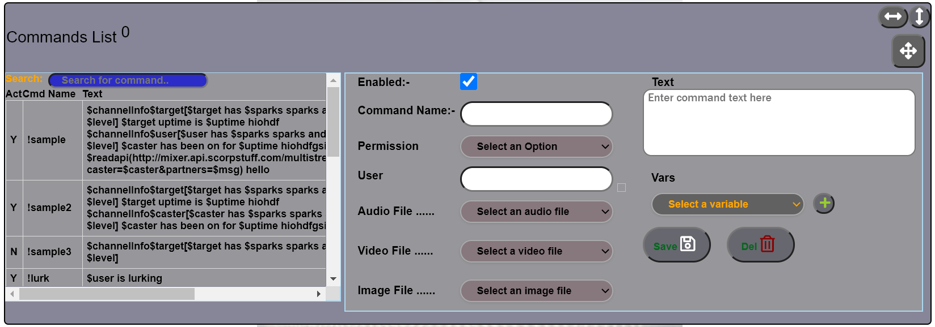

ComboBox Text UI Theme – (I know one of them doesn't change but it will soon)

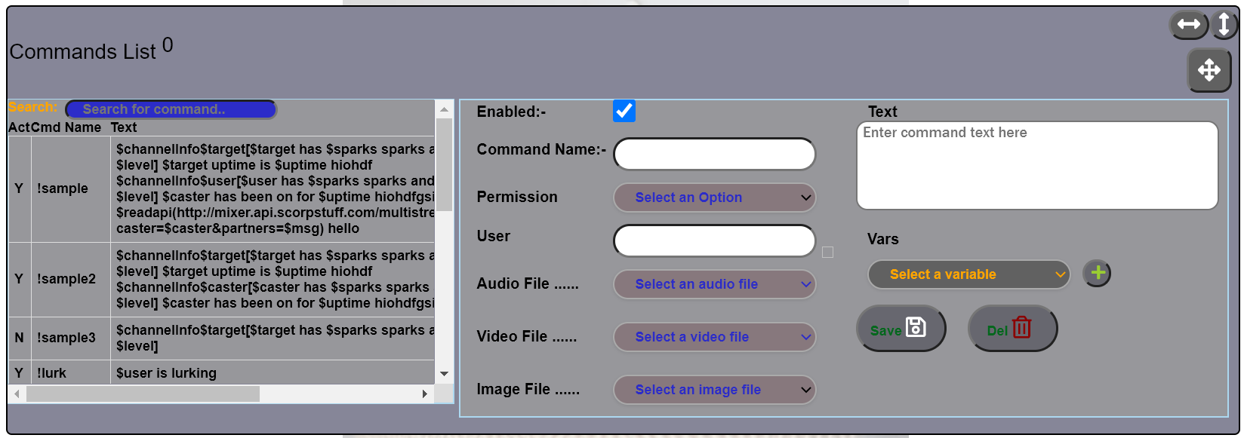
ComboBox Control UI theme
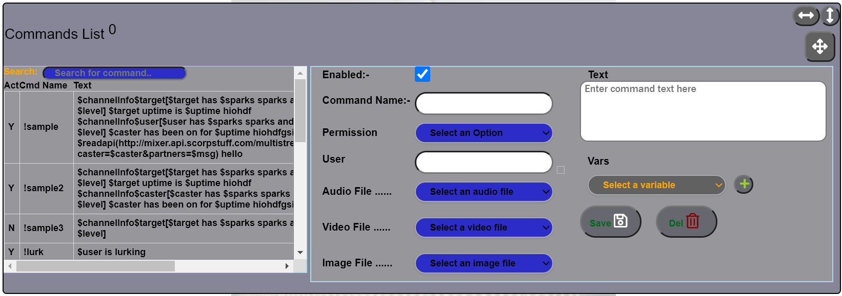

Text UI Theme – All text changes to the selected colour (List tables text colour to come soon)

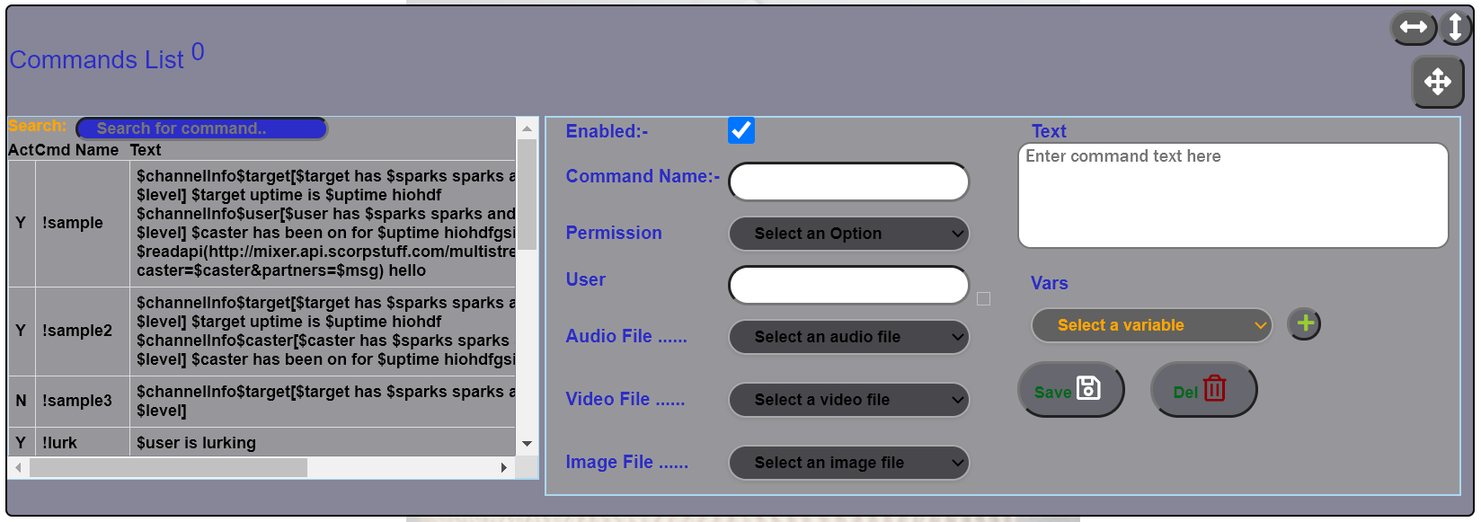

Chat Window

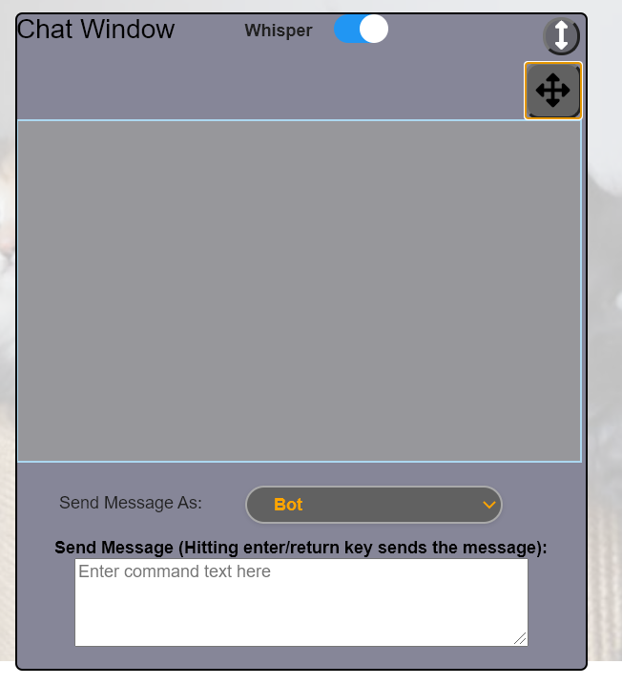

The chat window allows you to view messages from Mixer(working on Twitch integration). You can also use this to view both regular chat messages and whispers or you can hide/show whispers using the toggle switch. There is a whisper module that solely displays all your whispers in case you miss some. You can also send messages to Mixer as the Bot account or the streamer account by typing in a message in the provided text box and then hitting return/enter.

Viewer List
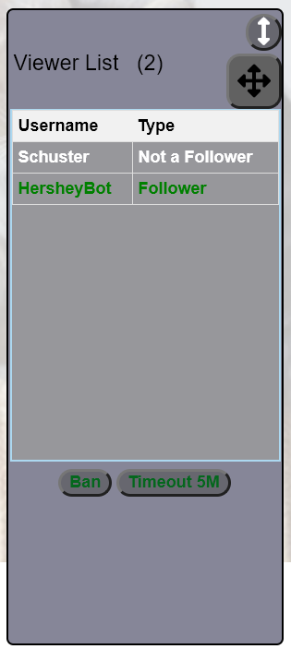
The viewer list shows who is in chat and also displays whether they
are a follower or not.

Future feature - This will be an opt in option in a future release
with a checkbox to turn on or off.

Additionally you can ban or timeout a user for 5 minutes by selecting the user and hitting the ban or timeout button.

Future Feature – This functionality will be enhanced by providing more options such as mute and more timeout options via a menu of some sort.

Whisper Window – Currently Under Development (empty Modules available)
Recent Followers – Currently Under Development (Empty list table module available)
Analytics – Currently Under Development (Empty list table module available)

Following List
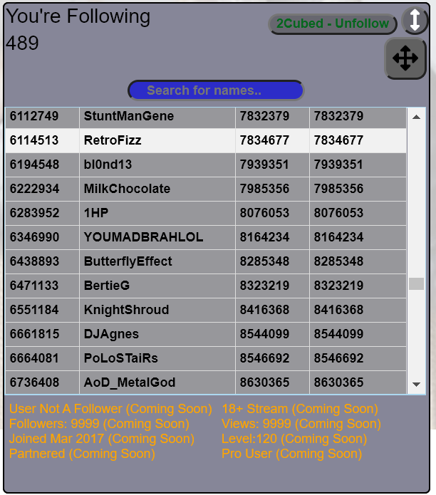
The following list show the users you follow and when
you followed them. In a future release you will be able
to click on the user and get more information such as
their mixer level, sparks etc.....

You can also unfollow by clicking on the user and
hitting the dynamic unfollow button that appears by the
module header text.

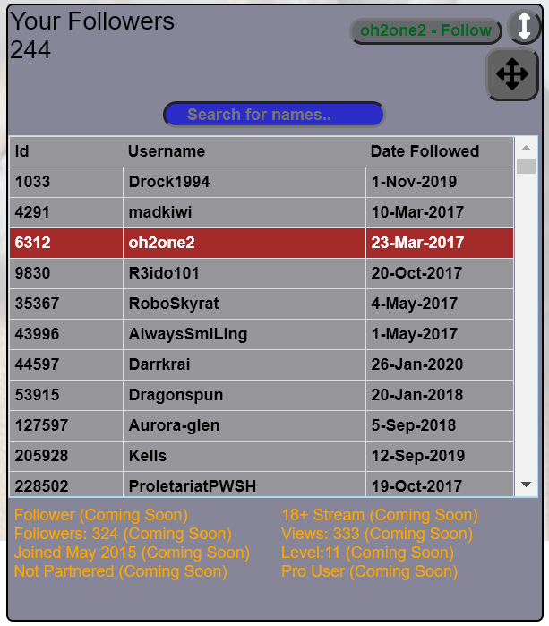
Follower List

The following list show the users you follow and when
you followed them. In a future release you will be able
to click on the user and get more information such as
their mixer level, sparks etc.....

You can also follow/unfollow by clicking on the user
and hitting the dynamic button that appears by
the module header text.

Commands List
Media Files
Alerts
Notes
Moderation Monitor
Timers

Currency and Rank

Notes Bell
Status Indicators – Mixer , Socket , Authentication status , Signal , Mixer Chat Icons , Check for Bot Updates
