Format of the funciton

[u,v,corcoef,{cmp}] = mat_piv(ImgA,ImgB,xi,yi,uest,vest,parameters)

Basic usage
Given PIV image pair ImgA, ImgB, return the 2-D displacement field [u, v] evaluated at the given locations [xi, yi]. The estimated displacement field, [uest, vest] has to be given as inputs.
- The input images must be Matlab DOUBLE matrices. If the images are imported by ‘fread’ function (i.e. read from ‘raw’ or ‘an’ files), they are double matrices by default. However, if read from image files (i.e., ‘jpg’, ‘tif’, ‘bmp’…) using ‘imread’ function, they are usually in format of UINT8, UINT16 matrices. You will have to convert them to double before calling mat_piv. If the image pair has formats other than DOUBLE, an error will be returned which suggest you to convert them to double.
- The input locations [xi, yi] can be either two vectors or matrices. They are defined in image coordinates, where [0, 0] is the left-upper corner of the image matrix. xi is positive to the right and yi is positive downwards. The estimated displacement field [ue, ve] must have same dimensions as [xi,yi], otherwise an error will be returned. Correspondingly, the returned displacement [u, v] will have same dimensions as [xi, yi].
- The vertical components (ve or v) of the displacements are positive upwards, which is different from the definition of image coordinates
- The datatype of parameters is a MatLab STRUCT which contains several fields. Most of the fields are optional except “Nx” and “Ny”. They are the integer size of the interrogation sub-window in horizontal and vertical directions, respectively. Details of parameters are described in the next section
- mat_piv applies cross-correlation (accelerated by FFTW) directly in Cross-Correlation mode or indirectly in PIV tracking or Minimum Quadratic Difference (MQD) modes. The cross correlation coefficients are normalized to be within 0~1. That said, coefficient equals to 1.0 corresponds to a perfect match of particle images. The maximal correlation coefficient at each evaluation location [xi, yi] is returned by mat_piv and saved in corcoef, which has the same dimensions as [xi, yi]. If at certain location, the correlation or the signal to noise ratio is lower than a predefined threshold value, or the PIV interrogation fails to converge, the corcoef will be set to 0. Thus corcoef acts as a map indicating the validness of PIV interrogation with those 0s representing an invalidate PIV results.
- The optional output {cmp} are the full correlation planes at each interrogation location. cmp is a 2D matrix with dimension [ncr ncc*length(u(:))], where ncr and ncc are the numbers of rows and columns, respectively, of one correlation plane. Thus cmp is actually all the correlation planes concatenated column wisely, in the order in which interrogation locations are inputted. This optional output are for advanced users and developer that want to evaluated the details of the correlation and design better algorithms to enhance the signal to noise ratio of the PIV interrogation.

PIV interrogation parameters
PIV interrogation parameters are given in form of a Matlab STRUCT datatype. There are 10 fields that you can assign values for. You don’t need to assign all of them (except for Nx and Ny). The order in which they are assigned does not matter, either. If not assigned, a default value will be given to that parameter. However, the name of the field must be exact (case insensitive, though) as described below.

Parameter name | Default value if not assigned | Description
NX | N/A | Size (image pixels) of interrogation window in x- direction
NY | N/A | Size (image pixels) of interrogation window in y- direction
Method | 0 | Interrogation methods: if Method=0, use cross-correlation method; Method=1, use PIV tracking method; Method =2: use Minimal Quadratic Difference (MQD)
Min_Corr_Coeff | 0.0 | Threshold value for the peak correlation coefficient (which should be within [0 1.0] ). If the correlation coefficient is smaller than this threshold value, the interrogation is considered as invalid.
max_pass | 0 | mat_piv tries to shift the sub-window dynamically (second order accuracy in space) to minimize the in-plane lost. This is an iterative process that stops when the integer parts of the evaluated displacements are zeros in both x- and y- directions. The max_pass is the maximal number of iteration steps. If after max_pass of iterations the interrogation still does not converge (has non-zero integer displacement), the interrogation is considered as invalid. However if max_pass is set to 0 or 1, mat_piv will carry out interrogation for one step after pre-shifting the sub-windows with the provide estimation. As long as a peak correlation is detected, the interrogation is considered as successful no matter if there would exist a convergence when further iterative shifting is applied.
Vel_Range | [-nx/2 nx/2 –ny/2 ny/2] | A 4 element vector which defines the range of the measured particle image displacement, in the order of [min_x max_x min_y max_y]. Measured displacement falls outside this range will be considered as invalid.
PIV_Tracking_Radius_x | nx/2 | This parameter (and the following one) is only applied when using PIV tracking or MQD (i.e., method = 1 or 2). It defines the extent of the searching (tracking) area in ImgB. Thus the resultant correlation plane has a dimension of [PIV_Tracking_Radius_y * 2 , PIV_Tracking_Radius_x * 2]
PIV_Tracking_Radius_y | ny/2
Sub_pixel_method | 1 | If Sub_pixel_method=0: use 3-point Gaussian curve fit. If Sub_pixel_method =1: use iterative image shifting in spectral domain combined with 3-point Gaussian curve fit (Liao & Cowen, 2005)
Hart_Correlation | 0 | A switch, when turned on by setting Hart_Correlation = 1, would trigger the execution of a PIV correction method proposed by Hart (2000). In most if not all the situations, this method enhances the SNR of the correlation map and decreases the effective sample volume (size of the interrogation sub-window).
Hart_Overlap | 0.5 | Applied only when Hart_Correlation = 1. It defines the size of the overlap region (nominally effective sample volume) of neighboring sub-windows in terms of the percentage of the interrogation sub-window size.

Example 1: Horizontal velocity field in a turbulent boundary layer
The global mean displacement is about 12 image pixels (horizontally) and the spatial variation (spatial RMS displacement) is less than 5 pixels. Hence iterative interrogation is not necessary, we will use PIV tracking method (method =1) and set max_pass=0. The turbulence level (ensemble RMS displacement) is very low, only 1~2 pixels. Sub-pixel accuracy is essential, thus spectral space shifting method will be used.

MatLab script:
close all;
clear all;

% Location and the prefix of the image files
fn_prefix='\Thesis_Data\Sec2A\ele2\PIV\p1_';

% PIV parameters
pp.NY=40; pp.NX=40; pp.max_pass=0;
% Use PIV tracking method
pp.method=1;
pp.piv_tracking_radius_x=10;
pp.piv_tracking_radius_y=10;
pp.Vel_Range=[8 16 -4 4];
pp.min_corr_coef=0.25;
pp.sub_pixel_method = 1;

% The grid and the estimated velocities
tmpx=linspace(60,963,80);
tmpy=linspace(60,963,80);
[xi,yi]=meshgrid(tmpx,tmpy);
[m,n]=size(xi);
ue=ones(m,n)*12;
ve=zeros(m,n);

figure(1);
set(gcf,'position',[100 20 740 700]);
for i=3:2:20

% Read in the image pair, and image pre-processing
tmp=sprintf('%06d',i);
fn=[fn_prefix tmp '.an']
fid=fopen(fn,'r');
junk=fread(fid,[1 1414],'uint16');
A=fread(fid,[1024 1024],'uint16')';
fclose(fid);
bk=median(A); bk=ones(1024,1)*bk; %Background level
As=A-bk; As=As.*(As>2); %Subtract the background

tmp=sprintf('%06d',i+1);
fn=[fn_prefix tmp '.an']
fid=fopen(fn,'r');
junk=fread(fid,[1 1414],'uint16');
B=fread(fid,[1024 1024],'uint16')';
fclose(fid);
bk=median(B); bk=ones(1024,1)*bk;
Bs=B-bk; Bs=Bs.*(Bs>2);

%Subtract the particles that are too bright
As=As.*(As<450);
Bs=Bs.*(Bs<450);
imagesc(Bs-As);
axis equal;
caxis([-200 200]);
colormap gray;

% PIV interroagion
[u,v,c]=mat_piv(As,Bs,xi,yi,ue,ve,pp);
hold on;
flag=(c>0);
uu=u.*flag+12*(1-flag);
vv=v.*flag;
quiver(xi,yi,uu-12,vv,4.5,'y');
pause;
clf;

end

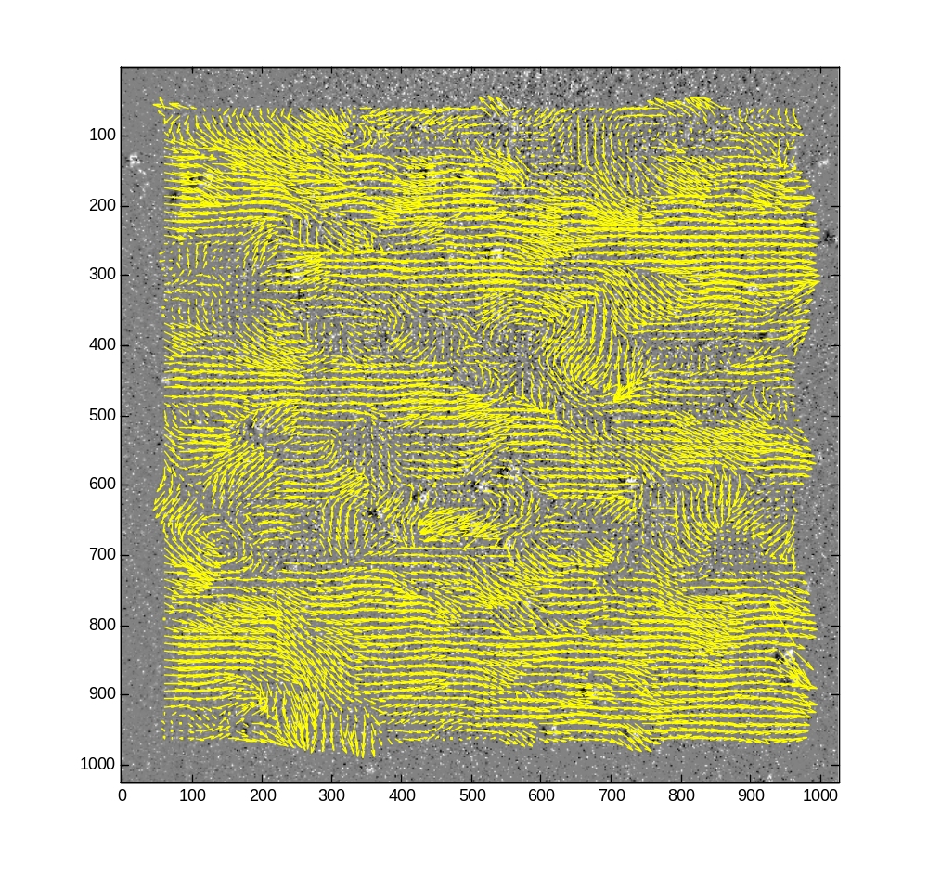
Figure 1. The instantaneous velocity field with global mean subtracted

Sub_pixel_method = 0 Sub_pixel_method = 1
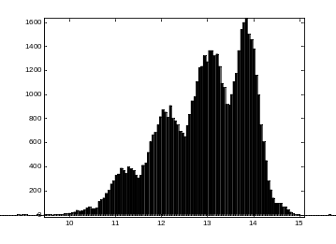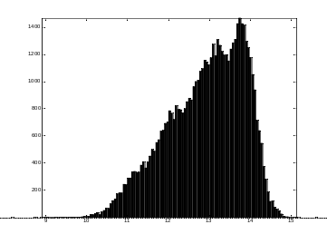

Figure 2. PIV tracking with different sub-pixel finding methods. Histogram of u

Example 2: Sub-pixel accuracy with different interrogation methods and sub-pixel estimation methods
PIV analysis is applied on synthetic images where simulated particle images are uniformly displayed by know distance varying from 0 to 1.0 pixel size. The following figure shows the bias error of PIV interrogation with different method. In general, peak-locking will be reduced by using tracking-based PIV (or MQD) compared with correlation-based PIV. For same interrogation method, anti-peak-locking by shifting sub-image in spectral space is more accurate than 3-point Gaussian curve fitting. The schemes used in this comparative study are:
A. Correlation-based PIV with 3-point Gaussian curve-fitting;
B. Correlation-based PIV with spectral sub-image shifting;
C. Tracking-based PIV with search radius = ± 2 image pixels, spectral sub-window shifting;
D. Tracking-based PIV with search radius = ± 4 image pixels, spectral sub-window shifting;
D. Tracking-based PIV with search radius = ± 4 image pixels, 3 point Gaussian curve-fitting.
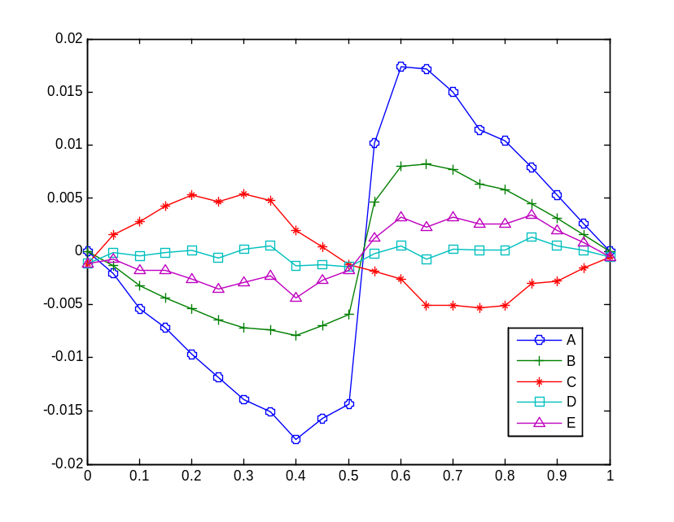
Bias error distribution with sub-pixel displacement

Example 3: Sediment movement imaged by fiberscope
The particles are irregular and big. The signal to noise ratio is low. In addition, sediment movement is driven by collisional mechanisms in sheet flow and differs a lot from continuum movement. It is more appropriate to apply PTV instead PIV in such a case. A careful image pre-processing is essential to increase the SNR and to identify each individual sediment particle in the image. In general this includes: subtract background from the raw image, smooth the image by low pass filtering, identify each particle using matlab functions (Image processing toolbox) “imextendedmax”, “bwlabel” and “regionprops”.
Matlab script:
clear all;
close all;

path='.\se';
fn='se.tif';

load meanbk;

%Image smoother (filter)
H=fspecial('Gaussian',18,2);

%PIV parameters
pp.nx=40; pp.ny=40;
pp.method=2;
pp.piv_tracking_radius_x=12;
pp.piv_tracking_radius_y=12;
pp.min_corr_coef=0.05;
pp.Vel_range=[-30 30 -100 10];

set(gcf,'position',[100 80 800 750]);
for i=1:2:190

A=double(imread(fn,i))-ma;
A=mat2gray(A(50:350,70:340));
%Enhance the contrast of the images
A=imadjust(A,[],[],1.5);
%Smooth the image
As=imfilter(A,H,'symmetric');
%Find out local extended maxima
PA=imextendedmax(As,0.1);

B=double(imread(fn,i+1))-mb;
B=mat2gray(B(50:350,70:340));
B=imadjust(B,[],[],1.5);
Bs=imfilter(B,H,'symmetric');
PB=imextendedmax(Bs,0.1);

imagesc(Bs.*PB-As.*PA);

hold on;

%label each individual sand image
binA=bwlabel(PA);
sA=regionprops(binA,'centroid');
locA=cat(1,sA.Centroid);
xi=locA(:,1);
yi=locA(:,2);
plot(xi,yi,'wo');
[mm,nn]=size(xi);
ue=zeros(mm,nn);
ve=ones(mm,nn)*(-20);

[u,v,c,cmp]=mat_piv(As.*PA,Bs.*PB,xi,yi,ue,ve,pp);
quiver(xi,yi,u,-v,0);

hold off;

pause(0.5);
end

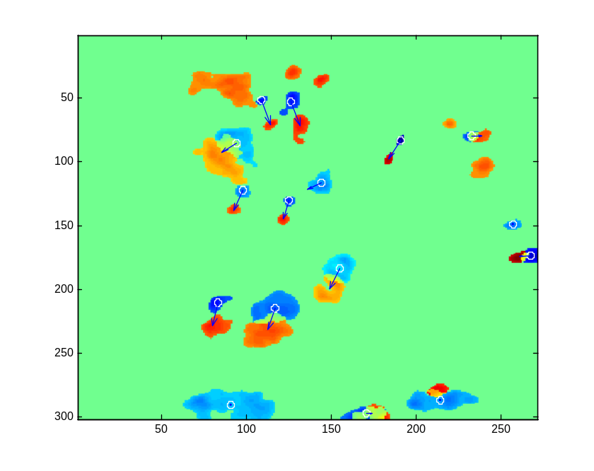
Image B – Image A, and detected particle displacements

Installation of Mat_PIV:
- Create a folder for Mat_PIV, for example: create C:\Matpiv.
- Copy mat_piv.c, piv_util.h, piv_util.c fftw.h to C:\Matpiv.
- Create a subfolder C:\Matpiv\fftw. Download fftw source code (version 2.1.5) from http://www.fftw.org/fftw-2.1.5.tar.gz Although there is a newer version (3.0.1) for fftw, the older one is more compact and is just good enough for our PIV program. Unzip this file and you will get a file fftw-2.1.5.tar, again, you need to unzip it which will generate a folder named “fftw-2.1.5”. In this folder you will find a subfolder “fftw”, pleas copy all files in this subfolder into C:\Matpiv\fftw. For your convenience, these files are also packed into a zip file: fftw.zip which you can find in attachments. They are just redistributions from http://www.fftw.org and the copyright are reserved to Matteo Frigo and Steven G. Johnson.

Compilation of Mat_PIV:
- Since Mat_PIV is a C-MEX function, which contains an interface between MatLab and C language. You will need to compile it using “mex” command in MatLab environment. On Windows platform, MatLab has an embedded C compiler: Lcc 2.4. This compiler is not as optimized as other commercial ones, such as Microsoft Visual C++. If you have Microsoft Visual C++ installed, I will highly recommend you to configure MEX to use this compiler. Use “mex –setup” to configure your MEX-C compiler.
- Another MatLab supported C compiler which is optimized and is absolutely FREE is the Borland C/C++ (free command line tool) version 5.5. This can be downloaded from http://www.borland.com/products/downloads/download_cbuilder.html . After installing this compiler, use “mex –setup” to update your change.
- On Linux and Mac OSX platform, since the gcc is the embedded compiler and is very efficient, you don’t need to worry about which compiler to choose.
- In the Matlab command window, type in “cd C:\Matpiv”, then type in “mex mat_piv.c piv_util.c fftw\*.c”. to compile mat_piv. A dll file (mat_piv.dll) will be created in C:\Matpiv. On Linux platform the result binary file is mat_piv.mexglx, and on Macintosh platform it is mat_piv.mexmac (I haven’t tried compiling on either Linux or Mac OS, though).
- In order to use mat_piv anywhere, you should add the path to Matlab. From the Matlab menu, following File → set path → add Folder. Please add C:\Matpiv into Matlab environment, then press “save” and “close”.
- For developers who want to modify mat_piv.c to add functionalities and/or their own flavors, it is wise to compile all the fftw modules into a lib file, so it won’t take much time to recompile them very time you make modifications to mat_piv.c. Once you have created the fftw library file (for instance, a file named fftw.lib), you just need to type in “mex mat_piv.c piv_util.c fftw.lib” to rebuild your mat_piv function.

